TCOP Thematic Group on the Use of I in Treasury Operations
VC, December 12, 2017
___________________________________________________

According to the Action Plan of the thematic group on the Use of IT in Treasury Operations, a VC on the experience of Kazakhstan with introducing the 4th budget tier at the local government level was held on December 12, 2017. The VC also discussed preparation of the thematic group meeting to be held on April 10-12, 2018, in Baku, Azerbaijan. The VC was attended by 15 members of the thematic group from 6 countries (Albania, Azerbaijan, Belarus, Kazakhstan, Moldova and Turkey). The VC was also attended by the TCOP resource team members – Elena Nikulina, PEMPAL Leader, and Ion Chicu, TCOP Advisor. The VC agenda is embeded.

Representatives of the MOF of Kazakhstan - Erlan Shalginbayev, Head of IT Department, and Zaifun Ernazarova, Head of the Budget Legislation Department – delivered a presentation reflecting the country’s experience with introducing the 4th budget tier at the local government (rural district, village, rural settlement, town) level. The VC participants were exposed to some brief information on the national budget system, revenues and expenditures of local governments, and the current local governments financings scheme. The speakers described the finalization of the integrated Treasury information system, Treasury-Client information system as well as efforts to integrate information systems. In addition, the VC participants learned about the way the treasury services would be provided to local governments after January 1, 2028 (see the below figure).
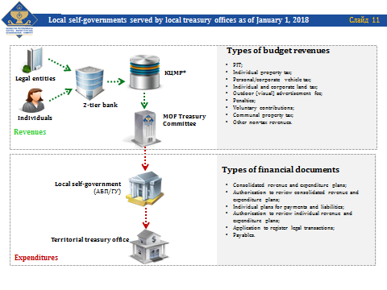

A more detailed version of the presentation will be available during the upcoming meeting of this thematic group in Baku in April 2018. The presentation will be amended to reflect recommendations from the VC participants as well as initial outcomes of the reform after January 1, 2018.
In the beginning of part 2 of the VC agenda, Elena Nikulina briefed the participants on the meeting of thematic group on the Use of IT in Treasury Operations to be held on April 10-12, 2018 in Baku, Azerbaijan. The TCOP ExCom tentatively decided that the first two days of the event would deal with issues directly related to IT, and day 3 will deal with the automation of the accounting function. Representatives of another TCOP thematic group - Public Sector Accounting and Reporting – are to join the meeting on Day 3. Elena Nikulina asked the VC participants to come up with their suggestions regarding the agenda for the Baku meeting.

Nazim Kasum-zade (Azerbaijan) informed the participants that the hosting country would make several presentations reflecting Azerbaijan experience. In particular, the hosting country would like to share its experience with developing the web-portal of the State treasury Agency (FMIS portal, public statements portal, etc; establishment of a flexible IT infrastructure (systems migration to cloud, project preparation, etc.); FMIS technological modernization; IT security in treasury systems; users access and creation of roles in the FMIS; user support issues; public sector accounting reforming using cloud technologies (“Farabi”); enhancing the quality of the public sector financial reporting through the implementation of ERP automatic platform. Also, a presentation on payment systems will be delivered by the Central Bank. The final list of presentations by the MOF of Azerbaijan together with their running order and duration will be submitted to the TCOP resource team before December 12. 2017.
Representatives of Belarus wanted the agenda to also cover automation of public sector accounting and reporting. Representative of Turkey expressed his interest in discussing approaches to classification of information and data processed in the hosting country’s information system. In addition, some interest in discussing integration of accounting software used in budget organizations into the general information system on Day was expressed.

Agenda for Day 3 will be developed will be developed based on the suggestions made during VC as well as opinions of the thematic group on the Public Sector Accounting and Reporting.

In addition to the meeting in Baku, in early March 2018 a VC sponsored by the thematic group on the Use of IT in Treasury Operations is planned. The VC will cover the experience of Georgia with automation of accounting function.

