PEMPAL Executive Meeting
Mid-Term Review of the PEMPAL Strategy 2012-17
_____________________________________________________________

Background
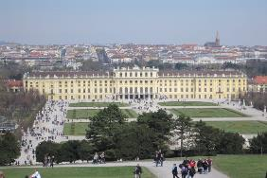
The mid-term results of the PEMPAL Strategy 2012-17 were considered by the PEMPAL Executive on July 16-17 2015, in Vienna, Austria. The meeting was attended by 20 member country representatives from 13 countries (Albania, Azerbaijan, Belarus, Bosnia and Herzegovina, Bulgaria, Croatia, Georgia, Hungary, Kazakhstan, Kyrgyz Republic, Moldova, Russian Federation, and Ukraine). Representatives from the Steering Committee including key development partners to the program: Ministry of Finance of the Russian Federation, the Swiss State Secretariat for Economic Affairs (SECO), and World Bank also participated. The list of participants can be accessed at http://www.pempal.org/event/eventitem/read/144/404

The objective of the meeting was to review implementation progress at the PEPMPAL Strategy’s mid-point ie for first 2.5 years from June 2012-December 2014 to:
- Determine whether objectives remain achievable within target timeframes and existing resource constraints;
- Formulate proposals for adjustments, which could include adjustments to the Strategy, its results framework, and costings in light of implementation experience; and
- Identify measures to manage any emerging risks that may impact on full implementation of the Strategy.
The workshop was facilitated by the World Bank Team Leader for PEMPAL, Ms Elena Nikulina, with inputs from the World Bank team that support the program. Logistical support was provided by Virginia Yates from the World Bank with support from the new PEMPAL Secretariat recently established within the World Bank Moscow Office.
A draft comprehensive report was distributed before the meeting summarizing the results. It included reviewing progress of 15 actions in the Strategy and analyzing available baseline and performance data for 35 performance indicators. COP Executive Committees, representing 8-9 member country governments of the 21-23 total members, examined this draft in preparation for the discussions. This report was prepared by analyzing a number of key inputs:
- The three Communities of Practice of Budget, Treasury and Internal Audit prepared submissions based on information required to measure the key performance indicators included in the strategy’s results framework.
- Donors provided written comments.
- The former Secretariat collated administrative and performance data in accordance with key performance information requirements.
- All members were invited to participate in an online survey. COP specific and PEMPAL survey results reports were then produced.

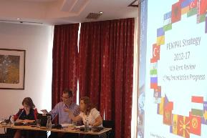
The meeting was opened by the Chair of the PEMPAL Steering Committee Ms Anna Valkova, from the Ministry of Finance of the Russian Federation, together with Mr Adrian Fozzard, World Bank Practice Manager. They commended the Executive on the good results found from the mid-term review, but emphasized the need to now start focusing on the period beyond the strategy, to ensure the network remains sustainable and to strengthen approaches to demonstrate the positive impact that PEMPAL was having on member country public financial management systems. The results of the review indicated several areas that the Executive could focus to strengthen the network’s sustainability and profile at high government levels, and they welcomed the discussions on the preliminary results, to inform the next steps in finalizing the implementation of the strategy, and laying the basis for the development of the next one.
- Overview of Results of the Mid-Term Review of the Strategy
An overview of the results of the mid-term review was provided by Ms Elena Nikulina and Ms Deanna Aubrey. The PEMPAL Strategy’s results framework was revisited and key results under the Goal and Outcome levels and the four output objectives outlined as briefly summarized below. Areas of possible improvement were also presented, which were then discussed and prioritized in group work.
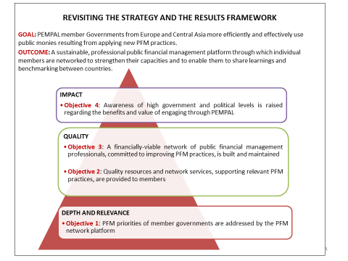
Source: MTR PEMPAL Strategy 2012-2017, Slide 4, presentation July 16 2015, Cross-COP Executive Meeting available at http://www.pempal.org/event/eventitem/read/144/400

Notwithstanding methodological challenges of measuring the impact of the strategy, PEMPAL has had a visible impact at the member country level. The results of the review found that 6 BCOP, 12 TCOP and 17 IACOP countries showed positive impact. Further, although PFM Indicators were not comprehensive or up to date across the region, evidence was found of surveys being regularly used to ascertain reform progress and success stories provided by the COPs illustrated the positive impact of PEMPAL.

Good progress was observed at the outcome level of the Strategy, with evidence of new and improved knowledge in Public Financial Management (PFM) practices and continuing rising high levels of satisfaction expressed by members. Satisfaction ratings taken from post event surveys, have remained consistently high ranging from 4.3 to a maximum of 5.0 in calendar year (CY) 2012, CY 2013 and CY 2014.
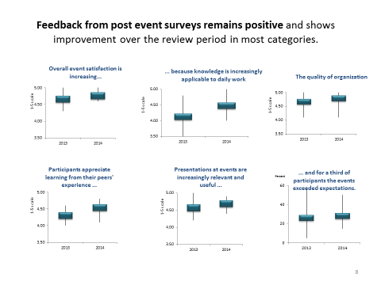Source: MTR PEMPAL Strategy 2012-2017, Slide 8, presentation July 16 2015, Cross-COP Executive Meeting available at http://www.pempal.org/event/eventitem/read/144/400

Available evidence suggests that mechanisms developed by PEMPAL to target PFM priorities of member governments are working well. Consultation processes to develop member driven action plans were strong across all COPs with increasing use of smaller working group/study visit formats proving to better target member needs.
The review found solid evidence of high and growing levels of member satisfaction with the quality of resources and services provided by the network. Materials, management, leadership, Secretariat and technical services provided by PEMPAL were rated as good quality or high quality by most respondents to the MTR surveys. Information posted on the PEMPAL website also remained in high demand and the rules of operation had been improved and clarified. The increasing use of Video Conferencing for meetings contributed to reducing costs (average expenses per participant) and the new contractual arrangement had also been effective in improving the quality of secretariat services although the Secretariat decided to discontinue its contract with PEMPAL by June 2015. It was noted that the challenge was to sustain the high overall quality of resources and services while continuing to encourage stronger participation of the members in producing knowledge resources, in the context of continuing growth, a new Secretariat support mechanism; reducing inputs from external experts; and reduced COP budget allocations.
The review also found evidence of strong member commitment to the network, high quality of membership as well as increasing provision of in-kind and financial contributions to the program by the member countries. Membership analyses showed core membership, coming from target ministries (central coordinating agencies) but also a significant number of newcomers which presents a challenge on how to ensure previous knowledge is shared.
Generous donor contributions to the PEMPAL Multi-Donor Trust Fund assured stable program funding throughout the strategy period supplemented with financial and in-kind contributions from members. ‘PEMPAL Champions’ were identified who were member countries who hosted one or more events or who sent additional participants at their own cost over and above those funded by PEMPAL. Russian Federation, Georgia and Albania were particularly praised for holding PEMPAL meetings of all three COPs over the last three years.
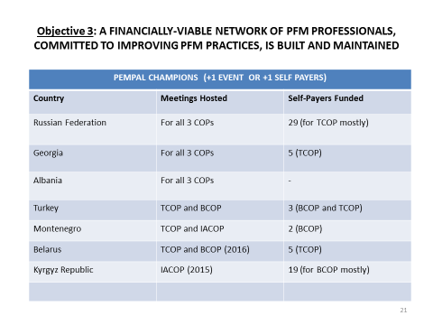 Source: MTR PEMPAL Strategy 2012-2017, Slide 21, presentation July 16 2015, Cross-COP Executive Meeting available at http://www.pempal.org/event/eventitem/read/144/400

There is convincing evidence of increased awareness of high government and political levels of the benefits and value of engaging through PEMPAL. However, donor partners see the need for investing additional efforts into this objective. Evidence of high level awareness of the benefits of PEMPAL were included in COP submissions and presentations (eg Ministers/Deputy Ministers opening meetings and attending events). A revised approach to marketing at senior management levels was also implemented with streamlined Thank you letters to Ministers implemented by the former Secretariat. It was noted that no progress had been made on the strategy action related to investigating feasibility of transforming PEMPAL into a more formal network of national PFM institutions. At the same time various stakeholders at the meeting expressed a strong preference against this option. After the presentation of results of the review, each COP delivered a presentation outlining their key results as outlined in their formal submissions to the review.

COP Results

Budget Community of Practice (BCOP)

The results and issues of BCOP were presented by the two Deputy Chairs of the Executive Committee from Albania and the Russian Federation. Ms Gelardina Prodani (Ministry of Finance, Albania) and Ms Anna Belenchuk (Ministry of Finance of Russian Federation), advised that there are several ways that BCOP supports the adoption of good PFM practices:
- Sharing international approaches and country case studies at plenary events helps members identify good and innovative practices in specific PFM areas and gives opportunity to discuss common problems and solutions with peers.
- Identifying reform status compared to international and regional good practice through formal and informal benchmarking surveys.
- Providing technical PFM reports and studies in PEMPAL languages to allow member countries to access to the latest trends and approaches.
- Examining reforms in-depth through study visits to specific countries and working groups established for specific topics (eg wage bill management and budget literacy).

BCOP provided the following examples of impact of BCOP activities:

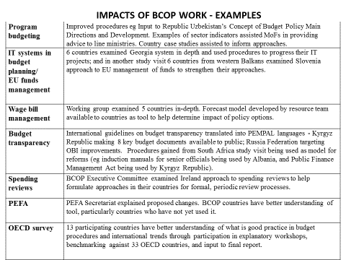
Source: BCOP MTR Results, Slide 3, presentation July 16 2015, Cross-COP Executive Meeting available at http://www.pempal.org/event/eventitem/read/144/400

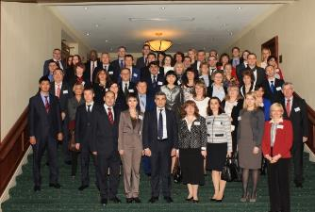
BCOP provided good evidence of progress under all the PEMPAL Strategy’s output objectives, highlighting significant growth from 2 events in CY 2012 to 8 being held each year in CY 2013 and CY 2014 and 9 in CY 2015. This growth has been supported by a strong Executive Committee, technical resource team and Secretariat. The format of TCOP’s Strategic Plan had also been adopted which has made BCOP’s plan more strategic and linked more explicitly to the PEMPAL Strategy. Further work is planned to make this plan more strategic over the remainder of the strategy period. Value for money has also been pursued with back-to-back meetings held with the annual OECD Senior Budget Officers (SBO) meeting; the annual plenary meeting; and the increasing use of Video Conferencing (VCs) for working group meetings. Two working groups (wage bill management and budget literacy) are currently operating with a new working group on program budgeting to be established over the next year. There are 61 core members of BCOP with the most active participation coming from the 8 member countries represented in the Executive Committee. The majority of members are from middle to high management levels, and all members come from target ministries (Ministries of Finance).
BCOP provided evidence of financial contributions, with 78 participant’s attendance being funded by member countries during the strategy period (largely from Kyrgyz Republic). BCOP follows the practice of allowing additional participants to attend events, over and above normal membership strategies, on proviso that they are funded by the government.

BCOP also provided evidence of significant in-kind contributions, For example:
- The Executive Committee provides significant time in leading and managing BCOP.
- 4 member countries hosted annual plenary meetings, one member has hosted a study visit and 16 have prepared and delivered presentations on the status of their reforms during the strategy period (ie Russian Federation 6 times, Turkey 4 times, Croatia 3 times, Albania, Georgia and Kyrgyz Republic 1 time each).
- There is also an increasing trend of member countries wanting to host meetings, with plans already in train for Belarus to host the 2016 BCOP plenary meeting.
- Participation in formal and informal surveys and participation in working groups is growing.

BCOP also advised that several Ministers and Deputy Ministers of Finance have shown their support through opening or attending BCOP meetings and provided several examples including the First Deputy Minister of Finance of Armenia Pavel Safaryan; First Deputy Minister of Finance of Belarus Maxim Yermolovich; Former Minister of Finance of Kyrgyz Republic (2012-March 2015), Olga Lavrova and the Treasurer of Croatia who provided the following written feedback:
Although the costs of organizing such events are very high, especially when joint plenary meetings of all three Communities are organized, our opinion is that such exchange of experience, with topics that are of interest for all participant countries, is invaluable, and that they should continue in the future as well, in spite of certain difficulties. Source: Thank You Letter to BCOP from Miljenko Fiçor, Assistant Minister and Chief State Treasurer from Croatia

BCOP indicated some challenges including working groups being dependent on the availability of member countries to lead them, which can be hampered by the demands of the budget process. Three languages present in the Executive Committee also mean translation needs are high, and it is important to monitor technologies that facilitate communication in such an environment. Areas of focus in the future included collaborations already established with the OECD’s Central, Eastern and South-Eastern European Countries (CESEE) Senior Budget Officers (SBO) network will be strengthened with proposed future joint work (potential areas include fiscal rules, fiscal risks and program budgeting). Joint collaborations with TCOP in the area of budget accounting and reporting will also be explored. Focus on producing knowledge products will continue and information in the member database will continue to be improved, to support membership monitoring.

Treasury Community of Practice (TCOP)
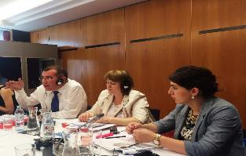
The results and issues of the Treasury Community of Practice were presented by Mr Vugar Abdullayev from State Treasury, Azerbaijan and Chair of TCOP. He advised that TCOP’s Strategic Plan 2013-15 was fully aligned to the PEMPAL Strategy, and had a focus on the following priority topics: public sector accounting and reporting; use of information technologies (IT) in Treasury Operations; Treasury Control; and Cash Management.

TCOP also advised that there were over 810 TCOP members participating in events during the strategy period, with high involvement of treasury senior managers in TCOP activities. Further the Executive Committee members comprise 7 treasury deputy directors and 2 heads of departments.

Significant member countries’ financial and thematic contributions to TCOP events were also evident:
- 11 member countries hosted TCOP events (8 in financial years 2013-2015)
- 54 members (about 10% of all participants) attended TCOP face-to-face events as self-payers (on their countries’ expense)
- 70 presentations and 4 Financial Management Information System (FMIS) live demonstrations made at TCOP events by representatives of member countries.

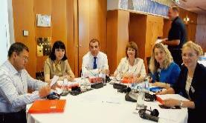
The following examples of outcomes were provided by TCOP:
- Successes in implementation of treasury information systems identified and demonstrated (the agenda of events held in Georgia, Russia, Azerbaijan included on-line demonstration of treasury IT systems). Colleagues from Belarus benefited from peer advice on their new FMIS Concept
- Peer review of developed draft Charts of Accounts (Tajikistan, Ukraine).
- Structure of the Practical Guide on Financial Reporting Consolidation developed.
- Contacts established with the Ministries of Finance of the UK, France, Netherlands, South Korea, Estonia, as well as the International Federation of Accountants (IFAC), Chartered Institute of Public Finance and Accountancy (CIPFA) and the International Public Sector Accountancy Standards Board (IPSASB).
- Collection of materials on treasury activities in the PEMPAL Virtual Library.
- Applications for financing PFM technical assistance based on information received within PEMPAL (Kazakhstan, Belarus).

TCOP also reported that several thematic groups were in operation:
- Integration of budget classification and Chart of Accounts (5 countries)
- Public Sector Accounting and Reporting with a focus on accounting standards (6 countries); public assets accounting (10 countries); and financial reporting consolidation (7 countries).
- Use of IT in Treasury Operations (10 countries)
- Cash Management (9 countries).

TCOP also provided very positive feedback from political levels to the value and impact of PEMPAL: Mr Nodar Khaduri, Georgian Minister of Finance, TCOP Workshop in Tbilisi, February 2014: "Georgia highly appreciates PEMPAL activities. My country has benefited from participating in this program directly".
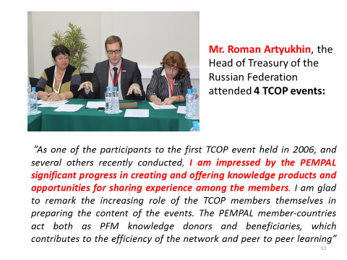
Source: TCOP MTR Results, Slide 13, presentation July 16 2015, Cross-COP Executive Meeting available at http://www.pempal.org/event/eventitem/read/144/400

Internal Audit Community of Practice (IACOP)

The results and issues of Internal Audit Community of Practice were presented by Ms Edit Nemeth, Ministry of Finance of Hungary, and Chair of IACOP. Ms Nemeth presented the IACOP’s Strategic Plan:
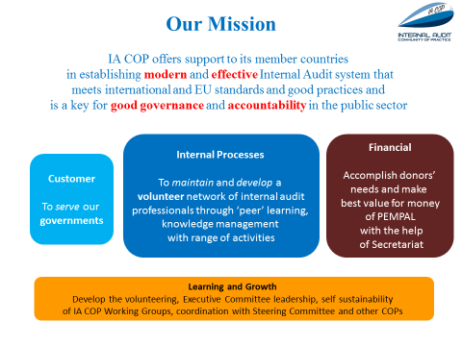 Source: IACOP MTR Results, Slide 3, presentation July 16 2015, Cross-COP Executive Meeting available at http://www.pempal.org/event/eventitem/read/144/400

Leadership roles are given to each member of the COP which encourages ownership and active engagement of all members. Such roles include External Messengers (who prepare a communique or resolution for external stakeholders); Critical Friends (who identify and communicate weak points of the event); Value Detectives (who explore created values); Agenda Activists (who identify new topics); and Social Reporters (who collect memories from social events).

In terms of meeting the impact objectives of the strategy, Ms Nemeth provided a series of graphs, one displaying the impact of IACOP by theme addressed:

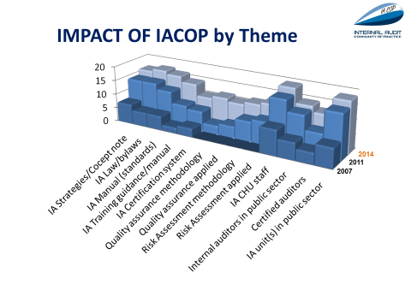Source: IACOP MTR Results, Slide 14, presentation July 16 2015, Cross-COP Executive Meeting available at http://www.pempal.org/event/eventitem/read/144/400
Ms Nemeth advised that IACOP are particularly strong on producing knowledge products which are developed over a number of years by member countries. These include methodologies which are tested and refined in member countries. These products are outlined below:
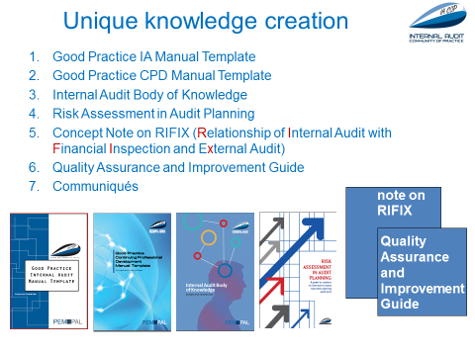
Source: IACOP MTR Results, Slide 17, presentation July 16 2015, Cross-COP Executive Meeting available at http://www.pempal.org/event/eventitem/read/144/400
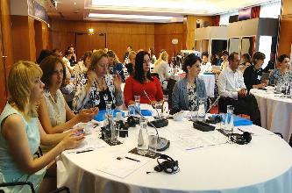
There has also been significant examples of in-kind contributions from members and an enabling group ‘Community Keepers’ continually looks for ways to promote sustainability of membership. PEMPAL member countries: Romania, Kazakhstan, Hungary, Montenegro, Russian Federation, Armenia, Georgia, Albania, Ukraine, and Croatia, hosted IACOP events during the Strategy implementation period. Examples of high level engagement were also given. According to Community Keepers recommendations, there are two different approaches for the invitation process to the plenary meetings. One participant can be nominated by IACOP and the second by the country MOF. The IACOP invites the most active members and those in charge of policy reforms in respective member countries. The Executive Committee has also established a robust nomination process which is applied to the events conducted by the IACOP working/thematic groups.

Development Partner Views

4.1. Swiss State Secretariat for Economic Affairs (SECO)

Ms Irene Frei from the Swiss State Secretariat for Economic Affairs outlined SECO’s submission to the review.
SECO were satisfied with the progress of achieving the Goal/Outcome levels and output objectives 1 and 2 of the strategy but indicated more focus would need to be made on Output Objectives 3 and 4 for the remainder of the strategy to ensure the network’s continued sustainability and to lay the foundations for the next strategy as illustrated in the slide below.
Possible areas of improvement for Output Objective 1 were outlined, included COPs providing more strategic information about their actions plans and rationale for the priority themes chosen. Further, despite the PFM system being integrated, with much interplay between the different components, this was not reflected in the work of the COPs with each COP being very independent from the others. Thus more work could be undertaken on identifying joint initiatives.
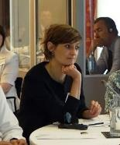
For Output Objective 2, the strong and committed governance structure of the network was acknowledged, but it was noted that the COPs played a passive role on the Steering Committee, and this role could be strengthened, including clarification of the role of observers on the Committee. Changes in the rules of operation could also be made so that decision-making was by consensus rather than vote, which would better suit the nature of the committee. For Output Objective 3, a better picture of what are the types of knowledge products produced by the COPs and how these are being used would be of benefit. With the growth in the production of such products, there is also a need to ensure PEMPAL manages this instrument, including ensuring relevant products are kept updated.
Output Objectives 3 is a concern to SECO as PEMPAL remains donor dependent, and the financing is not predicable or stable. In SECO’s view, PEMPAL should therefore look into ways of increasing member contributions. Further, although member contributions are evident, there is no clear and consistent approach on how these are collected and reported. Output Objective 4 is closely related to sustainability thus it is necessary to also engage the higher levels and clearly demonstrate concrete evidence of the benefits of PEMPAL to get donor and member contributions allocated.

4.2. Ministry of Finance of the Russian Federation

Ms Anna Valkova from the MoF of the Russian Federation noted that the original objectives of the Strategy remain valid, and that it was good news that there was no financing gap for the current strategy. She reported that the 2014 cross-COP meeting in Moscow on fiscal transparency and accountability was a very successful event that raised the profile of PEMPAL in the Russian Federation, in light of the event being opened by the Minister of Finance and the Minister of Open Government. This facilitated the securing of additional funds from the Russian Federation to support the PEMPAL initiative.

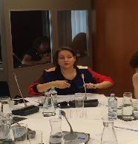
The MoF of the Russian Federation is also using the network to facilitate reforms in key areas such as budget literacy which has been established as a working group under BCOP. It also launched a separate joint project with the World Bank in 2014. The Russian Federation MoF is a pioneer in the region on this issue, and is currently designing training courses for school age children and will contribute to and use the work proposed under the BCOP working group to progress these reforms. The partnerships established under PEMPAL to ensure ongoing sustainability were also welcomed, noting BCOP’s cooperation with OECD, and using its methodologies to benchmark budget practices. Experiences of other networks such as CABRI will also be of benefit to ensure PEMPAL is moving in the right direction.
Opportunities existed for donors to increasingly know what is happening in PEMPAL, and to be made more aware of problems, outcomes, and agreed recommendations. Thus, donors should be in the context of the discussions not just in the reporting of the COP plans and their execution. In response, the Executive invited both donors to participate in their meetings, subject to their availability.
More interactive indicators to measure exchanges could also be adopted (ie not just number of events but record the bilateral exchanges between countries). Satisfaction was expressed with the PEMPAL website and adoption of modern technologies to facilitate communication and knowledge exchange and additional assistance was offered if needed noting current issues being experienced with the transfer of the website platform from the previous Secretariat.
The post 2017 period should also ensure that PEMPAL has a regional dialogue and voice in international discussions. For this purpose, Ms Valkova advised that the Russian Federation are happy to present PEMPAL at the development working group at the G20 and to encourage other donors to be part of the initiative. Gratitude was also expressed for the practice of inviting outside observers to PEMPAL, noting the involvement of MENA representatives at the 2014 Moscow meeting. In the future strategy, such practices should be encouraged to continue to extend the identification of best practices to other regions.

World Bank

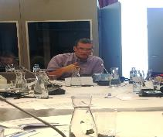
Mr Fozzard outlined the role and nature of the Bank’s engagement with PEMPAL noting it provided the core resource teams that provided technical support to the network in addition to managing the multi-donor trust fund from which the donor funds were managed.
It was important to the Bank that the benefits to the member states were clearly defined, including what global public goods were being produced at the regional level, and what new and different ways of thinking were being adopted about PFM. A more strengthened methodology for measuring impacts and reporting success stories was needed and should be considered in the context of the development of the next strategy. Monitoring and marketing success stories is particularly important to facilitate new donors to ensure ongoing sustainability. Additional thought needs to be given on how results should be portrayed, and a short promotional document could be prepared for this purpose. Within the next strategy it should also be clear on how will PEMPAL evolve over time, and wider communication strategies be established that communicate results outside of the ECA region.
Sustainability has many elements including quality, leadership, commitment, and cost effectiveness. All these elements need to be reflected in the next strategy. It was evident that the sense of ownership and interest in the network is high but the challenge is to expand that through organizations to facilitate political ownership. From feedback from members, keeping the network as informal aimed at practitioner and technical levels is the most preferred option, and this should be considered when decisions are made on the type of institutional framework (in light of one of the strategy’s actions indicating transforming PEMPAL to a more formal network should be explored). Links to other networks should also be facilitated, such as PEMNA, CABRI and LAC and a consistent set of indicators across different regions be considered to facilitate benchmarking and monitoring. Collaboration opportunities with these networks should also be explored as part of the next strategy.

Group Discussion Results

Group discussions were held whereby the group was broken into smaller groups based on language and cross-COP mix, to address the following questions for specific parts of the results framework.
Is progress adequate ie at the current level of implementation, will the respective objectives be achieved by the end of the strategy period?
Within the current resourcing constraints for the remainder of the strategy, what are the most important suggestions for improvement that should be implemented over the next two years? For this second question, refer to the MTR’s report Table 1 under those sections assigned to your group for ideas for suggested improvements. The group is requested to prioritize the actions it proposes (1. High 2. Medium 3. Low). The group is free to delete or add actions to the Table.

Key decisions made in the discussions are presented below, which were taken from the group presentations delivered the following day after the discussions. Group 1 (English/BCS language) addressed Output Objectives 1 and 2. Group 2 (Russian/English), addressed Goal/Outcome and Output Objective 4 and Group 3 (Russian only) addressed Output Objective 1 and 3. The allocation of these tasks was determined to ensure that workload was approximately equal. Group 2, had donor and COP Chair representatives, so higher level objectives were allocated to this group.
Box 1. Conclusions from Group Discussions
IMPACT/OUTCOME
- Group 2 discussed the issue of what is demanded from donors. The group concluded that:
  - There is a need for a product, justifying the value of PEMPAL at the policy level, to start discussion of continuing support within their agencies
  - There is a need to satisfy different stakeholders and needs in capturing results: collecting numbers, success stories, examples, etc.
  - Categorizing on various dimensions: what are the public goods, globally and for ECA region?
  - How to show the link between strengthening individual country capacity and impact: some countries attend events and learn about issues, but reforms are not progressing
  - Benefits need to be captured at both the individual and institutional levels including how one leads to the other.
- Group 2 assessed the MTR Report’s first recommendation of establishing a more systematic and standardized approach to collecting success stories be rated a high priority. The group also advised that:
  - Use of different methodologies for capturing results is important and results needs to be measured on various dimensions: Success stories, figures, examples, survey results, “value detectives” method
  - Important to monitor chain of results: Individual development –> dissemination of knowledge -> institutional development
  - MTR Report will have extract - summary of results - keeping in mind targeted audience.
- Group 2 also advised that suggestions by the MOF of Russian Federation to investigate the terms and conditions that contribute to PFM development could be removed from Table 1, given current resourcing constraints. The associated suggestion about collating available PFM assessments for each member country to better understand strengths and weaknesses of each country, should also be removed. However the rest of the suggestion should be retained, including continued expansion of more direct network service delivery approaches such as working groups, and also investigating approaches used by other networks. It was noted that it is necessary to monitor the results of the working groups.
OUTPUT OBJECTIVE 1
- Progress under this Output Objective is good, and both Groups 1 and 3 assessed that it was on track to being fully completed by the end of the strategy period.
- Group 1 noted that it was important to continue to mitigate the identified risks under this objective. Firstly Ministers continuing to assign participants to attend PEMPAL could be negatively impacted depending on financial contribution strategies considered (which was also connected to Output Objective 4). Secondly, consultation by COPs to ensure priorities of members are addressed – also needs to be monitored so that differentiated services continue to be delivered to ensure that countries in minority still get their needs met. Continued use and exploration of different formats should also be undertaken (eg working groups, study visits, peer reviews).
- Group 3 recommended a new action be included in Table 1, for more formal documentation of member country priorities be undertaken by the COPs through surveys of members, as undertaken already by some COPs.
- Group 1 recommended that cross-COP initiatives need to be identified earlier in action plan development (not after). Coordination between COPs also needs improving and a more systematic approach be implemented to facilitate attendance at each other’s events. Group 3 recommended the development and approval of a unified format of the COP Strategic and Action Plans should be an additional improvement action in Table 1, with the level of detail defined, taking into account survey results for member priorities, and the flexibility of updating plans throughout the year in response to emerging priorities.
OUTPUT OBJECTIVE 2
- Progress under this Output Objective is good, and Group 1 assessed that it was on track to being fully completed by the end of the strategy period.
- However, it was noted that PEMPAL needs to continue to manage ‘moderate risks’ identified under this objective to ensure they do not impede service delivery in the remainder of the strategy period. Firstly cost effective and sustainable communication technologies need to be managed and effective tools to communicate monitored and adopted (eg webex, webinar technologies, and information storage and exchange tools). Some Ministry policies disallow some tools (eg Skype) so the impact of this also needs to be managed. Secondly the Secretariat needs to ensure event preparation processes start well before event, to facilitate visa processes and accessibility by all countries.
- Group 1 noted that PEMPAL will need to manage new risks arising out of the new interim Secretariat mechanism including ensuring all data is captured over the next six months and extra support is given by the resource teams to ensure PEMPAL meets its reporting obligations.
OUTPUT OBJECTIVE 3
- Group 3 recommended that this Output Objective needs more focus for the remainder of the strategy and issues identified as part of the review, should be addressed in the development of the new strategy. The process of developing this next strategy of PEMPAL should be initiated soon and an improvement action be included in Table 1 to reflect this.
- Possible impediments to implementing member contributions were also noted including PEMPAL does not have the status of an international organization that would be required for any formal, legal appropriation/contribution from member countries; complex national legislation and difficulties associated with decision making at member national levels; and the mechanism for their implementation would need to be developed (size, frequency, collection mechanisms).
- Other impediments to member contributions comes from the nature of the program which may exclude some countries if they choose not to pay member contributions which goes against the values of network such as:
- Equal conditions for participation in PEMPAL for all countries
- Availability of resources and knowledge products for the representatives of all the countries
- Equal opportunity for decision making on the subject of the activities linked to the priorities of countries
- Providing the target audience and correct profile of event participants.
- Proposals were discussed to improve financial sustainability by Group 3 including the possible introduction of incentive mechanisms of delegating additional participants to attend PEMPAL events by member states, the costs of which are covered by the member country; explore the market for potential donors and establish contacts with them for financial support; and prepare a communication/marketing strategy for promotion of PEMPAL.
OUTPUT OBJECTIVE 4
- Group 2 (comprising donors and COP Chairs) decided that PEMPAL should not invest resources to establish a formal network of national PFM institutions. A formal network would involve huge bureaucracy and members would prefer to keep it informal. PEMPAL has value for technical level professionals and members would like to keep the platform primarily for this technical level. Thus the suggestion regarding investigating the feasibility of establishing a more formal network can be removed from Table 1. The suggestion about entering into more formal agreements with member countries should also be removed.
- There is plenty of evidence to demonstrate good progress on raising awareness and the Bank team advised that it was a conscience decision to focus on awareness rather than involvement of political levels. However, donors indicted they would still like an exchange at political levels under PEMPAL at least once a year as it would be beneficial. Thus it was agreed that PEMPAL will aim to have a special event for political levels whether during the next World Bank/IMF spring meeting or annual meeting;
- PEMPAL could explore promoting its agenda under G20 (Russian MoF can help with it), and through the Open Government Partnership (OGP).

Conclusions

In making the final meeting conclusions Ms Nikulina revisited the initial conclusions made in her earlier presentation and made a record of the decisions made by the Executive. These included the following.
- Original objectives of PEMPAL Strategy remain valid and PEMPAL is making very good progress at all levels. The sustainability of the network beyond the current Strategy period presents a concern. Several dimensions of sustainability (quality, secretariat support, financing) require attention during the final years of the Strategy implementation. In response it was agreed that:
- PEMPAL should consider its strategic vision for the next strategy by June 2016. In the next strategy when defining vision; values of professionalism, and equal access of opportunities should be endorsed. The new strategy should also include clearer definition of services and knowledge products. A communication plan should also be developed as part of the strategy.
- There is no need to seek additional funding for final years of this strategy but a marketing brochure on PEMPAL results should be prepared and aimed at external stakeholders - for fund raising, and promoting performance results.
- World Bank annual meetings would be used to further raise awareness and the Russian Federation will promote PEMPAL at G20 and OGP meetings to invest additional efforts to Output Objective 4.
- The current implementation arrangements are working well but the Secretariat services delivery model requires immediate attention. The Steering Committee considered the options and decided the most feasible option was to keep the interim mechanism until the end of the strategy period while investigating the market as part of the next strategy.
- The results framework for the next strategy should be simplified – less actions and less performance indicators – to facilitate monitoring and reporting.
In regards to specific actions and performance indicators within the Strategy, Ms Nikulina revisited the earlier recommendations in her presentation and the Executive made the following decisions in green.
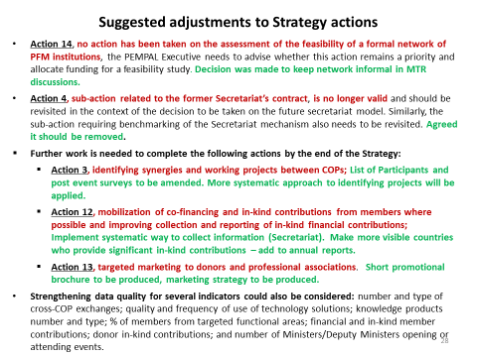
Source: MTR PEMPAL Strategy 2012-2017, Slide 27 (without amendments), presentation July 16 2015, Cross-COP Executive Meeting available at http://www.pempal.org/event/eventitem/read/144/400

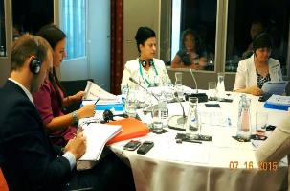
The final session of the meeting was devoted to clarifying next steps and getting feedback from participants on what they liked about the meeting, and what could be improved in the future. It was agreed by the Executive that the objectives of the meeting had been met and that the discussions were in-depth and high quality resulting in clear recommendations, and next steps. A strong sense of ownership of the network by the Executive was evident and the maturity and commitment of the group enabled critical and frank discussions, which contributed to a strong sense of common strategic direction. It was noted that the meeting was well prepared both from a logistical standpoint but also from an analytical standpoint with comprehensive analysis of progress facilitating the Executive in making decisions on the way forward. It was also noted that the format was balanced with a good mix of presentations and discussions, with the language based groups and questions well planned. The ice breaker activities were also commended which allowed members to get to know each other better, in an enjoyable way.
It was agreed that an event report on the meeting would be prepared in addition to an addendum to strategy comprising one page to be placed on website next to the current strategy. Table 1 of the MTR report would also be amended with group recommendations.
A PEMPAL Steering Committee meeting was also held to approve the recommendations and next steps decided by the Executive. It was also decided that the next PEMPAL Cross-COP Executive meeting will be held around mid-2016 and will address the development of the next PEMPAL Strategy.

The workshop program and materials can be found at the PEMPAL website:
http://www.pempal.org/event/read/144

The Public Expenditure Management Peer Assisted Learning network (PEMPAL) was established in 2006 and provides learning events, workshops, study tours and resource materials in accordance with member driven action plans in the thematic areas of budget, treasury and internal audit for member countries in Europe and Central Asia. Refer to www.pempal.org for more information
The core Bank team attending the meeting included Elena Nikulina (TTL and TCOP adviser), Ion Chicu (TCOP adviser/program operations adviser), Maya Gusarova (BCOP Lead Coordinator), Deanna Aubrey (BCOP adviser/network strategic adviser), Arman Vatyan (IACOP Lead Coordinator), Diana Grosu-Axenti (IACOP adviser), Marius Koen (member of Steering Committee), and Nina Duduchava (support for electronic post event feedback surveys).
The previous Secretariat, provided by the Center of Excellence in Finance in Slovenia, advised the World Bank that it would not continue providing services past June 2015, so an interim mechanism had to be urgently established.
Prepared by the World Bank team and subject to standard quality review processes of the Bank.
PEMPAL covers costs of participation for 2 members per COP, with additional participants allowed if the country is a member on the Executive Committee or active in agenda development or implementation.
Minutes to this meeting will shortly be available at: http://www.pempal.org/event/sc_meetings/

