PEM PAL BCOP Study Visit to Slovenia, April 2016
FEEDBACK SURVEY REPORT

On April 13-16, 2016 Study Visit of BUDGET COMMUNITY OF PRACTICE (BCOP) on public sector pay reforms took place in Slovenia.
After the event, the on-line survey in three languages was created. The aim of the survey was to receive event feedback.

Link to the survey – https://www.surveymonkey.com/r/H3F339Q

The survey started to collect responses on April 18 and finished on April 26, 2016.
Invitations to take part in the survey were sent to 23 participants of the workshop.
12 responses (53%) were received. In this report, we analyze all 12 responses. For further calculation, we take this quantity as 100%.
All these responses will be included in the general Feedback Event Database. All responses are not identified by source and sent on a confidential basis to Nina Duduchava of the World Bank who prepares this report.
The questionnaire comprises five parts: About the Respondent, Event Delivery, Event Administration, Overall Impression, and Recommendations for the Future. There are a total of 26 questions.
ABOUT THE RESPONDENT

Q1 You are..

11 (91.7%) respondents gave answers.
Answer Options | Response Percent | Response Count
Representative of PEMPAL member country | 81,8% | 9
Representative of Hosting institution | 18,2% | 2
Resource person | 0,0% | 0
Invited speaker | 0,0% | 0

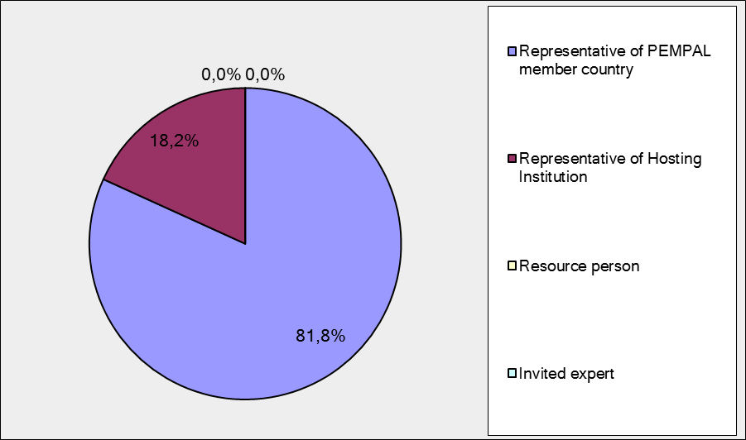
Q2. Was this your first participation in a PEMPAL event?

11 respondents (91.7%) answered this question.
Answer Options | Response Percent | Response Count
Yes | 45,5% | 5
No | 54,5% | 6

Representatives of PEMPAL member country

Answer Options | Response Percent | Response Count
Yes | 44.4% | 4
No | 55,5% | 5

Q3. How many PEMPAL events have you attended before?

This question was seen only by those respondents who chose “No” in the previous question.
6 respondents answered this question.

1-2 | 3-4 | 5-6 | more than 6 | Response Count
2 | 2 | 1 | 1 | 6
Representatives of PEMPAL member country

1-2 | 3-4 | 5-6 | more than 6 | Response Count
2 | 1 | 1 | 1 | 5

PART I EVENT DELIVERY

Q4. How do you rate your participation in this event?
11 (91.7%) answers were given.
Answer Options | Response Percent | Response Count
Active | 72,7% | 8
Average | 18,2% | 2
Passive | 9,1% | 1

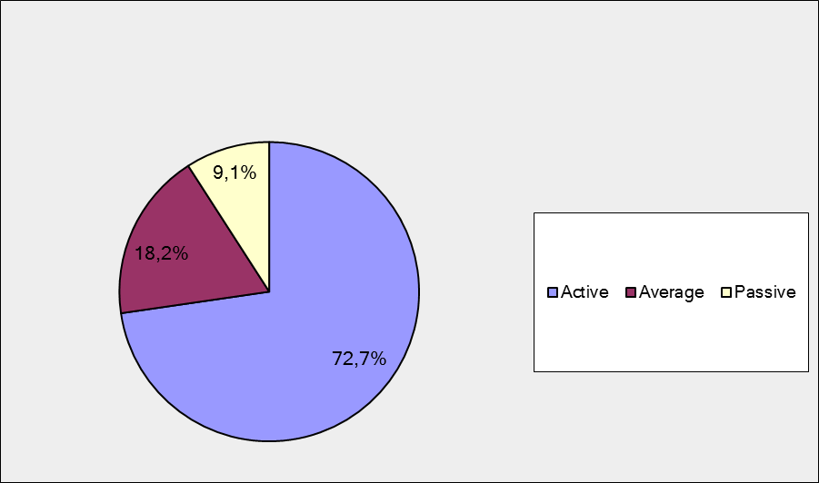

Representatives of PEMPAL member country

Answer Options | Response Percent | Response Count
Active | 77.7% | 7
Average | 11.1% | 1
Passive | 11.1% | 1

Q5. How do you rate the duration of the event overall?
11 respondents (91.7%) answered this question.
Answer Options | Response Percent | Response Count
Too short | 18,2% | 2
About right | 81,8% | 9
Too long | 0,0% | 0

Representatives of PEMPAL member country

Answer Options | Response Percent | Response Count
Too short | 22.2% | 2
About right | 77.7% | 7
Too long | 0,0% | 0
Q6. How much do you agree with the following statements about the participants of the event?
11 respondents (91.7%) replied to this question.
Answer Options | 1 strongly disagree | 2 | 3 | 4 | 5 Strongly agree | Response Count | Average
a) The level of the event was appropriate for a person with my experience and knowledge | 0 | 0 | 0 | 3 | 8 | 11 | 4,7
b) I learned from the experience of other participants in the event | 0 | 1 | 0 | 4 | 6 | 11 | 4,4
с) Participants had about equal level of prior expertise relevant to the event topics | 0 | 0 | 1 | 4 | 6 | 11 | 4,5
d) Content of presentations, hand-outs and other materials were appropriate for a person with my level of knowledge | 0 | 0 | 0 | 1 | 10 | 11 | 4,9
Representatives of PEMPAL member country
Answer Options | 1 strongly disagree | 2 | 3 | 4 | 5 Strongly agree | Response Count | Average
a) The level of the event was appropriate for a person with my experience and knowledge | 0 | 0 | 0 | 2 | 7 | 9 | 4.8
b) I learned from the experience of other participants in the event | 0 | 1 | 0 | 2 | 6 | 9 | 4,4
с) Participants had about equal level of prior expertise relevant to the event topics | 0 | 0 | 1 | 2 | 6 | 9 | 4,6
d) Content of presentations, hand-outs and other materials were appropriate for a person with my level of knowledge | 0 | 0 | 0 | 1 | 8 | 9 | 4.9
Q7. How much do you agree with the following statements about the content design of the event?
9 responses (75%) were received.
Answer Options | 1 strongly disagree | 2 | 3 | 4 | 5 Strongly agree | Response  Count | Average
a) The event agenda was properly planned | 0 | 0 | 0 | 0 | 9 | 9 | 5,0
b) The content of the event was properly prepared | 0 | 0 | 0 | 0 | 9 | 9 | 5,0
с) The event addressed issues important to my work | 0 | 0 | 0 | 1 | 8 | 9 | 4,9
d) The event covered a right number of topics for the amount of time available | 0 | 0 | 0 | 3 | 6 | 9 | 4,7
e) Presentations made during the event were relevant and useful | 0 | 0 | 0 | 2 | 7 | 9 | 4,8
f) Enough time was reserved for questions to speakers | 0 | 0 | 1 | 2 | 5 | 8 | 4,5
Representatives of PEMPAL member country
Answer Options | 1 strongly disagree | 2 | 3 | 4 | 5 Strongly agree | Response  Count | Average
a) The event agenda was properly planned | 0 | 0 | 0 | 0 | 7 | 7 | 5.0
b) The content of the event was properly prepared | 0 | 0 | 0 | 0 | 7 | 7 | 5.0
с) The event addressed issues important to my work | 0 | 0 | 0 | 0 | 7 | 7 | 5.0
d) The event covered a right number of topics for the amount of time available | 0 | 0 | 0 | 3 | 4 | 7 | 4,6
e) Presentations made during the event were relevant and useful | 0 | 0 | 0 | 1 | 6 | 7 | 4,8
f) Enough time was reserved for questions to speakers | 0 | 0 | 1 | 2 | 4 | 7 | 4,4
4 comments were left. (Here and after all negative comments were underlined and all comments from Representatives of PEMPAL member country were highlighted in Bold.)
- I would like to have a little more time on the coverage of the budget planning and adjustment in labor costs. Time limit was off, and we could not to ask all clarifying questions to employees of the Ministry of Finance.
- The organization and presentation were very successful for the participants of events.
- Everything was adequative.
- I have received enough information but it was necessary to have more time for clarifying some facts.
Q8. How much do you agree with the following statements about the outcomes of the event?
10 responses (83.3%) were received.
Event objective has been achieved: | 1 strongly disagree | 2 | 3 | 4 | 5  Strongly agree | Response Count | Average
To examine in detail the public sector pay reforms in Slovenia. The Ministry of Public Administration and Ministry of Finance representatives will provide lessons learnt and approaches related to employment regimes in the public sector, public pay policy and reforms, staffing policy and management, planning wage bill expenditures and payroll management including IT solutions for payroll management, and approaches to retaining highly skilled employees | 0 | 0 | 0 | 5 | 5 | 10 | 4,5
Representatives of PEMPAL member country
Event objective has been achieved: | 1 strongly disagree | 2 | 3 | 4 | 5  Strongly agree | Response Count | Average
 | 0 | 0 | 0 | 4 | 4 | 8 | 4,5
4 informative comments were left:
- Of course there were themes that I would like to explore in more detail, such as IT solutions for labor cost management..
- Presentations were relevant to the themes of the event, they were detailed and were professionally interesting for me.
- The reforms in the Republic of Slovenia were fairly explained in detail, and representatives of other countries have new information that should be present to ministers in their countries.
- It was not enough time for more detailed information. We hope that find it in the additional materials, which were promised to send.
PART 2 EVENT ADMINISTRATION

Q9. Please rate the quality of the organization and administration of the event:
Answered question – 10 (83.8%).
Answer Options | 1 low | 2 | 3 | 4 | 5 high | Response Count | Average rating
Quality of organization | 0 | 0 | 0 | 2 | 8 | 10 | 4,8
Quality of administration | 0 | 0 | 0 | 0 | 10 | 10 | 5
Representatives of PEMPAL member country
Answer Options | 1 low | 2 | 3 | 4 | 5 high | Response Count | Average rating
Quality of organization | 0 | 0 | 0 | 1 | 7 | 8 | 4.9
Quality of administration | 0 | 0 | 0 | 0 | 8 | 8 | 5
There was left 5 comments:
- Organization and administration of the event were very comfortable for the participants of the study tour, due to the high professionalism of the Pempal Secretariat team
- The quality of the organization was excellent.
- Quality of the organization and administration of the event were on a very high level.
- The hotel is some distance away from the city, otherwise the rest was excellent
- Everything was good. Thank you..
Q10. Did you receive agenda and event information in sufficient time before the event for them to be useful?
11 (91.7%) answers were given. And 100% of responses (11) were “Yes”. Among them were 9 responses from Representatives of PEMPAL member country
Q11. Did you receive practical information (about the accommodation and other facilities, etc.) prior to the event?
11 (91.7%) answers were given. And 100% of responses (11) were “Yes”. Among them were 9 responses from Representatives of PEMPAL member country
Q12. Are you satisfied with the quality of simultaneous interpretation provided during the event? Q15. Are you satisfied with the quality of written translation of event materials?
11 responses were given (91.7%) to Q12 and 11 (91.7%) – to Q13.
Answer Options | 1 low | 2 | 3 | 4 | 5 high | Response Count | Average rating
interpretation | 0 | 0 | 1 | 1 | 9 | 11 | 4,7
translation | 0 | 0 | 0 | 1 | 10 | 11 | 4,9
Representatives of PEMPAL member country
Answer Options | 1 low | 2 | 3 | 4 | 5 high | Response Count | Average rating
interpretation | 0 | 0 | 1 | 1 | 7 | 9 | 4,7
translation | 0 | 0 | 0 | 1 | 8 | 9 | 4,9
There were 2 comments to Q12 and 3 comments to Q13:
Q12
Overall not bad, but the Russian interpretation was not always detailed enough as compared to the information provided by the English speakers.
Very good
Q13
Everything was good and qualitative.
Quality of the simultaneous and written translation was completely satisfactory.
Very good
PART 3 OVERALL IMPRESSION
Q14. Did the event disappoint, meet, or exceed your expectations?

There are 10 (83.3%) answered question.

Answer Options | Response Percent | Response Count
Disappoint | 0,0% | 0
Meet | 90,0% | 9
Exceed | 10,0% | 1

Representatives of PEMPAL member country
Answer Options | Response Percent | Response Count
Disappoint | 0,0% | 0
Meet | 85,7% | 7
Exceed | 12.5% | 1

Q15. What did you like most about the event?

8 comments were left.

- I like how detailed the Slovenian Ministry of Public Management explained not only their positive outcomes, but also the shortcomings in the wage system. To some extent, that reassured me that the defects will exist in any system, and they also do not depend on the economic situation of the country. I also liked the IT solutions of wages by both the Ministry of Public Administration and the Ministry of Finance of Slovenia.
- The event was clear and well planned. Well trained speakers. Very clear and easy to understand reports are built. Friendliness and openness of the esteemed colleagues from Slovenia.
- The state policy in the field of employment and human resources management in the public sector, the Slovenian experience in the field of wage payment, unified system of classification of posts and legislative regulation of wages based on the received education, training and work experience, the decisive role of trade unions in wage issues as well as a huge opportunity, which provides a single IT software space for storing and processing of data relating to civil servants and their payment
- Organization.
- Presenting the Slovenian experience by the representatives of the host country
- The event included only materials and information related to the subject;
- I liked that participants were active.
- I liked everything.

Q16. What did you not like most about the event?
6 comments were left. And 4 of them are is “Everything was great”
Other comments:
- The only relative disadvantage was that the hotel was a bit far from downtown, but it did not affect the result of the training program..2. In connection with the theme of the program: it was a pity that the creation (and maintenance) of the common IT software is quite expensive acquisition
- Sometimes the participants were a bit too detailed in their explanations ...
Q17. Do you plan to brief your colleagues on this event?
10 responses were given (83.3%). And all 10 responses (100%) were “Yes”. Among them were 8 responses from Representatives of PEMPAL member country.
Q18. How do you plan to brief your colleagues?
10 (83.3%) responses were given. All of them are going to prepare a back-to-office report.
Answer Options | Response Percent | Response Count
Share materials | 60,0% | 6
Make a presentation | 30,0% | 3
Prepare a back-to-office report | 100,0% | 10

Representatives of PEMPAL member country

Answer Options | Response Percent | Response Count
Share materials | 62.5% | 5
Make a presentation | 37.5% | 3
Prepare a back-to-office report | 100% | 8

4 comments were left:
- At the present, we have also passed the materials on the payroll IT solutions, and are ready to use a part of the Slovenian experience for software developmentt
- I will make also a presentation
- I will share the Slovenian experience with my colleagues and give them the knowledge and best practices related to personnel policy among public officials and legislative regulation of wages
- Written and oral reports to my superiors..

Q19. How much do you agree with the following statement?

11 respondents (91.7%) replied to this question.
Answer Options | 1 not at all | 2 | 3 | 4 | 5completely | Response Count | Average
I will be able to apply the knowledge acquired at this event to my work | 0 | 0 | 2 | 7 | 2 | 11 | 4

Representatives of PEMPAL member country

Answer Options | 1 not at all | 2 | 3 | 4 | 5completely | Response Count | Average
I will be able to apply the knowledge acquired at this event to my work | 0 | 0 | 1 | 6 | 2 | 9 | 4,1

Q20. How can you apply the acquired knowledge?

9 comments were left.
- First I will review the sources of PEMPAL via the internet, then we are participating in the working group on wages, where can provide a number of recommendations, and to discuss them in these working groups. We also have the opportunity to say that we are moving in the right direction according to the Slovenian experience, And we kbow where tand what to change in the wage system.
- In preparation of legislation to reform the management wage fund
- Introduce good practices and experience to the management, which can be useful for the current reforms
- Proposals to superiors and oral explanation for other employees.
- I will introduce the resulting positive experience to my management
- In developing the wage reform plan, the adoption of the law
- I will try to discuss the unification of conditions of remuneration with colleagues from the ministry responsible for policy in this area, applying the experience of Slovenia and of other participants countries
- I will try to dispatch a part of the experience acquired in my sector through direct communication with superiors
- Partly I will use the experience gained to the extent possible based on my functional responsibilities. I will offer to my superiors to use Slovenian experience in our Ministry of the areas where I see the problem today, particularly on the wage monitoring transparency.
Q21. Overall, my satisfaction with the event was...

Answered question – 11 (91.7%).
.
Answer Options | 1not satisfied | 2 | 3 | 4 | 5 highly satisfied | Response Count | Average
 | 0 | 0 | 0 | 2 | 9 | 11 | 4,8

Representatives of PEMPAL member country

Answer Options | 1not satisfied | 2 | 3 | 4 | 5 highly satisfied | Response Count | Average
 | 0 | 0 | 0 | 1 | 8 | 9 | 4,9

RECOMMENDATIONS FOR THE FUTURE

Q22. Do you have any suggestions to improve the content, approach and other aspects of such events in future?

6 comments were left and 4 of them with suggestions.

I would like that we kept our working group on wages, and meet even in videoconferences. We could also organize such meetings in the countries-participants of PEMPAL, to share experiences.

I would like to receive relevant legislative materials in Russian.

It would be better if we were given more materials (laws on the subject)

Finding and other topics related to the public sector (program budgeting - experience).

Q23. What did you like most about being a member of this working group?

8 informative comments were left.

Information materials experience and knowledge exchange.

Organization, experience exchange, opportunity to get acquainted with the reforms in other countries and choose the best practices appropriate / acceptable / for local reforms

Combination of informational video conferences and possibility of more detailed study of specific technical issues at the training workshops for further practical application of the information and knowledge

The presence of representatives of the countries that need to apply the Slovenian experience, which is transparent and quite a good system the topics discussed..

Communication with the colleagues.

Experience exchange.

As I have mentioned before, I was present just at a few events of this working group, but anyway I was impressed by the ability of the participants to share their experience very openly with many details and straight approach to the subject

The opportunity to learn the practice of other countries in the wage management, since we did not have any other possibility for improvement in this area.

Q24. How could such working groups meet your needs better?

6 comments were left.

Best solutions and mechanisms adopted in various countries should be disseminated as much as possible using different methods; to organize such meetings on the sites.

More active cooperation of BCOP participating countries in the format of two or three-party meetings with the support of REMPAL

Extract useful information from communication with colleagues.

Open the mind.

Already offered is enough.

More experience and practice exchange in order to use best practices and eliminate negative experience.

Q25. Provide one to three concrete examples of how you used the learnings, resources, or relationships from this working group, to progress your reforms.

9 informative comments were left.

I am a member of the working group on wages, where we specifically included in the work plan to automate the population and wage system. Also, when developing policies, I constantly rely on the international experience and the principles of wage (transparency, IT solutions, etc.)

I participated in the payment system reforms and in creation of a draft of the single law on remuneration of public officers, as well as of government regulations which regulate the basic and additional pay for other public employees.

I provided the report to MoF managers (Deputy Minister) with proposals on approaches regarding wage bill reforming in the public sector, especially the costs of planning, risk assessment of existing resources, payroll, additional sources (redistribution within 2% at the expense of the organization), the creation of the reserve fund in the Ministry of Finance and others.In oral and written form and presented his proposed solutions to Ministry of Finance in order to efficiently monitor the effects of the work of employees..

We discuss implementation of Single electronic wage register.

In automatization.

I'm going to propose the modification of laws in use that establish the condition of remuneration of employees in the budgetary sector using experience of Slovenia as well as other participants countries

I'm going to suggest to my superiors to use the experiences of Slovenia in the public sector.

"Try to improve IT system in the direction of transparent accounting of wages in the public sector. We need help of the donors because of the high cost of carrying out these activities. Suggest changing some aspects of the legal framework for payment. "

Q26. Please provide any other comments you may have.

4 informative comments were left.

Special thanks to Maya Gusarova and Zach Mills for their help in the consultation in matters of wages

"It is necessary to take into account the fact that one of the most important areas in the field of public administration is the organization of public service and, in particular, of key importance in this respect is the payment for persons working in public office, starting from the point of view of social conditions and possibility to attract highly qualified staff. Each country in its way manage the area of public administration, which is constantly subjected to reform and implementations of different mechanisms for payment and to encourage government employees. Therefore, realizing that this area is constantly changing and corrected, and that such working groups are very effective method for collaboration and experience exchange, dissemination of best practices implemented in other countries, it is necessary to preserve the positive experience of the working group and to continue further communication between experts from different countries, as well as take into account the very valuable notes by World Bank experts. "

Many thanks. Proper planning and management of financial resources allocated for the salaries of the public sector is of great strategic importance for any country. All the more urgent becomes the topic in the limited financial resources.

it would be better to continue this group meetings and other countries experiences present

