**PEMPAL Treasury Community of Practice**

**Cash Management and Forecasting Thematic Group Meeting**

**November 27-29, 2023**

**_________________________________________________________**

**Vienna, Austria**

Introduction The PEMPAL Treasury Community of Practice (TCOP) Thematic Group on Cash Management and Forecasting held a meeting in Vienna, Austria on November 27-29, 2023. This was the first face-to-face meeting of the group since 2018 and the second such meeting organized by TCOP after the COVID pandemic. The main objectives of the meeting were to explore and share practices on the coverage of the Treasury Single Account (TSA), and on techniques, challenges, and practices in preparing reliable and timely cash flow forecasts. The group also discussed the investment of surplus cash and latest cash management developments in participating countries; and benefited from a presentation on liquidity management from the Austrian Treasury.

The meeting was attended by representatives of 16 PEMPAL countries (Albania, Armenia, Azerbaijan, Bosnia and Herzegovina, Croatia, Georgia, Kazakhstan, Kosovo, Kyrgyz Republic, Moldova, Montenegro, North Macedonia, Romania, Serbia, Tajikistan and Türkiye). Mr. András Réz (Deputy CEO, Hungarian Government Debt Agency) and Dr. Török Tamás Pál (Hungarian State Treasury) joined the meeting as invited guest speakers, as did Ms. Sabine Denk (Austrian Treasury) on November 27. The event was facilitated by the World Bank team, including Ms. Elena Nikulina, TCOP Resource Team Leader, Ms. Galina Kuznetsova, and Ms. Yelena Slizhevskaya (who attended remotely), with secretariat support from Ms. Tetiana Shalkivska and Ms. Mikaela Stepanyan. Mr. Mark Silins and Mr. Mike Williams attended as TCOP Thematic Advisors with expert support also from Mr. Ilyas Tufan.

Presentations mentioned in this report are available at https://www.pempal.org/events/tcop-cash-management-thematic-group-meeting.

**Ms. Elena Nikulina** welcomed everyone to the meeting. She particularly welcomed those who had not attended previous meetings, noting also that some countries were being represented for the first time in this thematic group.

**Ms. Mimoza Pilkati**, Director, Treasury Operations' Department, Ministry of Finance and Economy, Albania, welcomed everyone on behalf of the TCOP Executive Committee. She stressed how useful the group had proved, in terms of both its analytical work and the opportunities for peer learning and the exchange of ideas. Although the group had not met since 2018 (also in Vienna), it had continued to meet remotely during COVID. She thanked the World Bank team and all others who had contributed.

**Ms Elena Nikulina** thanked Ms Pilkati on behalf of the resource team, introducing its other members. She also introduced the other members of the Executive Committee attending the meeting:

* Mr. Rahat Tokbaev, Chair, Treasury Committee, Ministry of Finance, Kazakhstan
* Mr. Maxim Ciobanu, Head, State Treasury, Ministry of Finance, Moldova
* Mr. Nazim Gasimzade, Director, State Treasury Agency, Ministry of Finance, Azerbaijan
* Mr. Erekle Gvaladze, Deputy Head, Treasury Service, Ministry of Finance, Georgia

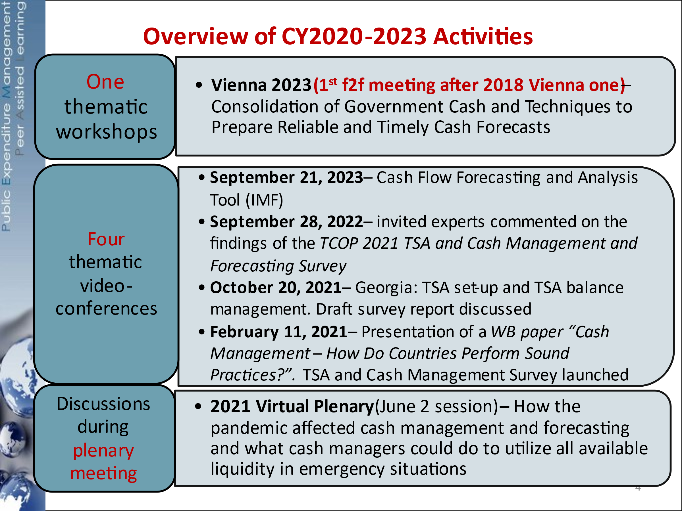**Ms. Elena Nikulina** summarised the recent work of the group -see slide. Her presentation noted in particular the 2021 survey of member countries’ cash management practices and the knowledge product summarizing its findings. Ms Nikulina also introduced the agenda for the meeting and reminded the participants about the preparatory work that went into it including the September videoconference of the group.

**Ms. Yelena Slizhevskaya**, speaking remotely, also passed on her wishes for a successful and productive meeting.

## Republic of Austria – Liquidity Management

**Ms. Sabine Denk**, Vice President, Liquidity Management, Austrian Treasury summarised the work of the Austrian Treasury (OeBFA), which was established as a company, wholly owned by the Republic of Austria, with responsibilities for debt and cash management. These included making recommendations on funding, liquidity and risk parameters, executing the annual borrowing plan, and maintaining a cash buffer (averaging about EUR 10 billion in 2023, although there had been periods of a higher or lower balance). The OeBFA, which currently had 38 staff, also issued for and lent to Austrian provinces and sub-sovereigns. Ms. Denk noted a diversity of funding sources, including issuance of green short-term instruments as well as green bonds, with commercial paper often being used to manage short-term cash flow volatility.

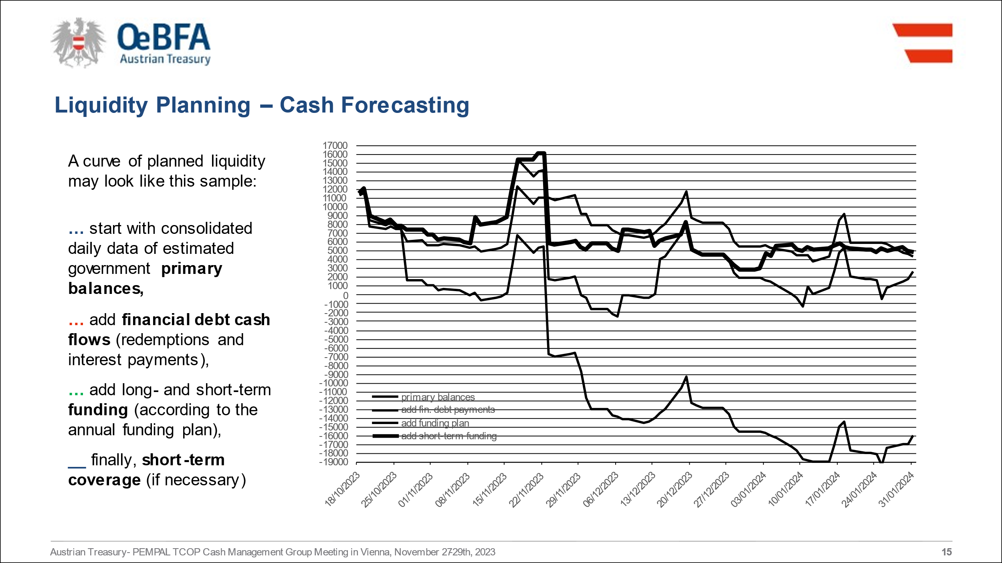Continuing, Ms. Denk explained that estimates of the primary balance cash flow relied heavily on past daily data (with adjustments for estimated future developments) unless other, more accurate information was available. Debt service flows were then added, together with those arising from the agreed annual borrowing plan. Short-term transactions were added as necessary with a view to meeting the cash buffer – see slide. Temporary short-term surpluses were invested for up to 1 month with a range of counterparties, subject to strict credit restrictions. The COVID pandemic had led to increased volatility and estimation errors in revenues and expenditures, uncertainties that had to be integrated into the funding strategy and cash management, requiring enhanced internal coordination and communication. Lessons learnt had included the need for greater diversification of instruments and investments, and greater flexibility including in market communication and internal processes. Greater use of repo was also being planned.

In questions, Mr. Gvaladze asked about development of the secondary market in government securities. Ms Denk summarised the primary dealer arrangements, noting also that the OeBFA itself took down part of each auction which could be sold into the market subsequently. The greater use of repo would also potentially be helpful in managing collateral squeezes. Following a question from Ms Pilkati, Ms Denk noted that the OeBFA coordinated within government primarily with the Budget Department; the structure and contractual arrangements associated with the TSA were managed in the Ministry, not by the OeBFA. Dr. Pál asked about the range of investors, and how far bonds were marketed to citizens. Ms. Denk explained that citizens could buy bonds through banks, but that the OeBFA was planning to launch a retail product which allows placing funds via mobile phones, with a minimum of only EUR 100. Mr. Assanali Duisembay, Director, State Borrowing Department, Ministry of Finance, Kazakhstan asked some clarification questions, in particular in relation to the interaction between debt management and debt sustainability. Following some discussion within the group, Ms. Denk confirmed that that the OeBFA’s main focus was management of debt portfolio and the borrowing requirement, the size of which was primarily determined by the fiscal framework and budget decisions.

## Coverage of the TSA

### Expert Presentation

**Mr. Mark Silins** reminded the meeting that in the past the “TSA” implied a single bank account; today, however, it had a much broader and flexible structure, usually with a unified structure of sub-accounts enabling consolidation of government cash to minimize costs and maximize returns. He stressed that consolidation was a core goal, not only in relation to the TSA, but more widely, allowing government to plan better, and manage and report its cash and broader balance sheet in a more reliable and timely manner.

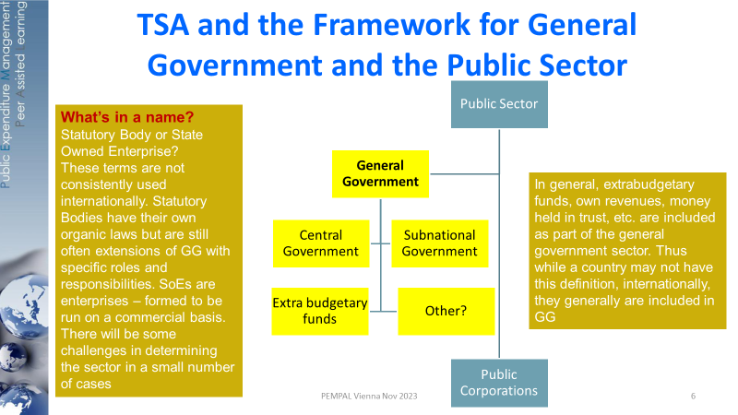The policy choices for consolidation related primarily to those parts of general government beyond budgetary central government – see slide. Each country was unique, but good practice saw the TSA covering all of general government, including budget funds, statutory entities which are dependent on the budget, extra budgetary funds (EBFs) such as the social and health funds, budget entity own-revenues, deposit and trust money, and development partner financing. Where subnational governments were controlled by central government, these would also often be consolidated. The 2021 TCOP Survey had reported several countries going beyond general tax revenues and including health, social and other EBFs in the TSA, although there was some doubt whether the extra balances were always fully fungible.

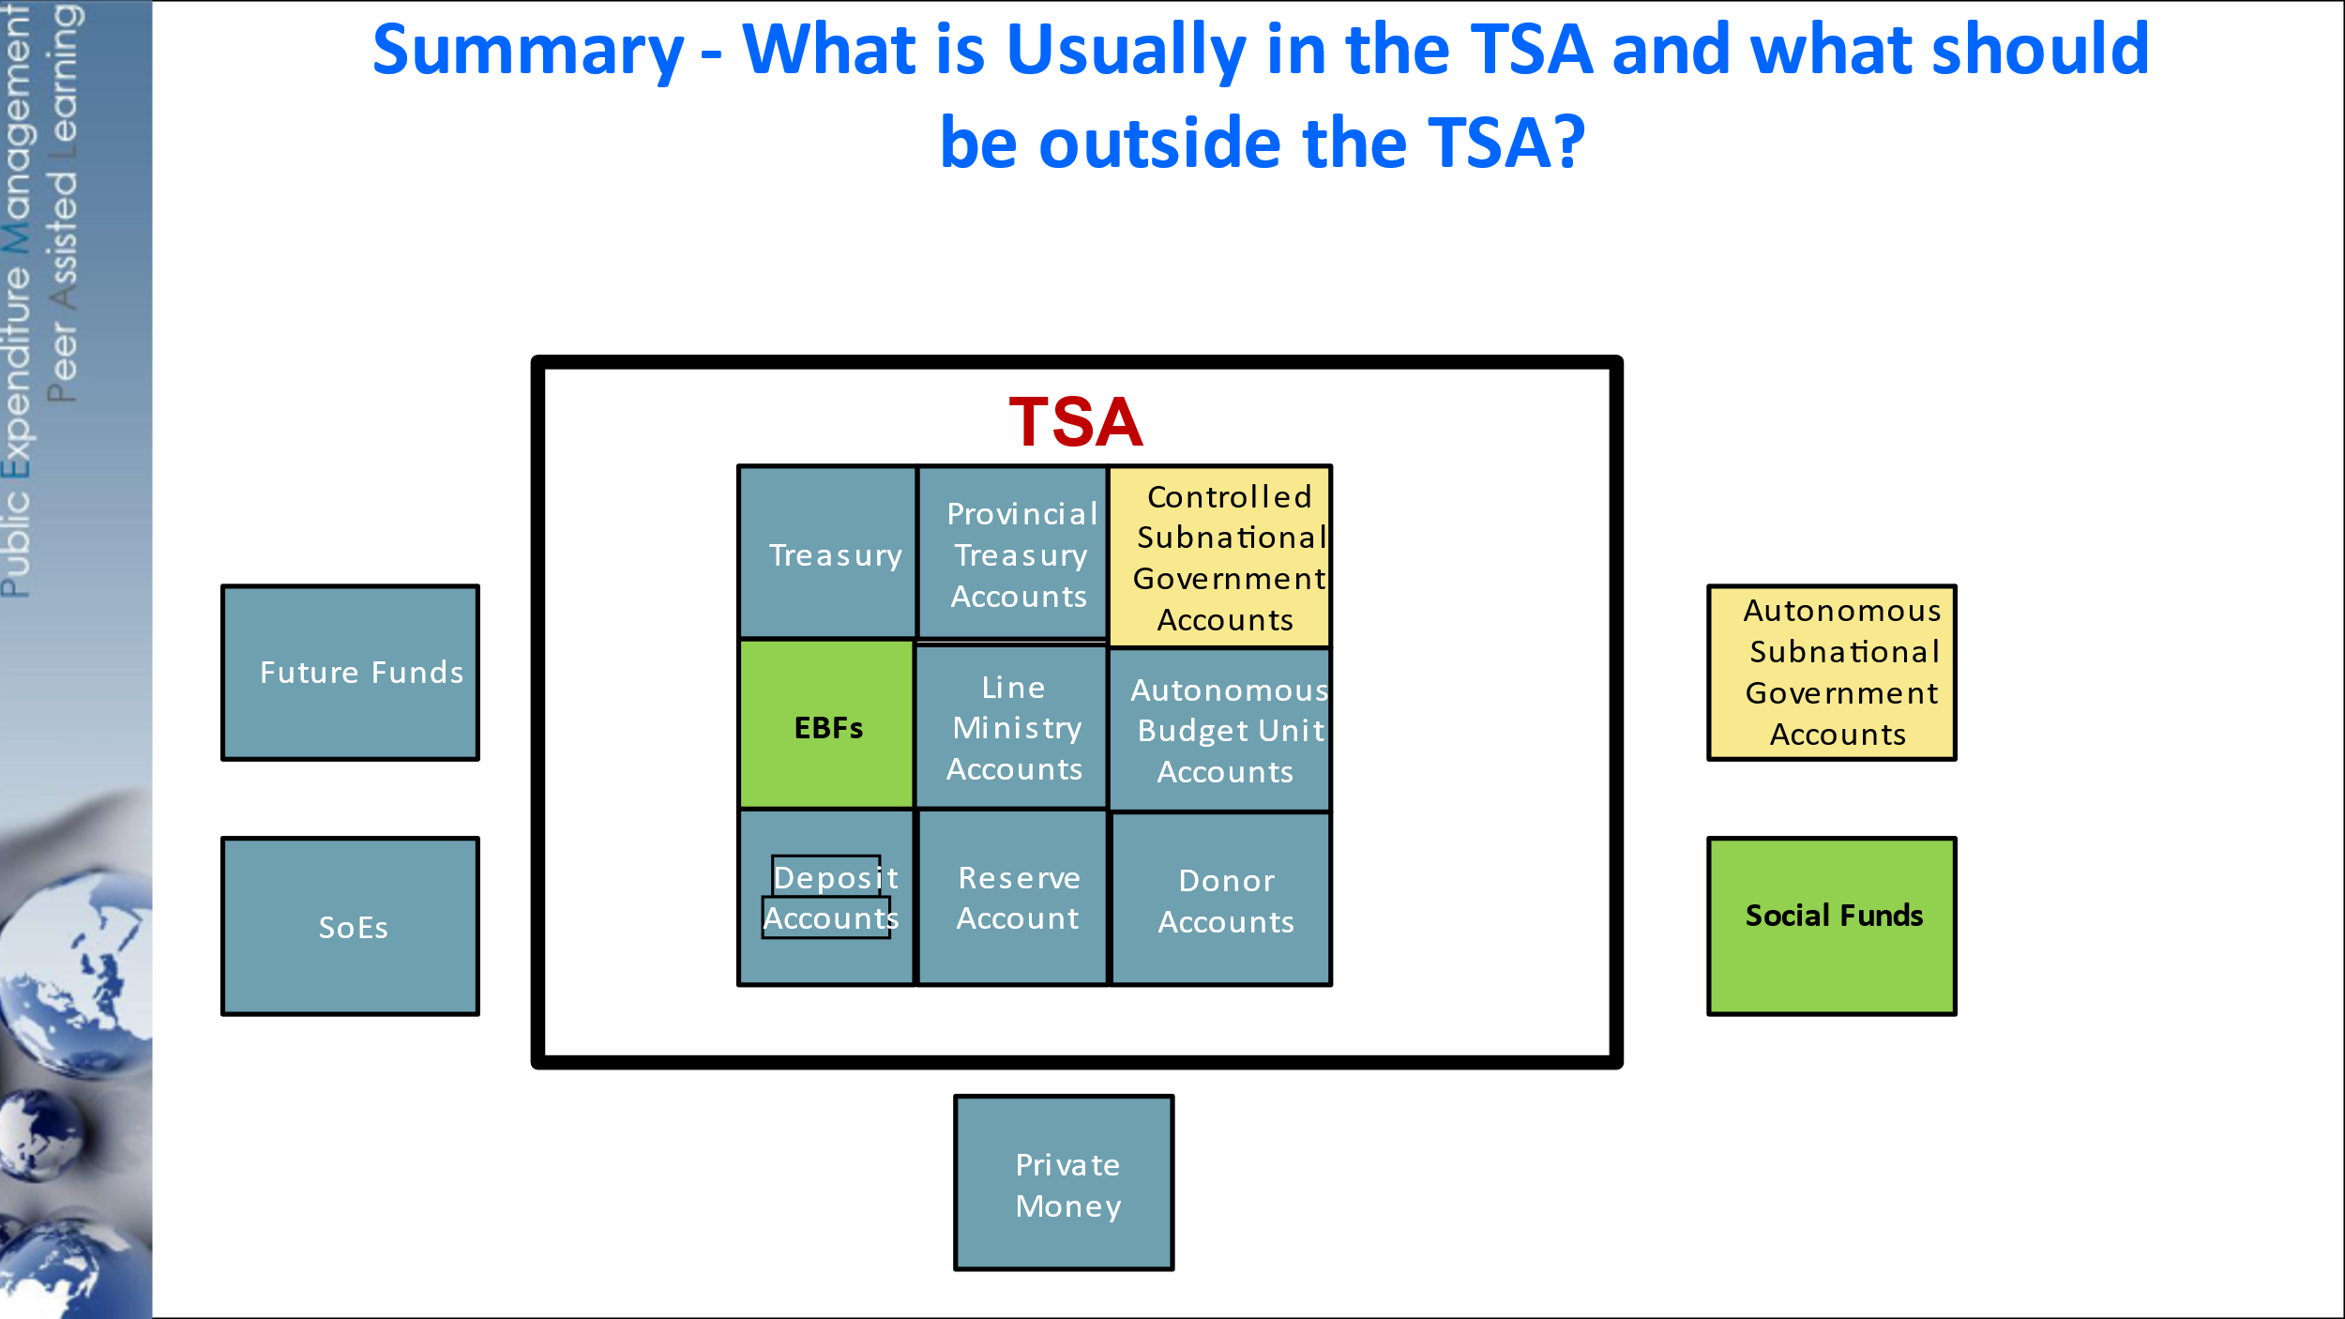Continuing, Mr. Silins noted that inadequate coverage of the TSA frequently resulted in significant idle balances and consequent higher borrowing costs. Full consolidation also allowed internal transactions across general government, which could be very significant, to be managed within the government IFMIS, eliminating the movement of cash into and out from government accounts. A single accounting system, general ledger and TSA, facilitated by the IFMIS, supported the consolidation of government cash, reporting and accounting. Wider consolidation of funds potentially also brought a number of benefits, although there were frequently challenges often associated with a perceived loss of autonomy. Key issues were whether the fund was a controlled entity to be reported in the general government sector; whether it had the skills to manage cash effectively; and whether the cash could be fungible with other TSA balances. A modern IFMIS could protect the fund’s claim on resources even when the cash was consolidated in the TSA. Similar arguments applied to the own revenues of ministries, which should also be consolidated to allow a single balance and forecast. Some of the same arguments applied to the balances of sub-national governments (SNGs). In many PEMPAL countries SNGs were subordinated to central government, although this was not the case in many other countries. State owned enterprises (SoEs) were usually outside the general government sector although where they were effectively arms of government, it would make sense for their balances to be in the TSA. Sovereign wealth funds (future funds, stabilisation funds, etc) would normally best be managed outside the TSA, as would strictly private money as it was not generally appropriate for the government to hold funds in competition with commercial banks – see slide for summary.

Concluding, Mr Silins stressed that all general government should be included unless exclusion is overall is in the best interest of governance. The Treasury should develop a plan for consolidation, incorporating the necessary assurances and incentives for stakeholders. High-level political support was always likely to be important.

### TSA System in Türkiye

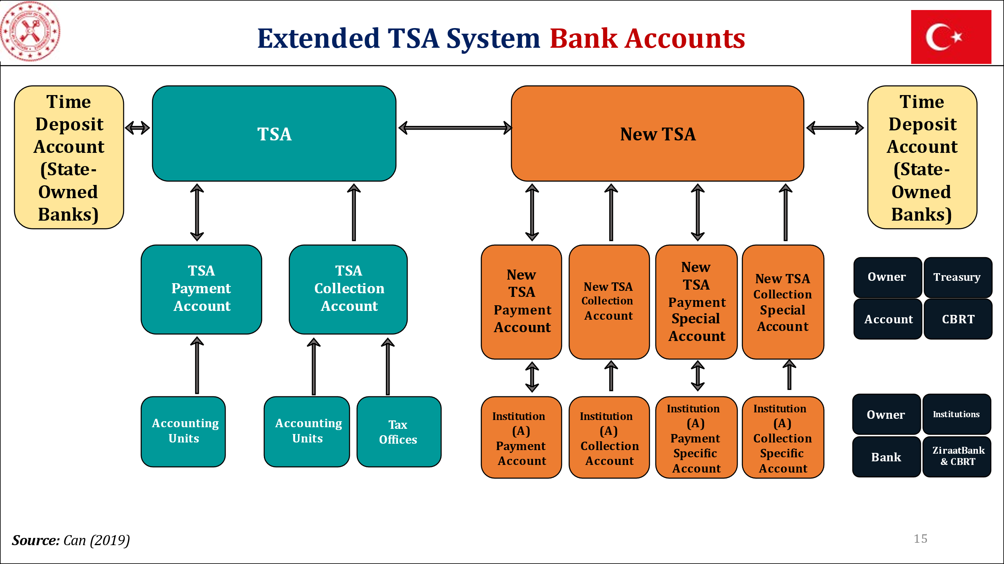**Mr. Barış Can,** Deputy Director, General Directorate of Public Finance, and **Mr. Yusuf Yavuz**, Head of Cash Management Department, both Ministry of Treasury and Finance, Türkiye presented the recent improvements to the Turkish TSA system. The system had developed substantially over several years with a plan for a new extended TSA established in 2018; by 2023 initial targets for institutional coverage had been exceeded. The new system provided for the financial resources of most public administrations (excluding the Unemployment Insurance Fund, local government balances and revolving funds), to be held in the TSA as receivables from the Treasury – see slide for architecture (the orange accounts relate to the Treasury’s role as “banker”) The balances were integrated in the accounting system, with both receivables and mirrored payables acting as control parameters.

Continuing, Mr. Barış summarised the benefits of the new arrangements, to both cash management and debt management, ensuring also that public resources were properly remunerated. The cash balance in the extended TSA had reached an average of TKY 60 billion in 2023. Temporary surplus cash could be invested back into the market, although currently only with state-owned banks.

Mr. Tufan summarised some of the takeaways regarding the TSA extension based on the Turkish experience and Mr. Silins’ presentation, noting also that the variety of stakeholders added to the complexity of the reform process, and that this issue should be taken into account in the TSA design, as it was in the Turkish case. Also, in order to achieve such a comprehensive reform high-level political support was essential, as was the need to change the mindset of many of those involved.

In subsequent discussion, Mr. Rahat Tokbaev asked how in practice political support could be generated and institutions convinced of the need for change. Mr. Yavuz stressed the benefits of the reform, many of which flowed widely across government.

### Discussion in Small Groups

The meeting broke into three groups with a view to identifying which funds might be included in the TSA, the pros and cons of consolidation and the challenges arising. Most countries prepared short presentations summarising the arrangements in their country and the issues arising under each of these headings. Others reported orally.

The three groups reported back to the full meeting on the morning of day 2 (November 28, 2023). In her introduction, Ms. Nikulina noted that the 2021 Survey had probably not gone into sufficient depth in relation to TSA coverage, as it was clear that in some cases the apparent extension of the TSA did not imply fungibility of the cash balances. All group reports followed a similar template.

**Group 1** (Azerbaijan, Georgia, Hungary, Kosovo, Romania, Türkiye, reported by **Mr. Erekle Gvaladze**). The wider benefits of consolidation for both cash and debt management were noted, including improvements of accountability and transparency and reduction in banking fees and costs of carry. Georgia, unusually, planned to include balances of underperforming SoEs in the TSA, partly to improve their management. On the other hand, governments were not always fully trusted, there were operational challenges and inclusion of the SoEs could affect their competitive position. Among the challenges there had been political and institutional resistance; and forecasting was complicated by greater cash flow volatility.

**Group 2** (Armenia, Kazakhstan, Kyrgyzstan, Moldova, Tajikistan; reported by **Mr. Talant Keldibekov**, Deputy Director General, Central Treasury, Ministry of Finance, Kyrgyzstan). There were variations of coverage between the countries, although several had plans for further expansion. Moldova had the most complete coverage but for liquidity management purposes the Treasury had access to only about a half of the TSA balances. The benefits of expanded coverage were generally clear, whether in terms of liquidity management, reduced borrowing requirements or cost reduction. But those managing the funds had concerns about loss of autonomy and income, and reduced service efficiency. It had been difficult to secure high-level political support; in some cases, the central bank had been unhelpful; and there could be technical difficulties in relation to foreign/domestic currency transfers.

**Group 3** (Albania, Bosnia and Herzegovina, Croatia, Montenegro, North Macedonia, Serbia, reported by **Mr. Mario Glibić**, Assistant Minister for Treasury, Federal Ministry of Finance, Bosnia and Herzegovina). Most countries reported a similar range of benefits, with better control, improved reporting, reduction in idle cash and lower borrowing costs. But there had been some resistance from institutions and also operational challenges (assuring IT access and a lack of capacity e.g. in municipalities). In response to these challenges some countries deployed a phased approach (e.g. Serbia was focusing initially on the better managed schools), made sure that the expansion was supported by the IFMIS, and sought generally to increase awareness. Albania stressed the need to improve debt and cash management coordination, not least to handle greater cash flow volatility.

In subsequent discussion, Mr. Silins noted that, although there were specific features in each, most countries in his group included cash resources for the entire general government including subnational government. He stressed the importance of cash fungibility, which still allowed accounting separation. He agreed that, where SoEs remained highly dependent on budget funding, there was an argument for inclusion in the TSA, at least for the budgetary resources; however, this should be done in a manner that ensured that these entities continued to have control over their resources and were able to make independent management decisions. A zero-balance account where balances were available during the day and only consolidated overnight might be the best solution.

Mr. Williams emphasised three points: the expansion should be part of a wider policy reflecting the degree of control and oversight of the affected institutions; the transition and phasing were important and needed prior consideration; and high-level support was usually needed to unlock resistance. Mr. Tufan noted the relevance of the legal and regulatory framework, the need for the Treasury to have an overview of all cash balances and the importance of managing ministries’ transactions efficiently.

Ms. Nikulina also noted that in some respects the Treasury had to develop as a service provider. She also asked how many at the meeting were broadly content with the coverage of the TSA or wished to extend it further. Only Armenia indicated that it fell into the first category.

## Cash Flow Forecasting: Techniques, Challenges and Practices

### Expert Presentation

**Mr. Mike Williams** started by emphasising the difference between cash planning (or cash programming) and cash forecasting. Cash forecasts were independent of control totals, focussing on what “will” happen, not what “should” happen. It was important to identify cash movements, and cash under control of the Treasury (usually the balance in the TSA). Forecasts should be developed for some period ahead, ideally at least three months ahead, and rolled forward regularly. If granularity was initially monthly, over time weekly and then daily forecasts should be developed; that helped to identify the intra-month cash flow profile. In practice forecasts relied heavily on past patterns although some care was needed to make the necessary adjustments. Econometric models had not proved very helpful, with experience, intelligence networks and pattern analysis usually more productive. Bottom-up, as well as top-down, data were important. Ministries Departments and Agencies (MDAs) and Revenue Authorities must cooperate as they were in the best position to provide up-to-date information on current and prospective movements. The scope to link days of inflow to days of outflow, which could reduce the volatility of cash balances, was often overlooked.

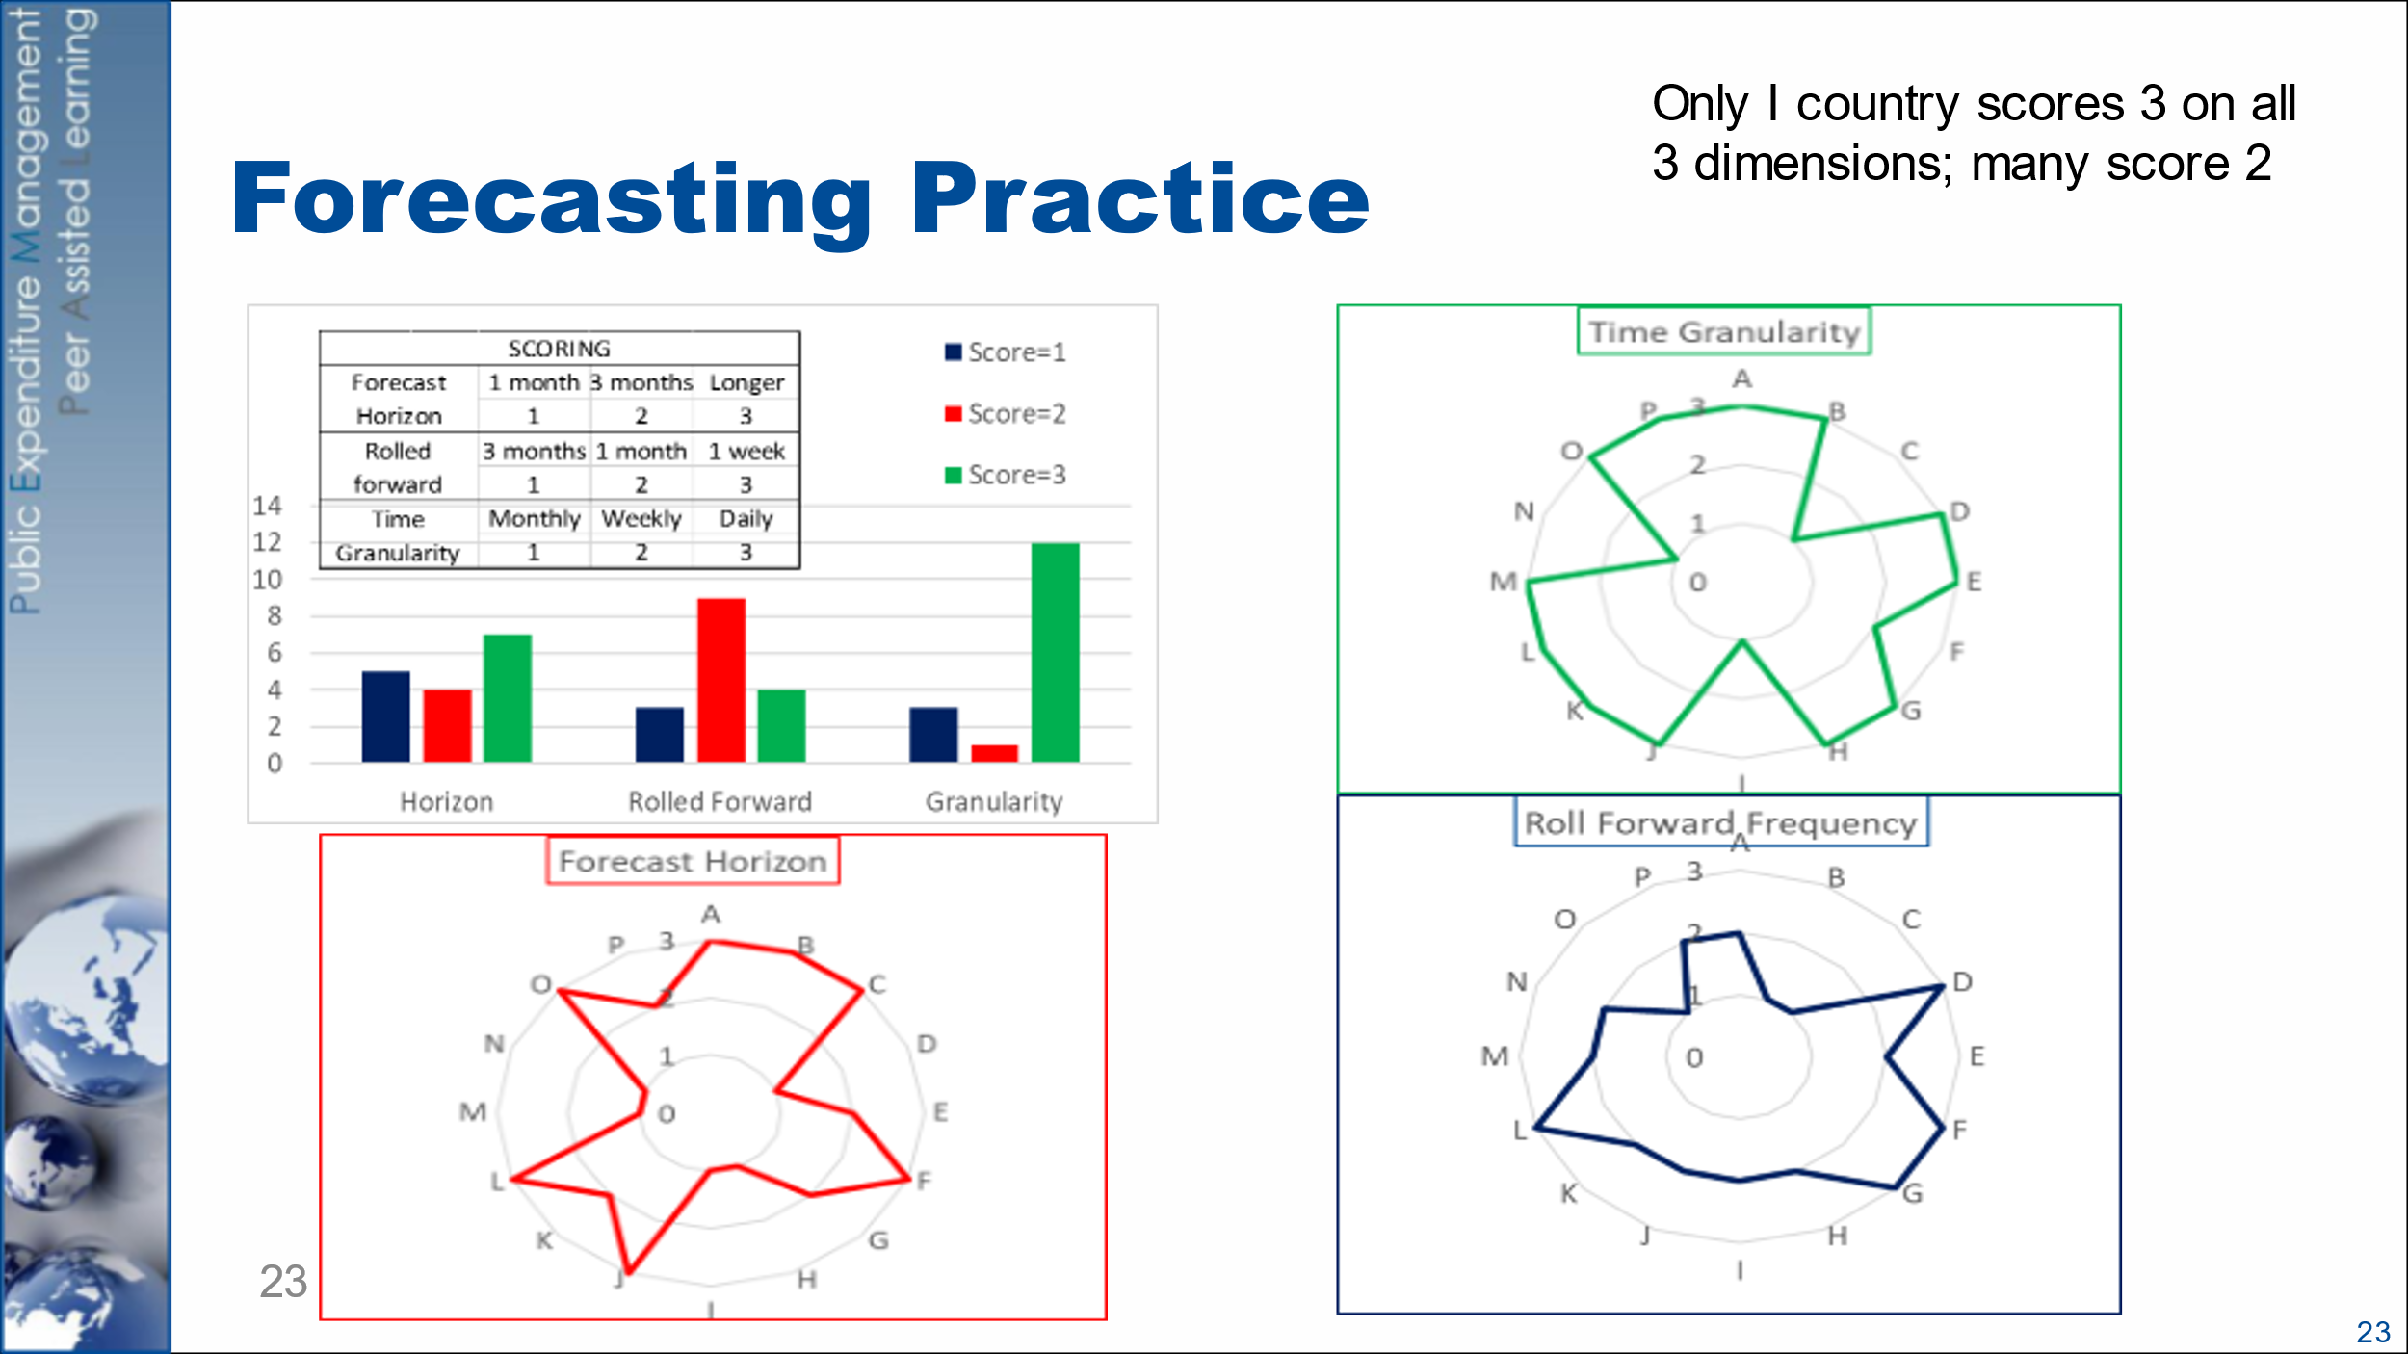Mr. Williams recognised that forecasting was difficult in all countries, with a range of challenges. Many lower- and middle-income countries had failed to meet the minimum requirements of the relevant indicator of the debt management performance assessment (DeMPA) tool. Based on his own experience, he summarised the main problems as: insufficient understanding of the importance of cash forecasts as well as cash plans; the lack of bottom-up information; too short a forecast horizon; poor or unstructured communication between the Treasury and the DMO; and a lack of engagement with the tools of more active cash management. The lessons of the COVID pandemic had included the need to put in place systematic cash/debt coordination structures, to bring MDAs and EBFs within processes, and to make greater use of scenarios. The 2021 Survey had confirmed that all PEMPAL countries had some forecasting capacity in place (although that did not of itself indicate good performance), although there were some variations in practice – see slide.

Continuing, Mr. Williams stressed that the forecast must be put to use, in supporting both cash management and budget execution. The cash forecasting unit was best placed to make recommendations, potentially in concert with the debt managers, to decision makers, e.g. in the cash coordination committee or equivalent. They should both indicate risks and give advice on the action required to ensure cash adequacy over the period ahead (or cost-effective use of temporary cash surpluses).

### Cash Forecasting and Cash Management in Hungary

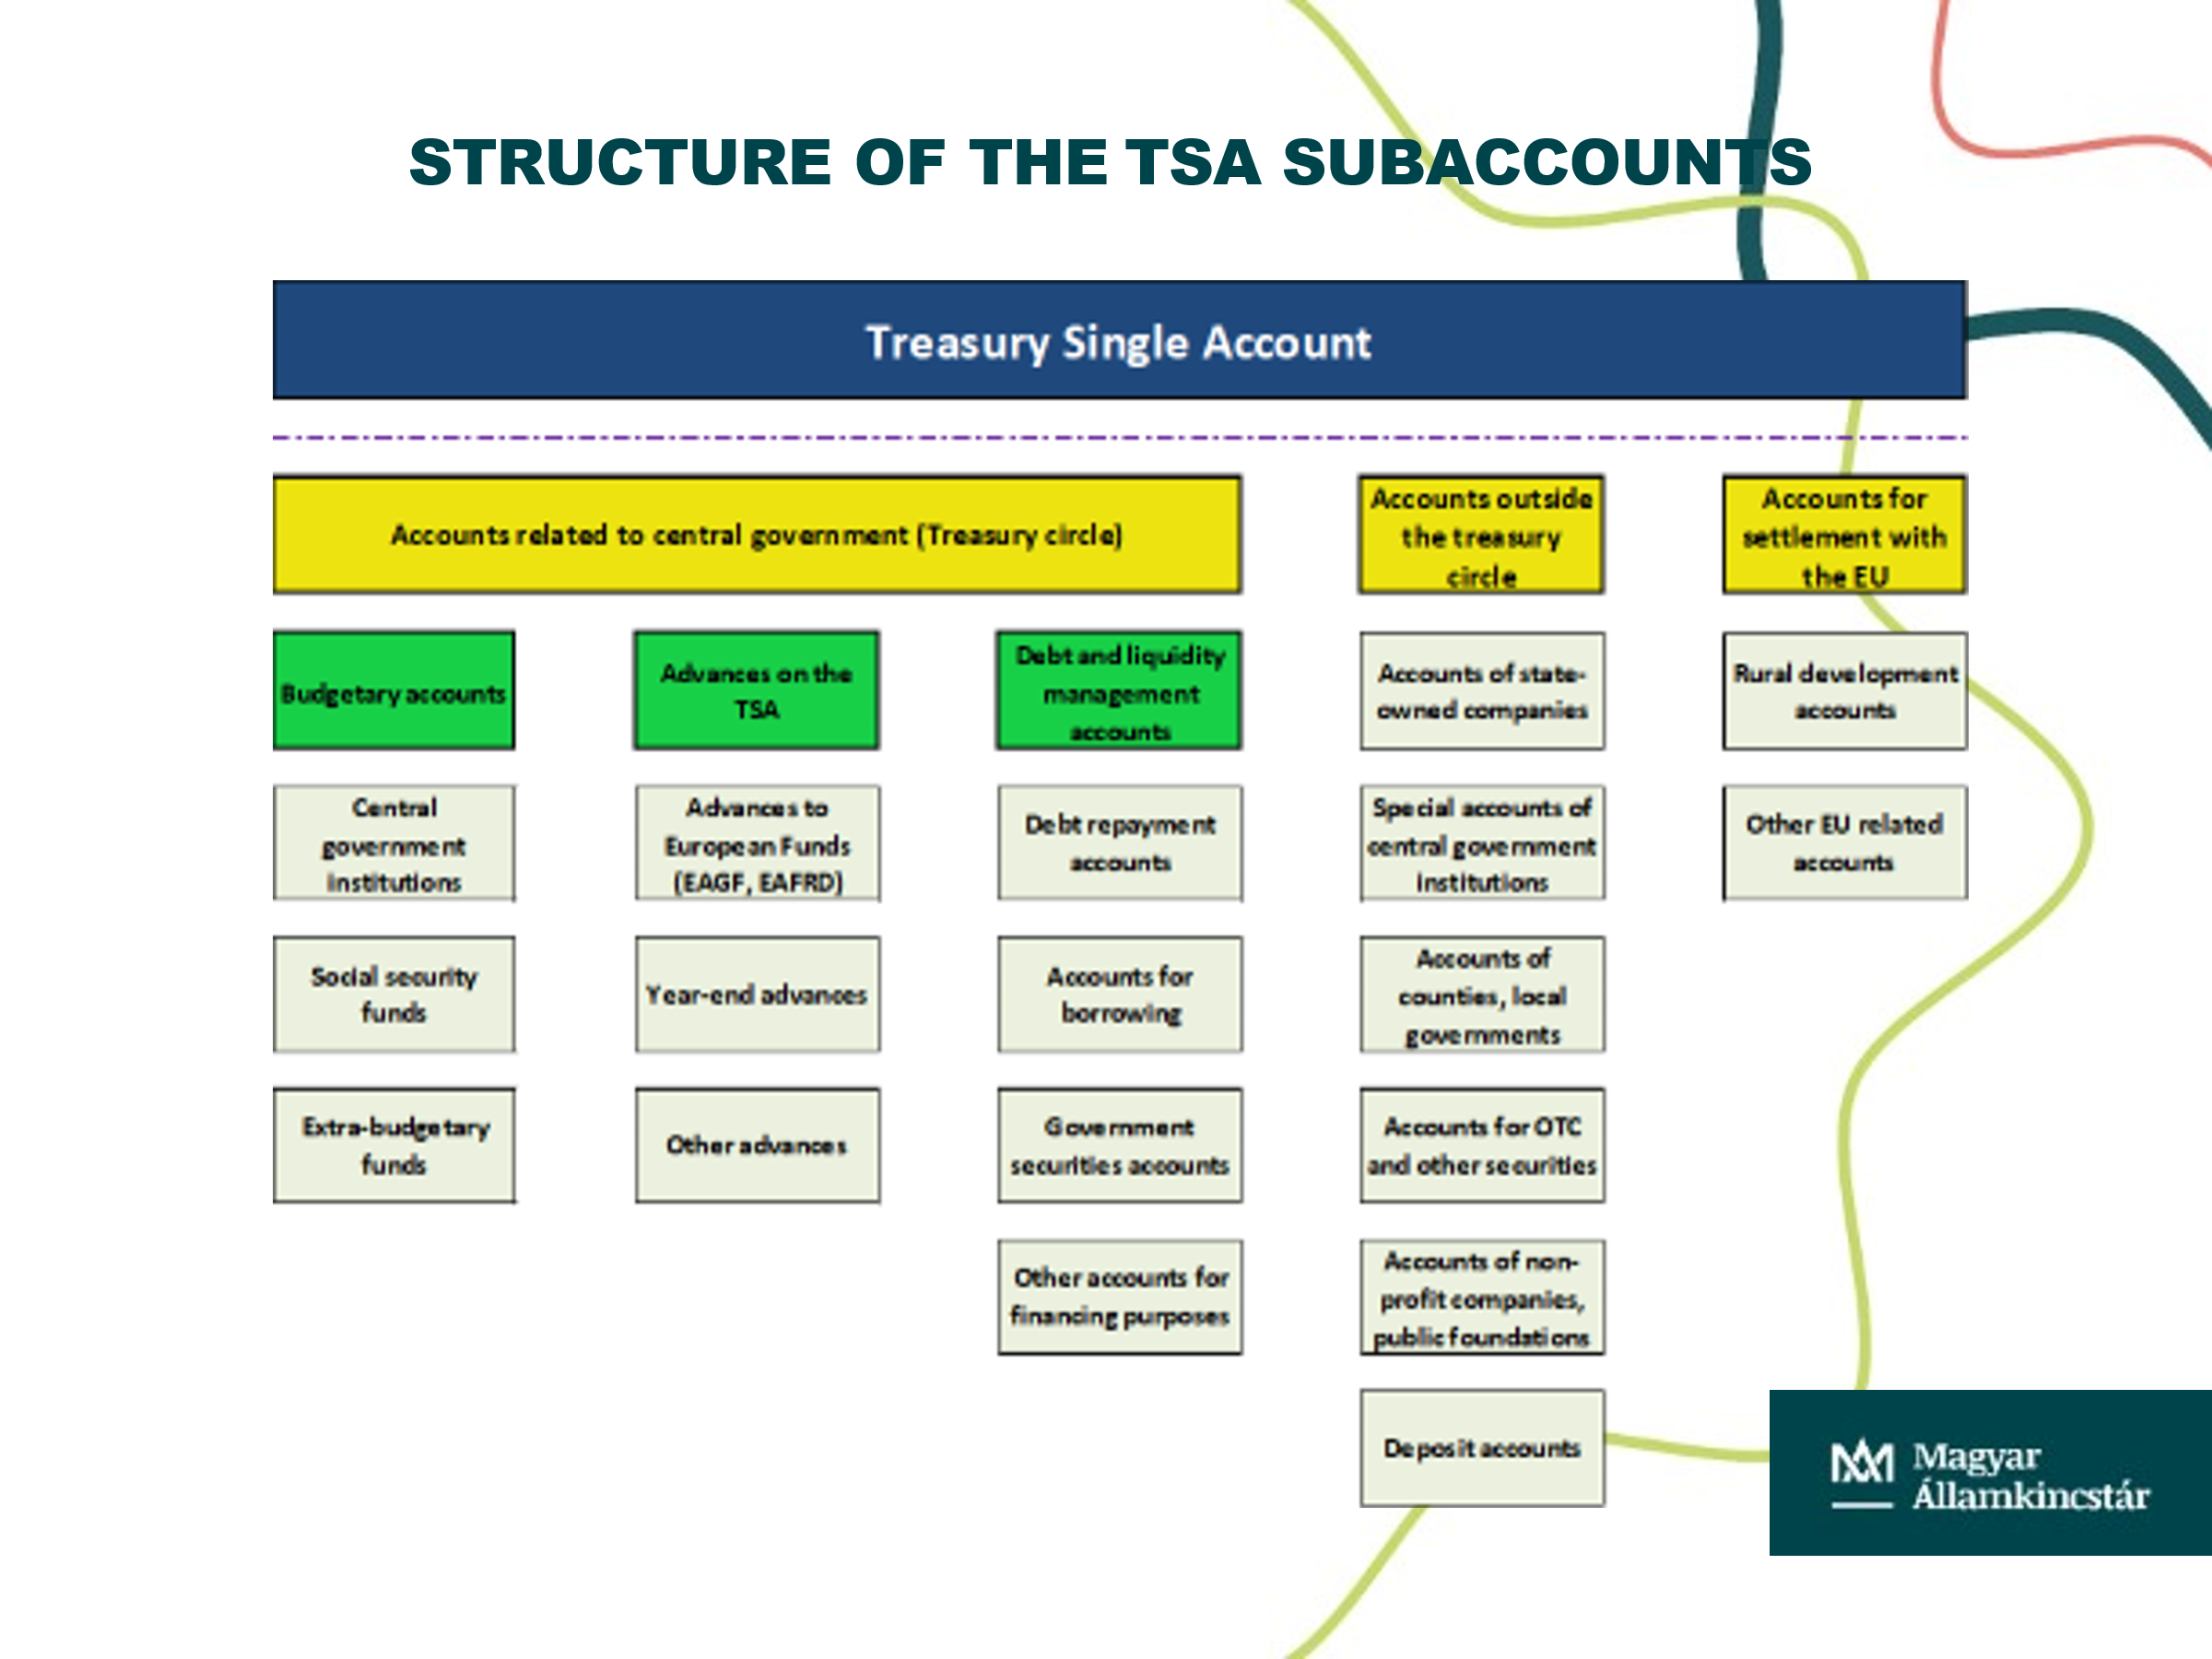**Dr. Török Tamás Pál** explained that the TSA was a mirror account, integrating a range of sub accounts, both budgetary and non-budgetary (local authorities could decide whether or not to include their balances in the TSA). A team of 3 people in the State Treasury prepared forecasts on the liquidity position of the public finance subsystem, updated twice weekly and with a daily breakdown covering the current month and subsequent two months. They were supported by a daily report on the budgetary position, with every account assigned a line in the report. The forecast table brought together both above-the-line and below-the-line transactions, identifying the balance in the TSA – see slide. That was then passed to the Debt Management Agency (ÁKK), and also to the National Bank and Ministry of Finance. Dr. Pál also noted that spending units had to inform the Treasury of all large transactions (if above EUR 2.5 million at least 3 days ahead, and above EUR 10 million 5 days ahead).

**Mr. András Réz** set out the background to the formation of the ÁKK as a government-owned company in 2001. Its cash management objectives included maintaining the required liquidity buffer, and reducing fluctuations in the TSA balance. The ÁKK proposed the level of the minimum liquidity buffer; it also sought to maintain an optimal cash balance, based on forecast error and refinancing risk, by means of borrowing and lending transactions in the money market. The cash buffer, which was a daily target, was increased following the 2008-09 crisis but had fallen back somewhat since; FX deposits were part of the buffer.

Mr Réz summarised the main tools of liquidity management – see slide. He noted that repo was also useful for supporting primary dealers in the event of a shortage of a specific bond. Overnight repo was very important for responding to unexpected forecast variations. Forecasts were received from the central bank as well as the Treasury – the Treasury’s forecasts tended to be pessimistic, but the Bank’s more realistic.

In questions, Ms. Andrea Kocelj (Ministry of Finance, Croatia) asked about the penalties applying to those submitting poor forecasts. Dr. Pál explained that the penalties were based on a forecast deviation of more than 3 percent but only applied to those bodies under direct government control and only for the forecasts in October and December. In response to questions from Ms. Pilkati and Mr. Duisembay, Mr. Réz explained that the Minister of Finance approved the debt management strategy, annual borrowing plan and the liquidity benchmarks. The required cash buffer tended to change each year but could be revised in-year if necessary. The ÁKK could also draw on some flexibility in the issuance program.

### Discussion in Small Groups

The meeting broke into two groups. They were asked to report on the experiences of testing the Cash Forecasting and Analysis Tool (CFAT), following the remote presentation in September 2023, and, irrespective of their experience with the tool, to share information on the existing cash forecasting practices. Several countries prepared short presentations summarising the arrangements in their country and the issues arising. Others reported orally.

The two groups reported back to the full meeting on the morning of day 3 (November 29, 2023).

**Group 1** (Armenia, Azerbaijan, Georgia, Kazakhstan, Kyrgyzstan, Moldova, Tajikistan, reported by **Mr. Nazim Gasimzade**). In relation to CFAT, the only country that tried it was Moldova. Based on that experience, the group noted that the tool could be helpful in developing the monthly profile for the current budget year, and for facilitating the decision-making processes of senior management, but was not suited to preparing daily forecasts. Not all of the countries in the group had a clearly defined cash forecasting practice, although they all had an established process for cash planning. There was less pressure on resource rich countries with larger reserves to develop elaborate cash forecasts. Moldova had an established methodology and developed cash management guidelines. In Armenia’s case the forecast was the responsibility of the debt management department.

**Group 2** (Albania, Bosnia and Herzegovina, Croatia, Hungary, Kosovo, Montenegro, North Macedonia, Romania, Serbia and Türkiye, reported by Mr.Yavuz). In relation to CFAT, several countries reported that they had reviewed the tool, but had not yet had the chance to test it. It was noted that CFAT was less useful for countries that were already preparing daily forecasts; but its suggestions for forecast presentation could still be relevant. In relation to forecast practices, most countries focused primarily on the TSA balance, but also on the main categories of revenue and expenditure. The time horizon and frequency varied, from quarterly with a monthly breakdown, to a daily profile for the whole year. The use of top-down information from others within the Ministry of Finance was common across countries but some also make use of bottom-up information e.g. from spending units. Most had also established a Liquidity Committee or similar to develop a more strategic approach to cash balance management. There was a wide range of sources of forecast error, including a failure to announce large urgent payments, requests for additional provision, delays in capital expenditure and unexpected macro developments (Montenegro noted revenue increases partly associated with tourist inflows).

In commenting on the presentations, Mr. Tufan noted that there was clearly room for improvement in many countries, e.g., in relation to the forecasting framework, the forecast horizon and the use of bottom-up information. Greater progress was needed in using forecasts in support of decision making. Mr. Williams noted that some countries had developed very sophisticated spreadsheets (e.g., Romania’s, which had been briefly presented to the group). But he also stressed the importance of a credible budget. If revenue budget targets were swollen or ministers were in the habit of adding expenditure provision in-year, cash forecasting would always be difficult.

## Investing Surplus Cash: Options and Institutional Arrangements

### Expert Presentation

**Mr. Mike Williams** emphasised that the investment of temporary surplus cash was an intrinsic part of modern cash management, not simply an add-on. Well-managed investment was not only inherently cost-effective, it also helped to smooth cash flows with the benefits arising from that. Cash managers should, however, be responsible for the investment of only short-term surpluses, i.e., cash that was likely to be needed within the next day or weeks (or very few months). Longer-term structural surpluses should be handled separately, with their own governance arrangements and asset allocation objectives.

Short-term investments gave rise to many of the risks associated with debt and cash management more generally, but Mr. Williams drew attention to liquidity and credit risk. The management of credit risk in particular often required building a new capability, although cash managers could draw on techniques used elsewhere. There was a range of money market instruments available, but in practice most used were (reverse) repo and term deposits in commercial banks. Repo was particularly important since it was flexible and secure and generated a range of benefits for both debt and cash management – see slide. In the absence of a developed repo market several countries used term deposits – but such deposits should be collateralised. The 2021 Survey had suggested that a number of PEMPAL countries invest surplus cash although some only with the central bank and only a few countries had the capability to borrow and lend through repo.

Continuing, Mr. Williams identified a number of the issues that the investment policy should address. The institutional, governance, and decision-making requirements that apply to the investment of cash surpluses were, in principle, no different from those that apply to other cash or debt management transactions. Both lending and borrowing should be handled by the same front office to avoid conflicting or confusing signals to the market. That was not a problem in an integrated DMO, but otherwise some form of cash coordination committee was essential to ensure an integrated approach. That should also include understandings with the central bank. Mr. Williams concluded by giving the example of Vietnam which had recently developed a repo capability.

In response to questions, Mr. Williams elaborated on the distinction between temporary and structural cash surpluses, the identification of the available surplus and the interaction with the central bank. Mr. Gasimzade noted that initial reluctance of the central bank for the Treasury to invest cash surpluses had been overcome by developing a partnership between the institutions. Mr. Gvaladze gave a brief presentation on excess liquidity management in Georgia. He drew attention to the use of the Bloomberg system for auctioning deposits, all of which were collateralised.

## Recent Country Developments

**Ms. Mimoza Pilkati** shared developments in Albania since the 2018 meeting of the group. She noted in her presentation the improvements that had been made in the coordination structure, in process and analysis, and in developing forecast templates. The membership of the Debt and Cash Management Committee (DCMC) had been expanded to include the central bank and also the Budget and Fiscal Affairs General Directorates, all of which were important stakeholders. Processes had been improved by linking the procurement system with the IFMIS (AGFIS) and controlling invoices against cash plans. Templates had been improved to facilitate analysis and focus on the main policy choices. Greater emphasis was being given to scenarios.

Mr. Tufan congratulated Albania on the sharper distinction between cash plans and cash forecasts. Mr. Williams strongly endorsed the wider membership of the DCMC, and the greater use of scenarios.

Mr. Gasimzade reported that Azerbaijan had reduced the number of regional Treasury offices; to date from 35 to 22 although further reductions were expected. In parallel the Treasury was improving business processes and exploring web-based solutions. Mr. Tokbaev noted that Kazakhstan had planned to reduce the number of local offices, but these plans had to be put on hold when it was decided to delegate more authority to local governments; in practice the Treasury offices had to act as consultants to them.

## Future Activities of the Cash Management Thematic Group

Introducing the discussion, Ms. Nikulina suggested that the meeting should consider: (1) what had been useful at the event and whether the knowledge could be applied; (2) which issues or topics might be discussed at the future events; and (3) any suggestions for improvement of the format. Volunteers to host the next meeting of the group were also invited to identify themselves. The points made in subsequent discussion are summarised under the respective categories.

**Useful and applicable new knowledge**: the distinction between cash plans and cash forecasts; the benefits of a Liquidity Committee or similar and more generally improved debt/cash interaction; the potential role of CFAT; procedures for investing surplus cash; some of the forecasting techniques, and the use of penalties for poor forecasts; the varying country legislative constraints; the risks of TSA expansion; the scope for improved consolidation; and the services that the Treasury could supply to others.

**Possible future topics**: analysis underpinning the chosen cash buffer; CFAT exercises and access to online training; the investment of cash under negative rates; parameters applying to the use of collateral; the role of artificial intelligence (AI) in cash flow forecasting and of IT more generally; the use of swaps in cash management; consultation with the central bank; and operational risk management.

**Format improvements**: small group discussions are a great fromat and should continue; ideally meetings should stop by 5 pm.

In his concluding remarks, Mr. Silins congratulated the PEMPAL team and participants on an excellent event. He noted that coverage of the TSA continued to be an important area for discussion. Ideally, any exclusions within general government should demonstrably be in the interest of government. Inclusion of balances beyond general government was not recommended and countries that were proposing to include SoEs’ balances in the TSA should carefully assess the pros and cons. Indeed he noted that this could be a useful topic to explore in more detail at future events. Mr. Silins also suggested that a practical focused activity assisting countries implement their own forecasting models might be beneficial, potentially utilizing the CFAT forecasting template. Expanding this template to support daily forecasting could also be a useful value-added process at a future event.

In relation to AI, Mr. Silins recommended that any future discussion be focused more broadly on digital transformation. Indeed an event, bringing IT and functional staff together, that examined how PEMPAL treasuries could enhance digitization could be very useful. In fact the IMF has just released a new framework, which could be utilised.

Mr. Williams acknowledged the interest in the cash buffer and the interaction with debt management, with the central bank and with stakeholders more generally. Some of the other issues raised might require a narrower focus. Mr. Tufan agreed that there was a better understanding of the cash planning/forecasting distinction. The cash buffer was clearly a potential future topic. If it was to be useful, AI was likely to require greatly improved and more extensive data.

Closing the meeting, Ms. Elena Nikulina thanked the Executive Committee, the resource team, the secretariat, both those present and Ms. Slizhevskaya, and interpreters, for the excellent work before and during the event, and participants for their contribution throughout.

