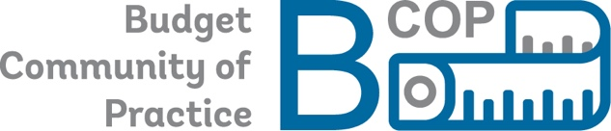

ECA PEMPAL* Budget Community of Practice (BCOP)**

LINKING STRATEGIC PLANNING TO BUDGETING
BCOP Program and Performance Budgeting Working Group (PPBWG) Meeting
June 21, 2023, videoconference

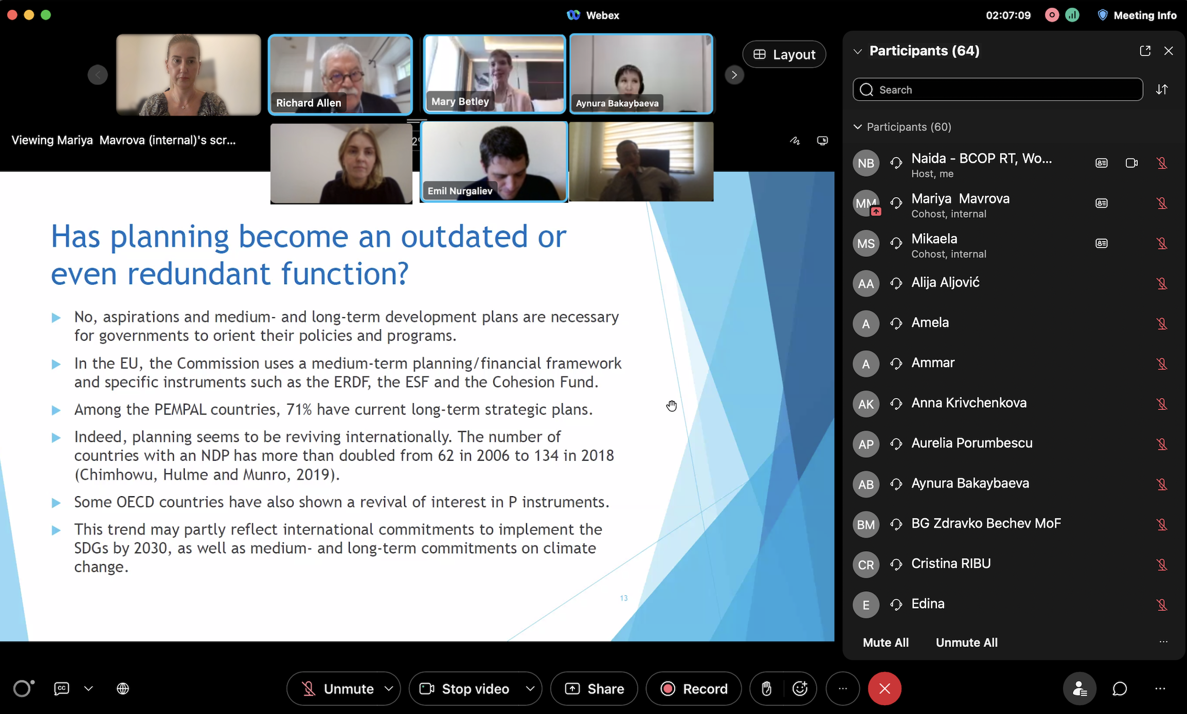

PEMPAL BCOP held a virtual meeting on June 21, 2023, to provide introductory presentations and collect members’ areas of interest within the topic of linking strategic planning to program and performance budgeting (PPB). This topic was selected as the top priority during the BCOP 2023 Plenary Meeting held in Ljubljana in March 2023 and in the follow-up online survey of BCOP membership.

Presentations were delivered by the BCOP Resource Team and an external expert and were accompanied by some PEMPAL country cases. Specifically, Naida Čaršimamović Vukotić, BCOP Resource Team Member, presented results of BCOP’s previous work in those areas. Richard Allen, BCOP Strategic Adviser, and Mary Betley, international PFM expert, presented opportunities and challenges in integrating overall planning and budgeting. Emil Nurgaliev, State Expert in the Budget Policy Division of the Budget Directorate in the Ministry of Finance of Bulgaria, and BCOP Deputy Chair, and Natia Gulua, Head of the Budget Department in the Ministry of Finance of Georgia acted as key discussants and supplied information on the status, challenges, and reform plans in their countries.

The meeting brought together 84 participants, including budget officials from 14 BCOP countries (Albania, Armenia, Azerbaijan, Bosnia and Herzegovina, Bulgaria, Croatia, Kazakhstan, Kosovo, Moldova, North Macedonia, Serbia, Tajikistan, Ukraine, and Uzbekistan).

The key takeaways included:
- Adequate strategic planning (at both the government-wide/sector level and at the institutional level) linked with PPB has now been globally recognized as an important success factor in modern budgeting. PPB is intrinsically linked to strategic planning as its essence is information on purposes of spending and achieved results. Consequently, the benefits of PPB cannot be fully used without an adequate connection to strategic planning. Splitting the budget into programs is the basis for PPB, with program goals and performance indicators at its heart. Budget programs and indicators should be connected to the Government’s objectives and high-level indicators identified in country-level strategic documents (e.g., national development strategies, sectoral strategies, government programs) and plans for individual ministries or sectors. Flexibility in budgeting and PPB design to handle the varied nature of government activities and the complex relationships between public spending and outcomes is another key piece of global advice.

- A proper PPB reform is more than just a budgeting reform - it potentially benefits overall public sector management; thus, it is an extremely complex reform as it reaches beyond just technical tasks. When implemented adequately, PPB transforms the role of the budget into a government's strategic document and communication tool. It promotes a culture of performance and user orientation in public administration. It provides a better management tool for budget users, a more direct tool for policy prioritization for the government, a better oversight tool for the parliament, increased clarity and context for the public, and a better basis for performance audits for the auditors.

- Initially, in many of the PEMPAL countries, PPB designs were insufficiently connected to strategic planning. This was partly due to weak and/or unstandardized whole-of-government strategic and institutional-level planning. There was also insufficient involvement and ownership of the line ministries and weak political support. There have been recent efforts to improve the PPB system in several PEMPAL countries, including the focus on linkages with strategic planning (e.g., Bulgaria, Georgia, and Bosnia and Herzegovina).

- Initial general advice on aligning PPB with strategic planning was already developed by BCOP in its 2020 knowledge product (KP) Performance Budgeting and Spending Reviews in PEMPAL Countries: Practices, Challenges, and Recommendations. This KP presented survey data, benchmarked to survey data for OECD countries, and provided food for thought advice, supplementing OECD’s advice from the 2019 OECD Good Practices in Performance Budgeting with additional considerations for the PEMPAL region. The KP provides 21 areas of advice for PEMPAL countries, including in alignment of expenditure with the strategic priorities. A simple pyramid approach is advised in linking i) national and sectoral strategies, ii) budget, and iii) institutional work plans. The program structure and performance indicators used in budget planning should be limited to the level that is useful for budget allocation decisions.

- Simplicity in the design of PPB and the linkages to strategic planning fosters accountability and transparency – the design should be practical and implementable. There is no one-size-fits-all design for PPB and the ways in which it should be connected to strategic planning. Each country is advised to carefully consider the global advice through the lens of its own unique historical, institutional, administrative, and political context and specificities and to implement any reforms on a step-by-step basis.

- It needs to be recognized that strategic planning and budgeting functions are separate, with different goals and objectives, and conducted by different institutions. Political decision-makers generally prefer planning, as it is aspirational (and often even properly costed), while budgeting is constraining. Globally, there is a revival of strategic planning: the number of countries with a national/whole-of-government strategy/development plan has more than doubled from 62 in 2006 to 134 in 2018. Additionally, there is an increased focus on sectoral strategies.

- Good coordination between strategic planning and budgeting functions is highly desirable and possible, but rare. Some of good examples include Colombia and Ireland where these two functions are coordinated at both political and working levels. In Colombia, a single high-level committee approves both the National Development Plan, the mid-term fiscal framework, and the annual budget. In Ireland, medium- and long-term projections are prepared jointly by the finance and planning ministries.

- There is no common practice or standardized model for institutional coordination of the overall budgeting and strategic planning functions. Globally, about 37 percent of countries have a single entity responsible for both functions; 48 percent have separate entities; 15 percent have no central planning entity. In Europe and Central Asia, over 40 percent of countries have no central planning agency. All PEMPAL countries have a central planning agency: under 20 percent have a single entity responsible for both functions; over 80 percent have separate entities. A key consideration is the need to balance the ambitions and long-term vision of strategic planning and the fiscal conservatism of budgeting. It is much more important for countries to ensure that their planning and budgeting functions are carried out efficiently than focusing on where these functions are housed institutionally.

- There are multiple options for better coordination of the strategic planning and overall budgeting functions (i.e., including but also going beyond PPB). This, inter alia, includes (i) strengthening linkages between strategic planning priorities and the budget ceilings, (ii) improving public investment management and methodologies for appraisal/selection of large investment projects, (iii) aligning the PPB system with the performance measurement system used in the strategic planning framework, and (iv) making technical changes to the strategic planning and PPB methodologies to align the processes (including priority setting, the time horizon and preparation calendars of strategic planning documents and the mid-term budget documents, and aligning performance measurement systems).

- Some lessons from the recent climate budget tagging efforts can be useful for designing overall linkages between strategic planning and budgeting. Green budgeting is effective when it is integrated into a strategic framework, which sets out a country’s national plan and mission on climate change and the environment (reflected in strategic planning and mid-term budget documents), and is embedded into program and performance budgeting. In addition, a clear institutional design with clearly defined responsibilities and a timeline for actions is essential, as well as using transparent reporting and independent oversight to ensure openness and accountability.

- BCOP members from Georgia and Bulgaria presented their recent efforts to better connect strategic planning and budgeting. In both cases, this included major changes and improvements to the strategic planning systems, to reduce the number of strategic documents, ensure their standardized structure, and prescribe how the planned objectives and activities from the strategic documents need to identify budget programs that contribute to these objectives, as well as the adequate performance indicators that should also be reflected in the budget program indicators.

- Overall linkages of policymaking with budgeting in Georgia improved significantly over the last few years. The key starting objective was to reduce the number of strategic documents and to ensure that all strategic documents are properly costed. The first step was to ensure adequately costed mid-term action plans of line ministries/budget users linked to the budget. These institutional action plans are adopted at the activity level, and each activity is costed and linked to an appropriate budget program. Second, it was prescribed that each strategic document adopted by the government includes an action plan with activities, objectives, and performance indicators and that each activity is costed and a funding source is identified – if the activity is funded from the budget, a code of the budget program to which the activity belongs needs to be given. This ensures that line ministries/budget users can link their institutional action plans to relevant strategic documents. Government administration ensures that the priorities and goals in all strategic documents are in line with the government’s work plan and priorities, while the Ministry of Finance ensures that budget programs are properly linked to the strategic documents and checks whether the resources are available/can be found. Line ministries/budget users ensure the compliance of their institutional mid-term action plans with the strategic documents and budget documents. All of this is prescribed in new legislation and all stakeholders have a 4-year strategic and fiscal framework within which they act.

- Georgia is currently working on further improving the usage of performance indicators from strategic documents in the budget process, including key indicators for gender, climate change, and SDGs. Additionally, efforts will be directed towards distinguishing between baseline expenditure versus spending on new policy initiatives, improvements in public investment management and its connection to strategic planning (e.g., project selection criteria, feasibility studies, etc.). Finally, there are plans to conduct mid-term reviews of budget programs. A gradual step-by-step approach is being taken, with lots of work on staff capacity building and awareness.

- Bulgaria has also invested extensive efforts to strengthen its strategic planning framework and its linkages with PPB, taking account of the OECD’s Good Practices in Performance Budgeting and the abovementioned BCOP 2020 knowledge product. New legislation on strategic planning was developed a few years ago, following the recommendations of an OECD Budget Review of Bulgaria. The key objective was to prescribe a national strategic framework that could be used for both planning and budgeting. The strategic framework is prescribed in law and restricts the number of strategies to one per sector, replacing the former proliferation of strategic documents.

- The new strategic planning system in Bulgaria prescribes rules on how the strategic documents are developed, as well as their structure and content, the costing of programs and projects, and the performance indicators to be used. Selected KPIs from the national and sectoral strategic documents are also used in the medium-term budgeting documents and budget programs. The law also specifies that there should be an obligatory impact assessment of any strategic document before it is adopted and a two-month public consultation stage. Transparency and accountability during both the drafting and implementation stages of strategic documents is considered important. Further work is required in Bulgaria to complete the implementation of these new reforms.

This VC meeting served as a scene-setting of the big picture for the complex topic of linking strategic planning and budgeting. It will inform the preparation of subsequent BCOP events and the potential development of a knowledge product in FY24. Specifically, the meeting provided the opportunity to familiarize BCOP members with the general issues and advice related to linking overall planning, budgeting and PPB. Feedback on members’ specific areas of interest within this topic for BCOP’s further examination was collected during the meeting and within a post-event survey.

Some of the options for BCOP PPBWG’s further examination of this topic in FY24 include: i) presentations of more detailed country cases (including PEMPAL countries, as well as examples from countries outside of PEMPAL region, such as France, Ireland, and Columbia); ii) a deep-dive study visit to a country with advanced experience in this topic; iii) inviting the OECD to present their newest Performance Budgeting Framework (which includes a pillar related to linking strategic planning and PPB) to BCOP members once it is completed; and iv) developing a high-level general guidance on the linkages between strategic planning and the overall budget process. These proposals will be considered by the PPBWG leadership, BCOP Executive Committee, and Resource Team in developing BCOP’s activities in FY24.

The plenary meeting agenda and meeting presentations are posted on the PEMPAL website.

*PEMPAL is the ECA regional program, supporting a peer learning network of public finance professionals of the 23 member countries. The network is organized into three thematic communities of practice (COPs): Budget, Treasury, and Internal Audit. Each of the COPs implements its activities according to the annual and strategic plan approved by its Executive Committee and endorsed by the program Steering Committee. For more information, please refer to https://www.pempal.org/.

** The main overall objective of BCOP is to strengthen budget methodology, planning, and transparency in member countries.

