TREASURY COMMUNITY OF PRACTICE (TCOP)

Knowledge Sharing Event of the Cash Management and Forecasting Thematic Group

February 11, 2021

Members of the PEMPAL Treasury COP (TCOP) met through videoconference (VC) on February 11, 2021 with two objectives: (i) to learn from and discuss the recent paper by M. Coskun Cangöz and Leandro Secunho on “Cash Management: How do Countries Perform Sound Practices?”, (ii) and to receive clarifications and comments on the launch of the 2021 Survey on the Treasury Single Account (TSA) and Cash Management and Forecasting Practices in PEMPAL countries.
The meeting was attended by 38 participants from 13 PEMPAL countries (Belarus, Croatia, Georgia, Kazakhstan, Kosovo, Kyrgyz Republic, Moldova, North Macedonia, Russian Federation, Tajikistan, Turkey, Uzbekistan and Ukraine). Representatives of the State Treasury of Hungary, Debt Management Agency of Hungary as well as World Bank observers also joined the session. M. Coskun Cangoz (former Head of Debt and Risk Management at the World Bank Treasury) and Mr. Leandro Puccini Secunho (WB Senior Debt Specialist) joined as invited speakers (authors of the publication). The meeting was facilitated by the World Bank (WB) resource team, including Elena Nikulina (TCOP Resource Team Leader), Yelena Slizhevskaya (TCOP Advisor), Ekaterina Zaleeva, Galina Kuznetsova (PEMPAL Secretariat), Mike Williams and Mark Silins (TCOP thematic advisors).
Summary of discussion
Presentation and discussion of the paper “Cash Management: How do Countries Perform Sound Practices?” by M. Coskun Cangöz and Leandro Secunho
The videoconference was opened by Ilyas Tufan, Deputy Director of the Directorate General of Debt Office, Turkey, who is also the Deputy Chair of the TCOP Executive Committee and the leader of the TCOP Cash Management Thematic Group. Mr. Tufan welcomed the participants on behalf of the TCOP leadership and introduced the authors and the paper to the audience. Elena Nikulina, WB Senior Public Sector Specialist and the TCOP Resource Team Leader, welcomed the participants on behalf of the WB resource team and was glad to note high level of interest in this online event. Ms. Nikulina reminded that as the TCOP discused in the past cash management is the function that represents the future of the treasuries in this region and there is room to further strenghten capacities in this area. She highlighted that this publication by Bank colleagues provides a great opportunity to refresh and revisit the fundamentals of the cash management and forecasting and benefit from many country examples used in the paper. This is particularly important in view of the limited published research in this area.
Coskun Cangöz, introducing the presentation, agreed that the importance of efficient cash management had tended to be overlooked, which was in turn perhaps a reflection of its integration with either budget execution or debt management functions when it was important to both. He explained that the WB had developed a cash management workshop in 2018 to provide technical assistance in this area; and that an excel-based cash flow forecasting tool had been specifically developed for the training. The tool was particularly useful in helping workshop participants to understand the interactions between debt and cash management. Much of the information reported in the paper had been provided by workshop participants, all of whom completed a survey.
After reviewing the objectives and main characteristics of cash management, which would be largely familiar to the group, Coskun Cangöz emphasised that cash management was not just part of the budget cycle, and not a tool to maintain fiscal control. However, in the countries surveyed there were in practice a range of governance and institutional arrangements, with the function variously part of the Treasury, a dedicated unit, dispersed across divisions or integrated with the debt management unit. None of these different arrangements intrinsically prevented an efficient cash management function developing.
Coskun Cangöz stressed that good quality cash flow forecasts – which were one of the main pillars of modern cash management – needed to combine top-down and bottom-up processes, as illustrated in the slide shown below. There was again a wide range of forecasting practices among countries in relation to the horizon of cash flow projections, their granularity and the frequency of their update. But Coskun Cangöz also noted that there had tended to be a lack of effective performance analysis in most of the countries surveyed.
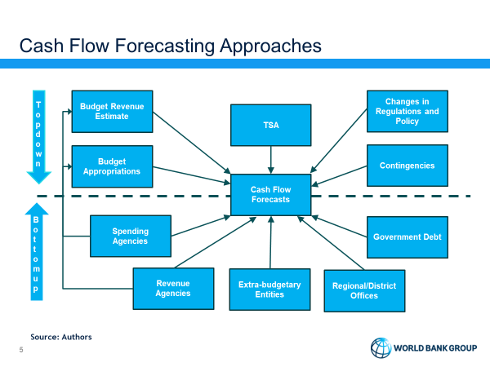
Leandro Secunho continued the presentation and went on to note that countries’ ability to finance their cash flow gaps varied substantially, depending on the robustness of the cash flow forecasts, the development of the domestic financial markets and access to the necessary financing instruments. He referred to the poor scores that had been recorded for cash management indicators by many countries when assessed by the World Bank Debt Management Performance Assessment (DeMPA) tool, which had reported on some 80 countries. The relevant indicators covered both the development of cash flow forecasts and cash management.
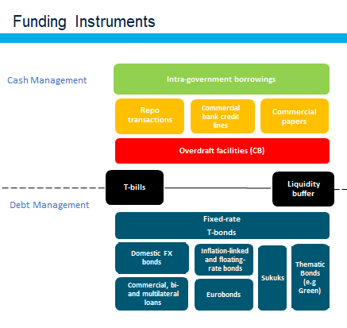
In relation to financing options, Leandro Secunho noted that countries used several instruments – as illustrated by the slide shown. It was noticeable that several countries used intra-government borrowings, particularly where the local money market was underdeveloped. More advanced countries were able to use repo, and in some cases drew on commercial bank credit lines or issued commercial paper. Several countries that had been surveyed had an overdraft facility with the central bank, although in these cases it was advisable that access should be limited in volume and time to avoid unnecessary monetary financing. Nevertheless, the pressures of responding to the COVID-19 pandemic had in some cases required more borrowing from central banks.
Treasury bills had a dual role in relation to both cash and debt management. Leandro Secunho also emphasised the importance of coordination between cash and debt management functions in other respects, in particular for example managing through liability management operations the heavy redemption payments associated with benchmark bonds, and by planning the dates of large debt maturities to be distant in time from low cash balance periods. He noted that several countries had a combined cash and debt management committee; and that this was even the case for some countries with an integrated cash and debt management unit, to ensure that all stakeholders were properly engaged.
Leandro Secunho went on to stress that debt and cash managers also needed to work together in deriving the size of the liquidity buffer. There was a trade-off between liquidity risk and the cost of carry, and a range of factors had to be considered in estimating the required buffer. These included cash flow volatility, the size of potential outflows, the ability to forecast cash flows, and the risk of having to stay out of the market in stress periods. He noted that some countries seemed surprisingly slow to put in place arrangements to invest temporary surplus cash, notwithstanding the extra returns available to them. However, a number of prerequisites had to be in place, and of course these included both good quality cash flow forecasts and an available range of appropriate instruments. The forecasts in turn allowed the maturity of investments to be linked to the prospective period of excess cash balances. Different countries exhibited a variety of practices also in this area, with some only investing in the central bank, but others in bank deposits, reverse repo or by buying government securities (or, less commonly, other securities).
Question and answer session was opened by Ilyas Tufan who thanked the speakers for the interesting presentation and asked if any software tools are available to support cash management, and in particular cash flow forecasting. Ilyas explained that this was very frequent question from many of the countries during earlier TCOP events. Coskun Cangöz reported that most of the countries surveyed tended to rely on MS Excel for assembling data cash flow forecasting; and although data could be available from the Integrated Financial Management Information Systems, in aggregating and manipulating the forecasts MS Excel tables tended to have advantages in terms of flexibility. Leandro Secunho also noted a recent IMF blog post that drew attention to some of the new techniques that cash flow forecasters could potentially use, drawing on business intelligence tools and building dashboards. In further discussion, the presenters emphasised the importance of both good quality data and a flow of bottom-up data to integrate with the top down analysis to come up with the sound cash forecasts. Responding to a related question from Vlado Delevski (North Macedonia) Coskun Cangöz said that econometrics had in general not proved helpful in developing cash flow forecasts. In practice, most countries had found that analysis of past patterns based on simple statistical methods together with a bottom-up information flow had proved more useful and simple to present the information and explain it to the senior management.

In further discussion, Oxana Pavlyukova (Russian Federation) asked about the availability of intra-day overdraft facilities. It was noted that a number of countries had legal restrictions on the availability of overdrafts, but the presenters said that the question raised had not been explicitly addressed with the surveyed countries.

Due to connection issues Mike Williams had not been able to respond to this question online, but in his written comments following the videoconference he explained that countries’ ability to access an intra-day overdraft will depend on how the payment system works. In many countries, the central bank will in effect support the liquidity of the banking system automatically, providing intra-day credits to the banks through the real-time gross settlement system. Insofar as this allows the banks to process payments, including government payments, early in the day, it could be regarded as an intra-day overdraft of the government. Sometimes it more explicitly supports government payments. In the United Kingdom, for example, the two commercial banks that manage most of ministries’ transactions are given a cash advance by the central bank at the beginning of the day; and that is then swept back into the central bank at the end of the day, netted with any inflows and outflows that arise during the day. Since there is no borrowing by the government at the end of the day, this would not normally be regarded as borrowing from the central bank; and should rather be interpreted as supporting the liquidity of the payment system. The amount required is technically determined primarily by the banks in discussion with the central bank, and not by the Treasury, although the advance can be seen as a claim on the TSA.

There were further questions from the participants about the wider availability of the MS Excel tool used at the WB workshops, and whether any further workshops were planned. The presenters said that they were considering making the tool more widely available, but that it had been designed in the first instance to support the workshops. All the workshops to date had been held before the pandemic; but the organizers are considering how to pilot a remote workshop in the near future.

Mike Williams had intended to offer some comments during the discussion, but connectivity problems precluded that. However, a summary of his comments is added below in italic.

Mr. Williams congratulated the authors’ on their work and noted that their presentation had provided a comprehensive and useful overview of country practices from a range of countries. Country experiences and practices were very diverse. Some of these differences reflected the extent to which they had been able to develop their cash management function in line with modern practice, and in particular how far they had progressed along the path from TSA, to cash flow forecasting, to active cash management. There were also different administrative capacities among the countries surveyed, and different degrees of market development both of which had a big influence on their ability to manage their cash effectively and efficiently. At the same time, it was interesting to note the extent to which the countries faced common challenges. This related to cash flow forecasting, and to its effectiveness and its purposes (i.e. supporting both budget execution and cash management and financing strategies).

This research has several potential messages for TCOP members:
- Cash flow forecasts: it was clear that forecasts had to support more than the budget execution processes, in particular financing strategies and the calculations underlying the cash buffer. In preparing cash flow forecasts, a collective effort was needed and an information network established to bring together bottom-up data in support of top-down analysis. The forecasts in turn needed to feed into the decision-making processes and calendar cycles related to both financing and budget execution. The lack of forecast performance analysis was striking; it was important that forecast errors were analysed both in relation to ensuring accurate policy responses in the short-term; and, over a slightly longer period, learning lessons for the future.
- Cash and debt management coordination: there were a number of examples in the paper of the importance of a close interaction between debt and cash managers, both in relation to financing transactions and the scope for cash flow matching and liability management operations that help to smooth cash flows. Where there was less than full institutional integration, cash coordination committees or similar were extremely important to ensure that all stakeholders brought the relevant information to bear and, as relevant, had an input into the policy responses.
- Instrument variety: the range of both borrowing and lending instruments was striking. The research revealed the extent to which some countries in practice borrowed from other parts of government, whether within central government, from subnational governments, or from state-owned enterprises. This option potentially offered more flexibility, but perhaps had to be used with caution, both to avoid distorting decision-making (particularly of commercially-oriented enterprises), and to avoid possible damage to money market development as a result of taking transactions away from the market.

Elena Nikulina, concluding the discussion on the first agenda item, again thanked the presenters for their interesting and important paper. She remarked that, although PEMPAL had discussed several aspects of cash management, it had been particularly useful to have an overview of the full range of cash management activities and how they fitted together.

Launch of the 2021 Survey on the TSA and Cash Management and Forecasting Practices in PEMPAL countries
Yelena Slizhevskaya and Elena Nikulina announced the forthcoming launch of the new TCOP survey and clarified the process. The survey aims to collect compatible information from the countries represented in TCOP on the main characteristics of TSA and cash management in each country. Information collected through this survey will be analysed and summarized in the new knowledge product which will benchmark the TSA and cash management practices within the countries of the ECA region, help to identify good peer practices and to promote treasury reforms in PEMPAL countries. It was explained that the results of the survey will be presented to the TCOP members during one of the future events and will be disseminated to a wider interested audience through PEMPAL’s website. Given the very technical subject of the survey the respondents were invited to familiarize themselves with the reference material (the list of survey questions and the explanatory note with definitions of the terms commonly used in the survey) before filling in the survey.
Ms. Slizhevskaya shared that the initial draft of the survey was prepared by TCOP thematic experts Mike Williams and Mark Silins with contributions from the TCOP Resource Team. The draft was further reviewed by the representatives of the Belarus, Georgian, Russian and Turkish Treasuries, and the Resource Team is very grateful for this important and substantial contribution with preparing the survey.
During the discussion that followed Jadranka Groksa Kardum (Croatia) commented that the results of the similar survey disseminated by the TCOP in 2016 had been very useful for the internal discussions and decision making in the Ministry of Finance of Croatia. They helped the staff of the treasury to benchmark their national practices to the peers and to inform the dialogue on the treasury reforms. Jadranka highlighted that to get the most value out of the new survey it will be very important to allow the countries enough time to prepare the data and fill in the survey. The Resource Team confirmed to give at least three weeks to respond to the survey, would any of the countries need more time the Resource Team stands ready to accommodate it on a case by case basis.
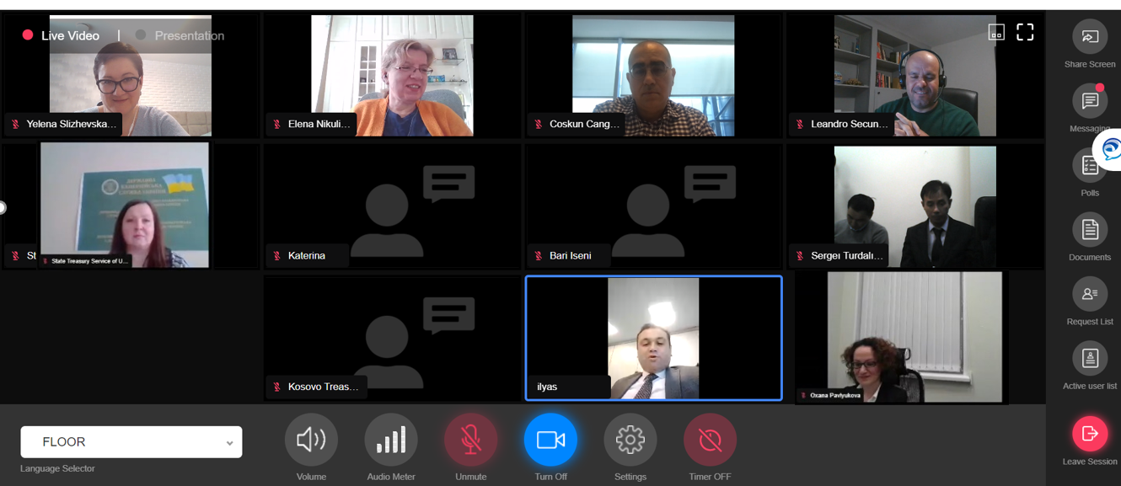

Some of the TCOP members had been participants at the World Bank workshops that provided the data behind the presenters’ paper
https://blog-pfm.imf.org/pfmblog/2021/02/-using-data-analytics-to-enhance-cash-management-.html?utm_source=feedburner&utm_medium=email&utm_campaign=Feed%3A+pfmblog+%28PFM+blog%29

