TREASURY COMMUNITY OF PRACTICE (TCOP)

Joint Videoconference of the Thematic Groups on Public Sector Accounting and Financial Reporting and the Use of Information Technologies in Treasury Operations

April 15, 2021

Members of the PEMPAL Treasury COP (TCOP) met through videoconference (VC) on April 15, 2021 to get acquainted with (i) the experience of the Treasury Committee of Kazakhstan to prepare consolidated financial statements of the republican budget; and (ii) the approach taken by the State Treasury of Belarus to pilot the new Unified Chart of Accounts. 64 officials from 14 PEMPAL countries (Albania, Armenia, Azerbaijan, Belarus, Croatia, Georgia, Kazakhstan, Kosovo, Kyrgyzstan, Moldova, Russian Federation, Tajikistan, Ukraine and Uzbekistan), and a representative of the Hungarian Debt Management Agency participated in the VC. The meeting was facilitated by the World Bank resource team, including Ms. Elena Nikulina (TCOP Resource Team Leader), Ms. Yelena Slizhevskaya (TCOP Advisor), Ms. Galina Kuznetsova (TCOP Resource Team member), Ms. Ekaterina Zaleeva (PEMPAL Secretariat), Mr. Mark Silins (TCOP thematic advisor).
Summary of discussion
Opening remarks
Ludmila Gurianova, the Deputy Head of the State Treasury of the Republic of Belarus and the Chair of the TCOP Executive Committee, welcomed the participants on behalf of the TCOP leadership and thanked them for dedicating time to meeting virtually in this challenging pandemic environment. Еlena Nikulina, the World Bank Resource Team Leader, also welcomed participants and noted that despite the challenges the interest in TCOP events is growing, as evidenced by the number of participants in the COP videoconferences (VC). Elena introduced the agenda of the VC and highlighted that this time discussions in small groups will also be trialed, a popular format during the face-to-face events.

Presentation by the Treasury Committee of Kazakhstan: Consolidated Financial Statements in the Public Sector
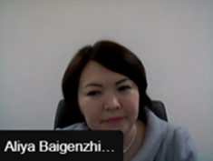
Aliya Baigenzhina, the Deputy Chair of the Treasury Committee of the Republic of Kazakhstan, commenced her presentation with an overview of the treasury system and public sector accounting and reporting reforms in Kazakhstan. Compliance with International Public Sector Accounting Standards (IPSAS) has driven reform of the national accounting and reporting system in the Republic of Kazakhstan. Commencing in 2010, Kazakhstan translates IPSAS and posts them on the Ministry of Finance webpage. These are updated each year to reflect changes and new standards. Kazakhstan has worked closely with international experts who assisted the authorities to prepare the methodological basis, pilot the new standards and develop the guidelines for IPSAS reporting. Establishing dedicated consulting teams in the regional treasury units also ensured a relatively smooth transition to accrual-based accounting and reporting in the public sector, as these teams provided hands-on support and advice to line ministries and spending units. The first accrual-based financial statements were prepared in 2013 with modified consolidated financial statements prepared in pilot regions in 2018.

In 2020 this culminated with four major achievements: (i) consolidated financial statements for the republican budget included in the Annual Report by the Republic of Kazakhstan Government (the report was submitted to the Parliament and audited by the Audit Committee).; (ii) consolidated financial statements for local budgets submitted to maslikhats (local representative bodies); (iii) consolidated financial statements for the state budget were also generated for analytical purposes, and a predictive consolidated financial statement for the 2021-2023 republican budget was generated based on historical trends and other budget indicators and assumptions.

The technology behind the consolidation grew from the existing e-MinFin solution. The capability to consolidate reporting by 77 entities subordinated to the Ministry of Finance was developed first, after which a dedicated subsystem was developed for other line ministries to enter their financial reporting data (manually or through xml-files). Consolidation is performed using a separate consolidation subsystem with embedded consolidation and elimination rules. The line ministries consolidate financial reports from their subordinated entities and the Treasury Committee consolidates the inputs into the financial statement of the republican budget. A similar process is undertaken at the subnational level.

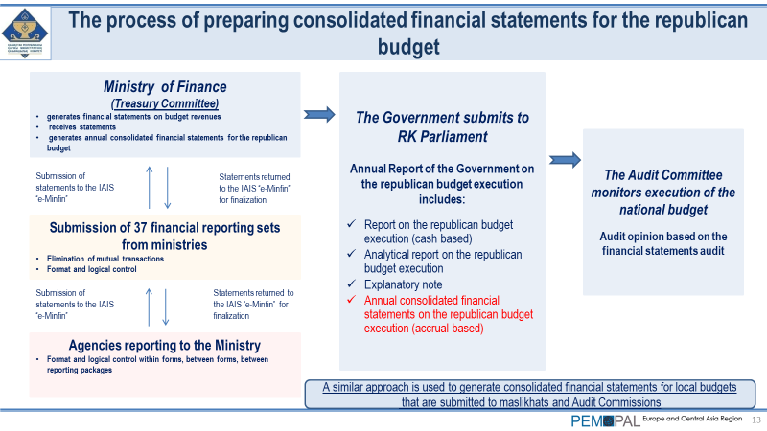
Mrs. Baigenzhina noted the benefits of automating the consolidation of the statements which included simplification of the processes to submit and accept reports, significant decrease in errors, streamlining the number and periodicity of reports, decrease in the cost of printing and document delivery with the transition to e-documents. Another benefit of the new system is its capability to facilitate remote submission of reports by accountants which became very important during the pandemic.

There has been significant debate whether all these efforts and investments to automate the consolidation of reporting was worth it, but now there is a unanimous agreement of the benefits of seeing information on all assets and liabilities in one statement, and being able to assess how budget policy decisions will affect not only the individual spending unit balance sheet but the balance sheet of the central government.

In the final part of the presentation Mrs. Baigenzhina shared the future plans for improving the national reporting system which include development and implementation of the new Unified Chart of Accounts, generation of the forward estimates in a financial statement format for the national budget and local budget, as well as integrating information from quasi-public sector entities into consolidated financial statements.

Participants from Azerbaijan and Belarus asked several questions during the Q&A session following the presentation:
In response to a question on quality control of the inputs submitted by line ministries the speaker explained that this is done by the treasury staff with each assigned to service several line ministries. System controls are complemented by manual verification and communication on errors is undertaken through the information system. Larger line ministries may have several iterations to correct balance sheet information. Technical support is also provided by the Center for E-Finance that supports the operation of the information system.
The participants of the videoconference were interested to know if additional staffing was provided to work on the consolidation process. The presenter indicated that a new unit for budget revenue accounting was created and consolidation unit was expanded with a net increase of just five staff.
Responding to the question whether the Audit Committee and the Parliament have challenges understanding accrual financial statements, Aliya explained that capacity building was provided to inform the members of parliament how to interpret consolidated financial statements, which were well received. It was also noted that a full audit by the Audit Committee will be undertaken for the first time in 2021, a partial audit was performed last year given the limitations imposed by the pandemic.

Presentation by the State Treasury of Belarus:
A Pilot to Test the Unified Chart of Accounts
Integrated with Budget Classification
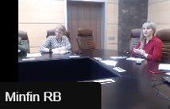
Natalia Rusakevich, the Head of the Public Sector Accounting and Reporting Reform Unit in the State Treasury of Belarus, presented the country’s approach to piloting its new Unified Chart of Accounts (UCoA) integrated with the budget classification. This will replace the multiple charts of accounts currently in use and serve as the core data structure for the new Integrated Financial Management Information System (IFMIS). A resolution of the government in 2019 mandated the alignment of the national accounting and reporting standards with IPSAS and implementation of a UCoA integrated with budget reporting.
The objectives of the new UCoA are: (i) to cover all general government sector transactions; (ii) to enable generation of high quality and timely budget execution reports and IPSAS-based financial statements; (iii) to closely align budget planning, budget execution accounting and financial statements generation; and (iv) to develop a unified information framework to serve as a foundation for the IFMIS.
The Ministry of Finance of Belarus opted to pilot the newly deveoped UCoA in a set of public sector organizations of different types aiming to check for sufficiency:
- of the ledger accounts;
- analytical and other reference codes;
- completeness of budget classification codes aligned with ledger accounts; as well as
- correctness of the guidelines for using the UCoAs to reflect public sector accounting operations.
The pilot was mandated by the 2019 order and during 2020 the State Treasury finalized the methodological framework and the Data-Processing Center of the Ministry of Finance developed the software. The timeline of the pilot is illustrated on the slide below.
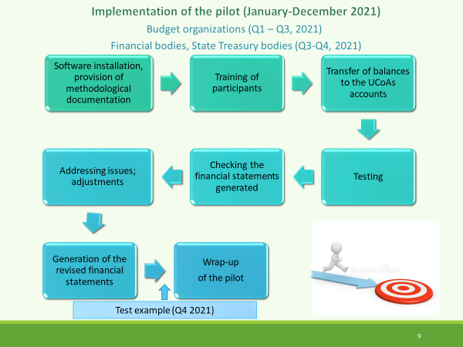
The colleague from Uzbekistan opened the Q&A session by noting that Uzbekistan is at a similar stage of reform and experiencing challenges in coordinating the old and new charts of accounts. Several questions ensued with the major topics and responses summarized below:
- having 5-digits out of the 32-digit code should be sufficient for core accounting purposes since all 32-digits of the code will be used in all accounting entries. At the same time the overall length of the code should not be seen as an impediment given most of the operations will be automated;
- the new UCoA will cover the whole general government sector;
- external consultants attracted under the World Bank project assisted the State Treasury with developing the design of the UCoA and supporting metholodogical documents;
- the work on the national public sector accounting and reporting standards is undertaken in parallel to the pilot which creates some challenges, but the Belarus Treasury is planning to have the main standards ready by the time the UCoA is approved after its piloting.
Responding to a question from Yelena Slizhevskaya, who was moderating the discussion, Ludmila Gurianova shared that contrary to the initial expectations, there was a high interest from the ministries, departments, and agencies to participate in the pilot. These agencies welcomed the opportunity to test the new UCoA at the pilot stage and provide their sectoral view and feedback to inform the decision on the final chart of accounts structure.

Follow up discussion in small groups
During the third part of the videoconference the participants were invited to split into two groups for the follow up discussion on the issues raised. Group 1 included representatives from Albania, Azerbaijan, Belarus, Croatia, Georgia, Kazakhstan, Kosovo, Kyrgyzstan, Tajikistan, and Ukraine. Group 2 included representatives from Armenia, Belarus, Kazakhstan, Moldova, Russian Federation, and Uzbekistan.
Summary of discussion in group 1 was reported back to the videoconference participants by Mark Silins. Participants were impressed by the reforms in both countries which represent significant milestones and provide useful reference points for reforms of other PEMPAL countries. Azerbaijan discussed how it had undergone a similar process to Kazakhstan opting for a specific system beyond the core Treasury system for consolidation of the financial statements. Albania and Croatia were also able to closely relate to the Belarus experience in implementing a UCoA. While their specific UCoA structures may vary the main components are the same as are the objectives. Consensus was that the presentations were extremely relevant and very practical providing an excellent base for future dialogue. It will be useful to revisit both countries in the future as they reach further milestones in their reform agenda.
Main takeaways from discussion in group 2 were presented by Elena Nikulina. The participants used the time to clarify additional aspects from the presenters and shared their countries’ experiences. Kazakhstan representative clarified that the UCoA is being developed but does not exist yet (integrated structure covering both budget and accounting requirements); consolidation is done using the financial reports from each organization rather than the accounting entries directly in the system (the budget reporting is undertaken by the Treasury, but not the financial reporting); originally the plan was to have a unified accounting system similar to the budget system, but it proved too complicated; there is no single software package for accounting; the consolidated financial statements for three years are prepared using the forecasted data (originally cash, but adjusted for accrual); the internal auditors carry out continuous audit reviews throughout the year and thus support the accountants in minimizing errors. Moldova shared their plans about implementing a standard product for accounting at the level of budget organizations as well as how they plan to further improve the consolidation process. Armenia indicated that they started to consider how to do the consolidation and what the options may be towards a more integrated model of budget classification and CoA. There were also words of appreciation from Kazakhstan participants for the TCOP knowledge product on consolidation developed quite some time ago. Kazakhstan made good use of it during their work on the consolidation solution. Given that they are now working on the UCoA a timely reminder was provided regarding the PEMPAL paper on the UCoA design which was published in December 2020.

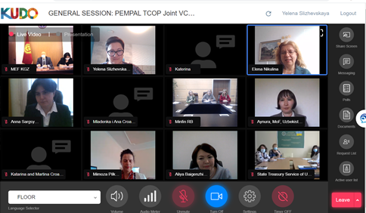

Conclusions and wrap up
Mark Silins noted the significant progress in both countries and how their frank and honest sharing of experiences was useful for all participants embarking on similar reforms. A common theme from both countries is the importance of planning and testing major reforms where possible. Belarus will be very certain about the UCoA when it is fully implemented and the way in which they have directly engaged stakeholders has ensured that the structures are implementable in a real environment, not just a theoretical structure. In Kazakhstan too, pilots for consolidation provided a lower risk method for ensuring the systems and processes were working. The benefits were also clear with new consolidated financial reports provided to a range of stakeholders at different levels of government – multiple reporting layers provided from the same single set of inputs by controlled entities. This is what effective use of technology can achieve. In addition, their decision to use financial reports to extrapolate the balance sheet forward is clever – decision-makers now see the impact of all of their policies on the balance sheet not just the cash flows. It will be difficult to ignore the financial impact of new policies with this type of information available, particuarly if it is made public. Few countries in the world take the consolidation forward to provide an outlook for govenrnment policy makers. This is probably an area for further discussion in PEMPAL, perhaps jointly with the BCOP. Looking beyond the forward estimates (three years) is also a possibility to see the intergenerational impact of current policies on future government balancesheets! He also noted that Kazakhstan may like to examine the UCoA developed in Belarus in more detail given their plans to focus on this in the future.
Mark further noted the contrasting pathways both countries have taken. Belarus redeveloped its UCoA first and next plans to implement IPSAS. In Kazakhstan the IPSAS process will be largely complete including the challenge of consolidation before the UCoA will be developed. Both have acheived success with their chosen reform sequence and both were the right fit at the right time. Mark commended both countries for their impressive achievements and excellent presentations. He also thanked participants for the level of engagement and interesting questions and discussions during the broader session and small groups.
Wrapping up the event Elena Nikulina thanked the presenters and participants and commented that the small group format worked well. She also announced the upcoming TCOP plenary meeting, to be held as a series of virtual events in the first 2 weeks of June. The invitations together with the registration link and a concept note will be send out shortly. TCOP Executive Committee and the resource team count on everyone’s active participation in the plenary sessions. In addition to sharing countries’ operational experiences from the COVID-19 pandemic period and discussing the implications for the further development of the treasury systems and processes, the plenary will also serve as a forum for developing the TCOP activity plan for the next year.

https://www.pempal.org/knowledge-product/optimizing-unified-chart-accounts-ucoas-design-tips-public-financial-management

