PEMPAL TREASURY COMMUNITY OF PRACTICE (TCOP)

Thematic Group on Evolution of the Role and Functions of the Treasury

February 27, 2020 Videoconference

The videoconference (VC) of the TCOP Thematic Group on Evolution of the Role and Functions of the Treasury took place on February 27, 2020. The meeting was attended by 26 participants from 10 PEMPAL countries, representatives from the PEMNA network also joined the videoconference as observers. The meeting was facilitated by the World Bank resource team (Ms. Elena Nikulina, TCOP Lead Coordinator, and Ms. Yelena Slizhevskaya, TCOP Advisor) and the PEMPAL Secretariat (Ms. Ekaterina Zaleeva). Mr. Mark Silins and Mr. Mike Williams, TCOP thematic experts also took part in the discussion.
Summary of discussion
Mrs. Mimoza Pilkati, Director of the Treasury Operations Department of the Ministry of Finance and Economy (MoFE) of Albania, and member of the TCOP Executive Committee, shared the experience of Albania in clearing government expenditures arrears and improving commitment controls.
At the start of her presentation Ms. Pilkati explained that government expenditure arrears presented one of the most significant problems in public financial management in Albania and an important issue for Albanian Treasury during the current decade. The government put significant efforts into clearing the stock of historic expenditure arrears, however it was not possible to eliminate them completely. Total central and local government arrears still represent around 1 percent of GDP (or 3.8 percent of public expenditures) with capital expenditures such as road construction and other infrastructure projects (45 percent of total amount), court decisions (19 percent), utility arrears (8 percent), road maintenance costs (4 percent) as the major problem expenditure categories. The 2017 Public Expenditure and Financial Accountability (PEFA) assessment undertaken by the World Bank documented that it was not fully possible for the MoFE to prevent new arrears occurring, as the ministry did not have a systematic approach for monitoring arrears through the treasury system.
Mrs. Pilkati further explained that expenditure arrears were a symptom of underlying weaknesses in the public financial management system including: unrealistic budget planning, liquidity shortages, weak commitment controls, lack of interoperability between different financial management systems, and gaps in reporting. All of these issues have negatively impacted the Treasury’s ability to generate reliable data on the stock of unpaid bills and to monitor overdue payments. In response to the situation the authorities developed a special strategy to prevent new arrears arising and to clear the existing ones (see the slide below), the later stages of which were incorporated into the current Albanian Public Finance Management Reform Strategy for 2019-2022. Improvements to the legislative and regulatory framework were an important element of the initial strategy. Albania introduced through the Law “On late payments of trade and contractual obligations” standard due dates for submission of invoices and processing of payments aligned with the European Union Late Payment Directive. Standard deadline for registration of signed contracts in the treasury system was also established.
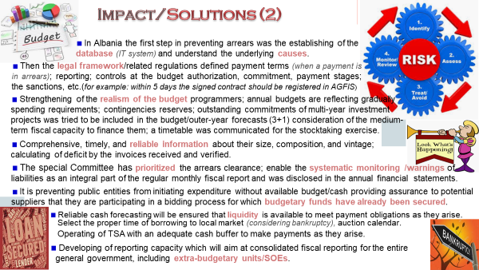

Mrs. Pilkati clarified how the changes to the existing treasury information system - AGFIS (and to the future integrated financial management information system - AFMIS) supported the reform measures to prevent new arrears rising. Three-year forward estimates and program budgeting were implemented in Albania in 2018 which expanded the horizon for monitoring fiscal data, including multi-year commitments. Previously data on arrears was accumulated in a manually compiled database (based on self-reporting by the budget units), however, since 2018 this information is collected from payment data entered into the centralized AGFIS, although the coverage of budget units (extrabudgetary units) is not yet completed. The current requirement is for signed contracts to be registered in the AGFIS within 5 days of the contract signature. Verification of the information with the public procurement system is currently done manually, but work is ongoing to link the two systems to ensure recording of the date once the funds are committed.
During the question and answer session that followed participants clarified that it is the treasury units that check whether budget organizations comply with registration of the contracts in the AGFIS within 5 days after signing. This is done by verification of the invoices submitted to the treasury. If any deviations are revealed this information is shared with the management of the spending unit / line ministry to improve compliance in the future.
Responding to a question on contracts registration Mrs. Pilkati explained that unique identification numbers are assigned for each contract in chronological order, and monthly reports are generated that contain information on the current year, as well as the forward two years for multi-year commitments. It was also noted that if a contract extends for more than three years, all the data for the subsequent years is recorded in a separate column in the system (T+4).
Participants also sought information regarding the templates used for registration of and reporting on multi-year commitments. Following the videoconference these were shared by Ms. Pilkati and added to the presentation slides (see slides 28-41).
Concluding remarks were provided by Ms. Nikulina and Mr. Silins who highlighted that while the size of central government arrears as a percentage of total expenditures is not particularly significant, the arrears are not evenly spread and are concentrated at the subnational government level. This has practical implications for how quickly budget units with high concentration of arrears can clear the arrears. Ms. Pilkati confirmed that indeed following the administrative reform of 2015 the 3-tiers of subnational governments were reorganized into a 2-tier system, and all the arrears of the 3rd tier were properly registered for the first time. It was also indicated that one of the key areas for arrears in Albania was road construction and maintenance and preventing new arears arising would require concerted efforts to strategically plan and budget this sub-sector’s activities as well as addressing the peculiar administrative aspects of contracting service providers. It was also noted that arrears from court orders should be formally monitored in advance of the legal decision by the courts through a comprehensive register of contingent liabilities.
Ms. Nikulina commended the Albanian Treasury which had made good progress in improving the processes for monitoring and reporting expenditure commitments and payment arrears. One remaining data availability issue is inability of the treasury information system (AGFIS) to generate data on the age profile of arrears. The soon to be implemented AFMIS is expected to address this problem and plans for its interoperability with the procurement system will further strengthen good practice.

http://www.financa.gov.al/ecuria-e-investimit-te-projekteve-2/

