# Summary PFM in Switzerland

## Historical development of accrual accounting in Switzerland

Prepared on behalf of the Swiss State Secretariat for Economic Affairs SECO by Christoph Schuler, Center for Public Financial Management, Zurich University of Applied Sciences ZHAW

**The Harmonized Accounting Model (HAM) for cantons and municipalities**

With the publication of the first edition of the "Handbook of Public Sector Accounting” (in German: “Handbuch des Rechnungswesens der öffentlichen Haushalte") in 1977 and a second extended edition in 1981, the first attempt was made to harmonize accounting in the public sector in Switzerland on the cantonal and municipal level. Although the accounting model and the guidelines published with it – today known as the “Harmonized Accounting Model 1 (HAM1)” – were non-binding and the introduction of the model was voluntary for the cantons and municipalities, there was nevertheless a far-reaching harmonization of accounting at both levels of territorial authorities. Although HAM1 contains certain requirements regarding recognition and measurement, there are no principles for disclosure. This shows that HAM1 does not meet the requirements of financial reporting according to the currently widespread principle of “fair presentation” (which also lie at the heart of the IPSASs), but that rather fiscal policy considerations were taken into account.

After a lengthy elaboration phase, the Conference of Cantonal Finance Directors published the handbook on the further developed accounting standards HAM2 in2008. Like HAM1, HAM2 is based on accrual accounting. However, the need for harmonization is particularly evident in the newly revised chart of accounts, which is to be standardized throughout Switzerland at the cantonal and municipal level. The cantonal finance directors have agreed to introduce the new accounting principles by 2018. However as of today, many cantons were not able to reach this goal (see figure 1).

In addition to HAM2, some cantons and municipalities have changed their accounting standards directly from HAM1 to IPSAS. Although HAM2 is clearly oriented towards IPSAS, it leaves much more room for maneuver with regard to options. These differences between HAM2 and IPSAS are reflected in the valuation methods on the one hand, but above all in the disclosure requirements.

The HAM2 cantons can be divided into two groups, namely HAM2 "plus" and HAM2 "light". The main difference is that the implementation of HAM2 "plus" focuses on the presentation of the financial situation according to the actual economic circumstances ("fair presentation"), whereas HAM2 "light" is dominated by the financial policy perspective. HAM2 "plus" is thus an implementation that goes beyond the minimum standards of the recommendations and also takes into account at least part of the optional recommendations. Practitioners from various cantons also describe a cultural change towards more transparent financial reporting when interpreting HAM2 "plus". By contrast, the implementation of HAM2 "light" will maintain the previous (according to HAM1) primacy of fiscal policy.

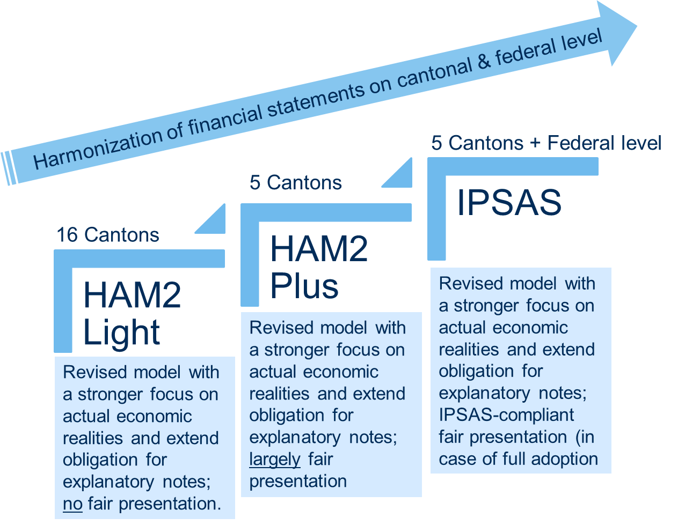

Figure 1: Harmonization of financial statements on cantonal and federal level in Switzerland (Source: Zurich University of Applied Sciences, 2019)

As highlighted in figure 1 the situation today presents a heterogenous picture in terms of harmonization. Many cantons still follow the traditional HAM1 system, however we see a steady trend towards implementing HAM2, both the light and plus version. The current global health crisis may present itself as an opportunity to further increase harmonization and thereby moving more cantons towards HAM2 plus or even IPSAS.

**Federal New Accounting Model NAM**

In comparison to the cantons, the federal level has only much later started reforming its public sector accounting System, while the most important element was the introduction and implementation of the New Accounting Model (NAM) in 2005, which is based on IPSAS. The conceptual work for the NAM project started in 2001, an important driver of change was the current IT environment, which was very heterogenous. Within the federal government alone, 17 different SAP configurations existed. However, the main reason the project was launched was the weaknesses of cash accounting and cash budgeting, which showed a substantial amount of inconsistencies with New Public Management (NPM), as it was implemented at the time in Switzerland on the federal level. Among some of the elements of NPM, cost accounting or intra-company invoicing has been introduced and both required full accrual accounting.

This led to the development of the New Accounting Model (NAM). In 2004, the decision was made to adopt a new accounting framework oriented towards IPSAS, with possible exceptions from these internationally recognized standards. As a result, in 2005 the Federal Budget Act came into law. The terminology might be misleading, since it was concerned with much more than just the budget. Thus, it would be more accurate to speak of a “Federal Financial Management Act”. In article 47 of the Federal Budget Act it is stated that the purpose of accounting is to deliver a “fair presentation of the net assets, financial position and results of operations”. Moreover, article 48 requires the “adoption of generally accepted accounting standards”. As a result, adoption of and departure from IPSAS have to be decided on cabinet level and acknowledged by parliament through a federal decree. Besides the adoption of IPSAS, the Federal Budget Act also introduced accrual budgeting on the federal level.

In 2007 NAM was implemented for the first time, starting with the now accrual-based budgeting process, through execution and ended with the first financial reporting under the new regime, with the first IPSAS-compliant financial statements in 2008. It was approved by parliament, however accepting major deviations from IPSAS (e.g. revenue recognition, scope of consolidation, military equipment, and others). Since then, the reform process has been ongoing and only very recently in 2018, Switzerland published its first IPSAS-compliant consolidated financial statements and today, the Swiss federal government shows a high level of compliance with the IPSAS. Figure 1 below depicts the gradual process of implementing IPSAS on the national level, which is still ongoing.

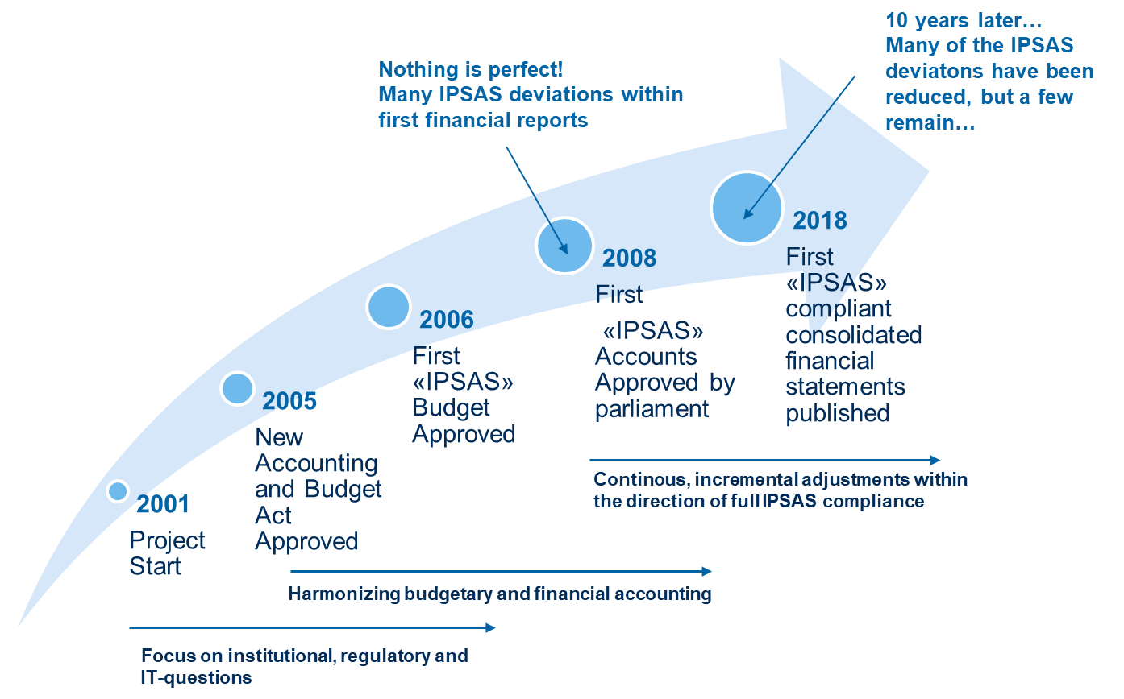

Figure 2: IPSAS Reform Swiss Federal Administration (Source: Zurich University of Applied Sciences, 2020)

## Fiscal rules and debt brake on cantonal and federal level

**Cantonal level**

Fiscal rules or debt brakes have a long history in Swiss cantons and the pioneering canton of St. Gallen introduced its debt containment mechanism already in 1929 as part of its fiscal law. Over the past three decades the majority of the Swiss cantons have reformed their fiscal legislations and introduced or revised the underlying debt brake mechanisms. Thereby, the cantons autonomously and individually elaborated their respective legislation to govern public spending. Due to the federal structure of Switzerland, the cantons have a high degree of autonomy regarding the introduction of fiscal rules, which means there is no national legislation forcing the cantons to introduce any type of fiscal rule.

**Federal level**

On the federal level, the debt brake is intended to protect the federal budget from structural imbalances and thus prevent the federal debt from rising as it did in the 1990s. It was adopted in 2002 by referendum with 85% of voters in favor of the new instrument and since than is part of the constitution (BV. Art. 126). It ensures a counter-cyclical fiscal policy by allowing limited cyclical deficits in downturns and by requiring budget surpluses in boom periods as generically displayed in figure 3 below.

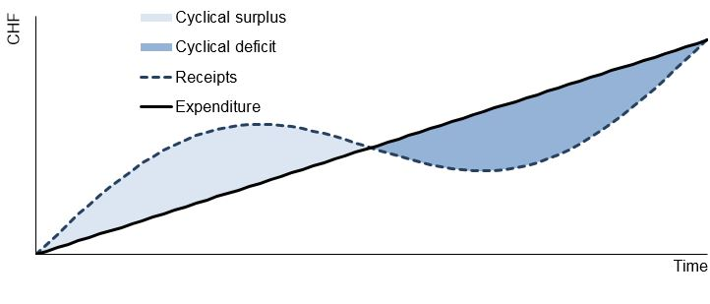

Figure 3: Schematic design of the Swiss debt brake over an economic cycle (Source: Federal Department of Finance EFD, 2020)

At the heart of the debt brake is a balancing rule by means of which the federal budget is controlled by limiting expenditure. This rule states that over an economic cycle, expenditure may not exceed income. The annual ceiling on expenditure is therefore linked to the level of revenue. In exceptional situations - for example severe recessions, natural disasters or a global pandemic - the expenditure ceiling can be increased by a qualified majority of both chambers of parliament.



Figure 4: Development of debt for the federal government (Source: Eidgenössische Finanzverwaltung EFV, 2019)

As highlighted in figure 4 above, the general development of the debt situation in Switzerland has been very positive, as a continuous reduction of the overall debt-level has been achieved in the past twelve years. Since the data is from 2019, the latest development regarding the global pandemic is not yet displayed. This being said, as in all other regions in the world, the government interventions regarding the COVID19 crisis will lead to a stark increase in government debt this year. Estimations today predict an additional debt between 30 and 40 billion Swiss Francs. However, due to the low level of debt pre-crisis, Switzerland will remain significantly below the Maastricht criteria of 60% debt/GDP ratio, with an estimated ratio between 40% and 50% by the end of this year. There is an unaccustomed agreement among most parliamentarians from all parties left to right that the strong position of Switzerland in terms of debt capability is largely due to the debt brake, and that without such measures in the past, the debt level after the crisis would present an even heavier burden as it is already.

References:

EFD, Eidgenössisches Finanzdepartement. 2020. “Die Schuldenbremse.” Retrieved June 4, 2020 (<https://www.efd.admin.ch/efd/de/home/themen/finanzpolitik/die-schuldenbremse/fb-schuldenbremse.html>).

Eidgenössische Finanzverwaltung. 2019. Federal Finances at a Glance: 2019 Results. Bern: Eidgenössische Finanzverwaltung.

FDK-CDF Konferenz der Kantonalen Finanzdirektoren. 2017. Handbuch: Harmonisiertes Rechnungslegungsmodell Für Die Kantone Und Gemeinden HRM2. Bern: FDK-CDF Konferenz der Kantonalen Finanzdirektoren.

Fuchs, Sandro, Andreas Bergmann, and Isabel Brusca. 2017. “Using Financial Reporting for Decision Making as a Measure Towards Resilient Government Finances: The Case of Switzerland.” Lex Localis - Journal of Local Self-Government 15(1):133–53.

Horni, Pascal, Nadia Yerly, and Gabriel Trinkler. 2017. “Debt Containment Rules in the Era of True and Fair Accounting: Fiscal Leeway between Hammer and Anvil.” Yearbook of Swiss Administrative Sciences 8(1):104.

Schuler, Christoph, Gabriel Trinkler, and Sandro Fuchs. 2017. “Kantonale Beteiligungen an EVUs Im Kontext Moderner Finanzberichterstattung Am Beispiel des Kantons Graubünden.”