PEMPAL TREASURY COMMUNITY OF PRACTICE (TCOP)

Cash Management Thematic Group

December 3, 2019 Videoconference

The videoconference (VC) of the TCOP Thematic Group on Cash Management took place on December 3, 2019. The meeting was attended by 29 participants from 12 PEMPAL countries, representatives from the World Bank and the PEMNA network joined the videoconference as observers. The meeting was facilitated by the World Bank resource team (Ms. Elena Nikulina, TCOP Lead Coordinator, and Ms. Yelena Slizhevskaya, TCOP Advisor) and the PEMPAL Secretariat (Ms. Ekaterina Zaleeva). Mr. Mike Williams, international expert on cash and debt management, also took part in the discussion.
Summary of discussion
- Presentation by Mr. Ilyas Tufan, Head of the Debt Management Department of the Ministry of Treasury and Finance of Turkey and the leader of the TCOP Cash Management Thematic Group, on approaches for setting and managing liquidity buffers.
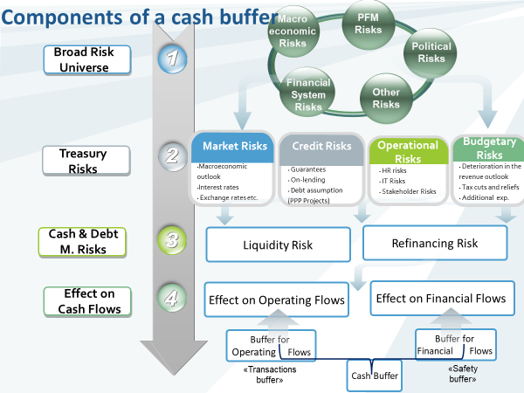
Mr. Tufan started his presentation with an overview of the cash buffer policy as well as components of the cash buffer. It was noted that the liquidity buffer represents highly liquid assets kept for the stress periods to meet any net daily government cash shortfalls, while the cash buffer represents the minimum level of cash balances to meet day to day cash requirements. The figure above illustrates the broad universe of risks whose effects on cash flows could be managed/mitigated through various cash buffer elements. Mr. Tufan further explained how to estimate the need for the transactions buffer (to smooth out the fluctuations of the operating flows) based on the cumulative net operating outflows, cumulative forecasting error and scenario analysis methods, as well as how to estimate the volume of the safety buffer. This was followed by the explanation of advantages and disadvantages of these methodologies.
The next part of the presentation was focused on how to set and manage the cash buffer and the target band for the daily reserves. It was explained that the narrower band will limit the cost of keeping excess cash but will likely require more frequent active cash management operations, while a wider band would capture more of the volatility of the daily cash reserves. The figure below illustrates the main policy decisions (PD) that need to be made and the key factors that inform these decisions to set and manage the cash buffer policy.
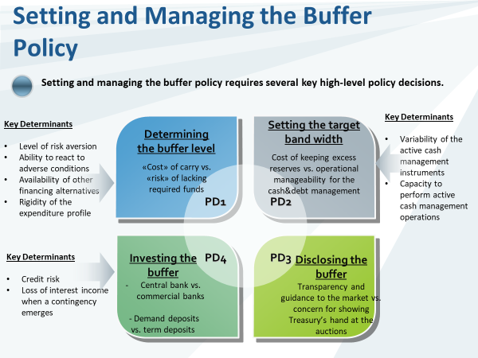
The presentation slides were shared with the participants prior to the videoconference and contained detailed information on the cash buffer policy and practice in Turkey. In the last part of his report Mr. Tufan provided short additional comments on the Turkish case and invited the participants for discussion.
The discussion started with Mr. Williams noting that the need for the cash buffers was emphasized by countries’ experience of the financial crisis which drew attention to the risk that they could not always rely on having sufficient access to the money markets or being able to borrow at acceptable costs.
One of the questions received prior to the videoconference came from Albania and was aimed to clarify whether cash buffers should be kept in separate bank account(s) in the central or a commercial bank, and whether the size of the balance corresponded to appropriations approved by the Parliament as reserve/contingent funds. Mr. Tufan clarified that the cash buffer is placed with the central bank in the form of a deposit (part of the Turkish Treasury Single Account) which is remunerated with a 1-week repo rate on an overnight basis, and the size of the buffer is determined by the Risk Management Committee on an annual basis around the end of October. Mr. Williams reiterated that such cash reserves should be easily accessible (completely liquid), so placing them in separate deposits (accounts) was likely to be suboptimal unless they were completely fungible with the balance in the TSA. There was very little relation with the appropriated contingency reserve, the use of which was usually spread over a period or carried some warning; the buffer was there to accommodate volatility or unanticipated flows in the very short term. Responding to the questions from the Federal Treasury of Russia Mr. Tufan clarified that the standard instruments used by the Turkish Treasury for cash management included deposits, buy-back operations and short-term borrowing (including several short-term money market instruments with maturities up to 1 month which are currently not used actively due to a policy decision); no overdraft mechanisms or Central Bank borrowings were used.
During the closing session of the discussion participants of the videoconference shared their appreciation for the detailed and interesting presentation. It was noted that the Turkish Treasury developed a sophisticated approach to setting cash buffers and countries will consider using some of the elements in their practice. It was also mentioned that cash management in many of the PEMPAL countries was at a much earlier stage of development; however, Mr. Williams commented that practitioners must not let the best be the enemy of the good – it was important to start building the proper processes even though the output may not be very sophisticated initially. Another point mentioned during the summary discussion was that cash management objectives may differ when the country operates significant wealth/commodity funds, a topic which could be covered in a separate discussion of the cash management thematic group.

- Discussion on ideas for the concept of the next face-to-face meeting of the Cash Management Thematic Group
Ms. Nikulina started the second session of the videoconference with an update on the November 12 meeting of the PEMPAL Steering Committee which approved additional allocations to the budgets of the Communities of Practice that would allow a small meeting of the cash management group to be organized in FY2020. Ms. Nikulina explained that this could be a separate event of the group, or a meeting back-to-back (immediately before or after) to the annual plenary meeting of the community. It is expected that the TCOP Executive Committee will discuss and decide on the format, topic and location of the event during its next meeting in January 2020.
During the conversation that followed the participants of the videoconference discussed what aspects of cash management and forecasting could be further explored during the face-to-face meeting of the group. The proposals included the following:
(i) to acquire information on the software used by countries for cash flow forecasting (proposed by Russia, Tajikistan, Turkey, Ukraine);
(ii) to discuss how to collaborate with the internal audit group to establish an effective internal control system for cash management purposes in a holistic manner (proposal from Turkey);
(iii) to learn about cash management in Kazakhstan (proposed by Russia);
(iv) special reserve funds (wealth/commodity funds, etc.) operate in some of the PEMPAL countries, which affects specifics of cash management in such countries, and could become potential topic for discussion.
Participants from Tajikistan also shared that they are developing a cash management module for the information system, which is expected to go live in 2021; and they will be ready to present their concept during one of the near events of the group, or to run the demonstration of the module once it has been put into operation.
Some of the countries experienced connection problems during the session and were not able to contribute to the discussion. Therefore, it was agreed that the resource team will circulate an additional invitation to provide proposals for the topic of the next thematic group event to seek the views of the members and inform the forthcoming discussion by the Executive Committee.

