PEMPAL Treasury Community of Practice
Meeting of Thematic Group on Public Sector Accounting and Reporting
October 23-25th, 2019 _________________________________________________________
Moscow, Russian Federation
On October 23-25th, 2019, PEMPAL Treasury Community of Practice (TCOP) held a meeting of its thematic group on public sector accounting and reporting in Moscow, Russian Federation. The main objective of the meeting was to enhance participants’ understanding of the challenges of implementation of public sector accounting and financial reporting reforms and discuss practical solutions to overcoming those challenges based on the experience of the Russian Federation. The meeting also served as a forum for participants to share the latest developments related to public sector accounting and financial reporting in their countries and advance the work on the TCOP knowledge product on unified chart of accounts (UCoA) design. The thematic group was represented by 31 participants from 9 countries (Albania, Azerbaijan, Belarus, Kazakhstan, Kyrgyz Republic, Moldova, Montenegro, Tajikistan and Turkey) joined by 17 representatives from the Russian Federation. The workshop was facilitated by the World Bank team comprising Mr. Arman Vatyan, PEMPAL Team Leader, Ms. Elena Nikulina (TCOP Resource Team Leader), Ms. Galina Kuznetsova, Ms. Yelena Slizhevskaya, Mr. Dmitry Gourfinkel and Mr. Mark Silins (Lead TCOP Thematic Advisor). Logistical support was provided by the PEMPAL Secretariat based at the World Bank Country Office in Moscow.
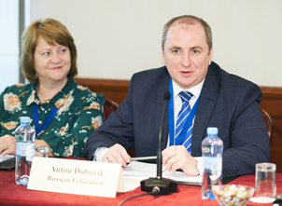
Mr. Anton Dubovik, Deputy Head of the Federal Treasury of the Russian Federation opened the Moscow event by welcoming the participants and expressing his appreciation for an opportunity to host this event and to share Russia’s experience and first results in implementing the new functional and organizational model for the public sector accounting and reporting at the federal level. Ms. Angela Voronin, the TCOP Chair and the Director of State Treasury of the Ministry of Finance of Moldova, welcomed the participants on behalf of the TCOP leadership and reminded that the public sector accounting and reporting thematic group was established in 2013 and currently includes 14 member countries. The last face-to-face event took place in Baku in 2018 and included the discussion on automation of public sector accounting and financial reporting at the spending unit level. The current event takes this discussion further and participation of colleagues from the thematic group on use of information technologies in treasury operation is expected to enrich the discussion. Mr. Voronin thanked the Federal Treasury and the Ministry of Finance of Russia for their initiative in hosting the event and ongoing support to PEMPAL.
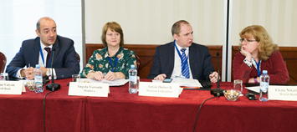
Mr. Arman Vatyan, the PEMPAL Team Leader, noted that PEMPAL has a culture of open dialogue, which helps countries in their reforms. He thanked the partners and donors of the program – State Secretariat for Economic Affairs (SECO) and the Russian Federation for their support for the program, as well as thanked the Federal Treasury for providing access to its knowledge. Ms. Elena Nikulina, the TCOP Resource Team Leader, continued by outlining the program of the event and thanking the hosts for investing significant efforts into preparation of the agenda, the first half of which is devoted to the experience of the Russian Federation and is close to a format of a study visit. Ms. Nikulina noted that the second half of the event will provide an opportunity for participants to further discuss the options for the chart of accounts design and share the latest news from their countries. Ms. Nikulina also highlighted this event will test new technology approaches, like livestreaming some sessions on YouTube, connecting remote participants to deliver the presentations, as well as video recording selected sessions for the benefit of those colleagues, who could not travel to Moscow to attend the event.
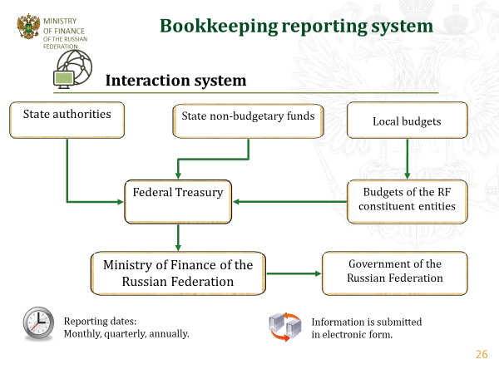
The first session of the thematic workshop commenced with an overview of the public sector accounting and financial reporting arrangements in Russia presented by Ms. Svetlana Sivets, the Deputy Department Head of the Ministry of Finance. She shared the progress of Russia in public sector accounting and reporting reform over the years. Implementation of the accrual-based reporting started in 2005 and continued with the introduction of the national standards harmonized with the International Public Sector Accounting Standards (IPSAS)which is ongoing. It was noted that in 2005 separate instructions for accounting in spending units and accounting for budget execution were replaced with the unified public sector accounting methodology, which enabled consolidation of reports at the general government level as well as transition to centralized accounting and reporting. Ms. Sivets explained that currently at the Ministry of Finance they can see the individual reports of the spending units, and apart from facilitating control function this information is very useful for budget planning. It was also mentioned that centralization of the public sector accounting should not be a goal in itself and the countries should seek for an optimal balance between centralized and decentralized processes. The presenter concluded by encouraging countries to move towards electronic document flow and standard data formats which will help decrease costs, save time and improve accuracy of reporting.
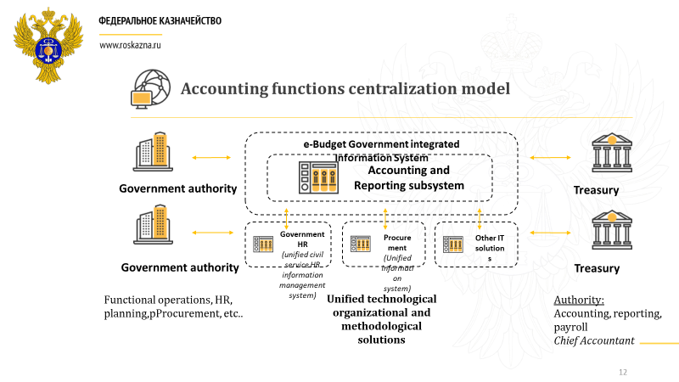
Mr. Anton Dubovik continued the session with the presentation on the transformation of the organisational and functional model for public sector accounting and reporting. He explained that the objectives of centralization of the accounting and reporting function at the federal government level were to reduce the costs of accounting and reporting processes and to decrease the risks of fiscal offenses (or the risks that budget execution report will not be confirmed by the Chamber of Accounts). The Treasury was selected to carry out centralized accounting and reporting for pilot federal agencies, as its staff possessed the needed accounting skills, the Treasury also already acted as the operator of the accounting and reporting module of e-Budget system, and had the vast regional network in place. The Treasury started with the uniform technological / software base, then implemented pilots with selected agencies/ministries. This was supported by the changes in the legal framework to define the Treasury as the only agency to do consolidated reporting for the government. It was noted that initial period of transition to the new system was marked with the increase in the workload and heated debates on delineation of the audit and control functions between the Treasury and the agencies. However, overall the initial results are seen as positive, as the centralization helped improve business processes, increase transparency, and created changes in internal control mechanisms. It was noted that it is planned that starting 2021 the Federal Treasury will be performing accounting and reporting functions for all the agencies managed by the Government of the Russian Federation.

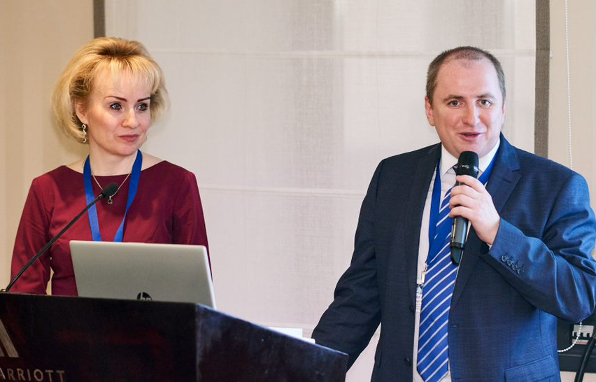
Next presentation was jointly delivered by Mr. Anton Dubovik and Ms. Yulia Semashko, the Director of the Financial Department of the Ministry of Science and Higher Education of the Russian Federation, who shared the first results from piloting the new model of the public sector accounting and reporting. Mr. Dubovik and Ms. Semashko discussed from their respective perspectives whether the new model is achieving the intended objectives in terms of streamlining the use of resources, improving quality of accounting and reporting, provision of timely and quality information to management, clear delineation of responsibilities and interaction with the control authorities. The discussion highlighted the complexity of implementation of the new model and importance of finding a compromise between the needs and objectives of different stakeholders.
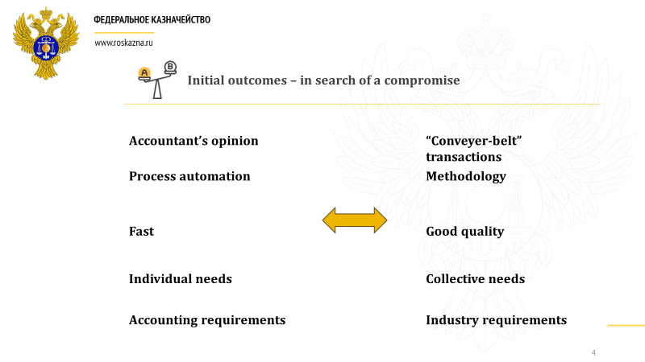
During the Q&A session it was clarified that the head of the line ministry has the first signature on the financial reports, while the Treasury has the second signature (acting as a chief accountant). The Treasury prepares the financial reports based on the accounting data. On the question regarding the remaining duplication of duties and how the ministry accounts for the subordinated entities, the answer was that the model applies only at the federal level and all the subordinated spending units keep their own accounting and submit their reports which are further consolidated based on the predefined requirements.
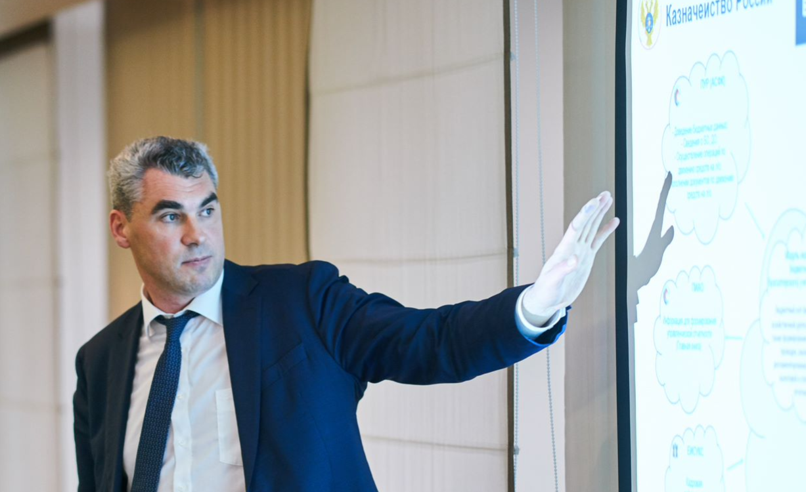
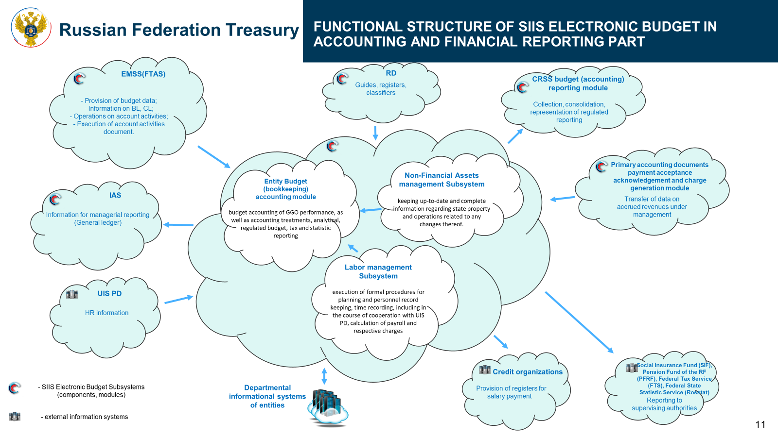
Next came the presentation from Mr. Alexander Albychev, Deputy Head of the Federal Treasury of the Russian Federation, who highlighted the key aspects of the information technology solution supporting the new model. He clarified that this solution presents a subsystem of the government’s financial management information system, e-Budget, which is integrated with other external systems. Among other achievements, the highly integrated nature of the e-Budget system enables the transition to electronic document management. Approximately 10% of the documents will continue to exist in hard copies, as they originate outside the public sector, but the information from the hard copy documents is entered into the system in a structured way allowing for one-time entry. The capability to use electronic acceptance acts is already piloted and is expected to be launched next year. The presentation was followed by a live demonstration of the accounting and reporting subsystem and its analytical capabilities. The solution was developed through customization of the 1S software, which is one of the most popular accounting software packages in Russia. During the demonstration it was clarified that the data is entered using the uniform reference information (e.g. register of legal entities, types of goods/services, etc.) and the Federal Treasury is the official holder of the national reference information which facilitates further integration of the government information systems.

The last session of the day provided the participants of the meeting with an opportunity to discuss in small groups the advantages and challengers of the new model implemented at the federal level in Russia as well as applicability of the approach to PEMPAL member countries. The reports from each group were presented in the morning of the second day and are summarized in the Box below.
Summary of discussion on the experience of the Russian Federation
Q1. Pros and cons of centralization of the public sector accounting and reporting in the Russian Federation
The advantages include:
- Integration of the public accounting subsystem with other modules of the financial management information system and with other government solutions;
- Standardisation of all processes;
- Digitalization of the primary documents leading to better quality of the information;
- The uniform accounting database, which enables generation of the comprehensive analytical reports for the management;
- Optimization of the costs for the implementation and maintenance of the information system (centralization of ICT budget under the Federal Treasury);
- Improved transparency and reliability of the financial information;
- Improved financial discipline (due to the use of the unified accounting methodology).
The challenges include:
- The unclear division of responsibilities between the line ministries and the Treasury, especially in case any errors are reported by the Accounting Chamber;
- The de-facto duplication of the chief accountant position (as line ministries tend to keep them, even if under another name);
- Delays in information provision (especially during the transition to the new model);
- Treasury staff does not know the sector-specific details of the line ministry operation;
- Increased training needs;
- The need for sophisticated information technologies to support the new model;
- Increased staff burden during the transition time
Q2. Whether the model presented by the Federal Treasury is applicable for other countries
The majority of the participants voiced their interest in having such technological platforms that would enable to operationalize the above-mentioned advantages of the new model. Most of the participants noted that centralization of the public accounting and reporting in their countries would make most sense at the level of the subordinated spending units or local governments, not the central or federal government level like in Russia. Many participants suggested that keeping accounting in the line ministries would help to keep better delineation of accountability and responsibility functions. It was also noted that reforms like the one implemented in Russia are long-term undertakings and require consistency in implementation and political stability, which may not be the case in some of the countries of the region.

Mr. Dubovik responded to the feedback from the discussion groups by acknowledging that indeed delineation of accountability and responsibility as well as the coverage of the new model remain controversial topics that continue to be debated internally. Mr. Dubovik proceeded with the final presentation on the early lessons learned during implementation of the new public sector accounting and reporting model in Russia and plans for its development. He stressed that the centralized model could be an effective tool for the public sector accounting and reporting, but feasibility of the model is dependent on the unification of the business processes across the entire public sector. The presenter commented that under the new model all three functions (review of the payment request, processing the payments, and audit of the operation) got concentrated in the Treasury and the consequences of this are being currently debated internally. Speaking of the future Mr. Dubovik mentioned the plans for further amendments of the budget, accounting and administrative legislation to support the new model, plans to reconsider the role of the accountants under the new model, elimination of the paper-based workflow and ensuring 100 percent of the data workflow becomes legally significant. In his final remarks Mr. Dubovik reminded that any peer experience needs to be understood through the lens of the reform goals and objectives, and in the Russian case the new model was aimed at improving transparency and accountability of the federal government and federal budget institutions, improving reliability of accounting and financial discipline and this is what it is on track to deliver.
Mr. Mark Silins, the TCOP Thematic Advisor, was invited to provide concluding remarks on the first part of the event. He reflected on the useful discussions around the tables which illustrated that the countries share a fairly common background with Russia and therefore they saw more alignment than differences with what the hosts were presenting. Mr. Silins complemented the hosts on the excellent and open discussion on the reform, including an opportunity to hear the position of the line ministry (Ministry of Science and Higher Education). Mr. Silins made the following specific points:
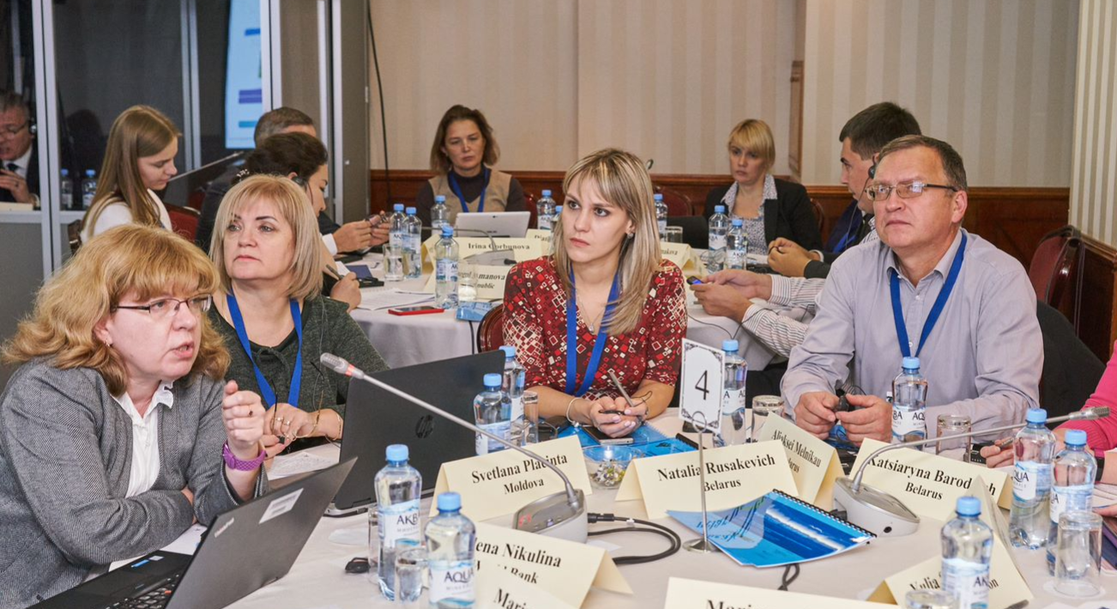
- Developing uniform accounting methodology and centralized solutions are becoming an international trend and the aspiration for many other countries. Many OECD countries that have undertaken significant decentralization would be envious of the functionalities implemented by the hosts, particularly given the very significant challenges these countries have experienced with consolidated reporting;
- Centralization verses decentralization – the challenge is in getting the right balance. The focus should always be on balancing results and risks;
- The model presented by the hosts focuses on centralization of solutions, policies and procedures, but it also entails some decentralization as the modern ICT is used to capture transactions at the point they are created rather than through manual processing, and this is the most important feature of the new approach;
- The new model has replaced the need for many manual control points. Therefore, the new question is what type of additional process control beyond which is occurring in spending units is required and where? It looks like in general most downstream controls will or should now be redundant, perhaps with the exception of higher risk transactions;
- Providing centralized accounting systems and tools for IPSAS based reporting represents indeed significant progress. However, some reservations arise whether a central authority has any role in signing off on an accountability process where they are not directly involved in that process (e.g. through delivering services). This seems contrary to the trend towards letting managers manage in line ministries ( results-based management). Therefore, the authorities may want to ensure that clear lines of authority and responsibility are also in place;
- The modern role of accounting in the government is evolving from a simple bookkeeping towards management accounting, and in addition to IPSAS, understanding costs and careful analysis become the needed critical skills – and they can hardly work centrally;
- It may be too costly for some countries to develop a fully-fledged single software accessible for all users. However, they can aspire to replicate the Russian approach in different ways – many countries are undertaking a more cost-effective option of developing e-documents and web-portals which can provide similar improvements to what Russia has developed, albeit not as integrated.
The second half of the event was devoted to discussions on the public sector accounting reforms in the member countries, news from the experts and discussions on the models of the UCoA in the member countries as well as good practice for its design.
The afternoon session of the second day started with Albania, Kazakhstan and Tajikistan presenting on recent developments with reforms in public sector accounting and reporting in their countries. Representative from Albania informed the participants that public sector accounting and financial reporting is currently done on a cash basis with elements of accruals for certain specific categories of assets and liabilities following the Public Sector Generally Accepted Accounting Principles (PS GAAP), which are codified in a complex, fragmented and ambiguous legal framework.The reform to adopt IPSAS has just started with the support of the project financed by the donors (WB and SECO) and its first phase covers 2019-2026 (detailed information on the action plan and the timeline for the reform was provided in the presentation). Kazakhstan provided their update on the progress with developing treasury information systems, the transition to accrual accounting and reporting in the public sector (the reform that started in 2007 and is nearing completion in 2020), as well as progress with generation of consolidated financial statements for the republican budget on the basis of the “e-Ministry of Finance” information system. Tajikistan concluded this session with the presentation on the approach the country had taken initiating the public sector accounting and reporting reform in 2013, and the lessons learned during the first six years of the reform implementation.
This session was followed by the presentations of the World Bank speakers on various international developments and initiatives related to the public sector accounting and reporting. Mr. Arman Vatyan presented the knowledge products developed under the PULSAR program, including (i) the template for the Public Sector Accounting (PSA) Reform Roadmap; (ii) Diagnostics: REPF Tool to facilitate assessment of the gap between the country’s PSA and IPSAS; (iii) PSA Education Plan – a toolkit to assist countries integrate PSA into educational curricula for the development of PSA professionals; (iv) Core Competency - a Framework for accrual based accounting core competency; (v) Benchmarking IPSAS/GFS2014/ESA 2010 - highlighting the linkages and conceptual differences of public sector accounting and statistical reporting requirements, (vi) A Good Practice Outline of the Multipurpose Chart of Accounts (CoA) - on development of a good practice Multipurpose CoA; as well as (vii) Awareness Raising & Communication - describing approaches and tools to awareness raising, and the value of accounting data. Mr. Vatyan advised to refer to www.pulsarprogram.org for these and other PULSAR materials, which are available in English, Russian, Bosnian-Serbian-Croatian and Albanian.
Dmitri Gourfinkel presented the experience of Latin American countries in implementing the public sector accounting reforms, as well as shared information on the regional initiatives, such as accountants general (FOCAL) and treasurer general (FOTEGAL) networks and CReCER conference. Mr. Gourfinkel also informed the participants of the meeting of the PULSAR’s Financial Reporting Community of Practice (FinCoP) work program and invited to promote further collaboration between the PEMPAL TCoP and the PULSAR FinCoP groups. The presentation also provided insights on current status and trends of implementing accrual-based accounting around the globe, as well as the IPSASB work program and projects proposed for the next two years.
Galina Kuznetsova was next to share the highlights from the Indonesian experience in the public sector accounting and reporting reform as well as selected information on modernizing of the national accounting standards and the whole of government reporting, which were made during the Public Expenditure Management Network in Asia (PEMNA) TCoP event in Moscow in the early October. This was the first PEMNA event organized outside of Asia thanks to the invitation of the Federal Treasury of Russia (PEMNA observer).
The final thematic session of the meeting was devoted to development of the TCOP knowledge product on the CoA design. The session followed the September videoconference and started with an update by Mark Silins on the progress with developing the knowledge product and next steps to further advance it.
In his presentation Mr. Silins also discussed whether a country can integrate budgetary and financial reporting requirements in single UCoA. He emphasized that nowadays PFM reforms require the officials to rethink the business processes to enable integration of the different elements of the PFM framework using modern ICT solutions and this can be optimized by developing a UCoA which operates across the entire PFM framework.
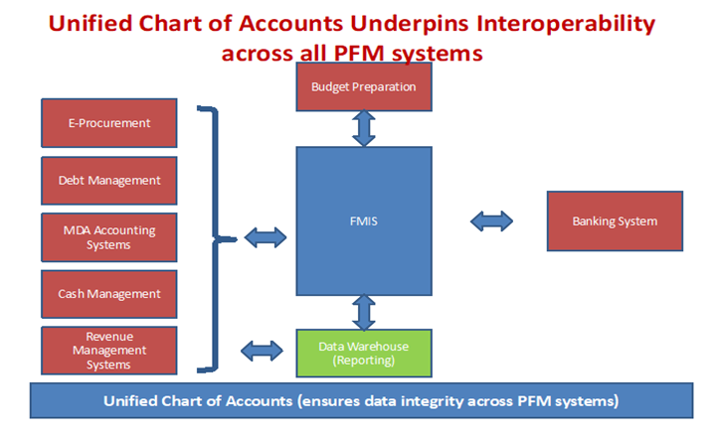
Integration issues will occur where different data structures are used in different systems. To maximize the benefits requires all stakeholders in the framework to understand the opportunities of integration and the cost of non-integration. This may be very challenging particularly for officials who have spent most of their careers working in a less integrated environment. Mr. Silins also highlighted that there are many ways integration can occur. He emphasized that full integration is possible where the same economic segment of the UCoA is used for all reporting requirements, but for many countries this will be difficult to achieve. Partial integration is also an option if the approach meets the fundamental principle that transactions are captured once, and all primary reports are derived from the UCoA which is used to record those transactions.
Discussion on this topic continued during the series of brief presentations on the structures of the existing budget classifications and CoAs and plans for their revision delivered by representatives of 9 countries (see summary table below). The presentations were followed by the group discussion session that confirmed that the topic remains acute for participating countries as in more than half of them the work on revising the existing budget classification and/or CoA structures is either already ongoing or planned.
Integration of the Budget Classifications (BC) and Chart of Accounts (CoA): current status and plans for revision
Country | Level of integration | Plans for revision
Albania | Full  (all financial, statistical, budget, etc. reports are directly derived from the BC/CoA) | The BC/CoA will be revised following decisions on the IPSAS implementation
Azerbaijan | Partial  (budget reports are generated from the BC structures, financial statements – from the CoA) | New software is needed to ensure linkage of the segments
Belarus | Missing – > Partial | The structure of the UCoA has been developed based on the current BC and new additional CoA segments. The UCoA will be piloted in 2020-2021. There may be a need to simplify the economic segment
Croatia | Partial  (classes of the CoA expanded to separately record budgetary cashflows (economic segment) from changes in the balance sheet) | The current UCoA was adopted in 2014, the largest changes were made according to Eurostat requirements
Georgia | Partial  (the CoA will include only those accounts that are necessary for IPSAS reporting) | Revisions of the CoA in line with IPSAS are taking effect from January 2020, the CoA will have to be further reviewed following the changes in the IPSAS requirements
Kazakhstan | Partial | Revisions are being prepared
Kyrgyzstan | Partial | There plans to update and better integrate the BC and the CoA subject to automation of the processes
Moldova | Full  (economic segment directly supports both budget and financial reporting) | On as needs basis
Montenegro | Full | Following the transition to accrual method
Russia | Full | There may be a need to simplify the economic segment to ensure an optimal balance between the efforts invested in producing the information and the results (information) achieved
Tajikistan | Partial | Discussion is ongoing on eliminating the economic classification and using the expanded CoA structure instead of it
Turkey | Full  (cash based for budgeting, accrual for reporting purposes) | There was a recent upgrade following modification of the national standards with some IPSAS elements

Summarizing the key messages from the discussions on the BC/CoA Mr. Silins noted that:
- Countries are seeking to maximize the integration but taking somewhat different paths to achieve similar results. Mr. Silins commented that there could be different approaches to define whether the classification structures are fully or partially integrated. However, this is not so critical if the BC/CoA can seamlessly address all major reporting requirements.
- Those countries that still largely undertake financial reporting and budget reporting on a cash or modified cash basis will not have experienced the same challenges as those that have moved to accrual – so for countries still largely on a cash basis integration issues may not be so apparent. This is particularly true for financial verses statistical reporting - despite the two frameworks converging, there remains differences at a detailed level which can present challenges for integration. Moving to accrual is where the major challenges exist as this is where the complexity comes into play and where the cash-based budget and accrual based financial and statistical reporting frameworks diverge somewhat.
- Budgetary reporting is not just about cash inflows and outflows but the changes in a government’s net cash assets and therefore the cash balance-sheet of the government (cash-fiscal balance). This is why it is important that the staff of treasury communicates with colleagues from the budget departments to build shared understanding that the cashflows in the budget should also be classified according to GAAC and aligned with GFSM2014.
- There is an important opportunity for every country to ensure a more integrated ICT PFM framework underpinned by a UCoA. When investing in more integrated IT solutions countries need to look at the convergence of different requirements rather than the differences as these are not different requirements but a reconfiguration of the transactions for different reporting .
- There is still an opportunity to create a fully or partially integrated UCoA and we encourage all countries to do this. However, this is not the entire challenge. The UCoA does not assure compliance with IPSAS, macro-fiscal reporting, budgetary reporting or GFSM2014. Countries still need to have extensive policies underlying this and there will be some natural differences between financial and statistical reporting and other reporting too. It is important to take a pragmatic approach and focus on the structure that best meets the decision- making needs of the government, and then identify how to migrate the financial information recorded for the other requirements.
- Also beware “the expert” opinion - a modern economic segment which allows you to capture transactional information in accordance with GAAC along with sound accounting policies, will go a long way to meeting most major reporting requirements in the PFM framework. However, there are many ways to present or structure the UCoA and to comply with international requirements. IPSAS provides no detailed specifications for the economic segment. Each country is building a unified reporting framework, not just reporting according to a single requirement in government.
The concluding session of the meeting was devoted to discussions on what went well and what could be improved further, as well as to discussion on the future plans of the TCOP thematic group on public sector accounting and reporting. The participants thanked the hosts, both the Federal Treasury and the Ministry of Finance of Russia, for the interesting and thought-provoking discussions that proved how relevant and timely the topic was to the participants. They were also impressed with the participation of the line ministry (beneficiary of the reform), and the use of technology including the live demonstration of the system, the WebEx presentations and the YouTube streaming pilots. On things to improve, the participants noted little time for the small group discussions this time and advised to allocate more time, as it was done before, for group sessions.
The thematic group members proposed the following topics for further discussions, which could be organized through video-conferences, future face-to-face events or study visits:
- Further technical discussion on selected IPSAS (the financial statements and measurement were mentioned) using country cases;
- Country cases of standards implementation;
- Consolidation (follow up on the knowledge product);
- Assets management module;
- Details on the modified cash method from various countries (what is cash based and what is recognized on an accrual basis);
- How to generate statistical reports from financial reporting;
- Other joint meetings with IT colleagues;
- An interest in a joint event with colleagues from other networks e.g. PEMNA.
- One suggestion was to invite university staff to attend such events (for knowledge sharing).

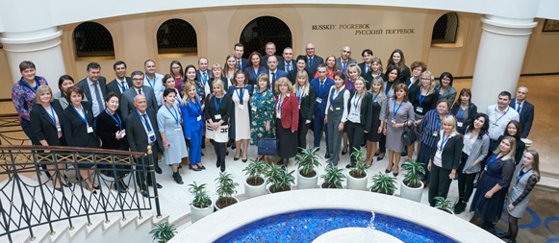
All the meeting materials are available at the PEMPAL website: www.pempal.org

Albania, Azerbaijan, Belarus, Moldova, Kyrgyzstan, Russia, Tajikistan presented in person, Georgia and Croatia connected remotely and presented through webex
The summary table captures the views of the participating countries representatives
Representatives of Moldova expressed particular interest in the views of the group on their CoA structure. In Moldova’s case the economic segment supports both budget and financial reporting directly, one of the few countries to fully integrate these two requirements. An interesting challenge for Moldova is that on occasions they have received criticism because their segment does not accord with a traditional accountant’s view and on occasions the suggestion has been made to change their structure accordingly. Moldova opted to create classes in the economic segment that aligned with a cashflow statement and GFSM2014 (operating, investing and financing) which sees separate classes for non-financial and financial assets, whereas in traditional private sector accounting the balance-sheet structure focusses primarily on current and non-current assets. However, Moldova is still able to report current and non-current assets and liabilities, so the criticism is unfounded.
As an example, you will always need a separate classifier for intangibles – this is required under both IPSAS and GFS. However, the fact that it is included within Non-Financial Assets (NFA) in GFS will not be an issue for financial reporting. NFA includes Property, Plant and Equipment (PPE) and Intangibles, and also other assets categories such as valuables, inventory, sub-soil assets, etc. While the bulk of NFA will be PPE it is not the same grouping. It is merely a different aggregation of the same detailed accounts. Both PPE and NFA should be reportable in a well-structured UCoA. There is a similar misunderstanding regarding current/non-current assets verses NFA and Financial Assets. Current/non-current are the typical classes required in private sector accounting whereas an NFA/FA split is more relevant for budget reporting (capital budget above the line and financing sources below) and the statistical framework. IFRS (and IPSAS) require to at least distinguish between operating, investing and financing cashflows. Assets for cashflows are therefore generally also split by NFA/FA. All of these requirements for reporting should and can be supported in a well-designed UCoA.
For example, how depreciation and amortization in financial reporting can be adjusted for consumption of fixed capital in the statistical framework

