PEMPAL TREASURY COMMUNITY OF PRACTICE (TCOP)

Joint Meeting of the TCOP Executive Committee and the Thematic Group on the Evolution of the Role and Functions of the Treasury

Preparations for 2019 TCOP Plenary - March 14, 2019 Videoconference

Joint videoconference (VC) of the TCOP Executive Committee (ExCom) and the Thematic Group on the Evolution of the Role and Functions of the Treasury took place on March 14, 2019. The meeting was attended by 20 participants from 8 countries. The meeting was facilitated by the World Bank resource team (Ms. Elena Nikulina, PEMPAL Program Leader, and Ms. Yelena Slizhevskaya, TCOP Advisor) and PEMPAL Secretariat (Ms. Ekaterina Zaleeva), and moderated by Ms. Angela Voronin (TCOP ExCom Chair, MoF, Moldova). Dr. Török Tamás Pál (Hungarian State Treasury) also joined the discussion.

Agenda
- Session of the Thematic Group on the Evolution of the Role and Functions of the Treasury: exchange of news on the recent developments
- Meeting of the TCOP Executive Committee to discuss preparation of the TCOP plenary meeting

Summary of discussion
- Session of the Thematic Group on the Evolution of the Role and Functions of the Treasury: exchange of news on the recent developments
Ms. Voronin welcomed the participants and noted that there was a special reason for merging the VC of the thematic group with the meeting of the ExCom, as the theme of the evolution of the role and functions of the treasury was supported by ExCom as topic of the 2019 plenary meeting and this joint discussion is expected to shape the concept and agenda of the plenary.
The session of thematic group started with a presentation by Mr. Ilyas Tufan (Ministry of Treasury and Finance, Turkey), who provided the members with an overview of the recent institutional changes that had taken effect in Turkey. There was a referendum in 2017 in Turkey and upon its results the administrative system of the country transitioned from a parliamentary into presidential system and the institutional structure of the government therefore undergone significant changes. It was noted that the number of the ministries went down from 26 to 16 (some of them have been merged, like the Ministry of Labor and Social Security and Ministry of Family and Social Policies, Ministry of Economy [responsible for Foreign Economic Trade] and Ministry of Internal Trade and Customs), some of the ministries have been reformed as agencies (Ministry of European Union became an agency under the Ministry of Foreign Economic Affairs).
The institutions engaged in the public finance management (PFM) have also been reformed and restructured. As illustrated in the presentation there were three major institutions that were taking part in the overall PFM process: Treasury, Ministry of Finance (MoF) and Ministry of Development. The Treasury used to be an Undersecretariat reporting to the Prime Ministry, who was delegating his authority to a Deputy Prime Minister. The top manager of the Treasury was an Undersecretary. Treasury was mainly responsible for such PFM areas as cash and debt management, receivables and PFM risk management; its other functions included oversight of the state-owned enterprises functioning and conducting foreign economic relations. The MoF was responsible for budget preparation and execution processes, determining the revenue policies and forecasts, enacting accounting legislation, operating financial management information systems (FMIS), coordinating internal control across the public sector, administering state real estate and etc. The Ministry of Development was responsible for medium- and long-term planning, executing and preparing the capital budget, including approving the investment projects of the line ministries.
In the new structure most of the functions of the Treasury were transferred to the new Ministry of Treasury and Finance (MoTF), like were the other PFM functions of the MoF. Another support institution was established which is responsible for budget preparation and execution processes, as well as medium- and long-term planning and capital budget execution and preparation - this is the Strategy and Budget Organization (SBO) under the Presidency. The peculiar aspect of the new institutional structure is that nearly all these critical functions of the SBO have to be conducted together with the MoTF (functions of the mutual responsibility). Mr. Tufan noted that even in the previous structure these functions were performed in a coordinated manner, but with the new structure this coordination was formalized by the relevant legislation.

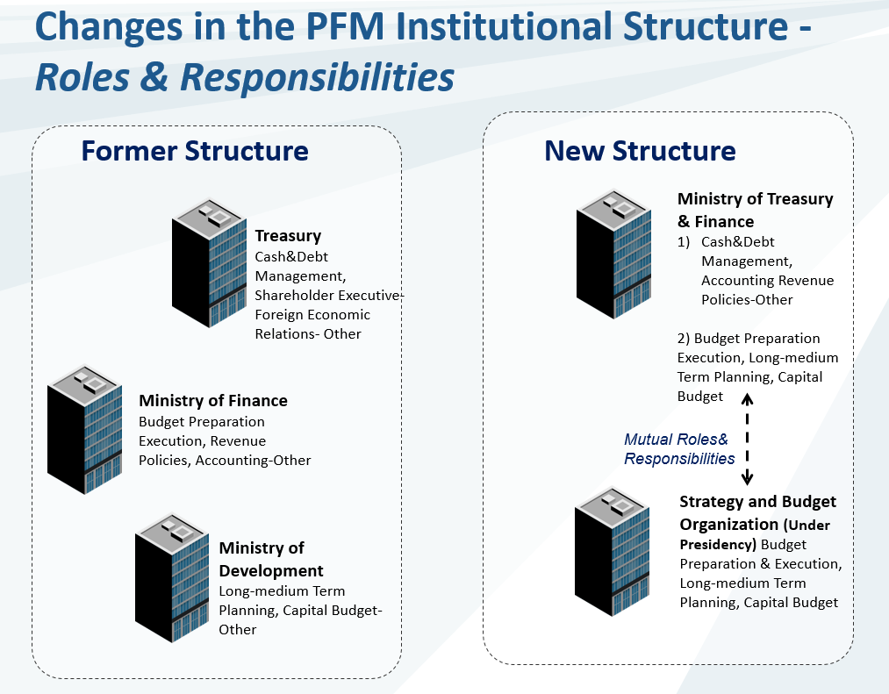

Mr. Tufan also provided an overview of the new institutional structure of the MoTF (see below) and opened the floor for discussion.

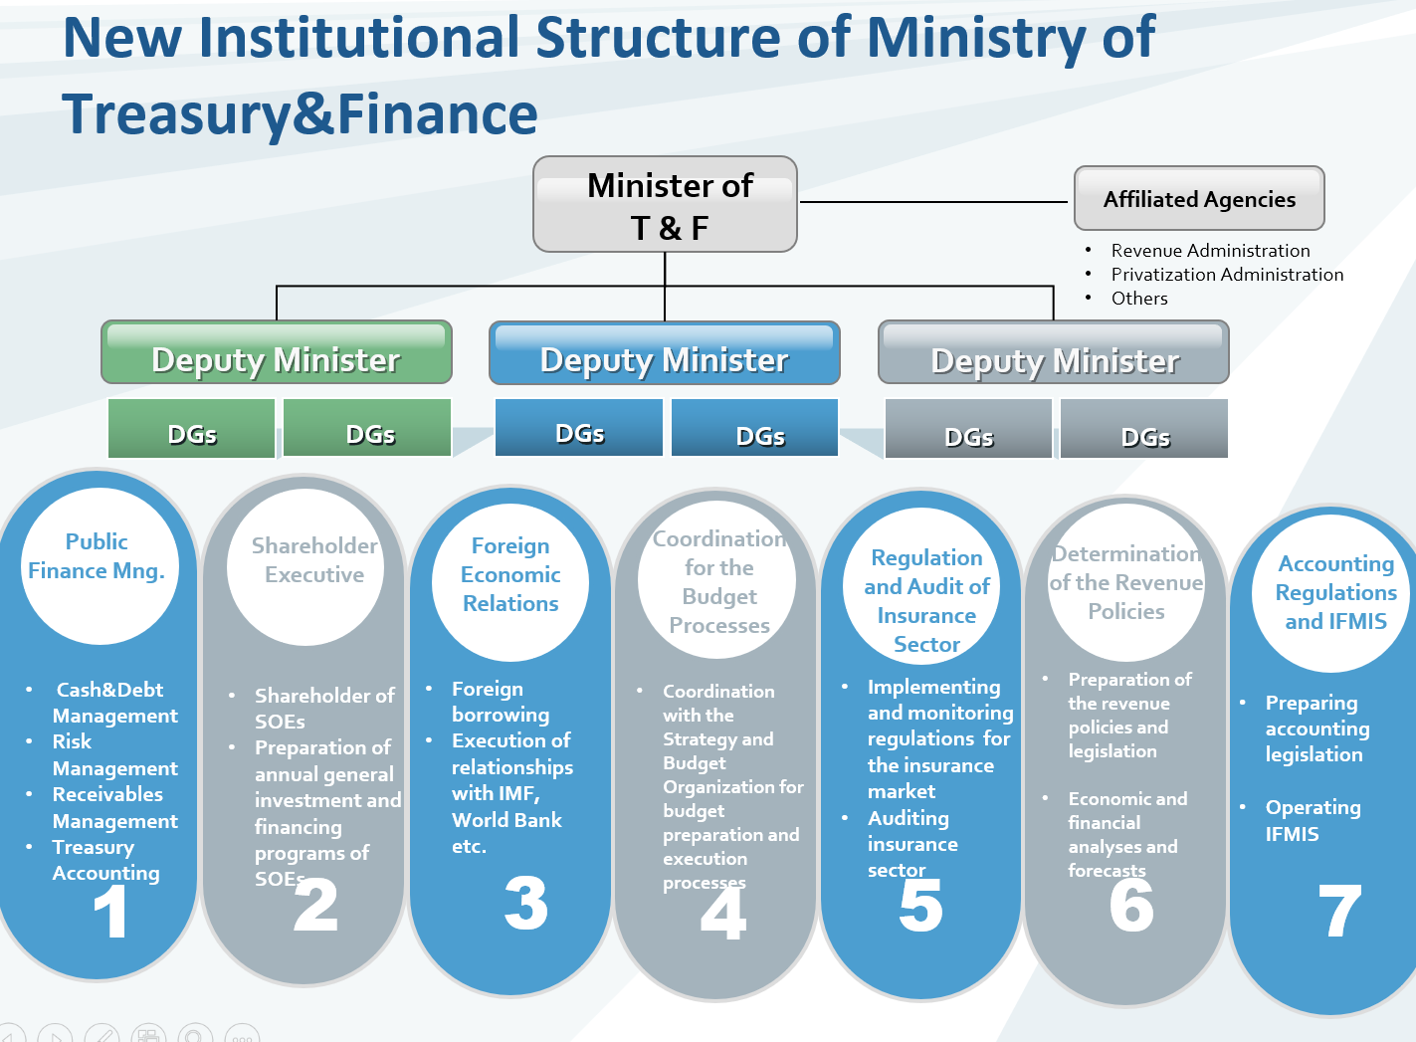

In the question and answer session that followed Ms. Voronin commented that the experience seems to be rather controversial to the trend observed in many other countries where separation of the treasuries from the ministries of finances is observed. Mr. Tufan agreed that indeed ideal institutional structure alternatives have always been at the core of intellectual discussions before this new structure has been adopted. This political decision fostered coordination between different PFM functions (such as cash and debt management which were conducted separately from the budget execution function), as well as addressed the need to coordinate public sector accounting and integrate it within the FMIS (which was operated by the MoF separately from the Treasury).
Dr. Török Tamás Pál was interested to hear about the relation between the MoTF and the SBO and what happens if they have different opinions on the professional issues within their mutual responsibility. In response to this question Mr. Tufan clarified that both, the MoTF and SBO are reporting to the presidency, and authorities are still working on the effective coordination mechanism. At the same time, it was noted that sufficient informal coordination culture already existed in the government which helped a lot.
Responding to the second question from Dr. Pál about the responsibilities for managing different PFM IT solutions Mr. Tufan clarified that in fact integration of the individual PFM IT systems was initiated some time ago and the process of merging IT systems and IT staff is ongoing. Mr.Tufan further explained that the plans for integration of the different PFM solutions do not imply that a single IT system needs to be created - the focus of the reform is on ensuring the integration between the solutions for their smooth operation, and this is a long and challenging process. Mr. Tufan further explained that this reorganization is expected to foster the integration of the PFM IT solutions in a more structed way, but in any way any reform process comes in pain and this one is not an exception, but the MoTF authorities hope to come up with effective solution at the end.
Ms. Nikulina asked how the staffing arrangements were handled during the merger and Mr. Tufan clarified that in fact all the main functional units continued to operate in the same way as before the reorganization, while other supporting functions, like HR, IT or legal departments, had been merged. The new unit established under the MoTF was the Transformation and Change Office which is responsible for the reform processes, oversees and conducts them, and the staff of the unit came from different directorates of the former Treasury and the MoF. Mr. Tufan also noted that no significant change in the total staff number occurred due to the merger.
Ms. Voronin was interested to hear about organization of the public procurement in Turkey and Mr. Tufan informed the participants that there is a special institution that performs both, regulatory functions, as well as oversee public procurement processes that are going on in the government, and this body is completely separate from the MoTF.
Ms. Nikulina commented that the Turkish treasury is the oldest treasury in the region, it historically existed separately from the MoF, and the current reform is a major change in the PFM landscape of the country. Ms. Nikulina also noted that TCOP Thematic Group on the Use of IT in Treasury Operations will also be interested to hear about the progress with integration of the separate PFM IT systems during one of the events in the future.

- Meeting of the TCOP Executive Committee to discuss preparation of the TCOP plenary meeting
The following TCOP ExCom members attended the VC: Ms. Angela Voronin (Chair, MoF, Moldova), Mr. Ilyas Tufan (Deputy Chair, MoTF, Turkey), Ms. Lyudmila Guryanova (Deputy Chair, MoF, Belarus), Mr. Alexander Demidov (Federal Treasury, Russia), Ms. Mimoza Pilkati (MoF, Albania), Mr. Levan Todua (MoF, Georgia), Ms. Zaifun Yernazarova (MoF, Kazakhstan).
Ms. Voronin started the next session during which the ExCom discussed preparation of the TCOP plenary meeting.

  - Confirming the location for the 2019 TCOP Plenary Meeting
Ms. Voronin reminded the participants that during the TCOP ExCom meeting on January 22, 2019 the colleagues from the Kazakhstan MoF confirmed their willingness to host the TCOP plenary meeting in the week beginning May 27, 2019. The preliminary estimate of the cost of holding the meeting in Astana turned out to be quite high and even with the possible co-financing from the hosts the available resources would not allow the TCOP to fully implement its Action Plan for FY2019 - they are only sufficient to cover the costs of the annual plenary meeting in Astana and there will be not enough funds to conduct the originally planned meeting of the Thematic Group on the Use of IT in Treasury Operations.
At the same time the ExCom had recently received an invitation from the State Treasury of Hungary to hold the 2019 Plenary Meeting in Budapest (this information was shared with Kazakhstan Treasury and the ExCom members prior to the VC). Hungary was not a member of the TCOP, but opportunities for future TCOP cooperation with Hungarian colleagues were discussed during the meeting that was organized back-to-back with the Cross-COP Executive meeting held in July 2018 in Budapest. The Secretariat prepared quick estimates that showed that holding the plenary in Budapest will cost approximately 25 percent cheaper compared with having the meeting in Astana, even with consideration for co-financing offered by the Kazakhstan MoF. Therefore, holding the plenary in Budapest will allow the TCOP not only to greatly reduce the cost of the plenary, but also to finance a face-to-face meeting of the Thematic Group on the Use of IT in Treasury Operations in FY2019 (back-to-back with the plenary), i.e. fully implement the TCOP Action Plan for FY2019. It was further clarified that during February 27, 2019 meeting of the PEMPAL Steering Committee it was confirmed that COPs budgets for FY2019 remain unchanged, i.e., no additional financing is envisaged before the end of the fiscal year.
Ms. Yernazarova confirmed that the Kazakhstan MoF discussed these new developments and accepts it fully understanding situation with the TCOP budget. Ms. Yernazarova also confirmed their readiness to present relevant Kazakhstan experience during the forthcoming plenary in Budapest.
During the discussion that followed the members of the ExCom agreed that current budget constraints should be treated as a priority and supported the initiative of the Hungarian State Treasury to host the event.
Ms. Guryanova expressed her interest in Kazakhstan experience in public procurement and public accounting and proposed that the plenary agenda accommodates it if possible. Mr. Tufan expressed his appreciation for the preparatory work that was done by the Kazakhstan colleagues and expressed his confidence that these inputs will be useful for agendas of the future TCOP events.
Based on the discussion the TCOP leadership agreed to organize the plenary meeting in Budapest, Hungary, and to conduct the meeting of the Thematic Group on the Use of IT in Treasury Operations back-to-back to the plenary.

  - Discussion on the concept and agenda of 2019 TCOP Plenary Meeting
The meeting was attended by Dr. Török Tamás Pál, an official from Hungarian State Treasury and the TCOP leadership confirmed with him suitable dates for the TCOP events, including June 4th for the meeting of the thematic group, and June 5th- 7th as the dates for the plenary meeting.
Dr. Pál informed the TCOP leadership that Hungarian authorities are ready to contribute to the plenary agenda by delivering four presentations on the topics listed below, as well as to contribute to the thematic group meeting as needed:
• Budgetary planning (MoF)
• Execution of the budget (Treasury)
• IT related questions of an IFMIS (Treasury)
• Professional issues of an IFMIS under introduction (Treasury)
It was agreed to set up a separate discussion between the resource team and officials from the Hungarian State Treasury to discuss thematic contribution from the hosts as well as to provide them with additional information on the expected logistical support (planned for the week of March 25, 2019).
Ms. Voronin further continued the VC by summarizing proposals for the plenary agenda that were received from the TCOP leadership in advance of the VC. Ms. Voronin commented that the topics that featured prominently in this feedback included: the link between budget planning and execution of the budget, including integration of the public procurement with treasury execution and integration of respective control mechanisms. It was also noted that various aspects of public accounting continue to also interest the participants.
During the discussion that followed Ms. Yernazarova confirmed that Kazakhstan is ready to present their system of budget planning and execution, as well as the public procurement arrangements. Ms. Pilkati informed the ExCom of Albania’s interest in learning more about the performance of the cash forecasts and cash management, as well as transition to accrual accounting. Ms. Guryanova reiterated Belarus’s interest in integrating treasury processes with public procurement platforms. Mr. Tufan suggested to have a deeper look at the Hungarian experience of risk management which could be an interesting and useful area for the TCOP countries. Mr. Demidov proposed to compare the trends in optimizing the treasury’s role and functions to have a look what exactly the treasuries are doing to improve performance. Mr. Demidov clarified that any administrative reform is highly dependent and linked to the new technologies that become available. These technologies enable automation of the controls following the risk-based approach and Federal Treasury is ready to share its experience. Mr. Demidov also touched upon the trend with centralization of the public accounting function – such a project was started in Russia (when budget institutions delegate their public accounting to special agencies) and Mr. Demidov suggested that this topic would be worth discussing as well. Another topical issue mentioned by the official was the interaction between public procurement systems and treasury execution one and Mr. Demidov informed that the Federal Treasury of Russia will be ready to share their experience with peers. Mr. Todua mentioned Georgia’s interest in learning more about other countries’ practices in accrual accounting for budget receipts. Participants from Croatia mentioned their interest in treasury development strategies, including the development of treasury IT systems and new payment processing technologies.
Summarizing the discussion Ms. Nikulina thanked the participants for providing a wide range of interesting proposals that would not only help to shape agenda of the July events, but could also inform agendas of FY2020 meetings of the TCOP. Ms. Nikulina kindly asked Hungarian hosts to cover their approach to risk management in the treasury operations, topics of spending controls and linkages between public procurement and treasury execution in their presentations to respond to the demand from the member countries. It was further noted that the topic of public accounting requires significant time and it would not be possible to cover it properly during the plenary meeting, however it should be possible to organize a meeting of the TCOP public accounting thematic group next fiscal year. It was agreed that the resource team will proceed with preparing the concept notes for the Plenary Meeting and the Meeting of the Thematic Group on the Use of IT in Treasury Operations and will additionally contact the members for their contributions to the meeting agendas.
Ms. Voronin wrapped up the VC and thanked the participants for productive and informative discussions.

Key Meeting Outcomes and Decisions
- The ExCom agreed to the proposal of the Hungarian State Treasury to host 2019 TCOP Plenary Meeting and the meeting of the Thematic Group on the Use of IT in Treasury Operations in Budapest during June 4-7, 2019;
- It was agreed to set up a separate discussion between the resource team and officials from the Hungarian State Treasury to discuss thematic contribution from the hosts as well as to provide them with additional information on the expected logistical support (planned for the week of March 25, 2019);
- It was agreed that the resource team will proceed with preparing the concept notes for the Plenary Meeting and the Meeting of the Thematic Group on the Use of IT in Treasury Operations and will additionally contact the members for their contributions to the meeting agendas.

