PEMPAL BCOP TGs MEETING IN PARIS
FEEDBACK SURVEY
On November, 5-6, the PEMPAL BCOP Workshop of Program and Performance Budgeting Working Group (PPBWG) and Budget Literacy and Transparency Working Group (BLTWG) took place in Paris, France.

After the event, the on-line survey in three languages was created on the base of the standard set of questions developed in June 2017. The aim of the survey was to receive event feedback and to learn plans for the future.

Link to the survey – https://ru.surveymonkey.com/r/8QGK8DV

The survey started to collect responses on November 8 and finished on November 18, 2019.
Invitations to take part in the survey were sent to all participants of the event. We sent 39 invitations. 21 persons respond to the survey. In this report, we analyze all 21 responses. For further calculation, we take this quantity as 100%.

All these responses will be included in the general Feedback Event Database.
The questionnaire comprises five parts: About the Respondent, Event Delivery, Event Administration, Overall Impression, and Recommendations for the Future. There are a total of 27 questions in the survey.
ABOUT THE RESPONDENT

Q1 You are...

21 (100%) respondents gave answers. Among them: representatives of PEMPAL country (but not members of the Executive Committee) — 12; representatives of BCOP Executive Committee — 4; resource persons — 2; invited experts — 3.
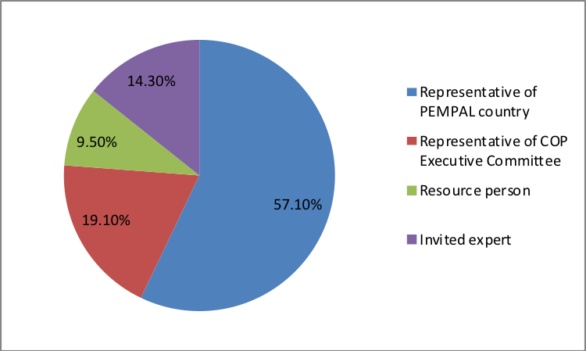

Q2. Was this your first participation in a PEMPAL event?

21 respondents (100%) answered this question.
Answer Options | Response Percent | Response Count
Yes | 19,05% | 4
No | 80,95% | 17

Q3. How many PEMPAL events have you attended before?

This question was seen only by those respondents who chose “No” in the previous question.
17 respondents replied.

1-2 | 3-4 | 5-6 | more than 6 | Response Count
5 | 4 | 1 | 7 | 17
PART I EVENT DELIVERY

Q4. How do you rate your participation in this event?

21 (100%) answers were given. 10 respondents think that their participation in the event was ‘Active’. 9 respondents think that their participation was ‘Average’. 2 persons chose the option “Passive”.

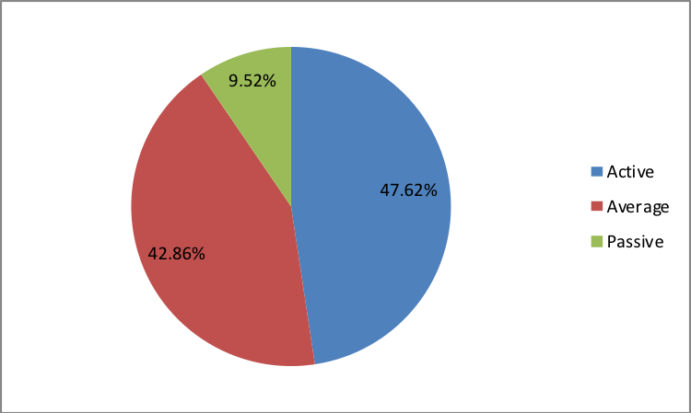

Q5. How do you rate the event duration overall?

21 respondents (100%) answered this question.

Answer choices | Response Percent | Response Count
Too short | 23,8% | 5
About right | 76,2% | 16
Too long | 0,0% | 0

Q6. How much do you agree with the following statements about the participants of the event?
21 respondents (100%) replied to this question.
Answer Options | 1 strongly disagree | 2 | 3 | 4 | 5 Strongly agree | Response Count | Average
a) The level of the event was appropriate for a person with my experience and knowledge | 0 | 0 | 2 | 5 | 14 | 21 | 4,6
b) I learned from the experience of other participants in the event | 0 | 0 | 0 | 6 | 15 | 21 | 4,7
c) Participants had about equal level of prior expertise relevant to the event topics | 1 | 0 | 6 | 8 | 5 | 20 | 3,8
d) Content of presentations, hand-outs and other materials were appropriate for a person with my level of knowledge | 0 | 0 | 1 | 4 | 16 | 21 | 4,7
Q7. What have you learned from other participants?
10 comments were left.
- Experience of their country.
- The activities that we can do in our country about citizen participation in budget procedure and spending review.
- This conference was useful for me and for the institution where I work.
- We have learned a lot from presenters as well as other participants in the conference.
- New knowledge was obtained. It will be used in our subsequent work.
- I have learned experience from other countries and compared their practices to our practice in my country to come up with the potential new approaches that we can implement in the future.
- Experiences related to modern citizens’ budgets and spending reviews.
- We have learned useful things about citizen engagement and how to ensure the involvement of all stakeholders, especially at the national level. In addition, experiences of New Zealand and Canada in terms of welfare and citizen-oriented budget were very interesting.
- Other countries’ experience in the area of program and performance and their challenges and success factors.
Q8. How much do you agree with the following statements about the content design of the event?
21 respondents (100%) replied to this question.
Answer Options | 1 strongly disagree | 2 | 3 | 4 | 5 Strongly agree | Response Count | Average
a) The event agenda was properly planned | 0 | 0 | 1 | 3 | 17 | 21 | 4,8
b) The content of the event was properly prepared | 0 | 0 | 0 | 3 | 18 | 21 | 4,9
c) The event addressed issues important to my work | 0 | 0 | 1 | 3 | 17 | 21 | 4,8
d) The event covered a right number of topics for the amount of time available | 0 | 0 | 3 | 2 | 16 | 21 | 4,6
e) The topics for the group discussions were relevant | 0 | 0 | 1 | 5 | 14 | 20 | 4,7
f) Enough time was reserved for group discussions | 0 | 0 | 1 | 7 | 13 | 21 | 4,6
g) Presentations made during the event were relevant and useful | 0 | 0 | 1 | 3 | 17 | 21 | 4,8
h) Enough time was reserved for questions to speakers | 0 | 0 | 0 | 8 | 13 | 21 | 4,6
2 informative comments were left:
- The topics presented and discussed by the participants were useful for us our work in the Ministry of Finance.
- Knowledge on very important main points on discussed topics were obtained in the two days of workshop.
Q9. How much do you agree with the following statements about the outcomes of the event?
21 responses (100%) were left.
Event objectives has been achieved: | 1 strongly disagree | 2 | 3 | 4 | 5 Strongly agree | Response Count | Average
a) To examine good practices from advanced countries and assess potential application to PEMPAL countries in two subtopics: i) capturing citizens’ satisfaction, perceptions, and engagement in performance indicators used for budgeting and ii) technical methodology and process for spending reviews in advanced countries | 0 | 0 | 1 | 4 | 16 | 21 | 4,7
b) To hold internal working group discussions to share updates on the developments in working group countries, decide on the future activities of the groups, and advance their work on development of knowledge products | 0 | 0 | 2 | 4 | 14 | 20 | 4,6

2 informative comments were left:
- The participants of the conference exchanged information on the budget planning practices during the event
- It was in particularly useful to learn about different practices for developing performance indicators based on citizens' satisfaction, perception and participation in the context of performance indicators for budget planning
Q10. Please rate the quality of the leadership, management and/or technical services provided to the event by the following:
21 responses (100%) were given.
Answer Options | 1 low | 2 | 3 | 4 | 5 high | Response Count | Average
BCOP Executive Committee | 0 | 0 | 1 | 1 | 19 | 21 | 4,86
BCOP Resource Team | 0 | 0 | 1 | 0 | 20 | 21 | 4,90

5 comments were left:
- The work of the BCOP Executive Committee and BCOP Resource Team as usual was at the very high level.
- Both the BCOP Executive Committee and BCOP Resource Team were well prepared, which has been exhibited also by good time management during the developments that took place at the conference.
- Everyone was professional, friendly, and useful.
- Quality of the leadership, management and technical services was at a high level.
- The resource team, as always, provided excellent experts and sessions.
Q11. Please rate the quality of work of the event speaker(s):
21 responses (100%) were given.
Answer Options | 1 low | 2 | 3 | 4 | 5 high | Response Count | Average
Quality of work | 0 | 0 | 1 | 1 | 19 | 21 | 4,9
2 comments were left:
- The topics discussed at the event were usually good / relevant to the agenda.
- The speakers were excellent, the topics were relevant, we received answers to all the questions asked.

PART 2 EVENT ADMINISTRATION
Q12. Please rate the quality of the organization and administration of the event:
Answered question – 21 (100%).
Answer Options |  | 1 low | 2 | 3 | 4 | 5 high | Response Count | Average
 | Quality of organization
- choice of venue |  | 0 | 1 | 0 | 0 | 20 | 21 | 4,9
- travel arrangements |  | 0 | 0 | 1 | 1 | 19 | 21 | 4,9
- event logistics |  | 0 | 0 | 0 | 1 | 19 | 20 | 4,95
 | Quality of administration
- Secretariat staff responsiveness |  | 0 | 0 | 0 | 0 | 21 | 21 | 5
- written communication |  | 0 | 0 | 0 | 0 | 21 | 21 | 5
- participant registration |  | 0 | 0 | 1 | 0 | 20 | 21 | 4,9
There were left 3 informative comments.
- I have no comment, the event was planned and managed very well by your team
- The basement room was perhaps a bit small for the group. However, the facilities were very good.
- The secretariat prepares every event well so we had no issues.

Q13. Did you receive agenda and event information in sufficient time before the event for them to be useful?
21 (100%) answers were given. And 95.2% of responses were “Yes”. 1 person respond “No.”
Q14. Did you receive practical information (about the accommodation and other facilities, etc.) prior to the event?
20 (100%) answers were given. And 100% of responses were “Yes”.
Q15. Are you satisfied with the quality of simultaneous interpretation provided during the event?
21 (100%) answers were given.
Answer Options | 1 low | 2 | 3 | 4 | 5 high | Response Count | Average
Quality of sim. interpretation | 0 | 0 | 0 | 2 | 19 | 21 | 4.9

1 informative comment was left: “Translators helped us to understand all speakers without any problems.”
Q16. Are you satisfied with the quality of written translation of event materials?
21 (100%) answers were given.
Answer Options | 1 low | 2 | 3 | 4 | 5 high | Response Count | Average
Quality of written translation | 0 | 0 | 1 | 5 | 15 | 21 | 4,7

1 comment was left: “"The materials were properly translated."
PART 3 OVERALL IMPRESSION
Q17. Did the event disappoint, meet, or exceed your expectations?

21 (100%) participants answered the question.
Answer Options | Response Percent | Response Count
Disappoint | 0,0% | 0
Meet | 57.2% | 12
Exceed | 42.9% | 9

Q18. What did you like best about the event?

13 comments were left.
Participants like different aspects of the event.
- Presentation of country cases.
- The presentation of Canadian experience in citizen engagement.
- All of the sessions were good, but the Irish presentation on spending reviews was particularly good.
- Presentation of the World Bank experiences and recommendations on spending reviews and the presentation of the spending review country case of Italy
- Although the topics for discussion were not new, a lot of interesting new information was received with examples from the various countries.
- The place and arrangements, agenda, presentations.
- High quality of discussions.
- The topics and discussions.
- Group discussion.
- Experience exchange related to the citizens’ budgets and the country experience related to spending reviews.
- Good range of speakers with varied experiences.
- Relevance of topics - issues presented on the basis of experience of OECD countries are relevant for PEMPAL countries.
- Speakers' expertise, their knowledge, and readiness to share useful lessons, as well as the openness of the BCOP members in the group discussions and the presentation of issues that they face in their countries.

Q19. What did you not like most about the event?
10 informative comments were left. 4 of them were “Nothing” or “Everything was OK”.
Rest 6 comments:
- Food in the hotel.
- Not enough time for such event.
- Examples of spending review reports were not provided.
- Somewhat tight schedule for presentations.
- Perhaps the basement room was less conducive to questions and answers than usual.
- There was little time for discussion taking into account that there were a wide range of the covered topics on budget literacy and program budgeting.

Q20. Do you plan to brief your colleagues about the event?
21 (100%) participants answered the question. And 100% of them responded “Yes”.
Q21. How do you plan to brief your colleagues?
Answered question –21 (100%).
Answer Options | Response Percent | Response Count
Share materials | 76.2% | 16
Make a presentation | 19.1% | 4
Prepare a back-to-office report | 42.9% | 9
4 comments were given:
- All the ideas achieved at this conference, not excluding your materials, we will share with our colleagues as well as we will tell them about all those modules that we have learned at the meeting.
- Non-structured engagement with key issues/outcomes from our perspective.
- As usually, at national conferences and workshops I will talk about what I learned at this event.
- We will make an addition to the work plan for the next year and to the roadmaps of PFM reform.
Q22. If your Ministry plans to promote this event, or PEMPAL in general, in internal or external media (e.g. MoF or other government website, MoF journal, television, radio, newspapers), please provide specific details so we can report to donors on any positive promotion of the value and benefits of PEMPAL.
2 informative comments were left.
- Of course we will promote these achievements in all instances of the MoF if required.
- Information acquired during the workshop, reflected in reports and speeches of our officials.
Q23. How much do you agree with the following statement?
21 respondents (100%) answered this question. Average rating is positive.
Answer Options | 1 not at all | 2 | 3 | 4 | 5 completely | Response Count | Average
I will be able to apply the knowledge acquired at this event to my work | 0 | 0 | 4 | 5 | 12 | 21 | 4,4
Q24. How can you apply the acquired knowledge?
10 comments were left.
- In preparing the new organic budget legislation and in planned activities in my department.
- I can apply the acquired knowledge during my analytical work concerning international experience on budget transparency matters and formulating suggestions on implementing it in my country.
- Apply the knowledge gained, including in budget processes and in the internal control of public finances.
- I can apply the acquired knowledge in practical work and in communication with relevant persons.
- When developing new program documents, during the implementation of the strategy for PFM reforms.
- In current activities in my department.
- In my daily work I will use recommendations from the the knowledge product on program budgeting
- During spending reviews.
- I will apply the acquired knowledge in my work on reforming our budget system as well as in workshops I hold.
- Since I work in the State Budget Execution Sector, the acquired knowledge will be useful in analyzing the expenditures of budget users when preparing various execution reports.
Q25. Overall, my satisfaction with the event was...
Answered question – 21 (100%). There were only positive answers.
1 not satisfied | 2 | 3 | 4 | 5 highly satisfied | Response Count | Average
0 | 0 | 0 | 4 | 17 | 21 | 4,8

Q26. If you have any other comments you would like to provide us, please provide them here.

No comments were left.

PART 4 RECOMMENDATIONS FOR THE FUTURE

Q27. Do you have any suggestions to improve the content, approach and other aspects of such events in future:
4 informative comments were left:
- I wish to all you and staff of PEMPAL and World Bank nice work and continued success in the future.
- Too "busy" agenda for such events.
- More practical examples related to the topic.
- A little more time is needed for discussions and presentations.

