PEMPAL BCOP PARTICIPATION IN OECD MEETING IN MINSK
FEEDBACK SURVEY
On July, 4-5, the PEMPAL BCOP participated in the meeting of the OECD Senior Budget Officials from Central, Eastern, and Southeastern Europe (OECD SBO CESEE) in Minsk, Belarus.

After the event, the on-line survey in three languages was created based on of the standard set of questions developed in June 2017. The aim of the survey was to receive event feedback and to inform plans for the future.

Link to the survey – https://www.surveymonkey.com/r/5LHWRLG

The survey started to collect responses on July 8 and finished on July 18, 2019.

Invitations to take part in the survey were sent to 16 participants of the event. 13 persons started to response to the survey. In this report, we analyze all 13 responses. For further calculation, we take this quantity as 100%.

All these responses will be included in the general Feedback Event Database.
The questionnaire comprises five parts: About the Respondent, Event Delivery, Event Administration, Overall Impression, and Recommendations for the Future. There is a total of 27 questions in the survey.
ABOUT THE RESPONDENT

Q1 You are...

13 (100%) respondents gave answers. Among them: representatives of PEMPAL country (but not members of the Executive Committee) — 11; 1 representative of BCOP Executive Committee, and 1 resource person.
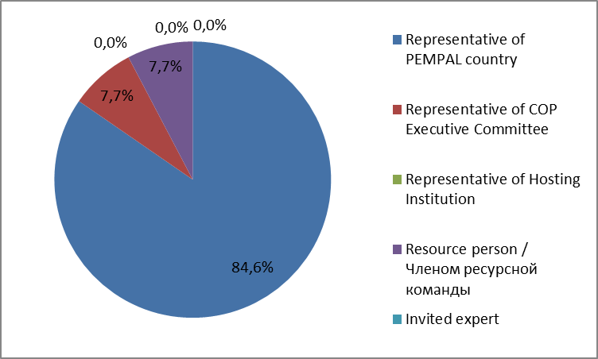

Q2. Was this your first participation in a PEMPAL event?

13 respondents (100%) answered this question.
Answer Options | Response Percent | Response Count
Yes | 53,9% | 7
No | 46,2% | 6

Q3. How many PEMPAL events have you attended before?

This question was seen only by those respondents who chose “No” in the previous question.
6 respondents replied.

1-2 | 3-4 | 5-6 | more than 6 | Response Count
1 | 1 | 0 | 4 | 6
PART I EVENT DELIVERY

Q4. How do you rate your participation in this event?

13 (100%) answers were given. 3 respondents think that their participation in the event was ‘Active’. 7 respondents think that their participation was ‘Average’. 3 respondents chose the option “Passive”.

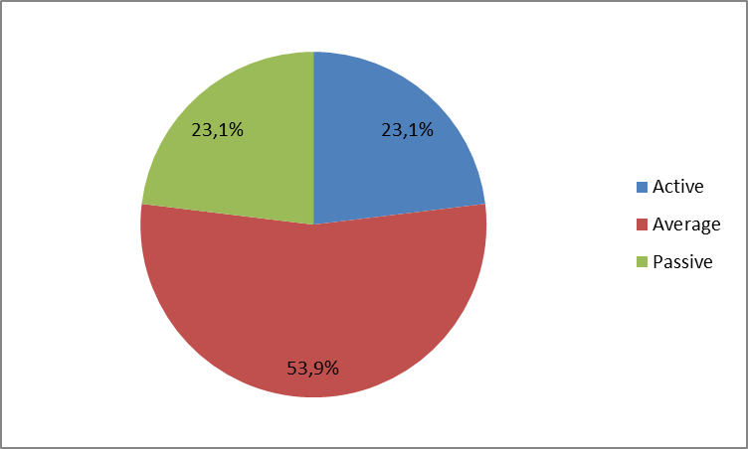

Q5. How do you rate the event duration overall?

13 respondents (100%) answered this question.
Answer choices | Response Percent | Response Count
Too short | 7,7% | 1
About right | 92,3% | 12
Too long | 0,0% | 0

Q6. How much do you agree with the following statements about the participants of the event?
13 respondents (100%) replied to this question.
Answer Options | 1 strongly disagree | 2 | 3 | 4 | 5 Strongly agree | Response Count | Average
a) The level of the event was appropriate for a person with my experience and knowledge | 0 | 0 | 0 | 1 | 12 | 13 | 4,9
b) I learned from the experience of other participants in the event | 0 | 0 | 0 | 2 | 11 | 13 | 4,8
c) Participants had about equal level of prior expertise relevant to the event topics | 0 | 1 | 3 | 4 | 5 | 13 | 4,0
d) Content of presentations, hand-outs and other materials were appropriate for a person with my level of knowledge | 0 | 0 | 0 | 1 | 12 | 13 | 4,9
Q7. What have you learned from other participants?
7 comments were left.

- Experience and ability to represent and analyze problems.
- Experience of communication was useful from the point of view of getting first-hand information about the features of the budget process in other countries.
- Exchange of experiences, best-practice sharing.
- Practical experience and details of spending reviews, OECD standards for budgeting, result orientation.
- Discussed topics and questions corresponded to my information.
- I learned about experience of other countries in different areas.
- Experience in other countries about spending reviews, performance budgeting, fiscal risks management, capital budgeting etc.
Q8. How much do you agree with the following statements about the content design of the event?
13 respondents (100%) replied to this question.
Answer Options | 1 strongly disagree | 2 | 3 | 4 | 5 Strongly agree | Response Count | Average
a) The event agenda was properly planned | 0 | 0 | 0 | 2 | 11 | 13 | 4,8
b) The content of the event was properly prepared | 0 | 0 | 0 | 1 | 12 | 13 | 4,9
c) The event addressed issues important to my work | 0 | 0 | 0 | 3 | 10 | 13 | 4,8
d) The event covered a right number of topics for the amount of time available | 0 | 0 | 0 | 2 | 11 | 13 | 4,8
e) The topics for the group discussions were relevant | 0 | 0 | 1 | 3 | 9 | 13 | 4,6
f) Enough time was reserved for group discussions | 0 | 0 | 0 | 4 | 9 | 13 | 4,7
g) Presentations made during the event were relevant and useful | 0 | 0 | 0 | 2 | 11 | 13 | 4,8
h) Enough time was reserved for questions to speakers | 0 | 0 | 0 | 0 | 13 | 13 | 5,0

No comments were left:
Q9. How much do you agree with the following statements about the outcomes of the event?
12 responses (92,3%) were left.
Event objective has been achieved: | 1 strongly disagree | 2 | 3 | 4 | 5 Strongly agree | Response Count | Average
Attend the 15h annual meeting of the OECD Senior Budget Officials' regional network for Central, Eastern and South-Eastern European Countries (CESEE- SBO) to review and share recent progress and trends on budgeting reforms of the countries from this region, including in spending reviews, key performance indicators for performance budgeting, fiscal risk, and capital budgeting | 0 | 0 | 0 | 1 | 11 | 12 | 4,9

1 comment was left: We had interesting discussions.
Q10. Please rate the quality of the leadership, management and/or technical services provided to the event by the following:
12 responses (92.3%) were given.
Answer Options | 1 low | 2 | 3 | 4 | 5 high | Response Count | Average
BCOP Executive Committee | 0 | 0 | 0 | 0 | 12 | 12 | 5
BCOP Resource Team | 0 | 0 | 0 | 0 | 12 | 12 | 5
No comments were left.

Q11. Please rate the quality of work of the event speaker(s):
12 responses (92.3%) were given.
Answer Options | 1 low | 2 | 3 | 4 | 5 high | Response Count | Average
Quality of work | 0 | 0 | 0 | 1 | 11 | 12 | 4,9
1 comment was left: It would be better to have more practical details in some topics.

PART 2 EVENT ADMINISTRATION
Q12. Please rate the quality of the organization and administration of the event:
Answered question – 12 (92,3%).
Answer Options |  | 1 low | 2 | 3 | 4 | 5 high | Response Count | Average
 | Quality of organization
- choice of venue |  | 0 | 0 | 0 | 0 | 12 | 12 | 5
- travel arrangements |  | 0 | 0 | 0 | 0 | 12 | 12 | 5
- event logistics |  | 0 | 0 | 0 | 0 | 12 | 12 | 5
- contribution provided by hosts |  | 0 | 1 | 0 | 0 | 11 | 12 | 4,75
 | Quality of administration
- Secretariat staff responsiveness |  | 0 | 0 | 0 | 0 | 12 | 12 | 5
- written communication |  | 0 | 0 | 0 | 0 | 12 | 12 | 5
- participant registration |  | 0 | 0 | 0 | 0 | 12 | 12 | 5
No comments were left.

Q13. Did you receive agenda and event information in sufficient time before the event for them to be useful?
12 (92,3%) answers were given. And 100% of responses were “Yes”.
Q14. Did you receive practical information (about the accommodation and other facilities, etc.) prior to the event?
12 (92,3%) answers were given. And 100% of responses were “Yes”.
Q15. Are you satisfied with the quality of simultaneous interpretation provided during the event?
12 (92,3%) answers were given.
Answer Options | 1 low | 2 | 3 | 4 | 5 high | Response Count | Average
Quality of sim. interpretation | 0 | 0 | 0 | 1 | 11 | 12 | 4.9

1 comment was left:
I’d like to note the high professionalism of the interpreters.
Q16. Are you satisfied with the quality of written translation of event materials?
11 (84.6%) answers were given. No comments were left.
Answer Options | 1 low | 2 | 3 | 4 | 5 high | Response Count | Average
 | 0 | 0 | 1 | 1 | 9 | 11 | 4.7
PART 3 OVERALL IMPRESSION
Q17. Did the event disappoint, meet, or exceed your expectations?
12 (92.3%) answers were given.
Answer Options | Response Percent | Response Count
Disappoint | 0,0% | 0
Meet | 75,0% | 9
Exceed | 25,0% | 3

Q18. What did you like best about the event?
8 comments were left.
Participants like different aspects of the event.
- Ability to learn the current situation in the countries and expert assessment.
- Themes discussed.
- Ezpertize of the participants. Friendly atmosphere. Clear organization of professional and accompanying events/sessions.
- Best-practice sharing.
- Organization of the event, increased attention to the participants by the host country, the relevance of the workshop topics (cost analysis, performance-based budgeting, capital budget accounting, budget risk management), opportunity for general discussion of the topics discussed and the friendly attitude of the meeting participants.
- Organization by the host party and PEMPAL.
- I liked everything.
- Excellent meeting with lots of different topics. Coffee breaks and lunch time were used to continue with discussions from previous sessions.

Q19. What did you not like most about the event?
1 informative comment was left: This meeting should last longer, minimum 3 days.

Q20. Do you plan to brief your colleagues about the event?
12 (92,3%) answers were given. And 100% of responses were “Yes”.
Q21. How do you plan to brief your colleagues?
Answered question – 12 (92,3%). Most of respondents will share materials.
Answer Options | Response Percent | Response Count
Share materials | 75,0% | 9
Make a presentation | 8,3% | 1
Prepare a back-to-office report | 66,7% | 8
1 comment was given: I will discuss the event results with my colleagues.
Q22. If your Ministry plans to promote this event, or PEMPAL in general, in internal or external media (e.g. MoF or other government website, MoF journal, television, radio, newspapers), please provide specific details so we can report to donors on any positive promotion of the value and benefits of PEMPAL.
No informative comments were left.
Q23. How much do you agree with the following statement?
12 respondents (92,3%) answered this question. All the ratings are positive.
Answer Options | 1 not at all | 2 | 3 | 4 | 5 completely | Response Count | Average
I will be able to apply the knowledge acquired at this event to my work | 0 | 0 | 1 | 1 | 10 | 12 | 4,75
Q24. How can you apply the acquired knowledge?
5 comments were left.
- Taking into account when preparing practical recommendations.
- Budget spendings, in particular capital expenditure planning.
- In preparing the legal acts governing the budgetary legal relations, I will keep in mind the principles and recommendations voiced at the event.
- During the fulfillment of work commitments (as part of the budget process)
- For example, the standards and best practices of OECD countries in the field of performance-based budgeting can be used to develop these tools in my country.
Q25. Overall, my satisfaction with the event was...

Answered question – 12 (92,3%). There were no negative answers.
1 not satisfied | 2 | 3 | 4 | 5 highly satisfied | Response Count | Average
0 | 0 | 0 | 1 | 11 | 12 | 4,9

Q26. If you have any other comments you would like to provide us, please provide them here.

No comments were left.

PART 4 RECOMMENDATIONS FOR THE FUTURE

Q27. Do you have any suggestions to improve the content, approach and other aspects of such events in future:
2 informative comments were left.
- It would be good to discuss capital expenditure planning, investment programs and experience of different countries in the field of public-private partnerships.
- It would be good to have more specific practical information.

