PEMPAL Treasury Community of Practice
Cash Management and Forecasting Thematic Group Meeting

Building a Soundly-Based and High-Performing Cash Flow Forecast
November 7-9, 2018 _________________________________________________________
Vienna, Austria

On November 7-9, 2018, PEMPAL Treasury Community of Practice (TCOP) Thematic Group on Cash Management and Forecasting held a meeting in Vienna, Austria. The main objectives of the meeting were to identify essential elements of soundly-based and high-performing cash flow forecasting; and to share ideas and experiences on how these could be developed in the participating countries. The group also explored the links between cash flow forecasting and budget execution and discussed latest developments in the area of cash management in participating countries. The meeting was attended by 33 specialists representing 16 PEMPAL countries (Albania, Armenia, Azerbaijan, Belarus, Croatia, Georgia, Kazakhstan, Kosovo, Kyrgyz Republic, Macedonia, Moldova, Montenegro, Russian Federation, Tajikistan, Turkey and Ukraine). Mr. András Réz (Hungarian Government Debt Agency) and Dr. Török Tamás Pál (Hungarian State Treasury) joined the meeting as invited guest speakers. The event was facilitated by the World Bank team, including Ms. Elena Nikulina, Team Leader for PEMPAL, Ms. Yelena Slizhevskaya, TCOP Advisor, as well as Mr. Mark Silins and Mr. Mike Williams as TCOP Thematic Advisors. Logistical support was provided by the PEMPAL Secretariat based at the World Bank Country Office in Moscow.
Mr. Ilyas Tufan, PEMPAL TCOP Deputy Chair and the Head of Cash Management Department, Ministry of Treasury and Finance of Turkey, opened the meeting and welcomed the participants on behalf of the TCOP Executive Committee. In his welcoming address he noted that such meetings provide unique opportunities for the members to share their country practices with each other and to learn from each other, not least because all the countries have somewhat different approaches to cash management.

Mr. Stanislav Prokofiev, Deputy Head of the Federal Treasury, Russian Federation, and the co-chair of the meeting, welcomed the participants and noted that soundly-based and high-performing cash flow forecasts are a necessary prerequisite for implementation of more active cash management. Mr. Prokofiev reported that, in parallel with expanding the coverage of the treasury single account (TSA), the Federal Treasury had substantially developed its cash forecasting – from forecasting the flows of selected large budget holders to detailed bottom-up forecasts that nowadays allow the Treasury to raise significant additional revenues for the budget (estimated at around USD1.5 billion for 2018). Mr. Prokofiev wished the participants fruitful discussions.

Ms. Elena Nikulina, PEMPAL Team Leader, welcomed the participants on behalf of the World Bank and the TCOP resource team and provided a brief overview of the meeting agenda. Ms Nikulina noted the increasing interest of the TCOP members in the topic of cash flow forecasting, as evidenced by the results of the survey conducted during the 2018 Tirana plenary meeting as well as by the growing membership of the group. Ms. Nikulina thanked the TCOP Executive Committee members for the valuable inputs they had provided during preparation of the meeting agenda and encouraged everyone to participate actively in the discussions, including on the future priorities of the group.

Mr. Prokofiev moderated discussions in the morning of the first meeting day.

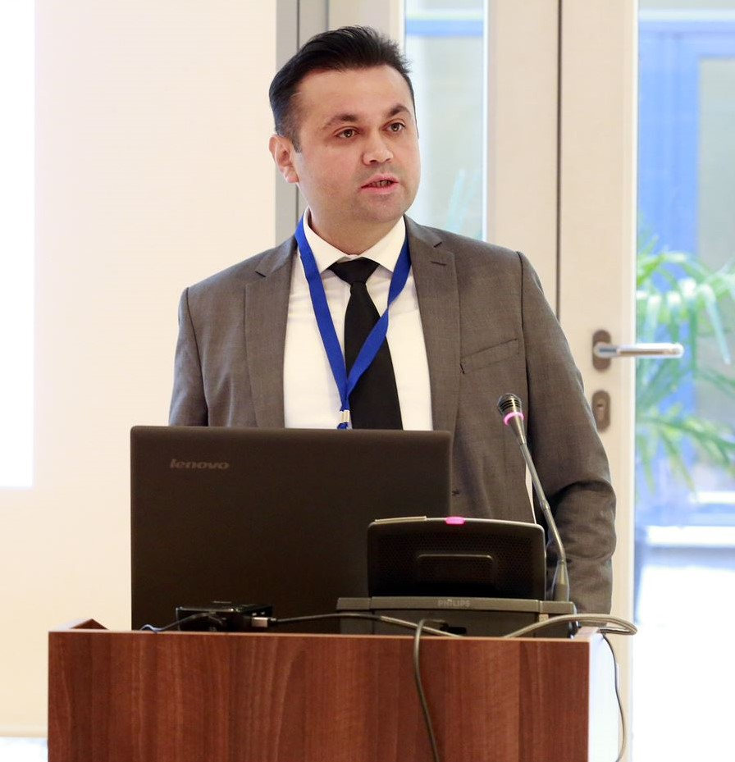
Mr. Ilyas Tufan, a leader of the Cash Management Thematic Group, briefed the participants on the activities of the group since the time of its establishment in early 2014. Over the last four and a half years the group have had four thematic face-to-face meetings and six videoconferences; issues related to cash management were also discussed as part of the two TCOP annual plenary meetings. This allowed the members of the group to cover different aspects directly and indirectly related to cash management: financial instruments for liquidity management, coordination with debt management, coordination with central banks and monetary policy, development of the service level agreements between the treasury (ministry of finance) and the central bank, targeting the TSA balance and cash buffer, and TSA operation and coverage. The cash management practices of Albania, Azerbaijan, Georgia, Moldova, Russia, Sweden and Turkey were also reviewed during the meetings; and videoconferences allowed the group to share practices and benchmark them against best international examples. Mr. Tufan noted that there were several new members in the group and encouraged them to refer to the PEMPAL website for additional information on the previous events and knowledge products developed by the group.

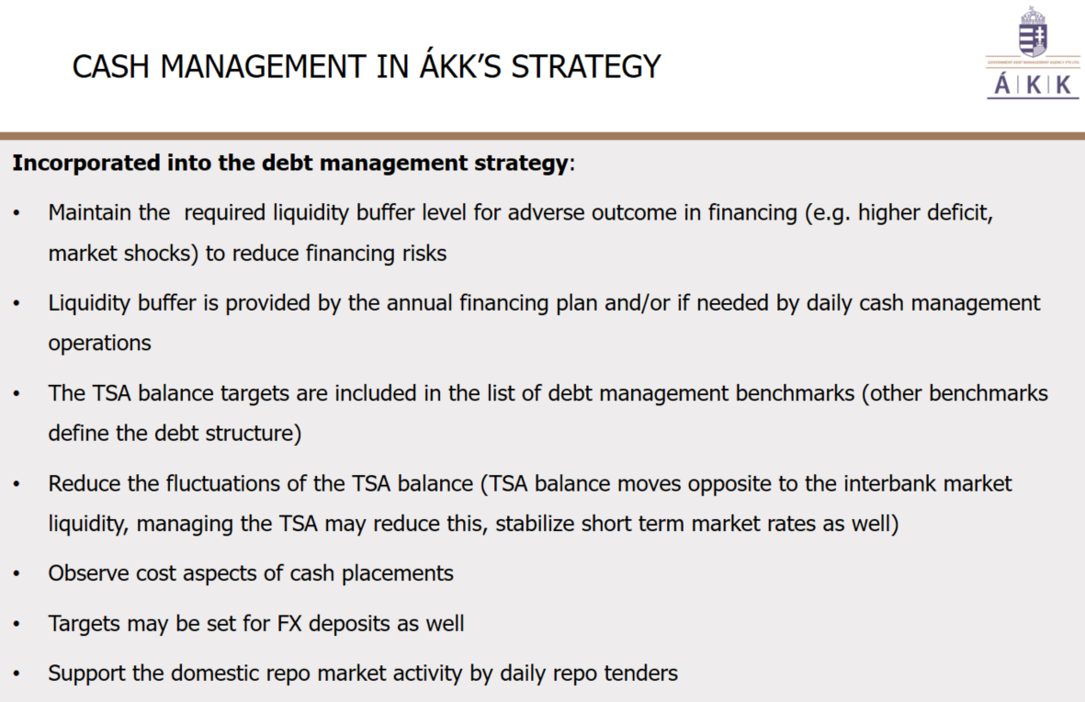
The event continued with two presentations delivered by the guest speakers from the Hungarian Government Debt Agency (ÁKK) and Hungarian State Treasury (HST). Mr. András Réz, Deputy CEO, ÁKK, introduced participants to the role that the ÁKK plays in government cash management in Hungary. The ÁKK has been responsible for the state’s cash management since 2003 when it was separated from the treasury and established as a limited liability company. As part of its debt management functions the ÁKK is responsible for ensuring that there is enough liquidity to execute the budget as well as for the management of the idle cash balances of the TSA. In performing these roles, the ÁKK plans and carries out all cash management transactions in the money market or with the Central Bank (FX swaps), while the HST executes the budget and prepares and shares with the ÁKK the forecasts of the TSA balance. The HST provides forecasts to the ÁKK twice a week for 2-3 months ahead; the Central Bank also shares its forecast twice a week for at least 3 months ahead. Each afternoon the HST also reports the expected TSA balance for that day to the ÁKK to inform its execution of end-of-day overnight repo. Mr. Réz also noted that the ÁKK is a daily market participant, contributing to the development of the repo market in the country; ÁKK effectively serves as a channel for liquidity flow between the Hungarian banks. The presentation generated significant interest as it reflected the integration of cash and debt management within ÁKK - the cash management operations are planned, carried out, controlled and settled by the same staff who have similar responsibilities for the debt management operations.

During the question and answer session that followed, the participants were interested to know how the ÁKK offsets the traditionally pessimistic or cautious nature of the TSA forecasts provided by the HST. Responding, Mr. Réz clarified that indeed the ÁKK corrected the forecast somewhat as over pessimistic forecasts carried some fiscal costs – the Central Bank pays close to zero interest rate on the TSA and although excess cash can be invested through reverse repo, money market rates were also low. But on the other side this cautious approach is the cost of reduced risk since it helps to satisfy investors’ expectations who prefer to see more cash on the TSA balance. The participants also clarified that 90 percent of government borrowing in Hungary is met through government securities for general budget funding, and not linked to specific projects. It was also noted that there are benchmarks for the currency structure of the government debt portfolio and that swap operations with the Central Bank are used to maintain it (the ÁKK is not allowed to exchange currency on the market so if there is a need to increase the TSA in forints it arranges a swap with the Central Bank).

Summarizing the discussion Mr. Mike Williams noted that, by putting liquidity back into market, the ÁKK is reducing pressure on both the banking system and the central bank’s monetary policy operations – an important benefit of active cash management.

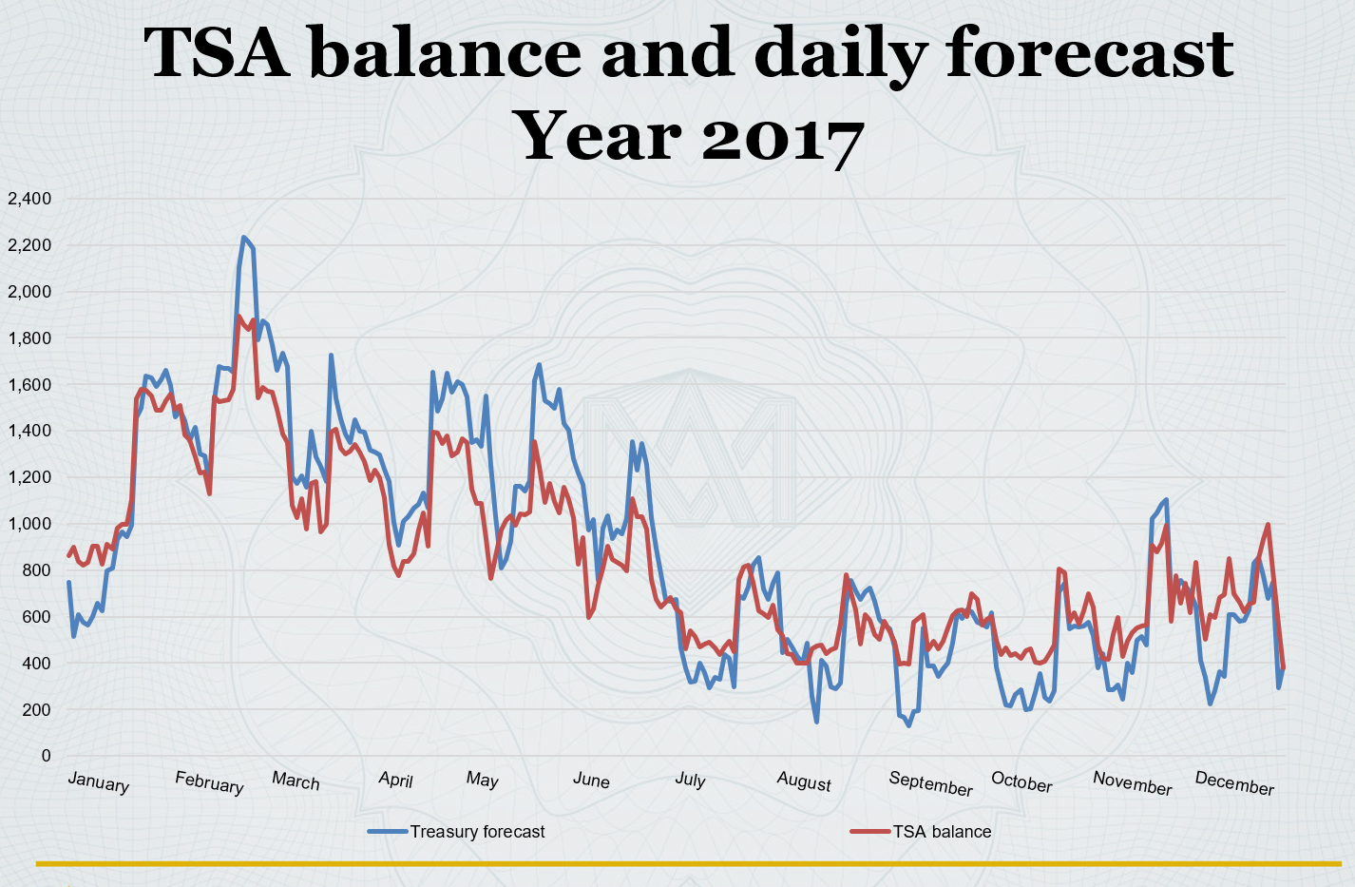
The next guest speaker, Dr. Török Tamás Pál, Head of Division in the Department for Budgetary Synthesis and Data Service, HST, focused his presentation on the liquidity forecasts prepared by the HST. Dr. Pál clarified that treasury liquidity forecasts cover cash inflows and outflows for the next day, as well as for the three months ahead. The forecasts are based on both bottom-up (institutional reports, commitments, financing plans, information on pre-notification of large payments) and top down information (facts and historical data); there is also continuous information exchange with the Central Bank, Ministry of Finance, Tax Authorities and other large entities. The result is 91.7 percent accuracy of the forecast in 2017. The main challenges in further improving the quality of the liquidity forecast in Hungary include large fluctuations of the cash balance within a month; disbursements concentrated at the beginning of the month (wages, family allowance, pension refunds of VAT, etc.) with incomes coming in the second half of the month; difficulties with planning some types of incomes (e.g. EU funds); and absence of data on commitments of the institutions.

During the question and answer session the participants clarified that bottom up information is collected from every budget chapter on a monthly basis; and according to the Public Finance Act the HST has the right to charge penalties if there are large deviations between the submitted cash flow estimates and actual execution, which has helped to improve the quality of the liquidity forecasts prepared by the HST.

Country News Session

In the afternoon of the first day of the meeting the members of the TCOP cash management thematic group exchanged their country news related to recent developments in cash management and other related areas. The afternoon sessions were moderated by Mr. Ilyas Tufan, leader of the thematic group. The reports from participants of the session are summarized below:

Azerbaijan

Mr. Ehtiram Isabalayev, Deputy Head of the State Treasury Agency of the Ministry of Finance, briefed the members of the thematic group on the progress with establishing the system of TSA medium term monitoring and forecasting. Mr. Isabalayev noted that establishment of the TSA in Azerbaijan created conditions for improving liquidity management. Another important step was introduction of the Treasury Information Management System which facilitated the transfer of all the transit accounts from commercial banks to the TSA. A number of other measures to improve cash management were implemented, including: the agreement between the Ministry of Finance, National Bank and the State Oil Fund on exchange of information; an agreement on investing the excess TSA liquidity with the State Oil Fund; establishing a Financial Stability Council; smoothing TSA balance fluctuations through the system of predictable transfers from the State Oil Fund, etc. Mr. Isabalayev also noted that expansion of the coverage of the Treasury Information Management System to all the treasury offices and spending units would allow the authorities to monitor expenditure commitments and to create the needed prerequisites for forecasting TSA liquidity.

Kazakhstan

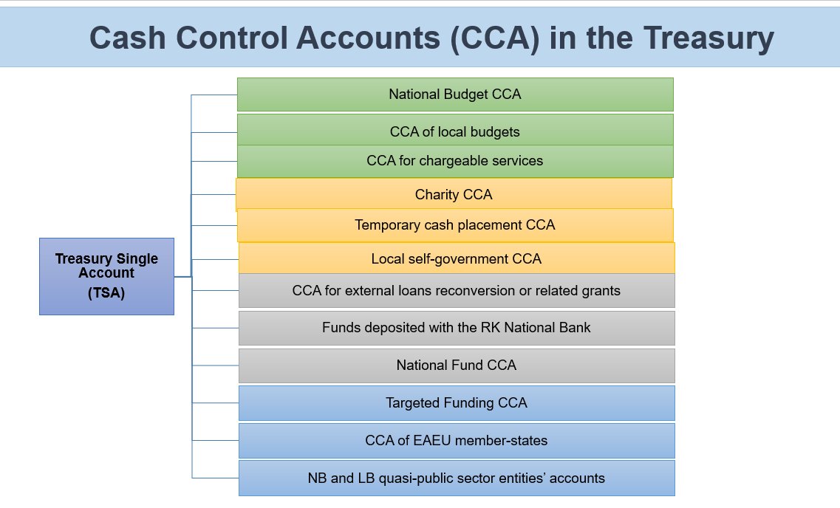
Ms. Aigul Baiguzhina, Acting Deputy Chair of the Treasury Committee, provided an overview of the cash management system in Kazakhstan. It was mentioned that Kazakhstan achieved very good coverage of the TSA (see the diagram), the last accounts transferred to the TSA in 2016 were the accounts of the external loans. This not only helped to streamline implementation of externally-financed projects, but also supported the TSA with extra liquidity. Ms. Baiguzhina explained that cash management in Kazakhstan is centred around forecasting of general government cash flows and estimating the size of a “guaranteed transfer” from the National Fund of the Republic of Kazakhstan required to cover the Treasury liquidity needs. The guaranteed transfer used to be sent to the TSA at the end of each month; but the methodology had been changed recently and these “guaranteed transfers” are now transmitted to the TSA at the beginning of the month according to the predefined schedule. This avoids TSA liquidity deficits within the month.

Turkey

Mr. Ilyas Tufan, Head of the Cash Management Department of the Ministry of Treasury and Finance, briefed the members of the thematic group on the progress with expanding the coverage of the TSA in Turkey. The project significantly progressed in 2018:
- new public accounting legislation was approved in February defining the accounting processes for the new system and pointing out the integration requirements between the new TSA ICT infrastructure and the accounting system;
- the law on the new TSA system was adopted in March prescribing the broad coverage of the system, establishing presidential authority to determine the detailed TSA coverage and the Ministry of Treasury and Finance’s authority to determine the TSA processes; establishing the business model for the system’s operation; etc;
- a Presidential decree and a Treasury decree were signed in August on the coverage of TSA system, sequence of transferring the accounts of the institutions to the TSA, as well as on the TSA major processes, bank account structures, accounting responsibilities, and remuneration of the TSA.

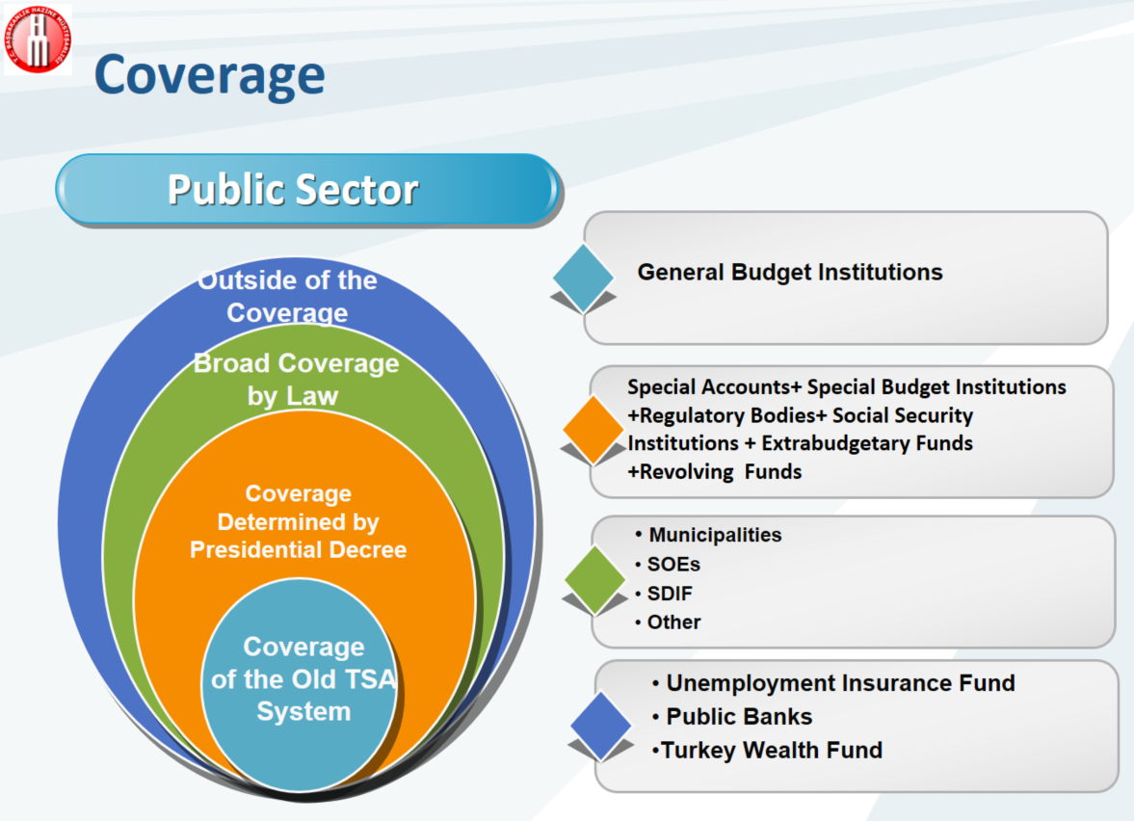
During the question and answer session Mr. Tufan agreed that the reform was very difficult initially, but the ministry made the process very transparent for the stakeholders. In a number of iterations, the ministry collected stakeholders’ inputs and views to inform the reform, then it made it very clear to the stakeholders that the reform would not be reversed. The inclusion of this reform in the (first) 100-days presidential program also helped to establish strong foundations and political support for the reform.

Macedonia

Ms. Angela Vasovska Shahpaska, Senior Assistant of the Liquidity Management and Forecasting Unit of the Treasury Department, familiarized the members of the group with the topical issues facing the PFM system in Macedonia. The participants learned that there is an ongoing review of the budget legislation in Macedonia with a large IFMIS project also being initiated. There are many solutions and technologies supporting the PFM processes in Macedonia, and the authorities are considering whether to develop a whole new IT platform, or to adapt and integrate the already existing systems. Regarding cash flow forecasting Ms. Vasovska Shahpaska noted that the Treasury is developing a new forecasting methodology (an Excel tool with interlinked spreadsheets containing historical data, baseline spreadsheet, forecast spreadsheet and the dashboard) and is testing new forecasting techniques (in particular ARIMA models).

Moldova

Mr. Maxim Ciobanu, Head of the Liquidity Management Department of the State Treasury, Moldova briefed the thematic group members on the recent establishment of the Unified Central Securities Depository of Moldova which was implemented as part of the financial market reform. The depository will be responsible for registration, recording and settlements for all the securities issued by all entities in Moldova – it already works with government and National Bank securities, and from December 31, 2018 the depository will also process corporate and investment trust securities. Mr. Ciobanu noted that the depository will not only be servicing securities transactions but will also support their placement.

Russian Federation

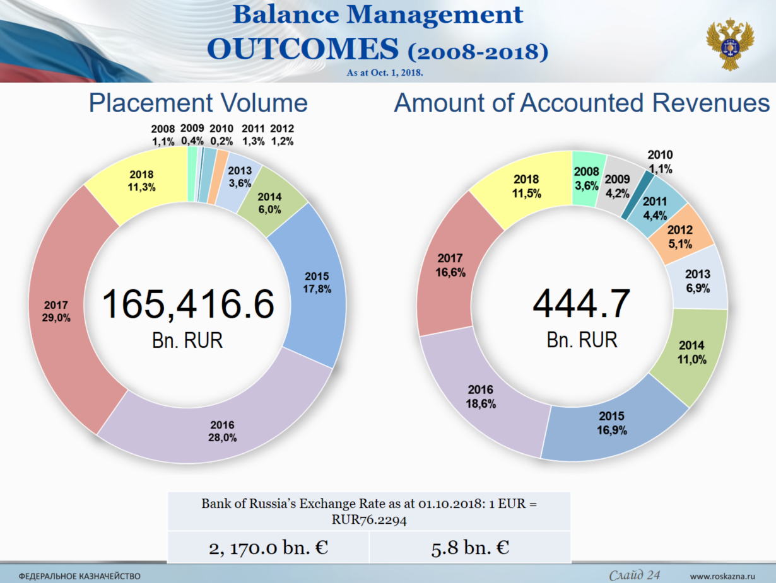
Mr. Oleg Drozdov, Head of Financial and Budget Operations Directorate, Federal Treasury, presented an overview of the TSA liquidity management operations in the Russian Federation. At the moment they include placement of the funds in bank deposits (both in local and foreign currencies), purchasing securities under repo agreements (including floating rate repo), lending to subnational and local governments, purchasing foreign currencies, and on-demand deposits. In December 2018 the Federal Treasury will be launching currency swaps; deposits with central counterparties are expected to follow in 2019. Mr. Drozdov noted that development of additional instruments to raise funds is somewhat lagging behind the initial schedule with sufficient cash availability being one of the reasons (idle balances placed by the federal budget currently constitute about 2 trillion of rubles compared to 16 trillion of federal budget expenditure) – these options are expected to be implemented during 2019-2021.

The final presentation of the news session was delivered by Ms. Mimoza Pilkati, the Director of the Treasury Operations Department of the Albanian Ministry of Finance, who briefed the members of the thematic group on the first workshop of Public Debt Management Advisory Group-PDMAG on cash flow forecasting and cash management organized by the World Bank’s Treasury in September 2018 in Skopje (Macedonia). During this five-day workshop short and practical presentations were supplemented with hands-on exercises in cash forecasting using the specially designed excel-based toolkit.

Wrapping up the first day discussions Mr. Mark Silins thanked all the presenters for the informative and thought-provoking presentations; and noted that many of the country presentations mentioned the expanded coverage of the TSA which gave room for more effective public funds management. Mr. Mike Williams added that one trend that had emerged in developed markets after the financial market crisis is the greater use of central counterparties to settle repo transactions. Some regulators see it as a worrisome trend as it concentrates the risks in one place, not to mention the extra costs implied when the central counterparties take collateral and build a risk fund. Mr. Mike Williams suggested that the group might consider discussing the operation of central counterparties in more detail in the future.

The second day of the event was moderated by Mr. Prokofiev and was devoted to an in-depth discussion on methodologies and tools for cash flow forecasting, both from international and country case perspectives.

The session commenced with a presentation by Mr. Mike Williams who provided an overview of the elements of good international practice in cash flow forecasting. Mr. Williams indicated that:
- there is a distinction between cash planning/programming in support of budget execution and cash forecasting which is aimed at ensuring sufficient funds are available to meet government financing needs (and that any surplus is used to best advantage);
- cash forecasts should be built independently of the budget process – the focus should be on what will happen, not on what should happen, and it is important to make sure that the MDAs understand that information provided by them for the cash forecasting purposes will not be used for planning this or next year’s budget;
- forecasts should cover some period ahead (at least 3 months) – to make decisions about financing (or adjustments to the budget) in a considered way;
- building forecasts does not rely on econometrics; pattern analysis, experience and intelligence networks are far more important. Some flows can be identified by the forecasters, but cooperation from MDAs and revenue authorities is essential. Information on commitments is a useful input, but it will not be sufficient.
- it is very useful to review and match the days of the main cash inflows and outflows to smooth the cash flow (e.g. spreading the salary pay days over the month or scheduling proceeds from the sales of assets for certain days with low inflows);
- forecasting does not require many staff – maybe only 2-3 – but they must be dedicated to the task with a clear objective; one of their functions should be to analyse forecast performance and errors to learn lessons for the future;
- managing data is a major task, but in practice most analysis is done in Excel;
- the forecast should be used to support financing decisions - they are often best addressed in some form of cash coordinating committee bringing together the Treasury, debt management and macro-fiscal teams, potentially also the central bank; the forecasters should identify risks and sensitivities and, with debt managers, be prepared to make policy recommendations.

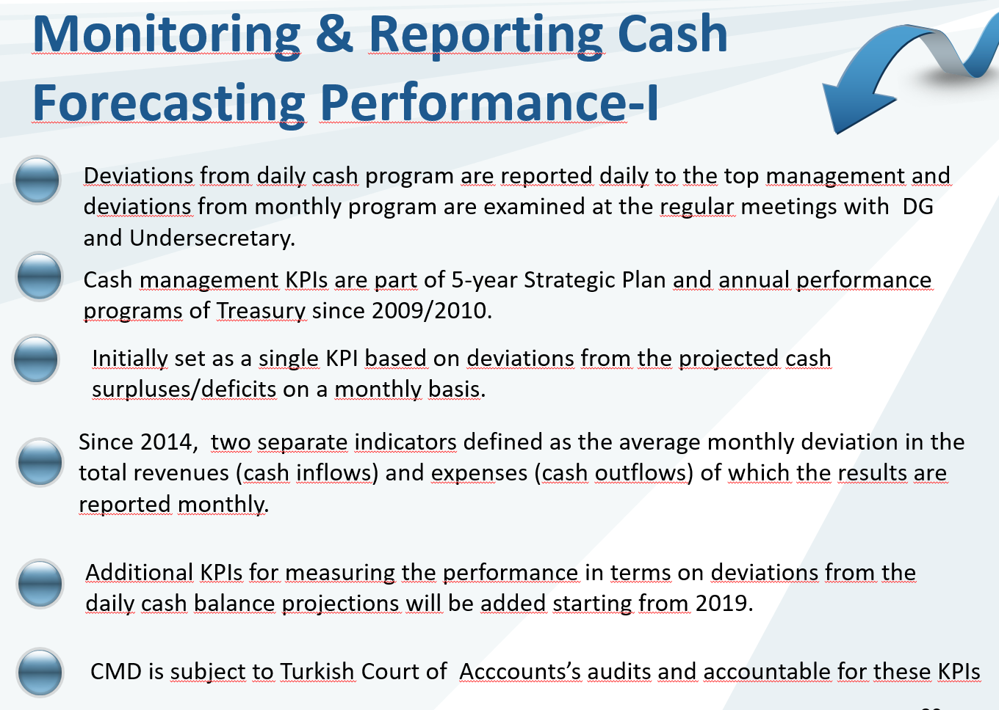
Mr. Ilyas Tufan, the Head of Cash Management Department of the Ministry of Treasury and Finance, continued by presenting the Turkish system of cash flow forecasting. Mr. Tufan explained that the top-down approach for forecasting is supplemented with the bottom-up inputs from the individual spending units, that are collected through the special Cash Request System (CRS). The CRS is an internet portal launched in 2011 to collect public institutions’ cash requests (in real time). The system is not used for cash rationing or allocation but has the option to provide public institutions with feedback on the next month’s projected cash transfers as needed and also enables spending units to revise their initial requests during the month dynamically based on changes in their projections. There is no direct link between the CRS and Treasury system, but the cash requests data is saved in the Treasury databases which are able to generate different reports. One interesting feature of the Turkish system is that there is a sanctions mechanism envisaged in the legislation (a penalty on the responsible official) for non-compliance with the requirement to submit inputs to the CRS (quality of data does not play a role) – the requirement is to ensure that the data is provided on a timely basis. The cash forecasting methodology is mostly based on time series analysis, with the databases cleaned for any one-off payment anomalies and large inflows/outflows treated separately. Mr. Tufan noted that initially the Treasury was keen to use econometric analysis, but historic pattern analysis proved to be more accurate. Benchmark values for the cash forecast performance are tightened each year; deviation of the actual cash flow from the forecast was 5.7 percent for revenues and 3.9 percent for expenditures in January-August 2018. At the close of his presentation Mr. Tufan added that there is an ongoing project to integrate all the public information systems in Turkey; and he hoped that this work will further contribute to improving the cash forecasting arrangements.

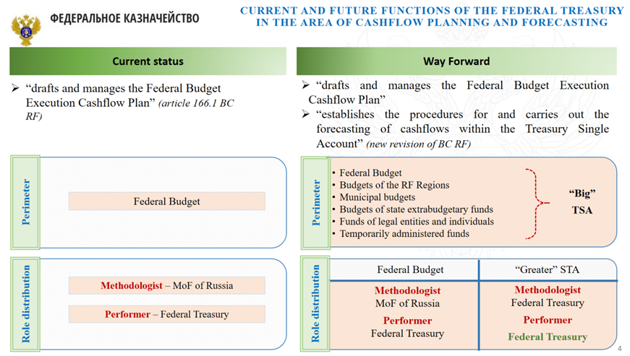
Ms. Ekaterina Semenova, the Head of the Federal Budget Execution Department, continued the session with the presentation of the Russian Federal Treasury’s cash flow forecasting and cash planning systems. Ms. Semenova started by clarifying that budget legislation of the Russian Federation currently uses the term “cash flow planning” and the cash plan is understood as a forecast of cash receipts to and cash payments from the budget in the current fiscal year (i.e. each budget has its own cash plan). At the same time work on amendments to the Budget Code and other supporting legislation is ongoing, and that will introduce the concept of a cash flow forecast. This forecast will go beyond a certain budget or a level of government – it will be aimed at forecasting the flows of the “new” expanded TSA that will not only include the resources of the federal budget, but will also consolidate the accounts of sub-national governments, municipal budgets, extra-budgetary funds, etc. This will be a major and innovative reform that will transform the way cash is managed by the government.

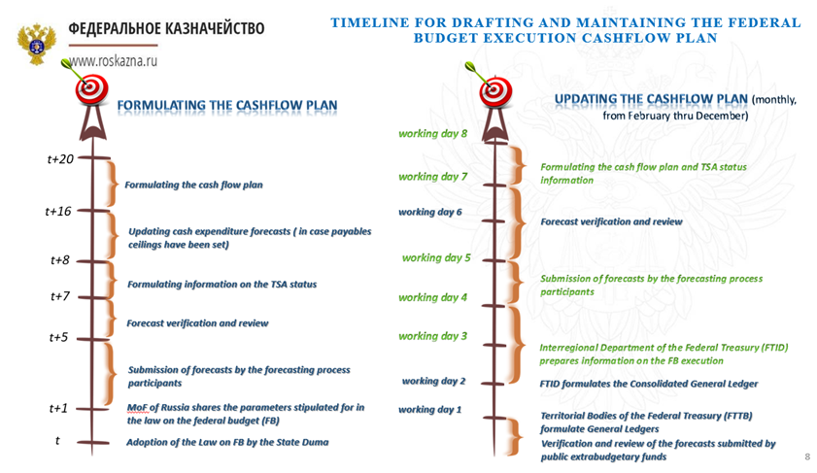
The participants of the meeting were given a detailed overview of the Federal Treasury’s cash planning system; it is fully automated, with manual verification of errors or discrepancies identified through the automated cross-checks. Ms. Semenova clarified that, unlike the Turkish Treasury (that is able to use the data from the budget proposal), the Federal Treasury of Russia can only work with the approved budget figures. The cash plans are therefore updated monthly during February – January (after the approved budget is available in the system). The members of the group learned that there are 555 quarterly reports generated, based on the cash plans data (monthly reporting has fewer forms) and there are 15 dedicated staff working on preparation of the cash plans and related methodologies. In January – September 2018 the actual accuracy of the 180 days TSA cash flow forecast constituted around 105 and 95 percent for, respectively, inflows and outflows.

The day concluded with the small group discussion session during which the participants were split into two groups. Each country delegation, with the exception of those who already presented during the joint session, was given the floor to describe the cash forecasting practices that exist in their countries. The groups were also asked to discuss cash flow forecasting capability in PEMPAL countries and to identify the main challenges in preparing cash flow forecasts in these countries and possible solutions.

At the start of the third day of the meeting both groups reported back on their discussions. The reports were presented by Ms. Olga Zvarych, the Head of the Liquidity Management and Treasury Operations Department, State Treasury Service of Ukraine, and by Mr. Ahmet Ismaili, the General Director of Treasury, Kosovo Ministry of Finance. Main points from the discussions are summarized in the box below.

Box 1: Summary of discussions in small groups
- The participants noted that detailed cash planning is still at the core of the cash forecasting for some of the countries, but there is a gradual shift towards cash forecasting as understood internationally;
- Participants noted that following the increasing capabilities of the government IT systems, as well as expansion of the TSAs in many countries, there is growing demand for improving national cash management and cash forecasting practices, including a growing trend for bottom-up inputs from the MDAs and formalizing the data collection processes;
- There are different institutional arrangements for the cash forecasting function in PEMPAL countries – different units in the treasuries, debt offices or the ministries of finance are managing it with the typically small number of dedicated staff involved in cash forecasting (ranging from 2 to 15, the latter in Russia);
- Establishing proper cash forecasting function requires dedicated staff and a change in the mind-set;
- The commonality is that most of the countries prefer to use MS Excel, with the exception of Russia and Turkey who, linked with TSA reform, are seeking more sophisticated solutions. The need for solutions alternative to MS Excel will become more apparent as forecasting becomes more advanced;
- Participants agreed that notwithstanding the absence of specific IT tools, the accuracy of the cash forecasts is rather high – deviations mostly fall within 3-7 percent interval, also confirming the relevance of the 80/20 rule, which is adopted in many countries;
- Active and effective cooperation between the parties involved in cash forecasting needs to be ensured (including mechanisms for early notification of large transactions). The most difficult items to forecast are tax receipts (often due to insufficient data exchange with revenue authorities), EU funds, court decisions and contingent liabilities expenditures;
- Not all the countries have good enough historic data series to analyse the cash flow patterns;
- Retention of staff is an issue in most countries, as well as a need for the on-the-job training, as there are very few relevant skills available from the market;
- There is room for more active use of KPIs as part of the mechanisms to give incentives for improvement of the forecasts; quality of the forecasts can also be improved through lessons learned from analysing their performance;
- Countries that have sovereign wealth funds (that are used to smooth the TSA balance fluctuations) may have different views on the objectives of cash forecasting.

Following the reports from the group discussions Mr. Mark Silins, the Lead TCOP Thematic Advisor, presented the final formal presentation of the event, sharing with participants how cash management and forecasting differ from cash and appropriation controls.
- Mr. Silins indicated that there are important differences between forecasting cash and budgetary controls over cash. The former has the objective to ensure that adequate cash is available to execute the requirements of the budget whereas cash controls seek to ensure that the budget appropriation limits are not exceeded. Cash controls require detailed and exact information regarding planned and actual spending to ensure that cash limits are never breached. In contrast, seeking detailed inputs for the cash forecast is usually counter-productive as it is resource or time intensive and does not add to the accuracy of the forecast (the volatility within detailed estimates is usually smoothed by grouping the sub-items together);
- The two processes also converge in key areas and are mutually supportive. For example, cash forecasting provides insights into where cash controls may be under stress and reporting against the cash budget provides an important input for monitoring and adjusting the forecast. Importantly, both processes benefit from analysing the information on planned commitments and payables;
- Mr. Silins pointed out that given the two different objectives the effectiveness of the two processes may be compromised when they are integrated. Historically, in the former Soviet union countries, the ROSPICE, which used to provide the line ministries authority for spending, was centrally released, sometimes without reference to real budgetary requirements. Some countries still claimed that they were largely meeting their cash forecast estimates, but if this was the result of central control over cash releases, it is more akin to “cash rationing” which may have been at the expense of budgetary performance and effectiveness for line ministries. A core recommendation from the presentation is for countries to ensure that going forward the two processes are undertaken by different units; efficient cash management is not about controlling the cash for line ministries, but about ensuring that they have enough cash to perform their functions.

Wrapping up the thematic agenda of the meeting the participants were invited to share their impressions and key takeaways.

Commenting on the discussions that took place during the event Mr. Williams noted that cash flow forecasting is a developmental process. Cash planning is an important support to budget execution and an essential and early component of the PFM architecture – and cash forecasting usually grows out of it. But it is important to recognise it as a distinct quasi-independent function and that the forecasters have a clear objective which should not be confused by dual responsibilities. Mr. Williams reiterated that:
- Forecasts do not need to be too detailed – the focus should be on major flows, with other flows assumed to follow a conventional pattern. For the purposes of deciding how to respond the numbers can be heavily rounded as too much detail is both time consuming and is not adding value;
- As forecasting develops data management often becomes increasingly complex and might require new IT systems to extract, collect, maintain and manage the data. But many operations, for example data manipulation and scenarios, will still probably continue to be done in Excel;
- There will always be practical challenges: shortage of staff resources; ensuring MDAs’ cooperation; collecting, aggregating and storing data; and presenting forecasts and associated risks in a format that is useful for decision making. Many of these challenges can be addressed if there is clear top management support – their recognition of the importance and the role of cash flow forecasting;
- KPIs can play a role, not least in helping to make any element for prudence more explicit.

Mr. Silins added that he was impressed by the richness of country information provided during the event, not just by the key-note speakers, but also during the group sessions. This made it very clear that few countries are standing still regarding these reforms which is very positive. His other comments included the following:
- The contributions from Hungary, Russia and Turkey were very impressive, and reflect advanced practices when compared internationally, but some challenges exist even for these countries. Ensuring the reliability of revenue forecasts and data from the main tax collectors was problematic as was forecasting capital spending and development partners’ financing;
- Cash forecasting is a strategic function for modern treasuries and many countries are achieving major returns for the budget through better cash management. Each country can achieve improvements in a similar way but to do this they must ensure that the forecasting function is resourced and prioritized;
- Even where active cash management instruments such as repo were available, their effectiveness could be compromised where the issuance is not fully subscribed, or the full sums sought were not available at acceptable interest rates. This is an important risk for all countries to note – even where active cash management tools are available, this does not provide complete assurance that countries have ready access to liquidity;
- A common theme that emerged from the country presentations was that coverage of the TSA is expanding, with many countries stretching it well beyond just central budgetary funds. There are now examples where almost all of the general government sector’s cash is held (or will soon be held) in the TSA;
- Another common theme relates to how to improve forecasting by optimizing the information collected at each stage of the payment process, including commitments and payables (using a due date), with the aim of improving certainty regarding the timing of future cashflows. This also provides a useful opportunity for participants to revisit materials of the previous PEMPAL events where the concept of risk management was discussed – focusing on just five percent of contractual payments may cover over ninety percent of the spending forecast.

The final session of the meeting was devoted to discussions on the future working plans of the thematic group; a summary of the topics and areas identified by the participants is presented in the box below:

Box 1: Summary of topics proposed for the future events of the group and the TCOP
- Training on the use of the Excel based cash forecasting toolkit, presented at the World Bank Treasury’s training in Macedonia in September 2018;
- Practical business case simulation on managing cash shortages and surpluses followed by strategic discussion on active cash management and optimal size of the data required to avoid creating excessive workload;
- Discussions on operation of central counterparties;
- Ukraine is ready to host peer visits and share its revenue planning and cash forecasting practices;
- The implications of the oil (wealth) funds for the public cash management;
- Deeper look at the risk aspect of cash management (liquidity risks, operational risks, etc.);
- ICT aspects of cash management and cash forecasting;
- Links between budget planning and treasury execution; treasury controls;
- Update on the recent trends in TSA expansion;
- New payment technologies;
- Update on the latest development of the treasury technologies and procedures in Germany and France;
- New knowledge product – template for cash forecasting inputs;
- Development of the training programs (for the MDAs - to improve quality of the forecasting, and for the cash managers and treasury staff – to provide continuous training) .

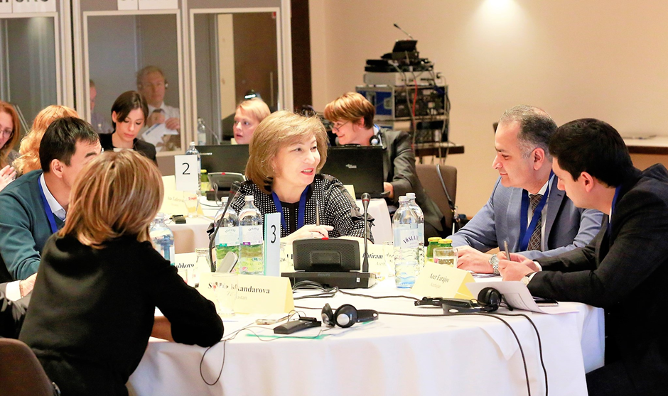
During the wrap-up session participants thanked the Executive Committee, TCOP resource team and PEMPAL Secretariat for the excellent organization of the event. The participants noted that PEMPAL events provide a unique format, with the meetings enabling the peers to share and exchange a huge volume of practical information in such a short period of time. The co-moderators of the meeting, Mr. Prokofiev and Mr. Tufan, assessed this event as highly successful, full of rich, informative and relevant information as well as thought-provoking discussions. The success of the group discussion sessions was also highlighted. It was also commented that it is not always possible to plant even the best peer experience into another national environment, but discussions on the reginal trends and their drivers do help to look ahead and inform the vision for reforms. The participants emphasized the importance of continuing the practice of country news sessions (even going beyond the main topic of an event) as it helps countries to identify the new areas for mutual knowledge sharing. In her closing comments Ms. Nikulina thanked Mr. Prokofiev and Mr. Tufan for the seamless and skillful co-moderation of the meeting, which was a new format compared to the usual TCOP practice, and this had also contributed to the success of the event.

All meeting materials are available at the PEMPAL website:
https://www.pempal.org/events/tcop-cash-management-thematic-group-meeting_eng

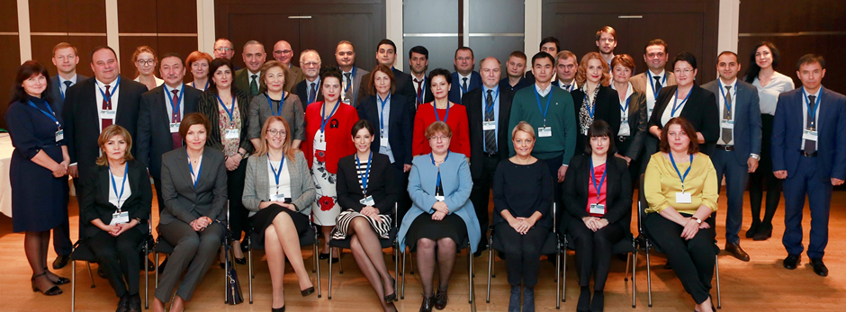

Transfers in excess of HUF 1,000 million have to be announced at least 3 days in advance.
An ARIMA model is a class of statistical models for analyzing and forecasting time series data. ARIMA is an acronym that stands for AutoRegressive Integrated Moving Average. It is a generalization of the simpler AutoRegressive Moving Average and adds the notion of integration.
Ms. Semenova, commenting on Mr. Silins’ presentation, clarified that in the case of the Russian Federation the ROSPICE does not have the restrictive role it used to have in the past. Over time it has transformed into a technical document that facilitates preparation of the budget proposal.
These topics might be addressed using different PEMPAL formats, including thematic videoconferences, workshops, or study visits.

