PEMPAL Executive Meeting 2018

Review of the Results of the First Year of Implementation
of PEMPAL Strategy 2017-2022

Budapest, Hungary, July 4-6, 2018

EVENT REPORT

Background
The leadership of PEMPAL network met on July 4-6, 2018 in Budapest, Hungary to review the results of the first year of implementation of the 2017-2022 PEMPAL Strategy. This meeting continued the tradition of PEMPAL annual executive meetings established during the previous year.
The meeting was attended by the members of Executive Committees of the three PEMPAL Communities of Practice, Treasury COP (TCOP), Internal Audit COP (IACOP) and Budget COP (BCOP). These included 19 representatives of Ministries of Finance and Treasuries from 15 PEMPAL countries (Albania, Armenia, Azerbaijan, Belarus, Bosnia and Herzegovina, Bulgaria, Croatia, Georgia, Hungary, Kazakhstan, Kyrgyz Republic, Moldova, Romania, Russian Federation, and Turkey). COP leadership was joined for the meeting by the representatives of the key donors to the program: the Switzerland Government’s State Secretariat for Economic Affairs (SECO), the Ministry of Finance of the Russian Federation, and the World Bank resource team. Total of 36 participants attended the meeting.
The main objective of the Budapest meeting was to review the results of the first year of implementation of the new PEMPAL Strategy 2017-22 (FY2018) that came in force in July 2017. Following the tradition of PEMPAL Executive meetings, agenda also allocated time for familiarization with the PFM system of the host country, Hungary. The main meeting was followed by parallel meetings of the COP Executive Committees, as well as a meeting of the PEMPAL Steering Committee which took place on July 6th.
The event agenda was developed by the Event Organization Committee, including representatives of the COP Executive Committees and the World Bank resource team. The event concept was endorsed by PEMPAL Steering Committee at its meeting held on May 31, 2018.

This event report provides a summary of discussions held during the main meeting as part of the network’s approach to capturing results of PEMPAL activities.
All presentations from the meeting are available at https://www.pempal.org/events/executive-meeting-pempal-leadership. Minutes of BCOP and TCOP Executive Committee meetings and minutes of the Steering Committee meeting are available on PEMPAL website. Minutes of IACOP Executive meeting are available at internal COP web resource.

Day 1: Familiarization with the PFM System of Hungary
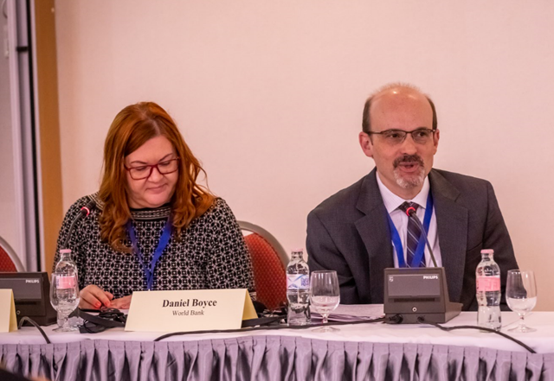
Following the tradition of Executive meetings, the first day of the event was devoted to familiarization with the PFM system of the hosting country, Hungary. The agenda of the day included three thematic sessions, each addressing the topics of particular interest for the COPs. These sessions were the first opportunity for two of the three Executive Committees to get familiar with the PFM system of Hungary (Ministry of Finance of Hungary is an active member of Internal Audit COP only). The day was moderated by Ms. Edit Nemeth, Head of the Central Harmonization Unit of the Ministry of Finance of Hungary and IACOP Deputy Chair.

Budget Planning and Execution

The first session started with an overview of Hungarian public administration system and covered in detail the processes of budget planning and execution.
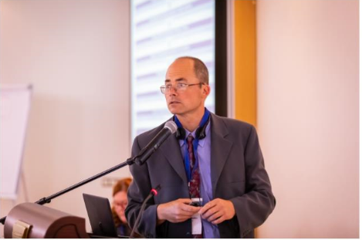
Presentation delivered by Mr. Laszlo Szabo, Head of Unit in the Ministry of Finance of Hungary, described fiscal rules and medium-term budgeting, budget preparation and budget execution, as well as procedures for year-end reporting in Hungary. The general government structure is similar to other countries and it includes central budget, extra-budgetary funds, social security funds, and local government. One exception is that other government organizations, such as state-owned enterprises are also included. Hungary applies EU fiscal rules on debt, budget balance, medium-term budgetary objective, and expenditure rule, and it also has the first three in its national legislation. The expenditure rule has been the most problematic for Hungary in practice, and the country has been in Significant Deviation Procedure according to the EU Stability and Growth Pact. Mr. Szabo discussed the complexity and problems related to calculation of EU expenditure rule and structural position, as very complicated econometrical methodology is required.

Medium-term budgeting is governed by the Government’s decisions on the mid-term budget revenues and expenditures of the central budget and general government balance and debt, EU Macroeconomic and Budget Outlooks, and EU Convergence Programs. Special attention is given to transparency and communication with the public. Annual budget planning is much more detailed than medium-term budgeting and key institutions involved in the process besides the Ministry of Finance are the Government, social partners, Fiscal Council, Parliament, and State Audit Office. Stakeholders with which coordination is undertaken in the annual budget planning process include Standing Consultative Forum for the Private Sector and the Government, National Reconciliation Council of Public Services, National Economic and Social Council of Hungary, Local Government Forums, as well as additional public forums such as the National Labour Council of Civil Servants and the Interest Reconciliation Council of Internal Affairs. The peculiarity of the current year, related to the political cycle, was that the budget had to be submitted to the Parliament before the summer recess, which was much earlier than the usual practice.

Budget documentation accompanying annual budget includes planning information with macroeconomic outlook, budget proposal, opinion of the Fiscal Council, and Opinion of the State Audit Office. Ms. Szabo discussed these in detail, as well as the role of the Fiscal Council, which in Hungary has authority to veto the budget if it concludes that the next year’s budget will not reduce debt. He concluded his presentations outlining the budget execution process and year-end report procedure.

Participants engaged in a detailed discussion with Mr. Szabo after his presentation. Issues that generated discussion included the role and composition of the Fiscal Council, use of program and performance budgeting, citizens’ budgets, reserve funds, fiscal rules, and monitoring of local governments’ debt.

Treasury activities and IT systems

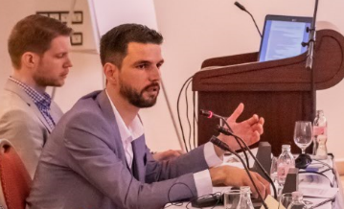
The second session was delivered by the representatives of the Hungarian State Treasury. Mr. Tamás Török, Head of Division in the Budgetary Synthesis and Data Service Department and Mr. Bálint Szablics, Project Lead of the IFMIS and Data Warehouse Project presented an overview of responsibility areas of the Hungarian State Treasury, its main functional processes, and supporting IT systems. The Hungarian State Treasury is performing more than 200 functions, including implementation of the central budget, accounting and reporting, managing payments, bank accounts, liquidity, payroll calculation, social benefits, funding and auditing of subnational governments, distribution of government securities, managing EU and domestic funds / grants / transfers (including agrarian and rural development), funding and control of non-state education and social care providers, etc. This scope of responsibilities is broader than in most PEMPAL countries.

Specific features of the treasury execution in Hungary were discussed during the presentation, including: the existence of the single reporting system for both central and subnational governments, with separate bookkeeping systems operated by spending units; different modalities for release of funds, which include equal monthly releases of funds to government bodies’ accounts and allotments proportional to performance of spending units in case of program appropriations; and special schedules for release of funds for selected cases, including social transfers.
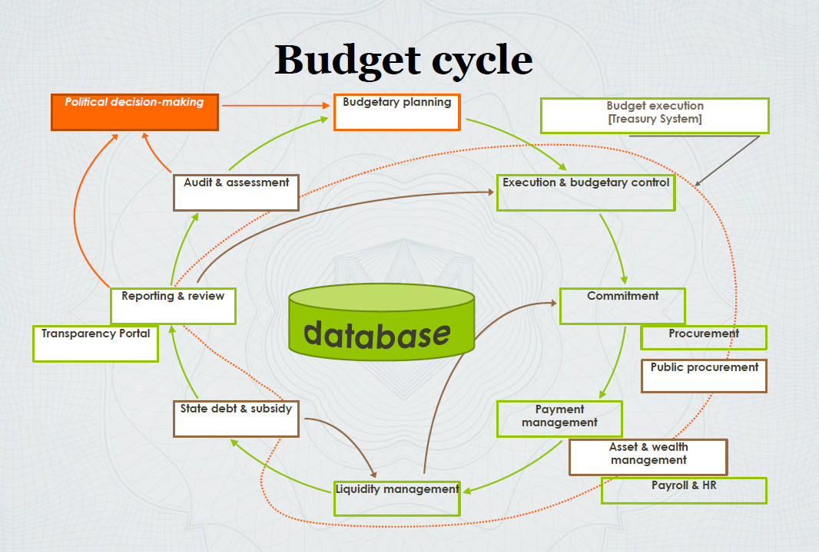
Representatives of the Hungarian State Treasury clarified distribution of functions between the Treasury, which is responsible for cash forecasting, and Government’s Debt Management Agency (ÁKK), which is responsible for active cash management operations, ensuring that central government’s deficit and debt redemptions are financed. The presenters noted that the accuracy of cash forecasting in 2017 was 91.7 percent and that further quality improvements are expected through the penalty scheme recently introduced for spending units whose spending significantly deviates from the cash plan. The broad scope of treasury functions is supported by 200+ IT solutions and 380+ IT staff. Authorities’ IT strategy for the next 5 years aims to transform these fragmented systems into a new integrated Financial Management Information System that would create a single-entry point for the users and would benefit from BI and big data potential.

During the question and answer session, participants of the meeting clarified details of payroll management in Hungary, coverage of the Treasury Single Account, specificities of document management in IT systems supported by the Treasury, as well as challenges of developing IT system requirements and business processes. Summarizing the discussion, Ms. Angela Voronin, the Head of the State Treasury Department of Moldova and the TCOP Chair, noted that experience of the Hungarian State Treasury and their ambitious reform plans are highly relevant for agendas of the TCOP countries and that Hungarian State Treasury officials would be welcome to participate in TCOP events in the future.

Harmonization of Reforms: Public Internal Control and Anti-Corruption

The third session of the day was devoted to sharing experience of harmonization of reforms in the areas of Public Internal Control and Anti-Corruption. The speakers were Ms. Nemeth and Ms. Marianna Szabone Gal, Deputy Head of Anti-Corruption Unit in the National Protective Service. Ms. Nemeth gave an overview of the setup of public internal control system in Hungary and the key institutions. Under parliamentary oversight, State Audit Office conducts external audits, while Treasury conducts financial audit of local government. At the governmental level, Government Control Office conducts financial inspections, while the Treasury is in charge of financial implementation of the budget, first level control activities, and ex-post controls of certain subsidies. Directorate General for Audit of European Funds conducts audits of EU funds. At the organizational level, there is an internal control system which includes an internal audit function.

Ms. Nemeth walked the participants through a historical overview of the development of the Hungarian public internal control system, starting with the establishment of the State Audit Office in 1989, adoption of the Public Finance Act in 1992, establishment of the State Treasury in 1995, establishment of the Financial Audit Department within the Ministry of Finance in 2000 that was a predecessor of what is now the Centralization Harmonization Unit, and the adoption of the Hungarian Public Internal Financial Control (PIFC) Development Strategy and adoption of internal audit standards in 2003. The chapter on financial control was the last chapter to be closed by the EU for Hungary in late 2003, right before Hungary joined the EU in 2004. First public internal control report and internal audit manuals were published in 2004. In 2009, PIFC system was reviewed and COSO model integrated and, in 2010-2014, a new government structure was introduced and the entire legislation related to public internal control was amended. Ms. Nemeth shared the challenges Hungary faced prior to integration of public internal control and anti-corruption reforms, including the fact that there was no single dedicated person for coordinated internal control system implementation. The two reforms were then merged, and integrity advisors were appointed who are in charge of internal control risk coordination. The legislation was subsequently amended to remove duplications and training materials were improved so that integrity advisors could conduct change management in their institutions. The implementation fully started in 2016 and organizations, in particular large ones, face complexities in implementation, however trends so far are promising towards implementation of new value-based approach with emphasis on integrity and ethics.

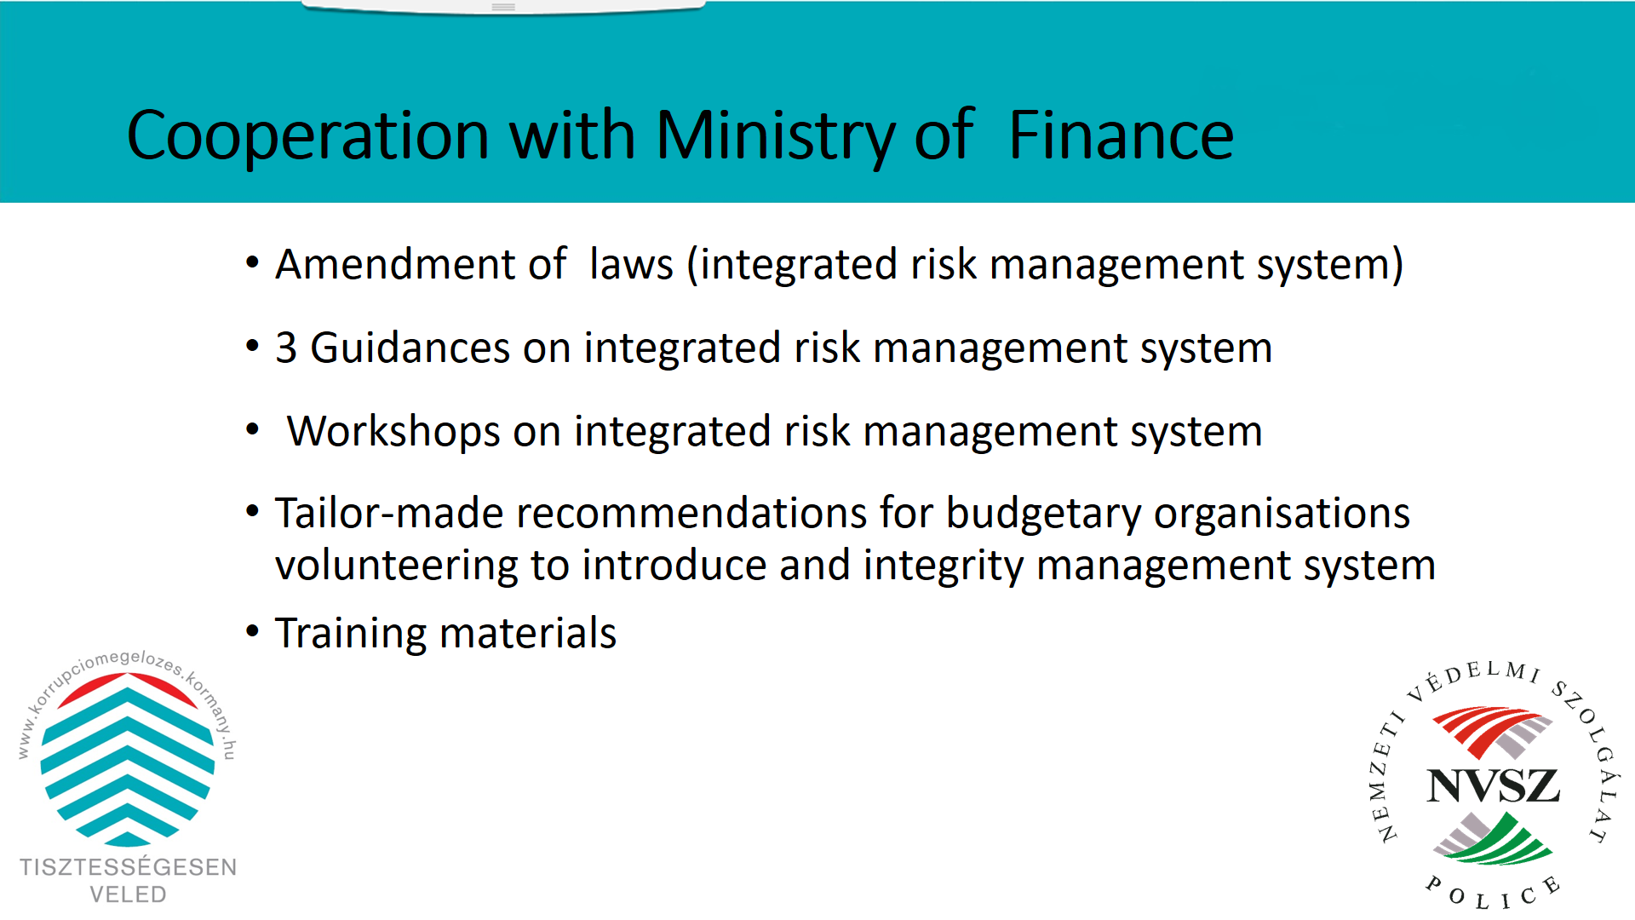
Ms. Szabone Gal presented the Hungarian integrity management development, including implemented anti-corruption measures, education and training of professional ethics and anti-corruption, joint-work with the Ministry of Finance, and integrated risk management system. She inter alia stressed that the State Audit Office has had a crucial role in establishing integrity culture and described the annual Integrity Survey conducted by the State Audit Office to examine the level of integrity and corruption vulnerability of public institutions and the institutional mechanisms to mitigate these risks. Survey topics include political environment, public procurement, EU funds, external control environment, internal audit functions, etc. The results of the 2017 survey compared to the 2011 survey show the strengthening of integrity awareness and reduced risks.

Ms. Szabone Gal also gave an overview of the work of the National Protective Service within the Ministry of Interior, which since 2014 implements corruption prevention tasks. The Corruption Prevention Department was established in late 2014 within this Service, tasked with anti-corruption strategic planning, methodological support, integrity management development, ensuring the continuous evaluation of the corruption situation and the governmental anti-corruption actions and provisions, conducting case-studies and integrity advisors network development, international cooperation, and training (so far more than 10,000 trainees). She concluded her presentation by explaining how the coordination with the Ministry of Finance is conducted, including a joint workshop on integrated risk management system. Following the presentation, participants engaged in a discussion with the speakers on several issues, including the data on anti-corruption prosecution cases, the role of the Central Harmonization Unit, the internal control governance structure, as well as further discussion on how presented Hungarian reforms focus first and foremost on prevention.

Day 2: PEMPAL Strategy Implementation Progress

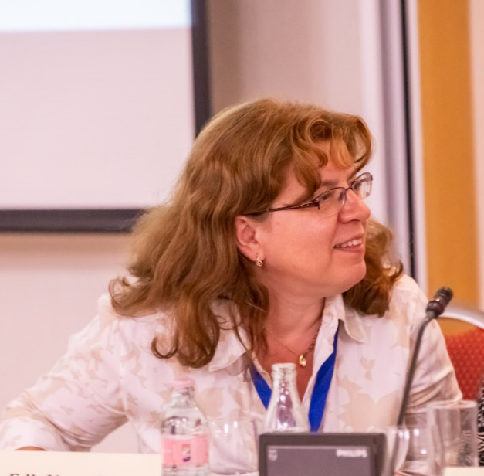
Discussions on the main topic of the event took place during day 2 which was moderated by the World Bank PEMPAL team Leader, Elena Nikulina.

Ms. Nikulina launched the agenda by presenting the overall progress with implementation of the first year of the 2017-2022 PEMPAL Strategy. She reminded the participants that PEMPAL achieved impressive progress and growth in the previous years, so the baseline values of the key performance indicators were on most dimensions already very high. The objective and at the same time challenge for the future is therefore to sustain the achieved levels. FY18 presented in this context a very successful start year for the new strategy period, despite the need to continue to apply savings measures because of uncertainties about the availability of funding for the later years.

Speaking of specific results achieved in FY18, Ms. Nikulina noted that:
- Based on results of the impact survey undertaken in the fall of 2017, more than 60 percent of senior managers of the beneficiary institutions assess PEMPAL impact on PFM systems and on staff capacity in their countries as high;
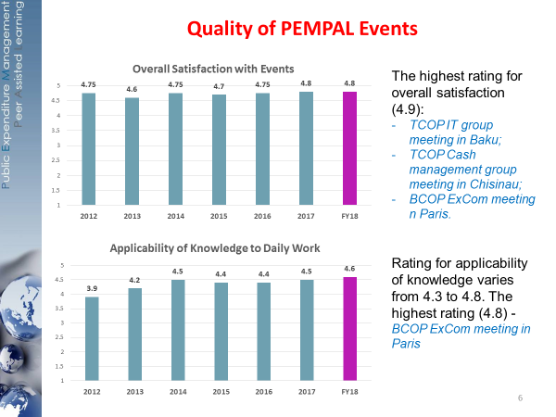
- Based on results of event evaluation surveys,
  - the rating for the overall satisfaction with PEMPAL events stood at 4.8;
  - the rating for applicability of knowledge to daily work had grown from 4.2 in CY2013 to 4.5 in CY2017 and further to 4.6 in FY2018;
  - quality of COPs leadership, resource team and speakers are rated 4.9, 4.9, and 4.8 respectively (new indicators introduced in FY18);
  - quality of event organization continues to be rated as high as 4.9 and reaches the highest possible rating of 5 for event administration);
- page views of the PEMPAL website continued to grow;
- all three COPs achieved significant budget savings in FY2018 which will be carried over to FY2019.

The floor was further given to the COPs’ leadership to present the FY18 activities and plans for FY19

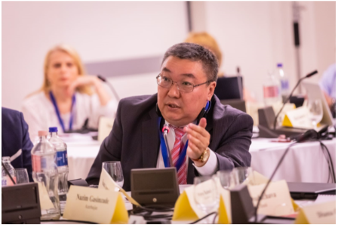
BCOP Deputy Chairs – Mr. Kanat Asangulov, the Head of the Budget Policy Directorate of the Kyrgyz Ministry of Finance, and Ms. Mladenka Karačić, the Head of the State Accounting Department of the State Treasury of Croatia, were the first to speak. The BCOP Deputy Chairs noted that currently 21 countries are members of the BCOP, with 16 countries participating in Budget Literacy and Transparency Working Group (BLTWG) and 15 countries participating in Program and Performance Budgeting Working Group (PPBWG). These working groups continue to drive the agenda of most of the BCOP activities, since their topics respond to the most common budgeting reform priorities of the BCOP countries. FY2018 was BCOP’s most active year with 13 events held and several knowledge products developed. In FY2017 and FY2018, BCOP continued and deepened its cooperation with OECD (through OECD’s contribution to BCOP events; BCOP’s participation and increasing content contribution to annual meetings of OECD Senior Budget Officials regional network for Central, Eastern and South-Eastern European Countries; BCOP’s participation at the meetings of OECD Network on Performance and Results; as well as facilitation of participation of PEMPAL countries in OECD surveys on budgeting processes and procedures and performance budgeting) and also achieved close collaboration with the International Budget Partnership (IBP) and Global Initiative for Fiscal Transparency (GIFT). It is expected that both working groups will continue to drive the BCOP’s agenda in FY2019. Additionally, the topic of integration of the capital budgeting / public investment in budget planning will be introduced at the FY2019 plenary meeting, in line with priorities identified by the BCOP countries in the recent BCOP country priority survey. BLTWG will focus its work on finalizing the knowledge product on public participation and further analysis of the results of the 2018 Open Budget Survey, while PPBWG will work on the knowledge product on spending reviews and participate in 2018 OECD Performance Budgeting Survey. In the question and answer session that followed BCOP’s presentation, BCOP and TCOP discussed the opportunities for conducting joint events on the topics relevant for both COPs (most notably on budget and financial reporting).

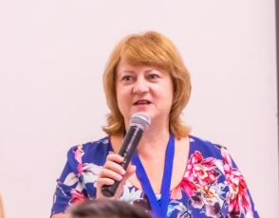
Overview of the TCOP FY18 activities and plans for the next financial year was presented by Ms. Angela Voronin, the Head of the State Treasury Department of Moldova and the TCOP Chair. Ms. Voronin noted that the TCOP continues to work in four key thematic areas: i) evolution of the roles and functions of the treasury (working group includes 15 countries), which continued to shape the agendas of the plenary meetings in the last three years due to high relevance of the topic for member countries, ii) use of information technologies in treasury operations (11 countries), iii) cash management (13 countries), and iv) public sector accounting and reporting (14 countries). In FY2018, the TCOP had a plenary meeting on approaches to measure and monitor treasury performance and 3 working group workshops, which covered interaction between cash and debt management; practical aspects of automating public accounting and reporting at spending units level; recent progress in using IT for PFM operations in the member countries. 3 thematic videoconferences with participation of 54 TCOP members, as well as 4 leadership meetings were also held during FY2018. The TCOP plans for the next year include the annual plenary meeting and 2 or 3 workshops of the working groups, depending on availability of funding (cash management, use of IT in treasury operations and, possibly public sector accounting and reporting). All four working groups are also planning to continue videoconference meetings throughout the year. The TCOP will also work on a new version of the knowledge product on the integration of the chart of accounts and budget classification, and the BCOP was invited to join this work as in most of the PEMPAL countries the responsibility for maintaining the budget classification spans across functional responsibilities of both budget departments and treasuries. The TCOP’s working group on public sector accounting and reporting also plans to explore a possibility of a joint meeting with PULSAR program.

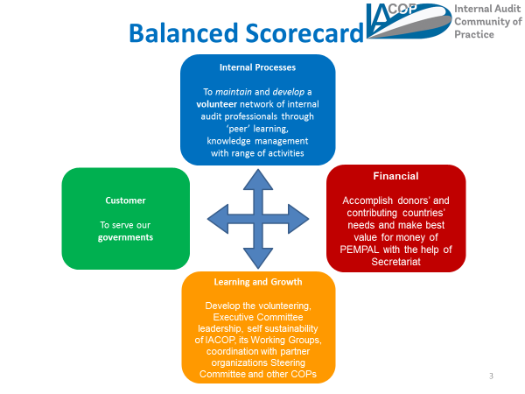
Overview of IACOP’s activities and plans for the future was presented by all the members of IACOP Ex Com attending the meeting. The IACOP has 23 member countries. The mission of the IACOP is to offer support to its member countries in establishing modern and effective internal audit system that meets international standards and best practices and is a key for good governance and accountability in the public sector. Throughout the years of its operation, the IACOP prepared multiple knowledge products that internal audit staff can use in their daily operation and this work is continuing. During the FY2018, IACOP had three face-to-face meetings to learn and share good practices on public internal financial control and internal audit reforms as well as to continue the work on its new knowledge products. These knowledge products include Good Practice for Internal Audit Engagement Planning (being developed by the Audit in Practice Working Group), Public Internal Control Glossary and PEMPAL Criteria for Assessment of the Managerial Accountability of a Budget Organization (both documents being developed by Internal Control Working Group). Work on the documents will continue in FY2019. During the question and answer session that followed IACOP’s presentation, PEMPAL leadership discussed that internal audit agenda has strong synergies with both BCOP and TCOP reform agendas, and there seems to be a good potential for organizing join events in the future.

Discussion on pending actions under 2017-2022 PEMPAL Strategy Action Plan

Ms. Elena Nikulina further focused PEMPAL leadership’s attention on selected actions of the 2017-2022 PEMPAL Action Plan that were agreed to be discussed additionally at the meeting before launching their implementation. These actions included i) collection of information on the use of knowledge products, ii) induction of new members to the network, iii) formalizing the requirements for the hosting countries and reflecting these in PEMPAL operational guidelines, iv) learning from experiences of other networks in achieving financial sustainability, and v) identification of additional savings initiatives. As part of preparations for this cross-COP leadership meeting, the Organization Committee discussed practical approaches to implementation of the respective actions and came up with proposals on several of them. In particular, there was an agreement that that there was no need to conduct a separate network-wide survey to gather feedback on usefulness of knowledge products – respective questions could be added to impact surveys conducted by COPs. For the induction kits, the proposal was that each COP could prepare its own induction kit that would also have a uniform introductory section about the network in general. The remaining three items were included as tasks for group discussion at the respective session of the Executive meeting to seek PEMPAL leadership’s views and proposals.
Setting further the stage for the subsequent group discussion session, Ms. Nikulina reminded that certain requirements for the countries hosting the events were already in place. These included inputs to the content of agenda, help and advice to the Secretariat on logistical aspects of events (visas, venues, local service providers), and organization of the social program (typically a dinner) for event participants. These requirements were communicated to the hosting countries by the secretariat at the start of event preparation process. The participants of this cross-COP leadership meeting were asked to consider if there was a need to keep the existing requirements as they were or tighten them by requesting host countries to finance some part of the event expenses. The participants were also asked whether requirements for the hosting countries should be further detailed and formalized in PEMPAL operational guidelines. On the second question the leadership was informed that the resource team had explored in the past the financing modalities used by other similar networks and concluded that two main modalities were in use. The first one implies collecting membership fees, which requires a formal legal status for PEMPAL network, the route the Steering Committee decided not to take at the stage of the new strategy preparation. This modality also requires an external secretariat for the network because the World Bank can not collect any fees. The second modality implies that participants or their institutions cover the costs of attendance in full or in part, which is already widely used by PEMPAL and its use is expected to continue to grow. The participants were asked to consider this information and discuss whether a separate study on other networks was still needed, and, if so, which specific aspects of similar networks operation the potential study should cover.
Ms. Nikulina further presented the results of PEMPAL expenditure review the implementation of which was also one of the actions under the 2017-22 PEMPAL Action Plan. The main conclusion of the expenditure review is that the savings measures implemented during the last years of the previous strategy period were effective and resulted in significant savings that assured a smooth transition to the new strategy. The review highlighted sources of savings already achieved by the network, including significant co-financing from hosts of IACOP events, the practice of back-to-back events, smaller number of participants in selected thematic meetings (study visits), reduced number of study visits, no face-to-face cross-COP executive meetings and steering committee meetings, implementation of “go-green” initiative, as well as World Bank value-add tax exemptions for contracts with event venues.

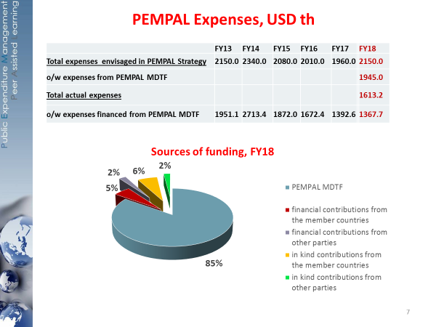
In FY2018, PEMPAL program expenses amounted to USD1.6 million compared to USD2.15 million envisaged in PEMPAL Strategy. Ms. Nikulina noted that the network was also able to reach the level of 11 percent for external contributions, which exceeded the target for the mentioned year. This was mainly due to the efforts of IACOP, which had introduced into their COP’s practice the requirement to plan face-to-face events in those countries that provide event co-financing. Sources of program’s financing included PEMPAL MDTF (85 percent), in-kind contributions from the member countries (6 percent), financial contributions from the member countries (5 percent), and in-kind and financial contributions from other parties which constituted 2 percent each.

The participants were further divided into three language-based groups and held group discussions on the questions related to financial sustainability of the network, including the need to formalize requirements for the hosting countries, learn from experiences of other networks in achieving financial sustainability, and further savings initiatives. Conclusions from the group discussions were presented by Ms. Angela Voronin, TCOP Chair, Ms. Ludmila Guryanova, TCOP Deputy Chair, Mr. Emil Nurgaliev, BCOP Executive Committee member, and Ms. Irene Frei, SECO, and are summarized below.

Participants agreed that requirements for the hosting countries should be formalized, especially those which were already in place (such as content inputs into agenda, logistical assistance, etc). The participants discussed that financial contributions could also be formalized but only as a recommended, not a mandatory requirement, not to leave out the countries which may not be able to financially contribute. It was agreed to consider specifying in the operational guidelines that in cases of several countries willing to host a particular event, readiness to financially contribute to event costs should be taken into consideration. The participants also proposed to specify in the operational guidelines that hosts of face-to-face events can delegate additional staff to benefit from the event held in their country.

On learning from experiences from other networks, it was noted that limiting factors for PEMPAL to follow some of the most common approaches of other networks have already been informally discussed in previous years (including legal issues related to membership fees), but there is a need to officially document it. Furthermore, the analysis of other networks’ approaches should look more broadly for networks that are perhaps less similar to PEMPAL, as this may inform potential further evolution of PEMPAL. Many representatives of PEMPAL leadership noted that against the general background of looking for savings options, investing resources in a full-fledged research did not seem to be prudent. Therefore, a lighter version of the research was proposed – a paper mapping out selected aspects of other networks’ operations and whether and how those would be applicable to PEMPAL.

When discussing possible additional savings options, the groups noted that a lot had been recently done to cut down on the costs of events and PEMPAL program in general, therefore further consolidation measures should be carefully analyzed not to jeopardize the quality and effectiveness of the network. The groups discussed pros and cons of different savings options, which included:

- Using host government’s training facilities for PEMPAL events to save on conference package, as well as on hotel accommodation if accommodation also available in such centers. To explore this option further, it should be confirmed which countries have such centers (Belarus, Macedonia, and Georgia were mentioned).
- Hosting agencies providing conference rooms for PEMPAL events (if close enough to the hotel and if translation equipment exists or can be brought in without security obstacles).
- Hosts assisting to negotiate lower hotel rates (e.g. as already done in Turkey for BCOP and in Uzbekistan for IACOP), paying or assisting to get lower in-country transportation rates.
- Further increasing usage of videoconferences for PEMPAL events.
- Cutting down on finger food with coffee breaks (which may be difficult to do as these are typically part of a standard conference package).
- Discontinue providing meals on the days of arrival and departure and cutting down on dinners during the days of the events. The participants discussed that such changes in the policy would need to be brought to the notice of delegating authorities to make sure that all participants are provided with per diems. At the same time some of the participants noted that cutting down on joint meals may decrease networking opportunities, which is an important part of the program.
- Taking into account airplane connections and ticket costs when choosing locations of events.
- Requiring hosts’ financial contribution for the most expensive host countries.
- Making events more compact, shorter, limiting maximum length; continuing to practice back-to-back meetings, though it should be understood that this doubles the work load for the Secretariat and the resource teams.
- Discontinue printing hard copies of PEMPAL Annual Reports.
- Reducing the frequency of Steering Committee meetings from quarterly to semi-annual (is unlikely to lead to significant financial savings but can free up some time of the secretariat and resource team for other tasks)
- Continuing to encourage self-payer participation. However, it needs to be ensured that the level of expertise and commitment by self-payers is adequate not to slow down the work and peer exchange.
- Limiting the number of participants of face-to-face events to one delegate per country, with all other delegates financed by authorities. This proposal was also questioned by many of the participants because of potential negative impact on continuity of membership.
- Further increasing third-party contributions, both in-kind and financial (e.g. as already done by OECD, GIFT, IBP, Belgian Government, and Dutch Academy of Finance).
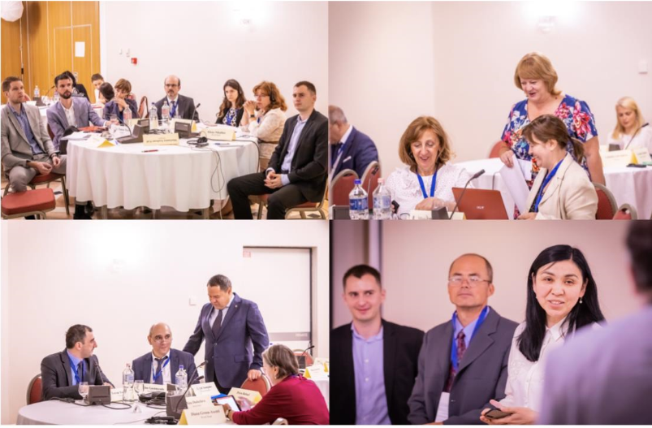
As part of the discussion Ms. Irene Frei noted that for SECO, as a donor, the issue of financial sustainability is very important, although there may be some differences in opinions with members. She suggested to document all the proposed savings options and task the program management team to analyze and prioritize them further. Summarizing the session Ms. Nikulina thanked the PEMPAL leadership for productive discussions which would inform proposals to be discussed by PEMPAL Steering Committee in the future.

Discussion on Success Factors of the PEMPAL Program

The last session of the day was devoted to reflection on PEMPAL success factors based on the draft completion report for the Strategy 2012-17 circulated to the participants prior to the meeting. The discussions were held in small groups with reporting back by Mr. Nikolay Begchin, BCOP Executive Committee member, Ms. Diana Grosu-Axenti, IACOP resource team member, Ms. Ljerka Crnkovic, IACOP Executive Committee member, and Mr. Ilyas Tufan, TCOP Deputy Chair. The success factors identified by the meeting participants included:

- Leadership exercised by COP Executive Committees. Network participants noted dedication, ownership and active leadership in developing and steering the content of COPs’ activities that is exercised by COPs’ leadership.
- Quality of network membership. Relatively constant membership of PFM practitioners in the network, adequacy of their professional profiles to the objectives and activities of PEMPAL network.
- Relevance of network outputs for the member countries due to demand driven agendas. PEMPAL outputs (knowledge products produced by the members with support from external experts and PEMPAL resource teams) are considered relevant for the member countries’ practitioners. Different PEMPAL countries are at different stages of PFM reforms, and this is properly addressed and taken advantage of so that countries can learn from each other and are able to organize work in smaller groups to address priority issues of interest. Cooperative development of knowledge products is uniquely tailored to country needs.
- Translation of PEMPAL materials and events into three languages (English, Russian and Bosnian-Croatian-Serbian), which allows practitioners to express themselves in sophisticated technical terms in their own language, thus contributing greatly to the quality of PEMPAL work. High quality of the translation facilitates effective information sharing.
- Different modalities and formats of activities to suit different needs. Frequency of meetings and continuity of activities allow to “stay hot” on the priority topics. The network provides the opportunities to speed up reform implementation by learning from the challenges and lessons shared by peers. Diversity of thematic working groups allows to capture and investigate in more details various topics of interest.
- Trust built among the peers. PEMPAL “family values” and trust built among the members allow to openly discuss issues and share knowledge. The unique atmosphere of trust and support (encouragement). “A forum for professional exchange.” Many of the network countries have common historical and political background which makes it easier to understand and learn from specifics of the PFM arrangements. Unique opportunity for peer exchange and mutual learning between policy makers and practitioners from different countries. Establishing personal contacts with peer officials from the member countries facilitates knowledge exchange.
- Quality of resource and logistical teams. High quality of contributions by international experts. Contribution of resource teams’ members who have appropriate practical experience of working in the ministries of finance and (or) other agencies relevant to COPs’ thematic areas. Availability of a permanent and highly qualified Secretariat. Support provided through PEMPAL website and visibility tools. Availability of detailed and comprehensive information on PEMPAL website facilitates and accumulates effects from learning.
- The unique entry point for best international practice and expertise. Participants noted that none of the countries would be able to reach out and receive this level of advice and expertise if requested individually. A unique source of learning about latest developments in the member countries, as well as the latest research, trends, and recommendations developed by the relevant international organizations and/or most advanced countries, which provides a unique opportunity for PEMPAL members to learn and discuss about these issues at the same time that the most advanced countries are discussing them.
- Donors support for the member driven approach to action plans and agendas formulation.

Summarizing the discussion Ms. Nikulina added that in her view, as a long standing program leader from the World Bank side, the first and the foremost success factor of the program was quality of leadership and membership of the network, and in particular the dedication of the COP’s leaders to the network’s objectives in spite of the busy schedules and day-to-day operational pressures which most of them experienced serving as mid- to senior level officials in their countries. Ms. Nikulina also noted the contribution of the COPs’ resource teams that supported the network for the last ten years of its operation.

Conclusions
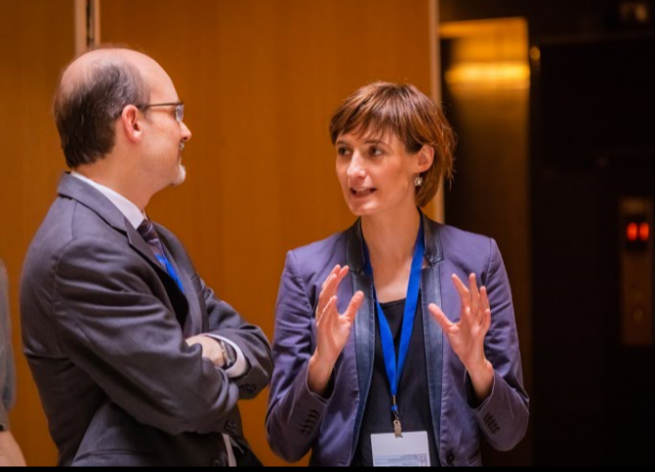
The reflections and conclusions from the Budapest cross-COP leadership meeting were discussed in the Steering Committee meeting held which took place on July 6th, 2018 after the COP leadership meetings and was attended by all the COP leaders as observers. Reflections about the cross-COP leadership meeting were very positive, with participants concluding that such cross-COP meetings were very useful for COPs to learn about activities of other COPs and to exchange views, as well as for the leadership to take stock of overall network progress and define ways for further improvement. Participants noted that the tradition of holding such meetings annually should be reestablished.

Participants also stressed the need for increased cross-COP thematic collaboration and COP representatives in particular discussed specific topics and format of such collaboration (e.g. TCOP and BCOP agreed to collaborate on update of TCOP’s knowledge product on budget classifications, while IACOP appointed contact points for other two COPs within the IACOP Executive Committee to explore collaboration options). Another area of improvement which was discussed was increase of external visibility of the network.

The host day in which the Hungarian Ministry of Finance held presentations was evaluated as exceptionally successful and participants thanked the hosts for such excellent content contribution to agenda. It was agreed that TCOP and BCOP, which have not had strong/any participation from Hungary so far would explore options for including Hungary officials in their future activities as guest speakers and/or resource experts.

Other reflections on the event included impressions that the level of ownership COP members have in matters of content and quality has increased further and that the discussion groups were very useful and also improved in depth and ownership by the members. The on-line survey would also be released after the meeting as part of PEMPAL’s standardized monitoring and reporting framework to gather further participants’ feedback.

All details of SC discussions are available in the SC meeting minutes at https://www.pempal.org/event/steering-committee-meetings.

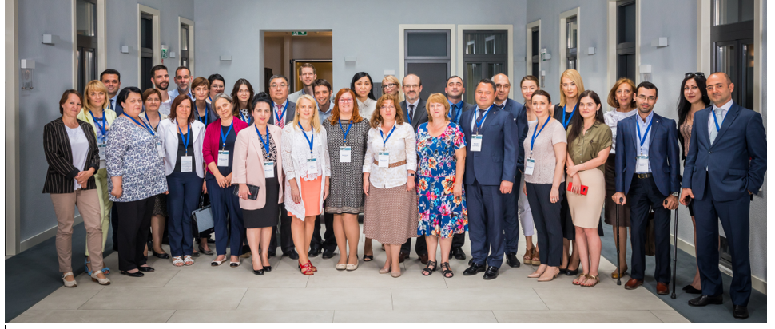

PEMPAL was established in 2006 and provides learning events, workshops, study tours and resource materials in accordance with member driven action plans in the thematic areas of budget, treasury and internal audit for member countries in Europe and Central Asia. Refer to www.pempal.org for more information.
The core Bank team supporting the meeting included Daniel Boyce (Steering Committee Chair), Elena Nikulina (TTL and TCOP Resource Team), Maya Gusarova (BCOP Lead Coordinator), Naida Carsimamovic (BCOP Resource Team member), Arman Vatyan (IACOP Lead Coordinator), Diana Grosu-Axenti (IACOP Resource Team member), Yelena Slizhevskaya (TCOP Resource Team member), and Nina Duduchava (virtual support for electronic post event feedback survey). Logistical and administrative services were provided by Ksenia Galantsova, Ekaterina Zaleeva, and Kristina Zaituna (PEMPAL Secretariat, World Bank Moscow Office).
An oversight body for PEMPAL program including representatives of the program donors (the World Bank, SECO, and the Ministry of Finance of the Russian Federation) as well as COP representatives (Chairs and Deputy Chairs of Executive Committees)
On a 5-point scale, with 1 being the lowest and 5 – the highest rating
Including “Results of the 2016 OECD Performance Budgeting Survey: OECD and PEMPAL countries”, “Breaking Challenges in Constructing Citizens’ Budgets for PEMPAL countries”, “Performance Indicators in PEMPAL countries: Trends and Challenges”, and “Background Paper on Public Participation in Fiscal Policy and Budget Process”

