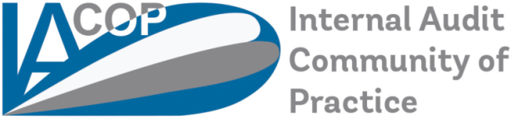
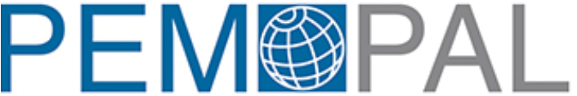

Welcome to PEMPAL!
This document is developed in order to provide you the most important information regarding our community. PEMPAL (Public Expenditure Management Peer Assisted Learning) is a network to facilitate exchange of professional experience and knowledge transfer among public finance management (PFM) practitioners across the Europe and Central Asia (ECA) countries. PEMPAL was established in 2006 with assistance from the World Bank.

PEMPAL work is organized in 3 Communities of Practice (COPs):
- Budget Community of Practices (BCOP)
- Internal Audit Community of Practice (IACOP)
- Treasury Community of Practice (TCOP)
You are invited to contribute to IACOP activities.

The IACOP holds regular meetings where its participants share experience and identify solutions to priority challenges related to the implementation of internal audit reforms in the public sector.
IAC)P has different working Groups, such as:
- Internal Control Working Group (ICWG),
- Audit in Practice (AiPWG)
Our mission: IACOP offers support to its member countries in establishing modern and effective Internal Audit system that meets international standards and best practices and is a key for good governance and accountability in the public sector.
Our core values: Professionalism, dedication to reforms, commitment to sharing knowledge and experience with the community (as professional family of peers), trust, unity and respect to diversity of 23 member countries.
IACOP Donors are: The World Bank, Ministry of Finance of the Russian Federation and Economic Cooperation and Development Division of the Swiss State Secretariat for Economic Affairs (SECO); in addition, the Dutch National Academy for Finance and Economy provides non-financial support.
The 23member countries of IACOP are: Albania, Armenia, Azerbaijan, Belarus, BiH, Bulgaria, Croatia, Czech Republic, Georgia, Hungary, Kazakhstan, Kosovo, Kyrgyz Republic, Macedonia, Moldova, Montenegro, Romania, Russia, Serbia, Turkey, Ukraine, Uzbekistan, and Tajikistan.
Usually, we also invite representatives from different countries and regions, such as Brazil, South Africa, Belgium, France, UK and European Commission – DG Budget to attend our events; they are our resource partners, which contribute in-kind by sharing their experience and knowledge.IACoP organizes 2 or 3 meetings/year, one being its plenary meeting. We use three official languages, English, Russian and Bosnian/Croatian/Serbian. We hold one plenary meeting per fiscal year. The plenary meeting is attended by more participants from the member countries, and we use this opportunity to report on working groups’ activities and results, present new knowledge products. The topics of such plenary meetings are more general and more focused on CHU challenges or possible cross-COP topics –Treasury COP, Budget COP and IA COP.
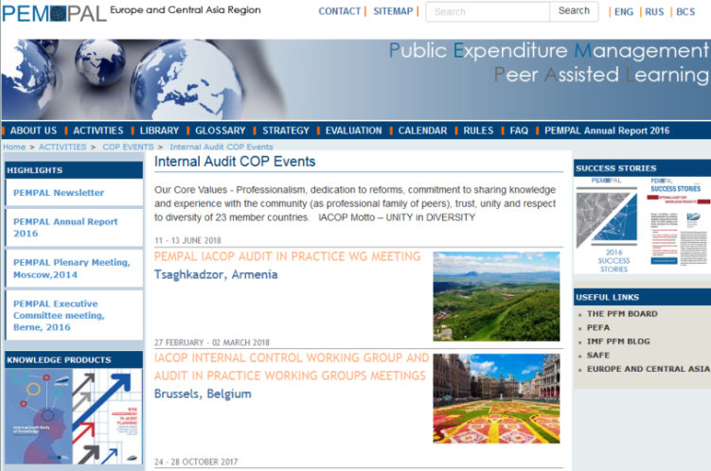
The website of PEMPAL is www.pempal.org. You can find all the documents on the website in the IACOP section (agenda, information letter, presentations, etc). All the documents will be available as electronic versions only, withno hard copies provided. The same website also contains our knowledge products.

The IACOP activities are directed by a well-organized and result-oriented Executive Committee (ExCom) team, comprised of nine members: Edgar Mkrtchyan (Armenia), Chair; Edit Nemeth (Vice-Chair, Hungary), Vice-Chair; Amela Muftic (Bosnia and Herzegovina), Vice-Chair; Ljerka Crnkovic (Croatia); Stanislav Bychkov (Russia); Zamira Omorova (Kyrgyz Republic); Mioara Diaconescu (Romania); Petru Babuci, (Moldova), Acting member; Olim Mirzoev (Tajikistan).
The persons responsible for organising IACOP activities are:
- IACOP Lead-Governance, the World Bank – Mr. Arman Vatyan;
- IA COP resource expert, the World Bank – Ms. Diana Grosu-Axenti;
- IACOP Chair Mr. Edgar Mkrtchyan – Deputy Head of Financial Management and Control Division – Ministry of Finance, Armenia
- ICWG Leader, Deputy chair of IACOP – Ms. Edit Németh - Deputy head of unit Public Finance Policy Unit – Ministry of Finance, Hungary
- AiPWG Leader – Ms. Mioara Diaconescu – Director – CHUPIA – Ministry of Public Finance, Romania.
Our PEMPAL has a Secretariat which main tasks include providing logistical and administrative support to COPs events. For IACOP the Secretariat services are provided by Kristina Zaituna (kzaituna@worldbank.org).
During the events the participants usually are allocated to 6-8 round tables. As a participant you will be involved in the discussions working on documents elaborated by the participants at that table. If you are invited to provide a presentation, you will be also involved in the Q&A session.
Our meetings are very interactive and we aim to involve all participants in the discussions. The meetings use different frameworks for discussions: talk show, panel discussion, table discussion, fishbowl, world café, role play, case studies. Please find below some information about these frameworks.
Talk show – in accordance with agenda, a subject will be discussed with the talk show participants. The discussion will be run by a moderator. Sometimes, at the end of the talk show we have a Q&A session for the rest of participants to engage.
Panel discussion – during panel discussion a group of experts, resource partners or members of IACOP discuss a topic and the audience is invited to participate in Q&A session.
Table discussion – the participants spend 10-30 minutes to discuss a topic at their tables. After this each of the tables reports back outcomes of the discussion to the full audience.
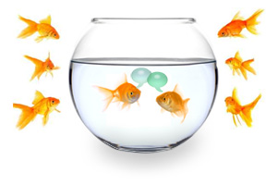
Fishbowl – all the participants are arranged in a circle. In the middle of the circle there is a moderator and 3-5 experts/participants. The moderator will start the discussion with those experts/participants. You have the possibility to replace one of the speakers in the middle in case you deen that you have important information or some other opinion about the subject. The discussion will continue following this pattern during the time allocated for this activity.
World Café – a World Café (also known as Knowledge Café) is a structured conversational process for knowledge sharing in which groups of people discuss a topic at several tables, with individuals – in our case experts – switching tables periodically and getting introduced to the previous discussion at their new table by a "table host".
We have a newspaper, too! The articles are produced on voluntary basis, and the newspaper is used to disseminate new developments in our countries as well as good practices.
Also, during the meeting we have different enabling groups; see some examples are presented below. Members of such grouls would be appointed at the beginning of the event.
Value detectives – explore created values and demonstrate outputs and impact.

Quality Friends –identify strong & weak points of the event in order to improve next meetings.

Agenda Activists –identify new topics for future events.

External messengers - prepare communique or resolution to make us visible.

Community keepers - find solutions for sustainability: welcoming new members, maintain contacts with photos on wiki, produce thank you letters

Social Reporters - at the end of the meeting the social reporters will present to participants the most entertaining and enjoyable moments of the event. They will also collect memories from the social and other events outside the main agenda..

Networking breaks & social events - You will notice that between the sessions there are networking breaks and usually there are some social events - mainly organised by hosts, Wewelcome everybody at such events, and we strongly encourage networking and establishing ties among our participants.

