PEM PAL IA COP AiP Working Group
Guidance to Audit Engagement Planning

A primary question to be addressed: do we want one or two distinct planning documents.
- One single audit plan
- A separate work program or a risk/control matrix
Expert suggestion:
- A structured and general audit plan, to be used for every audit engagement.
- Plus as an addendum, a risk/control matrix specific for the audit engagement to be performed.

Remember the four phases of an audit engagement:
- The initial planning
- The preliminary survey
- The fieldwork
- The report

Please mark all the elements you want to see included in the planning documents, and add anything that seems to be missing.

- The initial planning
# | Description | Yes | No
1. | Define the preliminary audit objective(s).
2. | Define the audit scope.
3. | Identify applicable laws, policies and standards affecting the process or system and related documentation such as the interconnectivity with other processes/systems, process/system risk assessment and process/system roles and responsibilities.
4. | Identify previous reports of internal audit and other internal/external assurance providers and consultants related to the process/system under audit.
5. | Define the required staff skills and expertise.
6. | Identify the audit team members.
7. | If technical support is needed, state what, when, who and estimated time/cost.
8. | Prepare a time budget plan for the following phases of the audit engagement:  - Initial planning  - Preliminary survey  - Field work  - Draft report  - Final report  - Administration  - Supervision  - Quality control
9. | Identify the relevant frameworks (criteria) for this audit engagement.
10. | Prepare an Engagement Memorandum that includes:  - Audit objectives and scope  - Estimated starting and completion dates  - Audit team  - Logistics and access rights required  - General questionnaire of background information needed
11. | Schedule a kick-off meeting with the auditees.

- The preliminary survey
# | Description | Yes | No
1. | Gain knowledge of the area being audited by reviewing related documents, conducting interviews and observing the processes and functions.
2. | Obtain the organizational chart of the area being audited and the job descriptions of staff members.
3. | List the major segments/processes of the area under review and reference to the detailed narratives or flowcharts for each.
4. | Include completed samples of input and output documents, forms and reports.
5. | Obtain or draft narratives and flowcharts of the processes being audited.
6. | Obtain auditee sign off on narratives and flowcharts to ensure accurate representation.
7. | Finetune the original audit objective(s).
8. | Finetune the original audit scope.
9. | Analyze the strengths and weaknesses of the major processes in the narratives and flowcharts.
10. | Prepare a Risk/Control Matrix that identifies the following for each preliminary audit objective:  - the risks and expected controls for each objective  - actual practices that fulfill each element (strength) or the absence of such (weakness) with work paper reference to the flowchart or narrative
11. | Discuss the design of controls with the auditees.
12. | Conclude on the adequacy of controls.
13. | Prepare a summary of proposed modifications to the audit scope and objectives and prioritize the objectives in order of significance.
14. | Develop the detailed fieldwork program in the Risk/Control Matrix to include test steps for each objective as well as the sampling plans.
15. | Prepare the working papers for the audit engagement. |  | ²²
16. | Submit working papers for review and clear subsequent review notes.

- The fieldwork
# | Description | Yes | No
1. | Perform testing as specified on the detailed fieldwork program in the Risk/Control Matrix.
2. | Ensure that testing results are discussed with affected personnel as encountered.
3. | For each testing section prepare a Conclusion Summary stating objective, conclusion, procedures and summary of the prioritized results of testing which substantiate conclusions.
4. | Submit working papers for review and clear subsequent review notes.
5. | Review work to ensure that working papers are complete:  - Have a heading, state name of the function examined, description of the contents of the work paper, period of the audit, and detailed fieldwork program steps performed.  - Have a page number, initial and date.  - State purpose, source, scope and conclusion.
6. | Submit working papers for review and clear subsequent review notes.
7. | Prepare overall conclusions with regard to adequacy and effectiveness of controls.
8. | Discuss conclusions with operational managers and directors, document the results.

- The report
# | Description | Yes | No
1. | Prepare a draft report:  - Write report introduction, background and scope.  - Consolidate conclusion summary into the report.  - Write memo for less significant items.  - Submit report for review and clear review notes.  - Set up the Closing Meeting and distribute Draft Report.  - Conduct Closing Meeting to brief on the audit results and request a date for completion of the corrective action plan. (Note: If any material changes to the audit report are identified, establish the date for revised report to be issued.)
2. | Obtain a corrective action plan:  - Analyze the corrective action plan for adequacy and document.  - Advise management of any apparent inadequacies in the corrective action plan and resolve.
3. | Prepare a final report:  - Add the revised corrective action plan to the revised draft report and prepare the final report.  - Integrate comments from the auditees if applicable.  - Submit the final report for review and clear review notes.  - Distribute the final report.

The Risk / Control Matrix
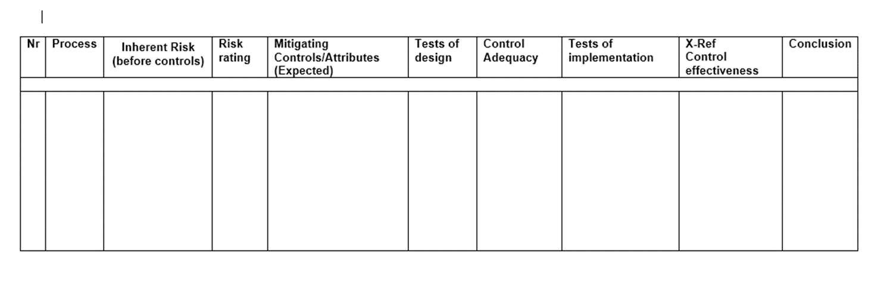

Components
# | Description | Yes | No
1. | Name of (sub)process
2. | Inherent risk(s) to (sub)process
3. | Risk rating
4. | Expected mitigating controls
5. | Tests of control design
6. | Conclusion on control adequacy
7. | Tests of control implementation
8. | Conclusion on control effectiveness
9. | Overall conclusion

