PEMPAL BCOP PARTICIPATION IN OECD MEETING IN ZAGREB
FEEDBACK SURVEY

On May, 23-25, the PEMPAL BCOP participated in the meeting of the OECD Senior Budget Officials from Central, Eastern, and Southeastern Europe (CESEE) and in the workshop of Global Initiative for Fiscal Transparency (GIFT).

After the event, the on-line survey in three languages was created based on of the standard set of questions developed in June 2017. The aim of the survey was to receive event feedback and to inform plans for the future.

Link to the survey – https://www.surveymonkey.com/r/QXZ76BP

The survey started to collect responses on May 28 and finished on June 7, 2018.

Invitations to take part in the survey were sent to 15 BCOP member participants of the event. 9 persons started to response to the survey. In this report, we analyze all 9 responses. For further calculation, we take this quantity as 100%.

All these responses will be included in the general Feedback Event Database.
The questionnaire comprises five parts: About the Respondent, Event Delivery, Event Administration, Overall Impression, and Recommendations for the Future. There is a total of 26 questions in the survey.
ABOUT THE RESPONDENT

Q1 You are...

9 (100%) respondents gave answers. Among them: representatives of PEMPAL country (but not members of the Executive Committee) — 3; representatives of BCOP Executive Committee — 6.
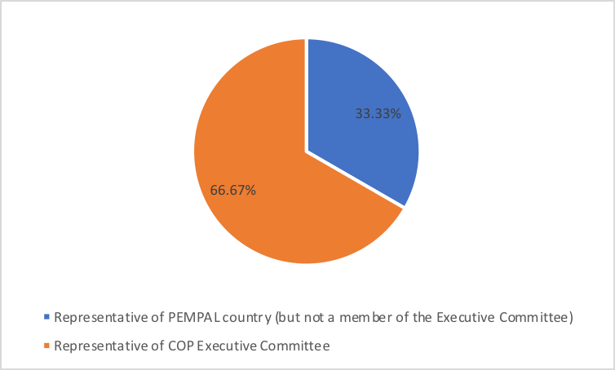

Q2. Was this your first participation in a PEMPAL event?

9 respondents (100%) answered this question.
Answer Options | Response Percent | Response Count
Yes | 22,2% | 2
No | 77,8% | 7

Q3. How many PEMPAL events have you attended before?

This question was seen only by those respondents who chose “No” in the previous question.
7 respondents replied.

1-2 | 3-4 | 5-6 | more than 6 | Response Count
1 | 0 | 1 | 5 | 7
PART I EVENT DELIVERY

Q4. How do you rate your participation in this event?

9 (100%) answers were given. 4 respondents think that their participation in the event was ‘Active’. 5 respondents think that their participation was ‘Average’. No one chose the option “Passive”.

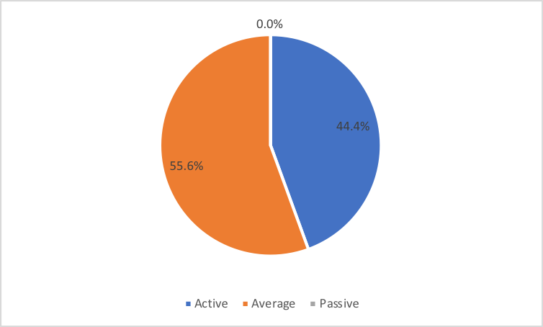

Q5. How do you rate the event duration overall?

9 respondents (100%) answered this question.
Answer choices | Response Percent | Response Count
Too short | 11,1% | 1
About right | 88,9% | 8
Too long | 0,0% | 0

Q6. How much do you agree with the following statements about the participants of the event?
9 respondents (100%) replied to this question.
Answer Options | 1 strongly disagree | 2 | 3 | 4 | 5 Strongly agree | Response Count | Average
a) The level of the event was appropriate for a person with my experience and knowledge | 0 | 0 | 0 | 2 | 7 | 9 | 4,8
b) I learned from the experience of other participants in the event | 0 | 1 | 1 | 1 | 6 | 9 | 4,3
c) Participants had about equal level of prior expertise relevant to the event topics | 0 | 0 | 2 | 3 | 4 | 9 | 4,2
d) Content of presentations, hand-outs and other materials were appropriate for a person with my level of knowledge | 0 | 0 | 2 | 1 | 6 | 9 | 4,4
Q7. What have you learned from other participants?
6 comments were left.

- Practical experience.
- Practices and experiences from different countries.
- This was opportunity to learn more about instruments for strengthening fiscal transparency, preparing spending reviews, etc.
- I learned some interesting ideas that I will try to implement in my practice. For example, a map visualization of capital investment projects and some related information (procurement contracts, actual expenditures etc.).
- Presentations were very informative.
- I have learned a lot about fiscal transparency and especially about the mid-year reviews, which are not prepared in our country.
Q8. How much do you agree with the following statements about the content design of the event?
9 respondents (100%) replied to this question.
Answer Options | 1 strongly disagree | 2 | 3 | 4 | 5 Strongly agree | Response Count | Average
a) The event agenda was properly planned | 0 | 0 | 0 | 4 | 5 | 9 | 4,6
b) The content of the event was properly prepared | 0 | 0 | 0 | 5 | 4 | 9 | 4,4
c) The event addressed issues important to my work | 0 | 0 | 0 | 3 | 6 | 9 | 4,7
d) The event covered a right number of topics for the amount of time available | 0 | 0 | 1 | 3 | 5 | 9 | 4,4
e) Presentations made during the event were relevant and useful | 0 | 0 | 0 | 5 | 4 | 9 | 4,4
f) Enough time was reserved for questions to speakers | 0 | 0 | 0 | 2 | 7 | 9 | 4,8

No informative comments were left:
Q9. How much do you agree with the following statements about the outcomes of the event?
9 responses (100%) were left.
Event objective has been achieved: | 1 strongly disagree | 2 | 3 | 4 | 5 Strongly agree | Response Count | Average
a) Attend the 14h annual meeting of the OECD Senior Budget Officials' regional network for Central, Eastern and South-Eastern European Countries (CESEE- SBO) to review and share recent progress and trends on budgeting reforms of the countries from this region, including in medium-term budgetary frameworks, spending reviews, and budget literacy and participation | 0 | 0 | 0 | 2 | 7 | 9 | 4,8
b) Attend the workshop organized by the Global Initiative for Fiscal Transparency (GIFT) to examine digital tools, information technologies, and citizens’ engagement | 0 | 0 | 0 | 1 | 8 | 9 | 4,9
c) Hold BCOP Executive Committee meeting to discuss progress with BCOP FY2018 action plan implementation, draft for BCOP FY2019 action plan, and the required BCOP inputs to Steering Committee for the upcoming Cross-COP leadership meeting | 0 | 0 | 0 | 1 | 8 | 7 | 4,9

1 comment was left: I'm not a member of Executive Committee so I cannot evaluate the achievement of Executive Committee meeting objective.
Q10. Please rate the quality of the leadership, management and/or technical services provided to the event by the following:
9 responses (100%) were given.
Answer Options | 1 low | 2 | 3 | 4 | 5 high | Response Count | Average
BCOP Executive Committee | 0 | 0 | 0 | 1 | 8 | 9 | 4,9
BCOP Resource Team | 0 | 0 | 0 | 1 | 8 | 9 | 4,9
No comments were left.

Q11. Please rate the quality of services provided by the event speaker(s):
9 responses (100%) were given.
Answer Options | 1 low | 2 | 3 | 4 | 5 high | Response Count | Average
Quality of service | 0 | 0 | 1 | 6 | 21 | 9 | 4,6
1 comment was left: I would like to mention speakers’ good knowledge of topics. But the topics were not new. It seems like we discuss the same things during the last five years.

PART 2 EVENT ADMINISTRATION
Q12. Please rate the quality of the organization and administration of the event:
Answered question – 9 (100%).
Answer Options |  | 1 low | 2 | 3 | 4 | 5 high | Response Count | Average
 | Quality of organization
- choice of venue |  | 0 | 0 | 1 | 0 | 8 | 9 | 4,8
- travel arrangements |  | 0 | 0 | 1 | 0 | 7 | 8 | 4,8
- event logistics |  | 0 | 0 | 0 | 1 | 8 | 9 | 4,9
- contribution provided by hosts |  | 0 | 0 | 0 | 2 | 6 | 8 | 4,8
 | Quality of administration
- Secretariat staff responsiveness |  | 0 | 0 | 0 | 0 | 8 | 8 | 5,0
- written communication |  | 0 | 0 | 1 | 0 | 8 | 9 | 4,8
- participant registration |  | 0 | 0 | 1 | 0 | 8 | 9 | 4,8
There was left 1 comment: As a representative of the host, I cannot evaluate the organization of the trip or the contribution of the host.

Q13. Did you receive agenda and event information in sufficient time before the event for them to be useful?
9 (100%) answers were given. And 100% of responses were “Yes”.
Q14. Did you receive practical information (about the accommodation and other facilities, etc.) prior to the event?
9 (100%) answers were given. And 100% of responses were “Yes”.
Q15. Are you satisfied with the quality of simultaneous interpretation provided during the event?
9 (100%) answers were given.
Answer Options | 1 low | 2 | 3 | 4 | 5 high | Response Count | Average
Quality of sim. interpretation | 0 | 0 | 0 | 6 | 3 | 9 | 4.3

2 informative comments were left:
- There were technical problems with the translation during the Executive Committee meeting. Later they were resolved.
- I propose to send presentations and other prepared materials to interpreters. It would help them to find proper terms for specific definition.
PART 3 OVERALL IMPRESSION
Q16. Did the event disappoint, meet, or exceed your expectations?
9 (100%) answers were given. And 100% of responses were “Meet”.

Q17. What did you like best about the event?
5 comments were left.
Participants like different aspects of the event.
- The opportunity to discuss different topics on reforms in the area of public finance.
- First of all, good organization of the event itself, as well as carefully selected topics and speakers.
- The friendly atmosphere and the possibility to discuss with real professionals.
- Very interesting presentations about Croatian experience.
- Practical examples from the participating countries, as well as discussions after the presentation, which I liked most.

Q18. What did you not like most about the event?
2 informative comments were left:

- A lot of presentations in a short time.
- Everything was good.

Q19. Do you plan to brief your colleagues about the event?
9 (100%) answers were given. And 100% of responses were “Yes”.
Q20. How do you plan to brief your colleagues?
Answered question – 9 (100%). Most of respondents will prepare a back-to-office report.
Answer Options | Response Percent | Response Count
Share materials | 44.4% | 4
Make a presentation | 0% | 0
Prepare a back-to-office report | 88.9% | 8
No comments were given.
Q21. If your Ministry plans to promote this event, or PEMPAL in general, in internal or external media (e.g. MoF or other government website, MoF journal, television, radio, newspapers), please provide specific details so we can report to donors on any positive promotion of the value and benefits of PEMPAL.
1 comment was left: We have published a short notice on the website of the Ministry of Finance: http://www.mfin.hr/hr/novosti/14-sastanak-visih-proracunskih-duznosnika-srednje-istocne-i-jugoistocne-eur
Q22. How much do you agree with the following statement?
9 respondents (100%) answered this question. All the ratings are positive.
Answer Options | 1 not at all | 2 |  | 3 | 4 | 5 completely | Response Count | Average
I will be able to apply the knowledge acquired at this event to my work | 0 | 0 |  | 0 | 3 | 6 | 9 | 4,7
Q23. How can you apply the acquired knowledge?
7 comments were left.
- I will share good practices I heard at the event which could be applied in my country.
- When participating in drafting of the new budget regulations in my country.
- By sharing some good practices.
- I will be able to apply the acquired knowledge in my daily work but also in amending the legislative framework in my country to improve fiscal transparency.
- I will change some widgets of our Fiscal Transparency Portal to create some new pages and new sections.
- When making changes and additions to legislation.
- I will share them with my colleagues. In future document changes, we will take in mind what improvements can be implemented in short term and what improvements can be implemented in long run or after changes in the legal provisions.
Q24. Overall, my satisfaction with the event was...

Answered question – 9 (100%). There were no negative answers.
1 not satisfied | 2 | 3 | 4 | 5 highly satisfied | Response Count | Average
0 | 0 | 0 | 3 | 6 | 9 | 4,7

Q25. If you have any other comments you would like to provide us, please provide them here.

No comments were left.

PART 4 RECOMMENDATIONS FOR THE FUTURE

Q26. Do you have any suggestions to improve the content, approach and other aspects of such events in future:
No comments were left.

