PEMPAL BCOP PLENARY MEETING IN VIENNA
FEEDBACK SURVEY
On March, 14-16, the PEMPAL BCOP Plenary meeting took place in Vienna, Austria.

After the event, the on-line survey in three languages was created on the base of the standard set of questions developed in June 2017. The aim of the survey was to receive event feedback and to learn plans for the future.

Link to the survey – https://www.surveymonkey.com/r/HFZNJPQ

The survey started to collect responses on March 20 and finished on April 4, 2018.
Invitations to take part in the survey were sent to all participants of the event. We sent 60 invitations.
30 persons started to response to the survey. In this report, we analyze all 30 responses. For further calculation, we take this quantity as 100%.

All these responses will be included in the general Feedback Event Database.
The questionnaire comprises five parts: About the Respondent, Event Delivery, Event Administration, Overall Impression, and Recommendations for the Future. There are a total of 27 questions in the survey.
ABOUT THE RESPONDENT

Q1 You are...

29 (96.7%) respondents gave answers. Among them: representatives of PEMPAL country (but not members of the Executive Committee) — 20; representatives of BCOP Executive Committee — 7; invited experts — 2.
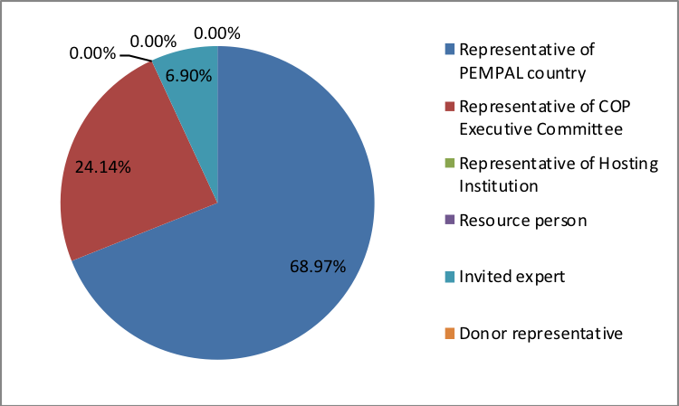

Q2. Was this your first participation in a PEMPAL event?

29 respondents (96.7%) answered this question.
Answer Options | Response Percent | Response Count
Yes | 10,3% | 3
No | 89,7% | 26

Q3. How many PEMPAL events have you attended before?

This question was seen only by those respondents who chose “No” in the previous question.
26 respondents replied.

1-2 | 3-4 | 5-6 | more than 6 | Response Count
5 | 7 | 4 | 10 | 26
PART I EVENT DELIVERY

Q4. How do you rate your participation in this event?

29 (96.7%) answers were given. 16 respondents think that their participation in the event was ‘Active’. 13 respondents think that their participation was ‘Average’. No one chose the option “Passive”.

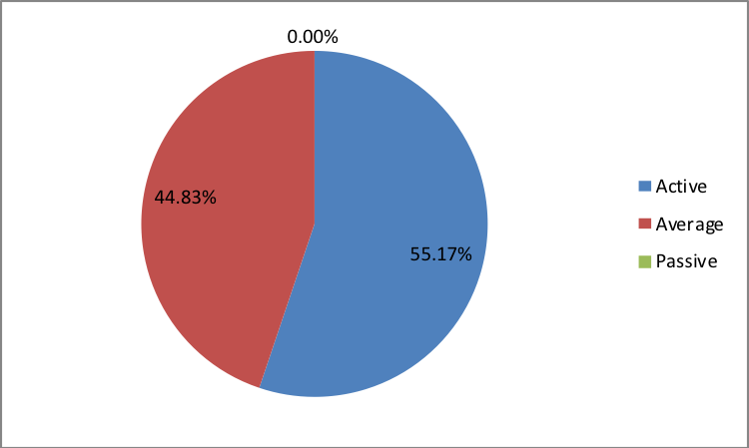

Q5. How do you rate the event duration overall?

29 respondents (96.7%) answered this question.

Answer choices | Response Percent | Response Count
Too short | 10,3% | 3
About right | 86,2% | 25
Too long | 3,5% | 1

Q6. How much do you agree with the following statements about the participants of the event?
29 respondents (96.7%) replied to this question.
Answer Options | 1 strongly disagree | 2 | 3 | 4 | 5 Strongly agree | Response Count | Average
a) The level of the event was appropriate for a person with my experience and knowledge | 0 | 0 | 2 | 9 | 18 | 29 | 4,6
b) I learned from the experience of other participants in the event | 0 | 0 | 3 | 8 | 18 | 29 | 4,5
c) Participants had about equal level of prior expertise relevant to the event topics | 0 | 0 | 3 | 16 | 10 | 29 | 4,2
d) Content of presentations, hand-outs and other materials were appropriate for a person with my level of knowledge | 0 | 0 | 1 | 9 | 19 | 29 | 4,6
Q7. What have you learned from other participants?
19 comments were left.
- Georgia presentation of the budget. Comparison for intergovernmental relations - central and local governments.
- Ways of drafting and presenting the citizens' budget.
- That the problems we are facing are similar and that the success of implementation depends on the expertise but also on the political will.
- Experience of other participants on the quality of performance indicators and budget transparency gave us an indication of how to do it and apply it in our country.
- I have learned a lot from other countries participants since we have the experiences of each country and have discussed many modalities
- Concrete proposals by the representatives of countries on program budgeting transparency.
- Different views related to certain budget reform issues.
- Ways and modalities of involving citizens and the public in budgeting, how other countries work on this. How program budgeting is implemented in other countries (particularly the examples of Russia and Serbia presented at the workshop were useful). - how it is possible to establish the program structure and hierarchy of goals, how to tie costs for programs, etc. Good practices in defining performance indicators. Problems and challenges that other countries face and the ways in which they overcome them.
- It was useful to hear knowledge and experiences from other countries.
- We exchanged our experience in our budget policy and implemented or work-in-progress practices.
- Mechanisms of public participation in budget process in Georgia.
- Many countries encounter almost the same problems: unclear/poor quality of expected results, poor quality of indicators, large number of performance indicators, etc. and share their experience on overcoming these problems. Russia's experience in creating a budget for citizens at the local level. Using performance indicators in providing target transfers.
- I learned a lot on up-to-date information on inter-budgetary relations in PEMPAL countries, on budget process in Austria, and on new tools for budget openness in other countries, for example, about the Georgian open budget portal.
- The tools that can be used to increase budget transparency and citizen participation in budget process.
- To not be afraid to express my own opinion.
- I have learned about other practitioners’ own experience in performance budgeting and budget participation through various examples from their practice.
- Good practices to motivate citizens to participate in budget process and budget literacy.
- The Russian Federation is making public contracts with agency performance indicators. Program budgeting has been introduced, but some areas have remained outside the program. Georgia has carried out significant budget reforms, particularly in the area of transparency, and has thus significantly advanced the survey on budget openness for 2017 by taking the 5th place. In order to increase public participation in public finance oversight, the Internet Budget Monitoring Platform was created.
- From Georgia – budget transparency experience.
Q8. How much do you agree with the following statements about the content design of the event?
29 respondents (96.7%) replied to this question.
Answer Options | 1 strongly disagree | 2 | 3 | 4 | 5 Strongly agree | Response Count | Average
a) The event agenda was properly planned | 0 | 1 | 2 | 3 | 23 | 29 | 4,7
b) The content of the event was properly prepared | 0 | 0 | 0 | 6 | 22 | 28 | 4,8
c) The event addressed issues important to my work | 0 | 0 | 1 | 5 | 23 | 29 | 4,8
d) The event covered a right number of topics for the amount of time available | 0 | 2 | 0 | 6 | 21 | 29 | 4,6
e) The topics for the group discussions were relevant | 0 | 0 | 1 | 6 | 21 | 28 | 4,7
f) Enough time was reserved for group discussions | 0 | 0 | 0 | 7 | 22 | 29 | 4,8
g) Presentations made during the event were relevant and useful | 0 | 0 | 1 | 9 | 19 | 29 | 4,6
h) Enough time was reserved for questions to speakers | 0 | 0 | 0 | 3 | 26 | 29 | 4,9

4 informative comments were left:
- The meeting sessions were very well organized.
- Special praise for the additional time given to the participants for discussion and questions. All praise for extraordinary event organization and excellent planned schedule.
- In my opinion, it is necessary to consider experience of other PEMPAL COPs, as well as similar networks, for example PEMNA, about ways of activating the work of participants at similar events. For example, distribution of roles between participants in discussion sessions.
- Information given by some speakers was outdated for example for 2014.
Q9. How much do you agree with the following statements about the outcomes of the event?
29 responses (96.7%) were left.
Event objectives has been achieved: | 1 strongly disagree | 2 | 3 | 4 | 5 Strongly agree | Response Count | Average
a) Provide the opportunity for BCOP member countries to review approaches and trends in intergovernmental fiscal relations, familiarize with developments in OECD countries and discuss possible approaches and options for PEMPAL countries | 0 | 1 | 2 | 9 | 17 | 29 | 4,4
b) Provide the opportunity for broad BCOP membership to review practices and approaches on the issues of BCOP Working Groups focus in the past year - use of performance indicators in performance budgeting and public participation. Get feedback from BCOP members on the BCOP Working Groups’ most recent work on knowledge products: a. Performance Indicators in PEMPAL Countries: Trends and Challenges (by BCOP Program and Performance Budgeting Working Group)b. Public Participation in Fiscal Policy and the Budget Process – How to establish and/or strengthen mechanisms in PEMPAL countries (by BCOP Budget Transparency and Literacy Working Group) | 0 | 1 | 2 | 9 | 17 | 29 | 4,4
с) Update members on BCOP progress since the last plenary meeting and to report back on countries’ priorities gathered in the pre-meeting survey to inform the development of the BCOP Action Plan 2018-19. | 0 | 0 | 1 | 5 | 23 | 29 | 4,8

1 comment was left:
Most PEMPAL countries develop performance indicators, but program and performance budgeting is a lengthy reform in which we need experts. Most governments that have developed good central government indicators still have problems at lower level governments. At this event, we had opportunity to listen to the expert presentations, but also to share experiences that greatly help us in further work. Both working groups have made great progress. Some knowledge products were prepared (or are under preparation): Performance Indicators in PEMPAL Countries, Breaking Challenges in Preparation of Citizens’ Budgets in PEMPAL Countries, and Public Participation in Fiscal Policy and Budgetary Processes. It was agreed that the themes associated with program planning and performance budgeting would be a priority for BCOP in the future years as well and to continue learning from the OECD countries on methodological approaches to performance budgeting.
Q10. Please rate the quality of the leadership, management and/or technical services provided to the event by the following:
29 responses (96.7/%) were given.
Answer Options | 1 low | 2 | 3 | 4 | 5 high | Response Count | Average
BCOP Executive Committee | 0 | 0 | 0 | 4 | 25 | 29 | 4,9
BCOP Resource Team | 0 | 0 | 0 | 5 | 22 | 27 | 4,8

4 comments were left:
- Excellent organization and properly selected topics.
- Resource team has done a great job of organizing and bringing experts to the event. Executive Committee is increasingly involved in organization and conduct of the gathering.
- As stated earlier, I think that the overall organization of events, content of the presentations and available documents, moderations were at an extremely high level.
- Great.
Q11. Please rate the quality of services provided by the event speaker(s):
29 responses (96.7%) were given.
Answer Options | 1 low | 2 | 3 | 4 | 5 high | Response Count | Average
Quality of service | 0 | 0 | 2 | 6 | 21 | 29 | 4,7
4 comments were left:
- All speakers showed a good knowledge of the topic they presented and provided important information.
- All presenters have great expertise in PFM, so their participation and answers to participants’ questions expanded the knowledge of participants.
- I think that the question about quality of ‘services” was designed incorrectly. PEMPAL events are the meetings of colleagues, professionals, single minders, dedicated to opinion and experience exchange on an equal footing and in an atmosphere of mutual respect, rather than "providing services." Such a statement of the issue indirectly contributes to the corresponding perception of PEMPAL events by individual participants, which cannot be assessed positively. Please take into account in further surveys. Thank you.
- All speakers were well-prepared and experts in the area they exhibited. Presentations contained a sufficient level of detail and all the questions we asked were answered.

PART 2 EVENT ADMINISTRATION
Q12. Please rate the quality of the organization and administration of the event:
Answered question – 28 (93.3%).
Answer Options |  | 1 low | 2 | 3 | 4 | 5 high | Response Count | Average
 | Quality of organization
- choice of venue |  | 0 | 0 | 0 | 2 | 26 | 28 | 4,9
- travel arrangements |  | 0 | 0 | 0 | 2 | 25 | 27 | 4,9
- event logistics |  | 0 | 0 | 0 | 3 | 24 | 27 | 4,9
- contribution provided by hosts |  | 0 | 0 | 0 | 7 | 19 | 26 | 4,7
 | Quality of administration
- Secretariat staff responsiveness |  | 0 | 0 | 0 | 1 | 27 | 28 | 5,0
- written communication |  | 0 | 0 | 0 | 1 | 26 | 27 | 5,0
- participant registration |  | 0 | 0 | 0 | 2 | 26 | 28 | 4,9
There were left 4 informative comments.
- Highly professional.
- Organization and administration of event were at a high level. Secretariat was at all times involved in the service by solving each problem in early stage.
- Praise.
- Thank you!

Q13. Did you receive agenda and event information in sufficient time before the event for them to be useful?
28 (93.3%) answers were given. And 100% of responses were “Yes”.
Q14. Did you receive practical information (about the accommodation and other facilities, etc.) prior to the event?
28 (93.3%) answers were given. And 100% of responses were “Yes”.
Q15. Are you satisfied with the quality of simultaneous interpretation provided during the event?
28 (93.3%) answers were given.
Answer Options | 1 low | 2 | 3 | 4 | 5 high | Response Count | Average
Quality of sim. interpretation | 0 | 0 | 1 | 7 | 20 | 28 | 4.7

2 informative comments were left:
- Translation was very good. Translators were also available during informal talks.
- Translation of certain terms in oral form and in writing in presentation materials did not coincide, which caused certain difficulties with perception and understanding of the material.
Q16. Are you satisfied with the quality of written translation of event materials?
27 (90%) answers were given.
Answer Options | 1 low | 2 | 3 | 4 | 5 high | Response Count | Average
Quality of written translation | 0 | 0 | 0 | 8 | 19 | 27 | 4,7

1 comment was left.
Some of the presentations seen during speeches differed in composition of the slides from those that the participants had on their hands in the translated version. Perhaps, it is advisable to inform the speakers in addition about undesirability of additional processing of presentations.
PART 3 OVERALL IMPRESSION

Q17. Did the event disappoint, meet, or exceed your expectations?

28 (93.3%) participants answered the question.
Answer Options | Response Percent | Response Count
Disappoint | 0,0% | 0
Meet | 75% | 21
Exceed | 25% | 7

Q18. What did you like best about the event?

19 comments were left.
Participants like different aspects of the event: but most of them mentioned experience exchange.
- Inter-fiscal relations and Georgia's presentation.
- Ratio between presentations by experts and representatives of PEMPAL member countries.
- Meeting with the group of colleagues and discussing specific technical topics.
- Comparative overview of the countries’ achievements in the topics that were dealt with and ability to see the progress of individual countries.
- All events have been organized as always at a high level, as the Secretariat of the PEMPAL is committed and coordinates well with the BCOP working groups and with all BCOP members, making sure that everything is clear to all participants
- Some specific presentations.
- Quality of presentations.
- Many concrete examples from member countries' practice, enough time for discussion and questions, working in groups was also particularly useful because we could find out more details in smaller groups. Some of the useful materials will be available later on the PEMPAL website.
- Work in groups and concrete examples of countries.
- Possibility to ask questions and to discuss in groups including to hear opinions of the international experts.
- Active participation of BCOP participants is growing every year. This year also GIFT (Mr. Guerrero) used a new form of presentation to involve participants from PEMPAL countries in delivering the presentation as well.
- Experience exchange in the budget sphere with participants from other countries.
- Substantive presentations were prepared by adequate speakers.
- I liked most the opportunity to meet experts from other PEMPAL countries and to discuss important budget issues together with the lecturers. I liked the organization of the plenary meeting.
- Sessions were very well planned, and the agenda was comprehensive and covered all important segments of the planned topics.
- Event organization, experience of experts.
- Friendly atmosphere, honest high-level discussions.
- The variety of participants.
- New format of discussion of country experience in small groups.

Q19. What did you not like most about the event?
8 informative comments were left. 3 of them were “Nothing” or “I'm very satisfied, it's everything OK”.

The remaining 5 comments:

- It was too short.
- Certain participants asking questions that are not related to the topics of presentations.
- Not all members actively participated in the discussions
- Early beginning (08.30).
- Too intensive agenda.

Q20. Do you plan to brief your colleagues about the event?
28 (93.3%) participants answered the question. And 100% of them responded “Yes”.
Q21. How do you plan to brief your colleagues?
Answered question –27 (90%).
Answer Options | Response Percent | Response Count
Share materials | 77,9% | 21
Make a presentation | 7,4% | 2
Prepare a back-to-office report | 66,7% | 18
4 comments were given:
- I have shared the discussions.
- As I participate in all budget reform processes in my country, I will learn how to use it in further work with colleagues.
- I've already distributed materials via e-mail and drew attention to several presentations that are particularly useful for my country at this moment. This was preceded by the oral briefing to my manager and working colleagues (heads of departments in the Budget Sector) at an internal meeting, where I introduced them content of the working group and targeted several activities that we could undertake and apply in our country. Also, at that time, we agreed to make the materials available to colleagues, after which we will determine the date of the new meeting where we will consider the proposals and determine the steps that will be taken further.
- Send links to the materials.
Q22. If your Ministry plans to promote this event, or PEMPAL in general, in internal or external media (e.g. MoF or other government website, MoF journal, television, radio, newspapers), please provide specific details so we can report to donors on any positive promotion of the value and benefits of PEMPAL.
4 comments were left.
- As a lecturer at seminars and workshops for employees in ministries, other budget users and local and regional self-government units (municipalities, cities, counties), I always promote PEMPAL and PEMPAL countries' experiences.
- I will be in touch with you.
- Presentations, hand-out materials and report are published in MoF Intranet.
- Deputy Minister who participated in the event will send his report to the Government for approval.
Q23. How much do you agree with the following statement?
28 respondents (93.3%) answered this question. Average rating is positive.
Answer Options | 1 not at all | 2 | 3 | 4 | 5 completely | Response Count | Average
I will be able to apply the knowledge acquired at this event to my work | 0 | 1 | 5 | 8 | 14 | 28 | 4,25
Q24. How can you apply the acquired knowledge?
14 comments were left.
- Can use the materials that were presented in this meeting.
- I will be participating in working group on further public finance reforms in my country, including amendments to the Budget Act and by-laws. Immediately after return from this meeting, we start to work on the amendments to the Budget Act. We will pay special attention to increasing budget openness, as we learnt at this meeting, as well as in the Working Group on Budget Literacy and Transparency.
- I will try to convince decision makers about the importance of citizens' involvement in the budget process
- Examples of good practices will be implemented in our procedures.
- When preparing budget documents, we will make certain improvements based on the acquired knowledge in relation to defining the performance indicators as necessary, and we will also work on raising budget process transparency.
- The knowledge gained by PEMPAL can be applied to my work greatly, as many conversations and discussions are related to our every-day work and are very useful and productive for me and the institution in which I work.
- We cannot apply the acquired knowledge in program and performance budgeting yet because we do not have yet a program budget, but when it comes to transparency, we can propose concrete measure which we learnt in PEMPAL.
- In preparing specific reform proposal in my country.
- As I already mentioned, I already sent the meeting materials to my colleagues and management and suggested good practices that we can apply in my country. Since I am directly involved in developing amendments to the legislation as well as in drafting bylaws that will include program budgeting and increase of budget transparency, the acquired knowledge will be directly applied in my proposals of these documents.
- I will apply the acquired knowledge when developing policy and methodology, as well as in my training on program budgeting.
- In my daily work.
- In drafting normative documents.
- In preparation of proposals using good practices to motivate citizens to participate in budget process and to improve the quality of budget documents.
- I can apply the acquired knowledge in preparing budget documents, reports and presentations as well as in developing the next edition of the Budget for Citizens.
Q25. Overall, my satisfaction with the event was...

Answered question – 28 (93.3%). There were no negative answers.
1 not satisfied | 2 | 3 | 4 | 5 highly satisfied | Response Count | Average
0 | 0 | 0 | 8 | 20 | 28 | 4,7

Q26. If you have any other comments you would like to provide us, please provide them here.

1 informative comment was left:

For other PEMPAL events in the future I wish you permanent success and good work.

PART 4 RECOMMENDATIONS FOR THE FUTURE

Q27. Do you have any suggestions to improve the content, approach and other aspects of such events in future:
1 informative comment was left:
For me everything is ok and professional.

