PEMPAL BCOP PBB WG MEETING IN VIENNA
FEEDBACK SURVEY
On March, 13, the PEMPAL BCOP workshop of the Program and Performance Budgeting Working Group took place in Vienna, Austria.

After the event, the on-line survey in three languages was created on the base of the standard set of questions developed in June 2017. The aim of the survey was to receive event feedback and to learn plans for the future.

Link to the survey – https://www.surveymonkey.com/r/HXRVF6P

The survey started to collect responses on March 22 and finished on March 30, 2018.
Invitations to take part in the survey were sent to all participants of the event. We sent 18 invitations.
9 persons started to response to the survey. In this report, we analyze all 9 responses. For further calculation, we take this quantity as 100%.

All these responses will be included in the general Feedback Event Database.
The questionnaire comprises five parts: About the Respondent, Event Delivery, Event Administration, Overall Impression, and Recommendations for the Future. There are a total of 27 questions in the survey.
ABOUT THE RESPONDENT

Q1 You are...

9 (100%) respondents gave answers. Among them: representatives of PEMPAL country (but not members of the Executive Committee) — 5; representatives of BCOP Executive Committee — 4.
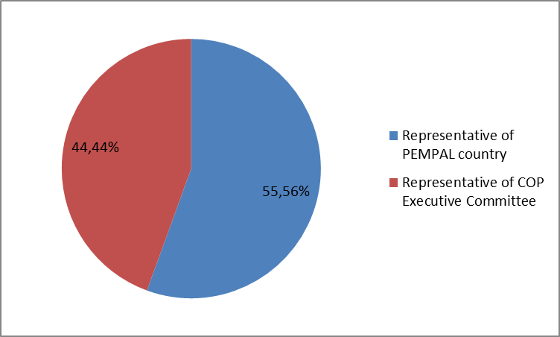

Q2. Was this your first participation in a PEMPAL event?

9 respondents (100%) answered this question. And 100% of them replied “No”.
Q3. How many PEMPAL events have you attended before?

This question was seen only by those respondents who chose “No” in the previous question.
In this case all 9 respondents replied.

1-2 | 3-4 | 5-6 | more than 6 | Response Count
1 | 1 | 2 | 5 | 9
PART I EVENT DELIVERY

Q4. How do you rate your participation in this event?

9 (100%) answers were given. 6 respondents think that their participation in the event was ‘Active’. 3 respondents think that their participation was ‘Average’. No one chose the option “Passive”.

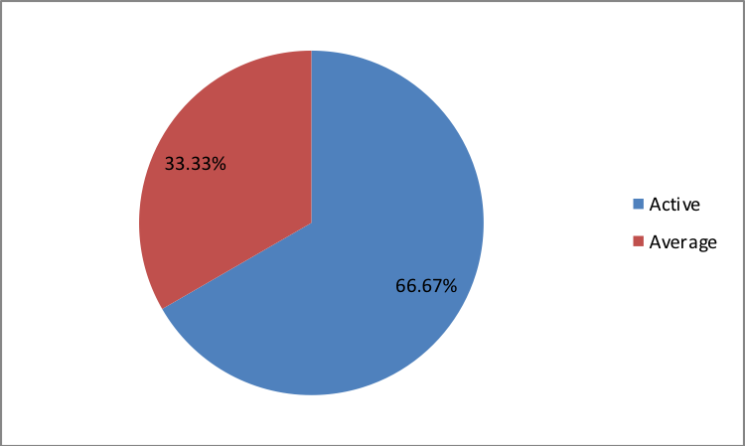

Q5. How do you rate the event duration overall?

9 respondents (100%) answered this question.

Answer choices | Response Percent | Response Count
Too short | 11.1% | 1
About right | 88.9% | 8
Too long | 0,0% | 0

Q6. How much do you agree with the following statements about the participants of the event?
9 respondents (100%) replied to this question.
Answer Options | 1 strongly disagree | 2 | 3 | 4 | 5 Strongly agree | Response Count | Average
a) The level of the event was appropriate for a person with my experience and knowledge | 0 | 0 | 0 | 1 | 8 | 9 | 4,9
b) I learned from the experience of other participants in the event | 0 | 0 | 1 | 2 | 6 | 9 | 4,6
c) Participants had about equal level of prior expertise relevant to the event topics | 0 | 0 | 2 | 4 | 3 | 9 | 4,1
d) Content of presentations, hand-outs and other materials were appropriate for a person with my level of knowledge | 0 | 0 | 0 | 0 | 8 | 8 | 5
Q7. What have you learned from other participants?
7 comments were left.
- Particularly interesting and useful information of representatives of other countries about the challenges, problems and risks they have faced during implementation of new budget instruments, as well as the measures that were being taken to preempt or reduce the negative impact. This is important to take into account when developing and implementing reforms in our country.
- In Austria, the Parliament adopts the general budget, while the details are only given to the parliament as additional information.
- I learned a lot of interesting good practices from other countries.
- Experience how to implement PBB and program budgeting.
- Experience in PFM reform from Austria – PPB implementation, impact assessment mechanism and budget structure.
- Experience receive in the discussions is very useful for our work.
- Performance information, key elements of program budgeting, role of MoF in RIA statement, Performance Management and Impact Assessments, Role of Federal Performance Management Office.
Q8. How much do you agree with the following statements about the content design of the event?

9 respondents (100%) replied to this question.
Answer Options | 1 strongly disagree | 2 | 3 | 4 | 5 Strongly agree | Response Count | Average
a) The event agenda was properly planned | 0 | 0 | 0 | 1 | 8 | 9 | 4,9
b) The content of the event was properly prepared | 0 | 0 | 0 | 2 | 7 | 9 | 4,8
c) The event addressed issues important to my work | 0 | 0 | 0 | 1 | 8 | 9 | 4,9
d) The event covered a right number of topics for the amount of time available | 0 | 0 | 0 | 4 | 5 | 9 | 4,6
e) Presentations made during the event were relevant and useful | 0 | 0 | 0 | 3 | 6 | 9 | 4,7
f) Enough time was reserved for questions to speakers | 0 | 0 | 1 | 2 | 6 | 9 | 4,6

2 informative comments were left:
- Like all the events so far, this one was prepared at the highest level. It included the topics that were useful for the work of all participants.
- Everything was okay and has fulfilled my expectations from this event.

Q9. How much do you agree with the following statements about the outcomes of the event?
9 responses (100%) were left.
Event objectives has been achieved: | 1 strongly disagree | 2 | 3 | 4 | 5 Strongly agree | Response Count | Average
Discuss the performance budgeting in Austria with the Austrian Ministry of Finance and the Federal Chancellery of Austria and identify lessons learnt from the Austrian experiences that may be applicable for PEMPAL countries. | 0 | 0 | 0 | 3 | 6 | 9 | 4,7

1 comment was left:
The aim of the public finance reform in Austria was to increase fiscal discipline. Effective planning and gender sensitive budgeting were introduced in the Constitution. Since 2013, accounting principles have been introduced in accounting, but also in budgeting and performance planning. A performance contract was signed. It is important to know who is responsible for it.
Q10. Please rate the quality of the leadership, management and/or technical services provided to the event by the following:
9 responses (100/%) were given. And all respondents gave the highest ranking to work f BCOP Executive Committee and resource team
2 comments were left:
- Good organization, friendly atmosphere.
- The resource team has done a great job of organizing and bringing experts to the event. The Executive Committee is increasingly involved in organizing and conducting the meeting.
Q11. Please rate the quality of services provided by the event speaker(s):
9 responses (100/%) were given.
Answer Options | 1 low | 2 | 3 | 4 | 5 high | Response Count | Average
Quality of service | 0 | 0 | 0 | 2 | 7 | 9 | 4,8
1 comment was left:
All speakers showed good knowledge of the subject they exposed and provided us with important information.

PART 2 EVENT ADMINISTRATION
Q12. Please rate the quality of the organization and administration of the event:
Answered question – 9 (100%).
Answer Options |  | 1 low | 2 | 3 | 4 | 5 high | Response Count | Average
 | Quality of organization
- choice of venue |  | 0 | 0 | 0 | 0 | 9 | 9 | 5
- travel arrangements |  | 0 | 0 | 0 | 0 | 9 | 9 | 5
- event logistics |  | 0 | 0 | 0 | 0 | 9 | 9 | 5
- contribution provided by hosts |  | 1 | 0 | 0 | 2 | 6 | 9 | 4,3
 | Quality of administration
- Secretariat staff responsiveness |  | 0 | 0 | 0 | 2 | 7 | 9 | 4,8
- written communication |  | 0 | 0 | 0 | 2 | 7 | 9 | 4,8
- participant registration |  | 0 | 0 | 0 | 1 | 8 | 9 | 4,9
There was left 1 informative comment.
Organization and administration of events were at a high level. Secretariat was at all times involved in the service by solving each problem at an early stage.

Q13. Did you receive agenda and event information in sufficient time before the event for them to be useful?
9 (100%) answers were given. And 88.9% of responses were “Yes”. 1 respondent replied “No”.
Q14. Did you receive practical information (about the accommodation and other facilities, etc.) prior to the event?
9 (100%) answers were given. And 100% responses were “Yes”.
Q15. Are you satisfied with the quality of simultaneous interpretation provided during the event?
9 (100%) answers were given.
Answer Options | 1 low | 2 | 3 | 4 | 5 high | Response Count | Average
Quality of sim. interpretation | 0 | 0 | 0 | 4 | 5 | 9 | 4.6

1 informative comment was left:
- Translation was very good. Translators were also available during informal talks.
Q16. Are you satisfied with the quality of written translation of event materials?
8 (88.9%) answers were given.
Answer Options | 1 low | 2 | 3 | 4 | 5 high | Response Count | Average
Quality of written translation | 0 | 0 | 0 | 2 | 6 | 8 | 4.75

PART 3 OVERALL IMPRESSION
Q17. Did the event disappoint, meet, or exceed your expectations?

9 (100%) participants answered the question.
Answer Options | Response Percent | Response Count
Disappoint | 0,0% | 0
Meet | 88.9% | 8
Exceed | 11.1% | 1

Q18. What did you like best about the event?

6 comments were left.
Participants like different aspects of the event:

- Most of all I liked that we had the chance to hear the Austrian experience as well as the experience of other countries.
- Possibility to discuss PFM reforms with colleagues and international experts, informal communication.
- Agenda.
- The Austrian experience in PBB.
- Austrian experience in implementing PBB.
- Performance Management and Impact Assessments at the federal level of government Austria.

Q19. What did you not like most about the event?
2 informative comments were left:

- Little time to get acquainted with Vienna. I would like to have at least a small tour.
- I have no objections.

Q20. Do you plan to brief your colleagues about the event?
9 (100%) participants answered the question. And 100% of them responded “Yes”.
Q21. How do you plan to brief your colleagues?
Answered question – 9 (100%).
Answer Options | Response Percent | Response Count
Share materials | 88.9% | 8
Make a presentation | 22.2% | 2
Prepare a back-to-office report | 88.9% | 8
2 comments were given:
- As I participate in all the budget process reforms in my country, I will be able to use it in further work with my colleagues.
- I will prepare a plan of measures to implement the experience.
Q22. If your Ministry plans to promote this event, or PEMPAL in general, in internal or external media (e.g. MoF or other government website, MoF journal, television, radio, newspapers), please provide specific details so we can report to donors on any positive promotion of the value and benefits of PEMPAL.
4 comments were left and all of them are informative.
- As a lecturer at seminars and workshops for employees in ministries, other budget users and local and regional self-government units (municipalities, cities, counties) I always promote PEMPAL and other countries' experiences.
- A press release will be published on the Ministry of Finance' website.
- Material will be used in our work.
- This issue will be discussed with the decision makers in the finance ministry.
Q23. How much do you agree with the following statement?
8 respondents (88.9%) answered this question. Average rating is positive.
Answer Options | 1 not at all | 2 | 3 | 4 | 5 completely | Response Count | Average
I will be able to apply the knowledge acquired at this event to my work | 0 | 0 | 0 | 3 | 5 | 8 | 4,6
Q24. How can you apply the acquired knowledge?
8 comments were left.
- Directly.
- Participating in working groups discussing on further public finance reforms, including amendments to the Budget Act and by-laws. Immediately after return from this meeting, we start to work on the amendments to the Budget Act. We will also pay special attention to increasing budget openness, as we learnt at the plenary meeting, as well as in the Working Group on Budget Literacy and Transparency.
- Some elements of learnt Austrian experience will be used in improvement of the normative and methodological basis for formation and implementation of the state programs, as well as in development of the conceptual documents on PFM improving.
- In our daily work in developing approaches and methodology, as well as in the ongoing trainings on program budgeting.
- As a head of the methodology department of the budget process, treasury execution, internal audit and financial control, I can use the acquired knowledge when preparing the NRA, the plan-measures for improving the management of public finances, when preparing the draft budget, etc.
- By changing methodologies, classification and training people involved.
- In developing normative documents.
- At the moment this is not possible since we have budgeting based on the organizational structure but once the conditions for the transition to the program budgeting are met - the budgeting based on the performance I am willing to organize meetings and trainings with the budget staff first in the Ministry of Finance and then with officials of the line ministries.
Q25. Overall, my satisfaction with the event was...

Answered question – 9 (100%). There were no negative answers.
1 not satisfied | 2 | 3 | 4 | 5 highly satisfied | Response Count | Average
0 | 0 | 0 | 2 | 7 | 9 | 4,8

Q26. If you have any other comments you would like to provide us, please provide them here.

1 informative comment was left:

Thank you for possibility to learn the latest international tendencies in the budget sphere.

PART 4 RECOMMENDATIONS FOR THE FUTURE

Q27. Do you have any suggestions to improve the content, approach and other aspects of such events in future?
5 informative comments were left:
- Material translation into Russian requires improvement, especially in terms of terminology.
- It would be useful to develop guidelines on the effectiveness criteria, evaluation of effectiveness, and so on until the next event.
- To dedicate more tome in order to discuss in detail the topic.
- Everything was on a high level.
- To take example of connection between strategic documents, Economic Reform Program, Medium Term Expenditure Framework with the annual budget in specific sectors (education, health) evaluated with objectives and measures indicators such us outcomes and outputs and to make measures between planned and achieved-effectivity.

