Meeting of the PEMPAL Treasury Community of Practice Working Group on Use of Information Technologies in Treasury Operations
_____________________________________________________________
Vienna, Austria, March 20-22, 2017
On March 20-22, 2017, representatives of PEMPAL Treasury Community of Practice (TCOP) went on a study visit to the Federal Ministry of Finance of Austria. The main objective of the visit was to familiarize the participants with the main features and functionalities of the Austrian Financial Management Information System (FMIS) SAP R/3. The meeting was attended by nineteen participants representing 8 PEMPAL countries (Albania, Azerbaijan, Belarus, Georgia, Kazakhstan, Moldova, Russian Federation, and Ukraine) and facilitated by the World Bank resource team working with TCOP. Logistical support for the visit was provided by the PEMPAL Secretariat.
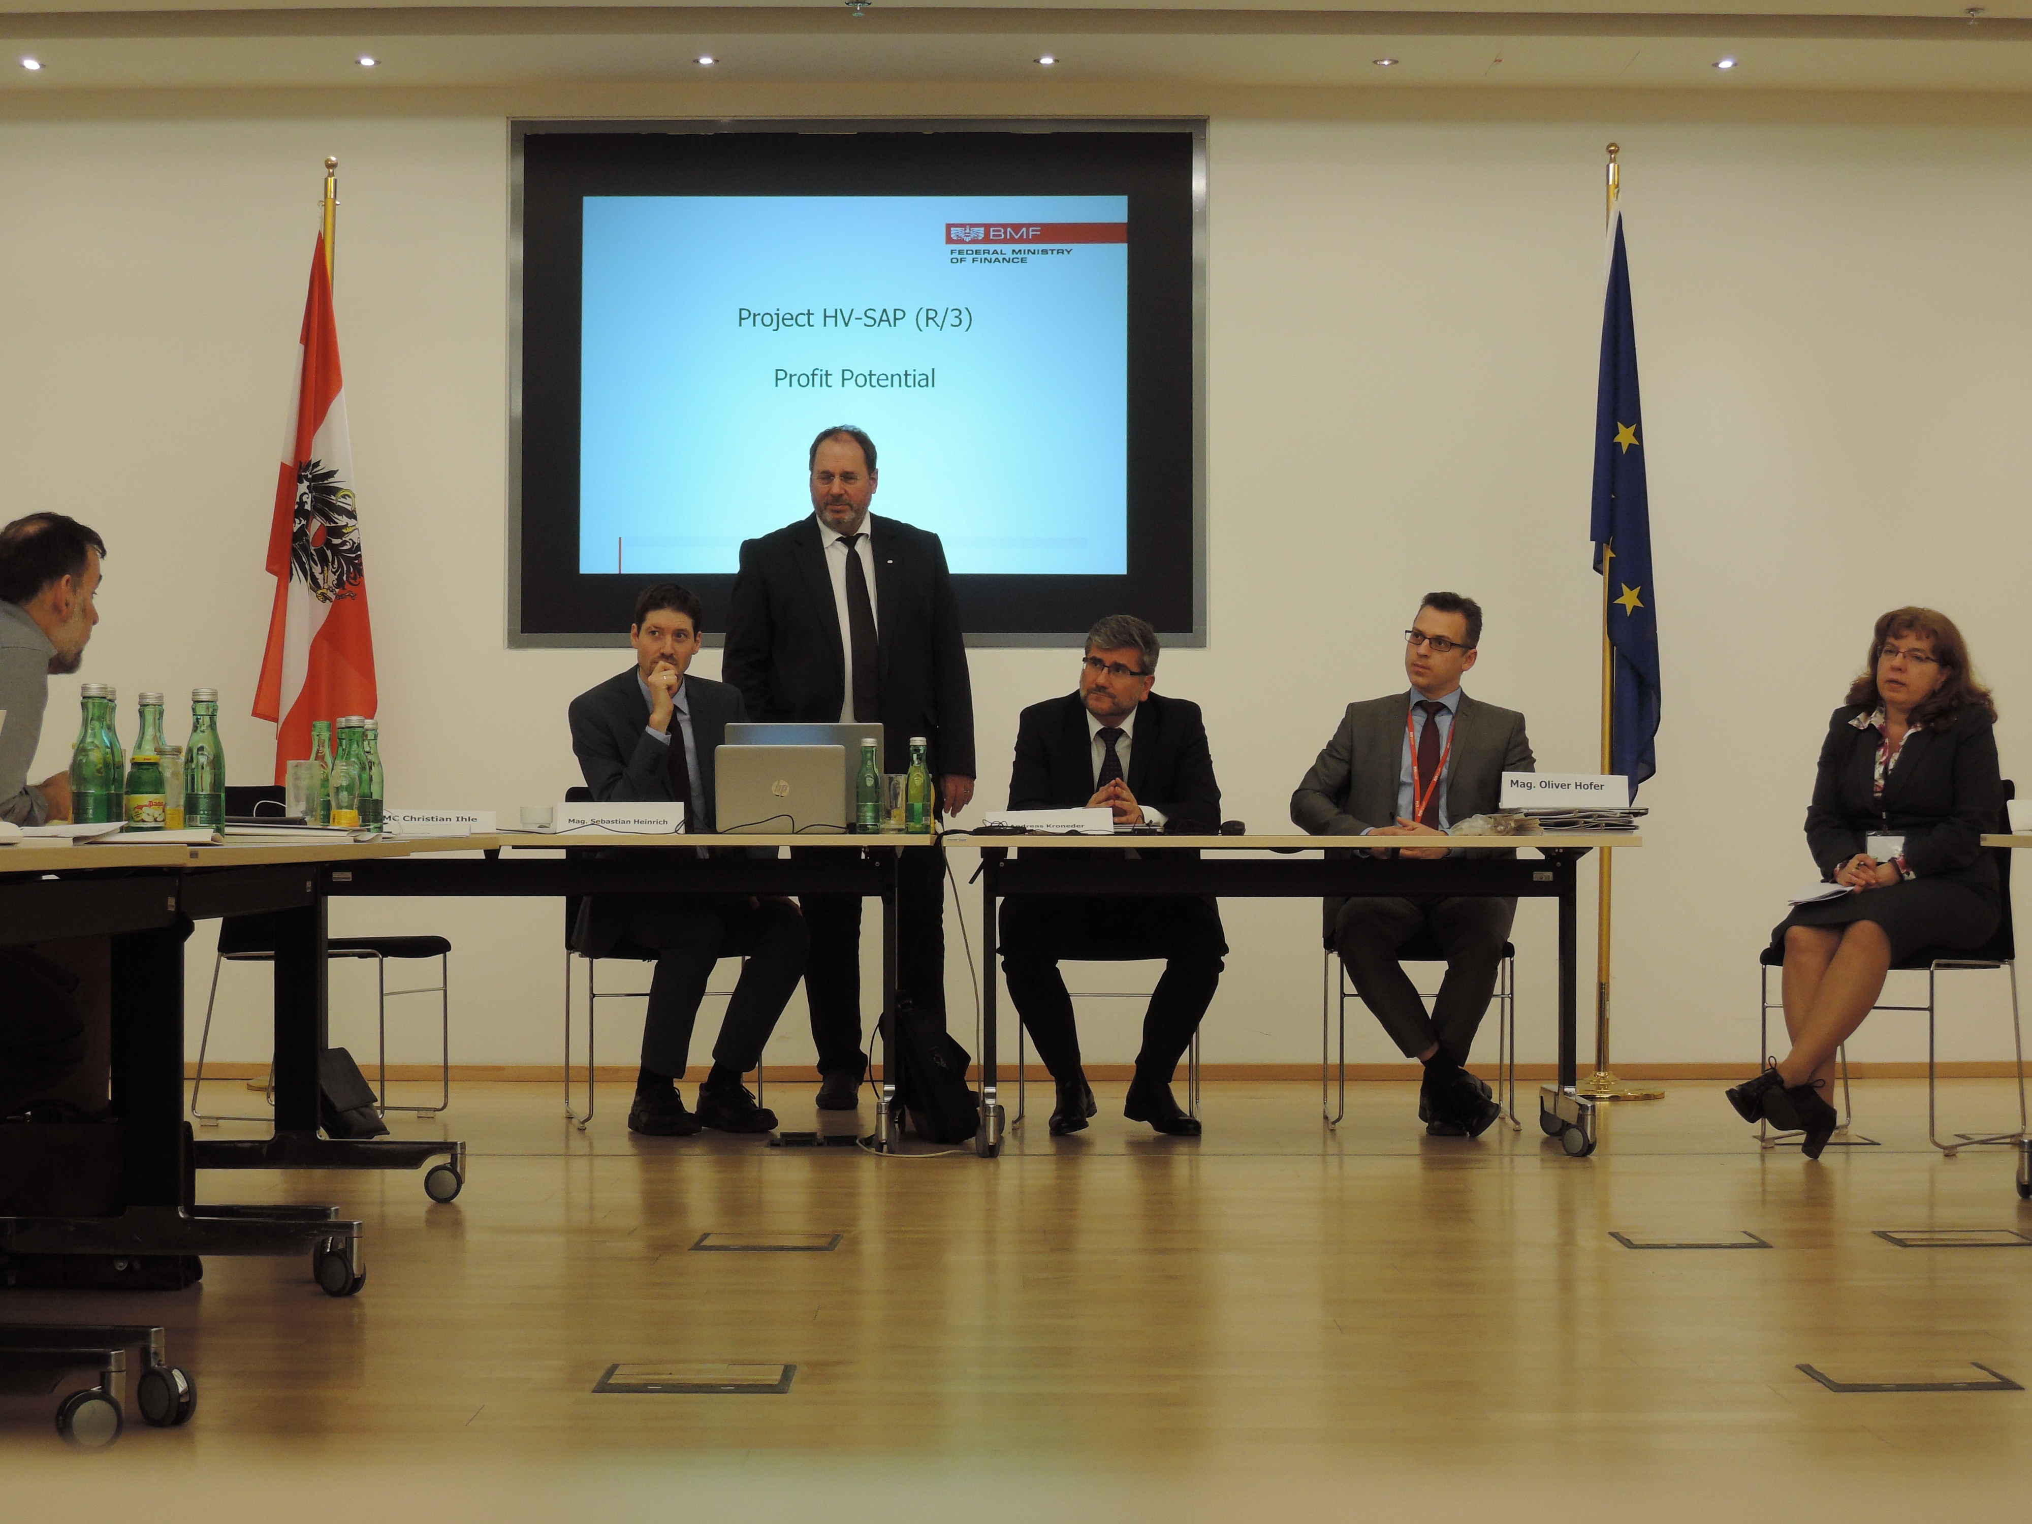
The event started with welcoming address of Mr. Christian Ihle, Director of IT and organization of accounting and payment transactions (DG V–IT) of the Federal Ministry of Finance of Austria (MoFA). In her welcoming remarks Mrs. Elena Nikulina, PEMPAL Program Team Leader, reminded that the interest of TCOP representatives in Austrian financial management information system (FMIS) implementation goes back to early 2015, when TCOP delegation visited MoFA to learn about Austria’s experience in PFM reforms which were supported by implementation of modern IT systems. On behalf of the participants Mrs. Nikulina thanked the MoFA for hosting this visit and opening to the TCOP representatives an opportunity to learn about Austrian experience in implementing and applying the SAP R/3 system.
The thematic program started with presentations by Mr. Ihle in which he covered main roles and functions of the MoFA in general, as well as of its DG V-IT. Similarly to broad functions of the MoFA in regard to determining public financial management rules, process and IT systems for the whole federal government, the Directorate is responsible for a broad range of activities concerning organization of IT solutions for the Ministry of Finance and the rest of the federal government (including budget and personnel issues); organization of the federal government's accounting systems and treasury operations; IT support for different Austrian bodies of administration (including tax offices and customs administration, Ministry of Justice). In performing these functions for the whole federal government, the Directorate determines ICT requirements, carries out implementation of the projects, organizes adaptation of legal procedures, provides user support, instructs ICT service providers, and provides interface services. It was noted that among strategic objectives of the Directorate are cutting costs, simplification of processes and achieving synergy effects by using the same technologies for all bodies of administration. Therefore the majority of software applications are run on SAP platform. Central IT service provider for the federal government is a private sector organization Federal Computing Centre Ltd which is primarily responsible for the tax administration and operation of more than 100 federal IT processes. The annual budget of DG V-IT is about 14 million of euro.
Mr. Dieter Kraft, the Head of Accounting System Application of the MoFA, delivered a presentation on Federal budgeting and accounting in Austria using SAP R/3. Mr. Kraft provided an overview of the project,that was implemented during more than 25 years, allowing the MoFA to replace a set of custom built software applications with an integrated financial management information system. New system became the single information system for the day-to-day information requirements of the central agencies, which was made possible due to the following preconditions: (i) guaranteed continued existence of standardized budgeting and accounting system for the entire federal government; (ii) requesting functionality lacking in standard SAP solutions (if necessary) and not an alternative solution; (iii) redesign of all business processes of the budget administration; (iv) new design of the organizational and flow structure; (v) existence of basis for e-commerce and e-procurement.
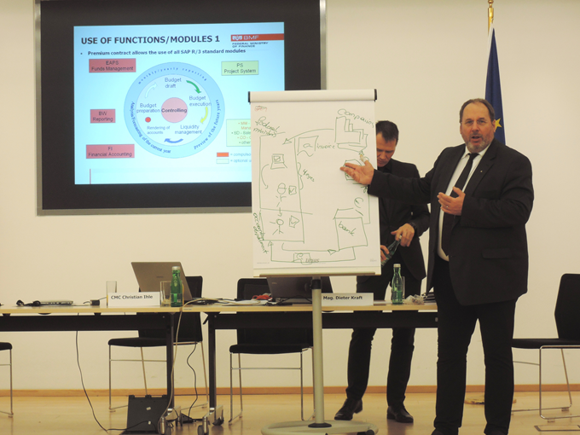
During the question and answer session that followed it was clarified that the system covers only federal level, subnational governments do not operate in the system due to separation of authority between the levels of government. The participants of the visit noted that in many of the PEMPAL countires there is another trend when the new FMIS are designed to cover operation of subnational governments as well, which poses developers with additional challenge of managing big number of users and information flows.
Another question that had risen a lot of interest from participants was Austrian experience with establishing in 2005 the Federal Accouning Agency as a centralized accounting servce for the governmennt. The establishment of the agency allowed to cut the number of government bookkeepers by half (from 1100 to 550). This process took place in parallel with the implementation of the SAP solutions, and based on the information from the Austrian Court of Audit, of it allows to save 28 million euro each year. The participants agreed that this is an interesting reform that is worth being considered for replication in participating countries.
Mr. Thomas Knap, the expert for IT for Budget management, planning and transactions, DG V-IT, MoFA, in his presentation IT – Budget Structure – Look and Feel Within the System provided an overview of IT system modules used for budget planning, execution, reporting and disclosure (all of them – part of SAP solution), which are illustrated in the slide. Mr. Knap explained that federal master data is administered centrally (centrally provided for all other applications) through a special master data management application (“Budget Structure”) which is not part of an SAP solution, but was developed in-house. An interesting feature is that every master data put in the system is set for the next 4 years, because of the rolling budget planning cycle.
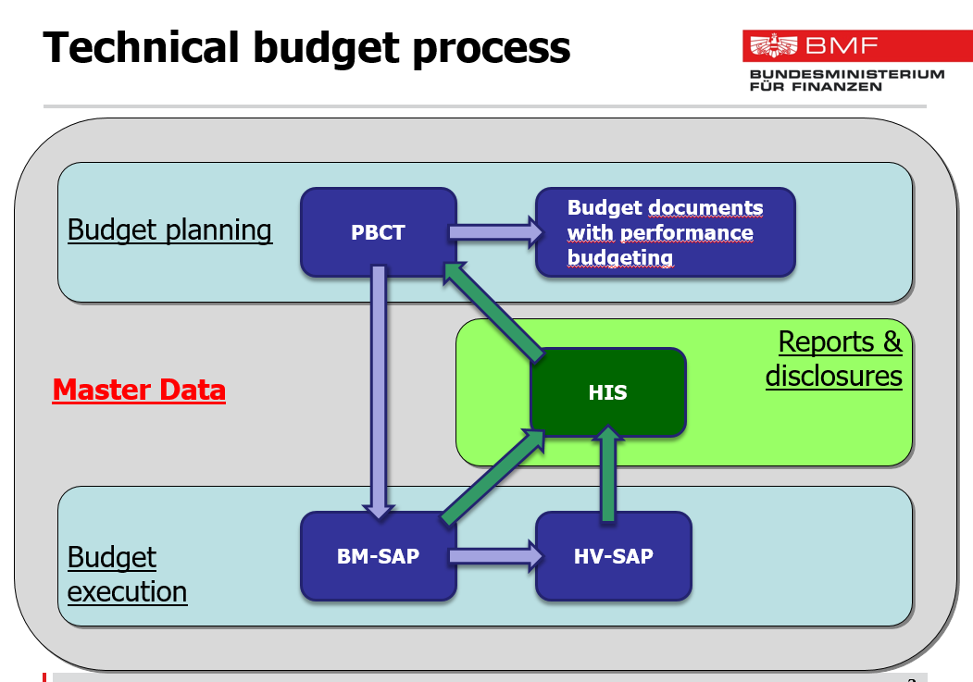
Mr. Knap informed the participants that in 2014 the MoFA began producing not only cash flow statements, but also profit and loss statements, which showed the information on accrual basis.
After lunch Mr. Knap had continued the presentation with an overview of the budget report structures and fiscal statements, explained how program budgeting was implemented supported by in-house solution and had answered a number of additional questions from the audience. During the question and answer session the participants clarified the role of the Federal Chancellery and Court of Audit in reviewing ministry level performance information and how the system supports it. It was explained that performance information is filled in by ministries before the budget is finalized. Federal Chancellery uses the same system to get a copy of performance documents and to review them. At the same time Court of Audit also has a role to play in this regard – upon review of the accounts it puts into the system its statement and then the ministry needs to enter their explanations to address the comments in the statement. During the question and answer session the participants also clarified that SAP solutions do not support preparation of macroeconomic forecasts or revenue planning.
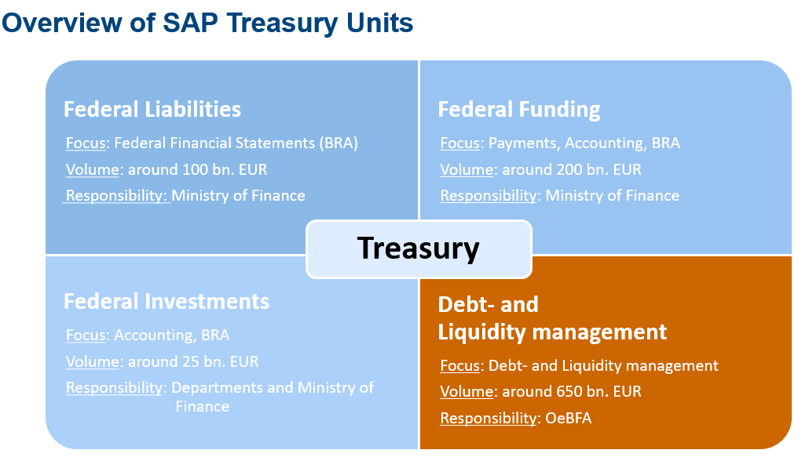
Mrs. Anja Tritremmel, Federal Treasury Agency, continued the agenda with presentation about the Treasury and the Federal Debt Management Processes. The presentation covered the functions of the Austrian Treasury Agency, benefits of the SAP solution, overview of IT process landscape and SAT Treasury Units as well as other technical details of treasury processes. TCOP representatives have learned that the Austrian Treasury was founded in 1993 as Debt Management Office, nowadays it acts in the name and for the account of the Republic of Austria issuing Austrian government debt, performing centralized cash management (including daily liquidity management), managing government debt through various financing programs. The Treasury also performs financial activities for other legal entities of Austria and Austrian Provinces.
Austrian Treasury uses SAP Treasury since 2015, which was introduced to achieve synergy with the IT procedures of the Ministry of Finance and to implement cross-company business processes in one system. The users of the system are Austrian Treasury, Federal Accounting Agency and the Ministry of Finance. The system is administered by Federal Computing Center. The system has a number of build-in controls that allow to perform limit checks (e.g. exposure limits, rating of business partners) and validate entry of the data (master data is entered with “4-eye control”, deal entries – with “6-eyes control”). The system allows to generate a wide range of reports for different types of recipients (Austrian Treasury, MoFA, Federal Accounting Agency, Austrian Court of Audit, Parliament, etc), which are available with real-time data or at least with daily updated data. All reports are based on one data source and access is controlled via the authorization concept.
During the next session representatives of Austrian Treasury provided a presentation on the placement of government bonds which stirred a lot of interest from the participants.
Next presentation was delivered by Mr. Sebastian Heinrich, Treasury System, MoFA, who presented the system of Federal Investments in Austria. The system is effectively an asset management module of the SAP Treasury. The volume of assets managed by this system reaches 25 billion of euro and includes around 200 direct investments (e.g. companies, banks, universities, museums, etc.) and 600 indirect investments. Austrian asset management recognizes the following business cases: acquisition, additional purchase, capital increase, corporate actions, appreciation/depreciation in value, disposition (selling) which are booked directly in SAP Treasury. Additionally to the bookings there is an obligation for the ministries to enter some financial statements data regarding assets in SAP Treasury once the annual accounts are closed. This includes information on net assets, nominal capital, own capital, profit or losses, number of employees, which is entered into separate application developed in-house. Later this information gets consolidated and published in the federal financial statements.
Mr. Christian Ihle continued the session with a presentation on the Profit Potential of implementation of the new FMIS, based on SAP. Mr. Ihle noted that at the time of preparing the SAP project the authorities were dismayed by the potential project costs and therefore needed to assess all the costs and benefits of implementing the new system to be able to communicate it to the Government. Such a study was ordered from 2 universities which carefully studied all the information provided and produced their estimates for the cost-benefit analysis (see summary results in a figure below). It was estimated that over a 10-year period (1998-2007) the value of project benefits (cutting costs on staffing in accounting and procurement, improved liquidity management, savings on maintenance costs) reached around 372-402 million euro. Comparing to the costs of project implementation and operation (57-71 million euro) the net profit from the project was estimated at around 315-331 million euro. Mr. Ihle noted that in addition to the benefits that could be numerically assessed, there was a number of qualitative project benefits, including introduction of standardized administrative and business processes, increase of security, improvements of data quality, avoidance of isolated solutions. The project also helped to reach strategic objectives of the MoFA by implementation of e-procurement and all-electronic exchange.
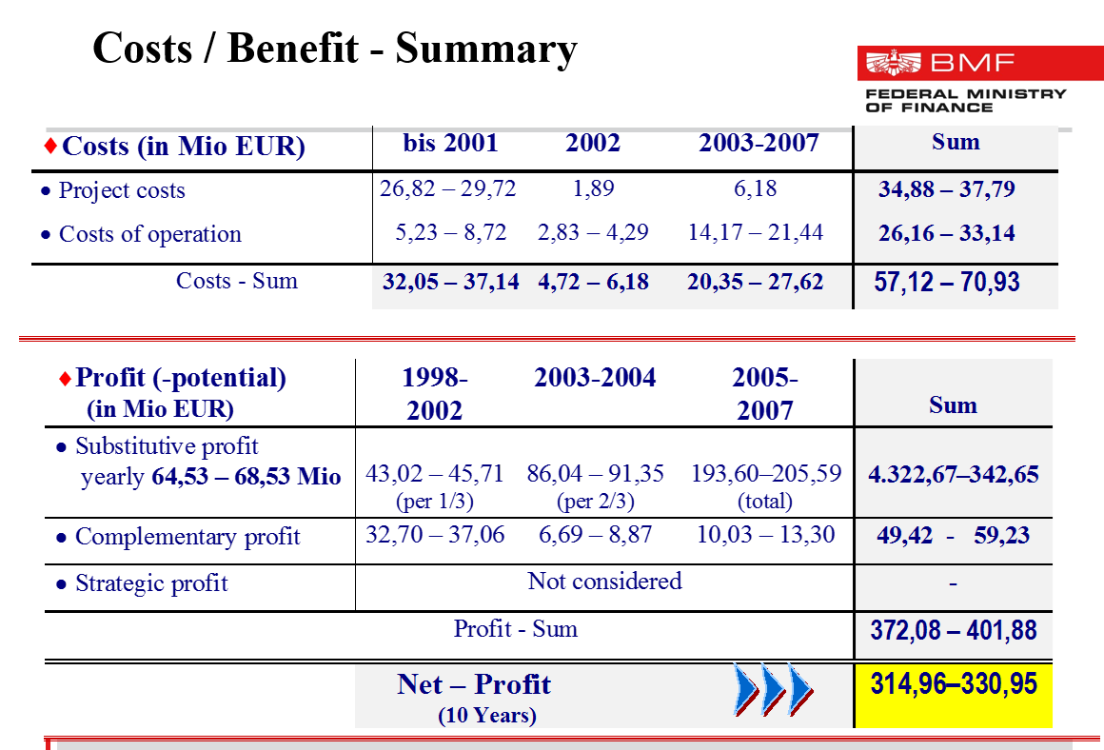

Summarizing the discussions of the first day, Mrs. Elena Nikulina noted that one of the topics of interest of the TCOP is the question of evolution of the functions of treasuries. And the Austrian Treasury is a good example of the set of functions which the TCOP sees as future functions of a modern treasury. Mrs. Nikulina also congratulated Austrian authorities with successful implementation of the cash management module. She also underlined that automation of asset management is topical issue for many of the PEMPAL countries, and it was very useful for participants of the meetings to familiarize themselves with the solution implemented in Austria. Mrs. Nikulina noted that through establishing Federal Accounting Agency Austria was able to implement centralized accounting model, and the TCOP would be interested in learning more about its operation. In her concluding remarks, Mrs. Nikulina commented that Austrian Treasury has a lot of useful experience to potentially share with PEMPAL countries and invited the Treasury to participate in TCOP activities, especially in the work of the TCOP cash management working group.
The sessions of the second day took place at the premises of the Federal Computing Center of Austria. Mag. Manoela Bodiroza, International Affairs, Federal Computing Center (hereinafter - BRZ), has provided the participants of the meeting with an overview of the core competencies and market of BRZ, its business strategy and strategic challenges. The BRZ is a publicly owned but privately run company which was set up in 1997 as an outsourced structure to provide IT services for federal government. Currently BRZ is number one public IT service provider which provides IT services to federal ministries and Chancellery, supreme federal state authorities, state-owned enterprises, and universities. All in all BRZ operates around 400 e-government applications (with MoFA being the biggest customer). Few facts and figures about the company’s operation are presented in the slide below. The mission of the company is to provide to the federal administration IT solutions which meet the highest standards in quality and security at the best price.
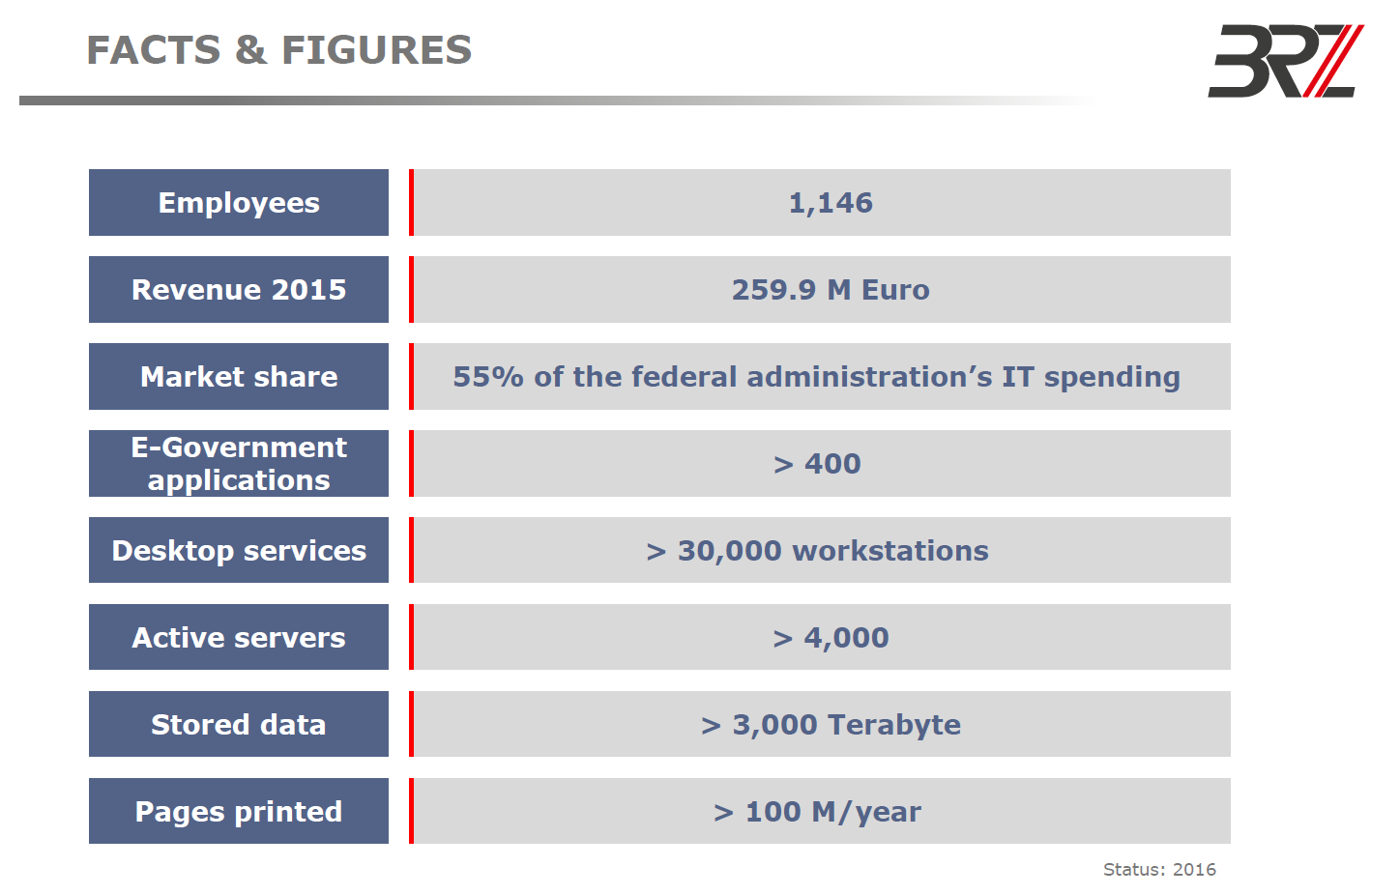
The introductory presentation stirred a lot of interest from the study visit participants. During the question and answer session it was further clarified that:
- Different ministries use different applications and BRZ does its best to ensure that these solutions meet the requirements of ministries. At the same time BRZ ensures that already developed solutions are used to the extent possible to cover the needs of the ministires – the Center first looks if there is already similar solution that could be used by a ministry with some customization if needed. If no solutions exists then the next step is to develop a new one for the customer, but in close cooperation with the MoFA, as the MoFA defines requirements for all the ministries (for example there is only one system for personnel management at federal level, and the MoFA sets the requirements for the system). Intergration is done based on the unified approach to master data – chart of accounts is centrally defined by the MoFA and is the same for the whole country;
- Unlike the experience of some of the PEMPAL countries there are no centralized registers of individuals of companies, addresses, banks, etc in Austria – there are different databases in different ministries. The participants and hosts agreed that centralization of this sort information could bring additional benefits to the system, if implemented.
- In line with current trends and technologies BRZ is in the middle of developing its own cloud infrastructure and is moving all of its applications from Power based to X86 based servers.
Next presentation was delivered by Mr. Ernst Steiner and Mrs. Alexandra Zanelli, BRZ, who provided an overview of implementation of the treasury solution. It was noted that initially solutions used for accounting and debt management were developed in-house and were about 30 years old, so during the Austrian budget reform, when profound changes to accounting standards were being introduced, the Treasury decided to go for SAP Treasury.
Implementation of the treasury solution met with several challenges, the biggest being the quality of existing data (which made automatic upload not possible as the data structure was not fitting new requirements) and complex organizational processes when a lot of interests had to be taken into account (MoFA, accounting, auditors, treasury) – this was addressed through close coordination with responsible customers and investing a lot of time and effort in communications with counterparts.
BRZ officials also identified a number of lessons learned during the project implementation:
- Detailed analysis of the data structures needs to be done form the very beginning – some data will stay the same, but a lot of different information will be found in different databases and project teams need to know what data can be used, and what will have to be created a new;
- Supporing interfaces need to be analysed. The requirements tend to change over time and the review may show better ideas for solution design, but it is important to remember that sometimes it is more wise to go the old way;
- Coordination with customer. There is a need to sit together and discuss on a permanent basis, workshops once a week will not be enough;
- Creating business case portfolio. Customers have their own business cases in mind, while standard solutions will have different processs. So there is a need to create business case portfolio and walk with customer through all business cases, so the customer is aware and has opportunity to think over if some of his usual processes are still needed. For this kind of work it is imprtant to keep in mind that the less complex the system is the easier it will be to maintain.
During the quesiton and answer session the participants clarified a lot of questions relating to system’s implementation and functioning. It was further discussed that BRZ does not provide special training courses for system users. High attention is given to preparing detailed user documentation (which is usually around 1000 pages) and training key users. These key users run training for other users, which is quality assured through a special system.
The visit to the BRZ concluded with a tour of BRZ, including a visit to user support center which provides 24/7 support for all applications of the federal government.
The third day of the study visit started with internal round table discussions on the Austrian experience in applying IT in PFM processes and lessons learned from the visit. Summary of major comments from participants follows below:
- Establishing a single platform allows to set a centralized and flexible system, with standard approaches to technical issues, but the SAP platform is very expensive, and has high maintenance costs. So in taking a decison whether or not this approach will work in other countries it will be needed to carefully consider the costs of a project. Belarussian and Russian delegations agreed that such a system would be much more complex and expensive for their countries, as their governments have far more ambitious plans in regard to coverage of functions, users and tiers of government;
- Customization of the system for Austrian needs was relatively small, taking into account that standard SAP solutions are pretty much aligned with IFRS and therefore with IPSAS, while for the PEMPAL countries the level of customization (and respective costs) will be much higher;
- Baseline approach to offer ministries some standard solutions first allows to minimize the costs of development and maintanace of these solutions in the future;
- It was noted as a positive element that development of IT solutions in Austria is focused not on automation of functions/tasks, but on automation of processes, which provides an opportunity for upgrade of the business processes in line with best available practice;
- Austrian modules on cash management, debt management and asset management stirred a lot of interest from the participants, including for potential further study visits. Build-in functions for risk management were mentioned as part of the strong features of the system;
- Participants arrived to the understanding that license management is a separate seroius issue that requires a dedicated unit;
- It was noted that an interface for the vendors to enter their invoices right into the portal is a benefit of the Austrian system, which saves a lot of time for the ministries and MoFA, which only need to verify the informatoin. In majority of the PEMPAL countries invoices are entered into the system by treasury staff;
- It was agreed that the strong side of the system development in Austria was the focus on engaging various stakeholders into the process;
- In regard to training it was mentioned that Austrian approach may not be applicable for many of the PEMPAL countries, as people in our region are not used to reading thousand page manuals, but prefer to have special training.
Summarizing the discussions Mrs. Elena Nikulina noted that Austrian experience in implementing IT solutions for the federal government is very interesting, but differs significantly from what the PEMPAL countries are used to have. The autonomy of regions is highly valued in Europe, and this also relates to the ability of regions to manage their own resources. Another difference is in distribution of functions between the ministries of finance and treasuries. Austrian experience is closer to the usual OECD practice, while in most of the PEMPAL countries treasuries are tasked with execution of the central budget and are often part of the ministry of finance. Another interesting issue is the distribution of functions between the Federal Accounting Agency and spending units in Austria, and the interest of the study visit participants to learn more about it in the future was noted.
The final session of the day was devoted to discussions on the future working plans of the TCOP working group on the Use of Information Technologies in Treasury Operations. The group members agreed that this working group should continue its operation in the next PEMPAL program period with a focus on more specific issues of ICT services for the government. It was mentioned that with time communication between customers and IT service provides becomes more and more intense, the customers are also trying to understand the opportunities offered by the new technologies and equipment to optimize their business processes, therefore it would be useful to start including IT staff into TCOP thematic activities. The working group members also expressed their interest for the following topics, which could be discussed during the video-conferences or separate events or study visits in the future: Austrian public accounting reform in part relating to centralization of public accounting at the Federal Accounting Center; liquidity and asset management in Austria; IT projects management, licenses management, project risk management, project portfolio management (costs of implementation, cost of ownership, etc.). It was suggested also to collect and summarize the information about the current IT systems used in PFM systems of TCOP member countries. This information might be useful for the future discussions within the group, as well as for monitoring the progress achieved by member countries in modernizing their FMISes.
The group also decided to delegate the group leaders, Nazim Gasimzade and Andrei Narchuk, to attend the 2017 TCOP Plenary meeting on Risks Management, and deliver at the event a presentation on the management of risks related to use of IT in PFM.
All meeting materials are available at the PEMPAL web-site: https://www.pempal.org/events/tcop-study-visit-thematic-group-use-information-technologies-treasury-operations

Mrs. Elena Nikulina, PEMPAL Program Team Leader, Mr. Ion Chicu, TCOP Leadership Adviser, Mrs. Yelena Slizhevskaya, PFM Consultant.

