Meeting of the PEMPAL Treasury COP Working Group on
Public Sector Accounting and Reporting
_____________________________________________________________
Minsk, Belarus, October 2016
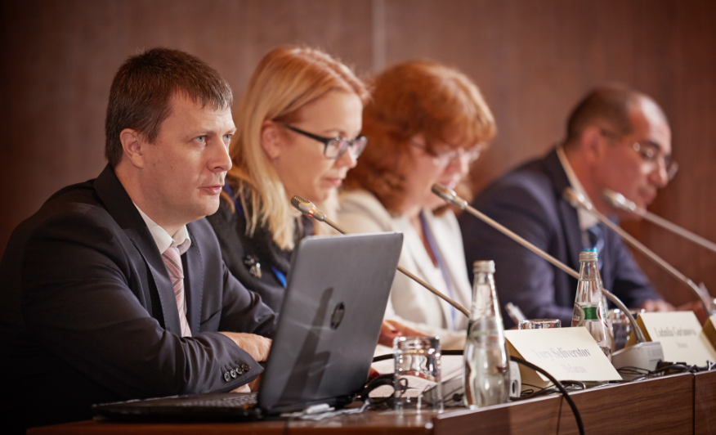
On October 3-5, 2016, PEMPAL Treasury Community of Practice (TCOP) organized in Minsk, Belarus, a meeting of the working group on public sector accounting and reporting standards. The main objective of the meeting was to offer an opportunity for its members to deepen the understanding of the practical issues in aligning public sector accounting standards with International Public Sector Accounting Standards (IPSAS). The workshop served as a forum for the working group members to exchange news on the progress of public sector accounting and reporting reforms in their countries. The participants also provided peer advice to the hosting country, Belarus. The hosts commenced the planning process for implementation of public sector accounting reform in 2015, and were looking forward to the opportunity to discuss with colleagues the progress achieved and plans for the future. The meeting was attended by forty five specialists representing 13 PEMPAL countries (Albania, Azerbaijan, Belarus, Bosnia and Herzegovina, Croatia, Georgia, Kazakhstan, Kyrgyz Republic, Moldova, Russian Federation, Tajikistan, Turkey and Ukraine) and facilitated by the World Bank resource team working with TCOP. Logistical support was provided by the PEMPAL Secretariat based in the World Bank Country Office in Moscow.
Mr. Yury Seliverstov, Deputy Minister of Finance of the Republic of Belarus, formally opened the workshop and briefed the participants about the commencement of the public sector accounting reform and his looking forward to the opportunity to discuss and receive feedback from colleagues regarding the progress achieved and plans for the future. In welcoming participants of the workshop, Mr. Vugar Abdullayev, PEMPAL TCOP Chair and Deputy Head of the State Treasury Agency of the Republic of Azerbaijan, noted that Belarussians are known for their comprehensive and informed approaches to any reforms – changes are implemented only when they are really needed, which usually serves as a significant success factor for any reform. In her opening remarks, Mrs. Elena Nikulina, PEMPAL Program Team Leader, reminded the participants that public sector accounting and reporting was a focus of interest for PEMPAL at a number of earlier events, with several working groups established at a PEMPAL meeting in Skopje, Macedonia in 2013. The Working Group on Accounting Standards was one of three groups formed at that event, consolidation and assets management being the other two. The group has met on several further occasions including events in Montenegro in 2014 and Georgia in 2015. Several video conferences on the topic have also been convened since the working group’s inception in 2013. Of the three working groups formed in Skopje, this is the only group which continues to meet, given its continued significance for a number of countries, and the lengthy periods which countries take to implement the full set of standards. Mrs. Nikulina noted that Minsk meeting provides a very good platform for discussion of the progress of public accounting and reporting reform in PEMPAL countries taking into account recent reform initiatives in this area in Belarus.
The thematic program started with presentations by the host country. Mrs. Lyudmila Guryanova, Deputy Head of the State Treasury of Belarus Ministry of Finance, delivered an introductory presentation with an overview of the PFM system of Belarus, focusing on the organization of budget execution and reporting performed by the Treasury. Mrs. Guryanova explained that the objective of Belarus public accounting reform is to promptly generate high quality information to facilitate decision-making process and to facilitate the best use of this data. This is currently a challenge in Belarus due to the existence of different methodological guidelines and charts of accounts (CoA) which do adversely impact integration across the PFM system (See slide below),
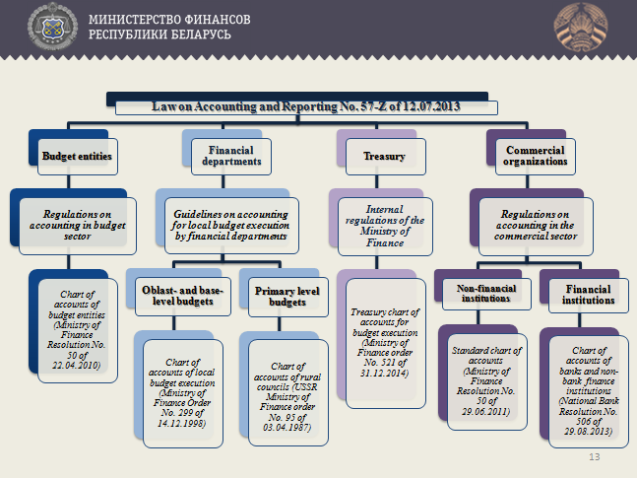
Mrs. Lyudmila Bobrovskaya, Consultant of the Public Sector Accounting and Reporting Unit of the State Treasury, delivered a presentation on Belarus’s first steps with public sector accounting reforms. Mrs. Bobrovskaya highlighted the main problems of the current national accounting and reporting system,: (i) existence of multiple CoAs and different accounting and reporting arrangements for various entities of the general government sector (GGS), (ii) incomplete registration of cash flows, public assets and liabilities in the Government accounts; (iii) and inconsistency of the majority of national accounting and reporting standards for the GGS with international principles and standards. Mrs. Bobrovskaya indicated that in order to improve the system of public accounting a dedicated unit was set up in the State Treasury of the Ministry of Finance to lead public accounting reform. With the help of external consultants the unit conducted a gap analysis and developed a draft concept note on the national accounting and reporting system and transition towards IPSAS. Mrs. Bobrovskaya indicated that the Ministry of Finance needs to make major decisions on the design of the ongoing reform program including:
- unification of accounting methods used by financial bodies, Treasury, budget entities, government bodies and introduction of the Unified CoA (UCoA);
- improvements to the quality of public property management;
- centralization of all types of accounting operations on all budget levels; optimization of accounting costs by providing budget entities with access to centralized accounting system; and
- improving transparency of information on performance of GGS entities, usability of financial reports, and making public finance information accessible to the general public.
During the question and answer session that followed the participants of the workshop clarified further details of current Belarus public accounting and reporting arrangements and provided Belarus counterparts with practical advice on further simplification of the UCoA design.
In the afternoon Mrs. Natalia Rusakevich, Head of the Public Sector Accounting and Reporting Unit of the State Treasury, presented further information regarding the challenges with public sector accounting reform in Belarus. Mrs. Rusakevich highlighted a number of critical decisions to be made in order to progress the reform beyond the early concept stage. Mrs. Rusakevich explained that the State Treasury is considering preparation of national IPSAS-based standards on a modified accrual basis. However, the following issues need to be clarified before the reform can be progressed:
- coverage of institutional units - currently there are serious deviations between the definitions of public sector units used for statistical reporting and fiscal reporting; these deviations are even bigger for those budget entities that have a significant share of extra-budgetary operations (which are taking place outside of the treasury system and reported within a separate set of reports);
- the level of standards application – whether new standards will be applied for preparing consolidated reports only, or will equally apply to all entities throughout the budget system (it was noted by the hosts that in their view, the first option will not serve the purpose if the objective of the reform is to improve the quality of financial information);
- there could be different consolidation options, given the standards apply to all general government sector entities;
- composition and structure of reports for different types of public entities; and
- sequencing of standards implementation – current thinking is to focus on a ten year horizon but sequencing of standards implementation remains an open issue.
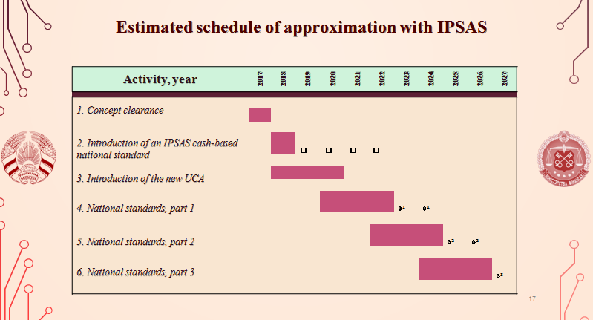
During the final session of the day, participants convened round table discussions on the host country’s presentations, and provided peer advice on how to progress the reform. A summary of major comments from the participants follows below:
- The participants agreed that the State Treasury of the Ministry of Finance of Belarus had done a thorough job in identifiing the challenges of the prospective public accounting reform which is likely to result in more informed decision making on the future reform road map;
- The Majority of participants agreed that the proposed reform timeline (10 years) is about right giving the scale of reform proposed. A few participants saw this as a risk – the long timeframe may see a loss in the momentum for reform and of qualified staff over time;
- The participants agreed that consolidation of financial reporting data should ideally be done based on a bottom-up approach following the existing budget system structure. This will allow easier identification and elimination of inter-entity transactions;
- The participants did not agree to a single position on whether reform should aim for modified or full accrual accounting – the opinions and arguments differed. Representatives from Kazakhstan highlighted the importance of improved cash accounting as a first step (this was particularly important given the significant amount of extra-budgetary funds and resources of the budget entities that do not pass through the treasury system in Belarus);
- The participants agreed that national standards should apply to every budget entity increasing the reliability of consolidated financial reports;
- Most of the participants agreed that implementation of the national IPSAS-based standards would be a better option compared to adoption of full IPSAS for many reasons, one of which is the opportunity to reflect country specific issues in the national standards.
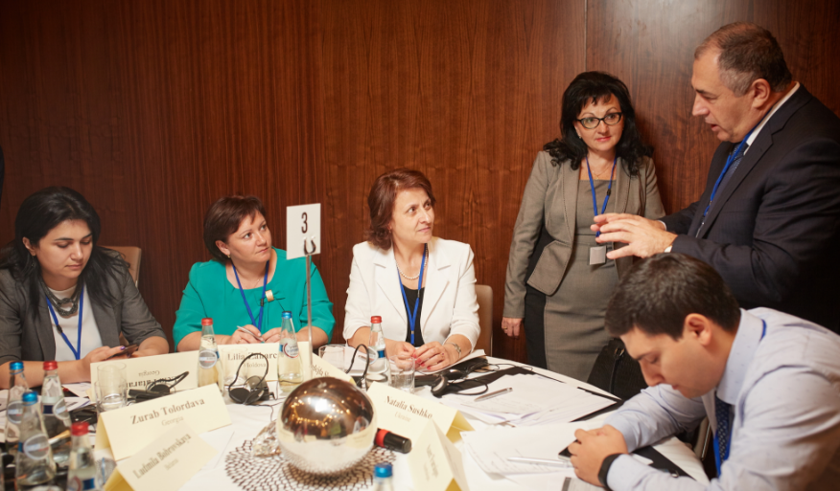
- It was noted that public accounting reform can not be a stand alone exercise. There are many other initiatives that are usually taking place in parallel to the reform, contributing to its progress and success. Among these are development of internal control and audit functions, and design and implementation of Finacial Management Information Systems (FMIS) in the country.
Summarizing the discussions of the first day, Mr. Mark Silins, Lead Thematic Adviser for TCOP, noted that the meeting shows that the staff of the State Treasury of the Ministry of Finance of the Republic of Belarus has gone a long way in developing their capacity for the reform during only few years. He highlighted the following key points:
- Uniform CoA is a critical element – this does not mean everything has to be the same, but the principles and concepts must be consistent - you do need to ensure that you comprehensively define what is required in the CoA - this must be done early in the process. Some countries in the group (e.g., Moldova and Kyrgyz Republic, have taken many years to implement a unified BC/CoA. Belarus can learn from this and probably do it more quickly. A major reason for the lengthy time is that it is more than mapping accounts, it is also getting stakeholders to understand the conceptual changes this involves. A conceptual framework agreed across stakeholders is therefore important. The paper the TCOP produced on this issue is also worth mentioning again here as it uses country examples to focus on how to integrate these structures (https://www.pempal.org/sites/pempal/files/good_practice_design_of_coa_in_tcop_member-countries_eng.pdf)
- Not every entity, particularly at lower levels, need to understand and report every element of the accounting framework – most small entities will not have financial assets and liabilities beyond accounts payable and receivable;
- Consolidation in Belarus is different to many other countries - public ownership is very high - thus the type of reports obtained from statistical reports on the economy would not necessarily be very different from that obtained from consolidated financial statements for the public sector. Thus the needs regarding consolidation may be different here, given the significant role of government in Belarus; and
- Bad implementation of accrual can undermine fiscal integrity – one extreme example outside of the group saw a small island economy unable to produce financial statements for five years. Gradual implementation is the sensible way forward for most countries, including Belarus - ten- year minimum timeframe is sensible.
Mr. Ranjan Ganguli, an invited expert on public sector accounting, additionally emphasized the need to define and agree a clear rationale and purpose of the reform to create a common understanding and gain stakeholder support for the changes. Mr. Ganguli suggested accounting reform should also be coordinated with the sequencing of PFM and other policy priorities, thus taking into account demand for improved or additional public information.
Day two of the workshop was devoted to discussions on the progress with public accounting reforms in working group member countries, along with insights into broader international experience.
The day commenced with Mr. Ranjan Ganguli’s presentation on the reform of public sector accounting in Poland. It was noted that the driver for initiation of the reform in Poland was the prospect of European Union (EU) imposing European Public Sector Accounting Standards (EPSAS). The Ministry of Finance of Poland decided to investigate what the imposition of EPSAS would mean for the country in terms of costs of the reform, existing capacity constraints and the timescale to comply with new requirements (see Box 1 below for the details).
Box 1. Overall Approach to Reform of the Public Sector Accounting in Poland
Research Areas

- Compare Polish generally accepted accounting principles with IPSAS - completed in mid-2015
- Develop and deliver training on IPSAS to key government officials – completed in end-2015
- Study tours to EU countries that apply IPSAS or similar standards to understand costs, benefits and approach to reform – completed in mid-2016 (France, Austria, Portugal, Switzerland visited)
- Understanding of the needs of Polish users – to be done
- Inventory of human capacity and IT systems – to be done
- Summarize results of about – drafting started
Preparing Reform Action Plan
- Workshop to share results and start development of reform action plan – planned for November, 2016

Polish authorities identified a number of lessons learned following their exchange with the European peers, including that:
- public accounting reform is likely to have little traction and impact in the absence of a clear rationale and high-level support;
- accounting reform is a long-term and costly undertaking;
- they would prefer to adopt IPSAS directly - even if in a phased manner - rather than trying to maintain IPSAS-based standards;
- accounting standards should be harmonized across all levels of the general government sector though simplified standards may be appropriate for entities below specific materiality levels;
- revised financial reporting standards will require changes to financial reporting IT systems and as such the functionality of currently used systems should be carefully considered;
- consolidation is an onerous exercise and careful consideration is required of which entities should be consolidated for which purposes - budget reporting purposes, statistical reporting or general purpose public sector financial reporting purposes;
- work required to produce the opening balance sheet of an entity in accordance with new accounting standards should not be underestimated;
- professional capacity and training of accountants are critically important for the success of the reform, however it is not necessary to have a large cadre of public sector accountants with specialist knowledge of IPSASs as the finer points of IPSASs are rarely needed
- apart from training of staff and government officials there is a need for education and support to politicians and parliamentarians to help them understand and be able to use accrual-based financial statements.
During his presentation Mr. Ganguli mentioned that in mid-2016 the Ministry of Finance of Poland had drawn attention to the fact that there have been numerous, fragmented and incoherent reform efforts across many PFM areas in recent years, and these needed to be streamlined and better integrated, including with public accounting reform. This issue regarding the appropriate place for public accounting reform within the overall country reform agenda raised a lot of debate among the workshop participants. It was agreed that accounting reform should not be viewed as a standalone effort, but rather a tool for other system improvements, e.g. if there is demand for better fiscal information - improvements to public accounting will contribute to improvements to fiscal reporting.
Mrs. Svetlana Sivets, Deputy Director of the Department for Budget Methodology and Financial Reporting in the Public Sector, Ministry of Finance of the Russian Federation, provided an overview of the public accounting reform in the Russian Federation (initiated in 2012). In 2015 Russia started preparation of national IPSAS-based standards which are expected to be completed in 2020. Mrs. Sivets indicated that sequencing of national standards development should be driven by the priorities defined by the Government (e.g. seeking improved information to address high public property maintenance costs) along with those areas which are already closely aligned with international practices and therefore relatively easy to implement. An interesting element of Russia’s approach to standards implementation was the decision of the Ministry of Finance to simultaneously hire two consulting companies to facilitate this work due to a very limited timeline for the task – one company was to work on accounting, the other on reporting. Mrs. Sivets admitted that the decision did bring additional coordination challenges to the process, but it also helped the ministry to find better solutions as well.
Ms. Zaifun Yernazarova, Director of the Department of Budget Legislation of the Ministry of Finance of Republic of Kazakhstan, updated the participants on the progress with introduction of accrual accounting in the Republic of Kazakhstan. Republic of Kazakhstan had extensive prior experience with implementation of International Financial Reporting Standards (IFRS) which served as a good starting point for the public sector accounting reform. Transition to accrual accounting was declared in 2007 as one of the objectives for the public sector in the Republic of Kazakhstan. The reform itself was implemented during 2009-2012, a number of factors and decisions facilitated the transition within such a short timeframe:
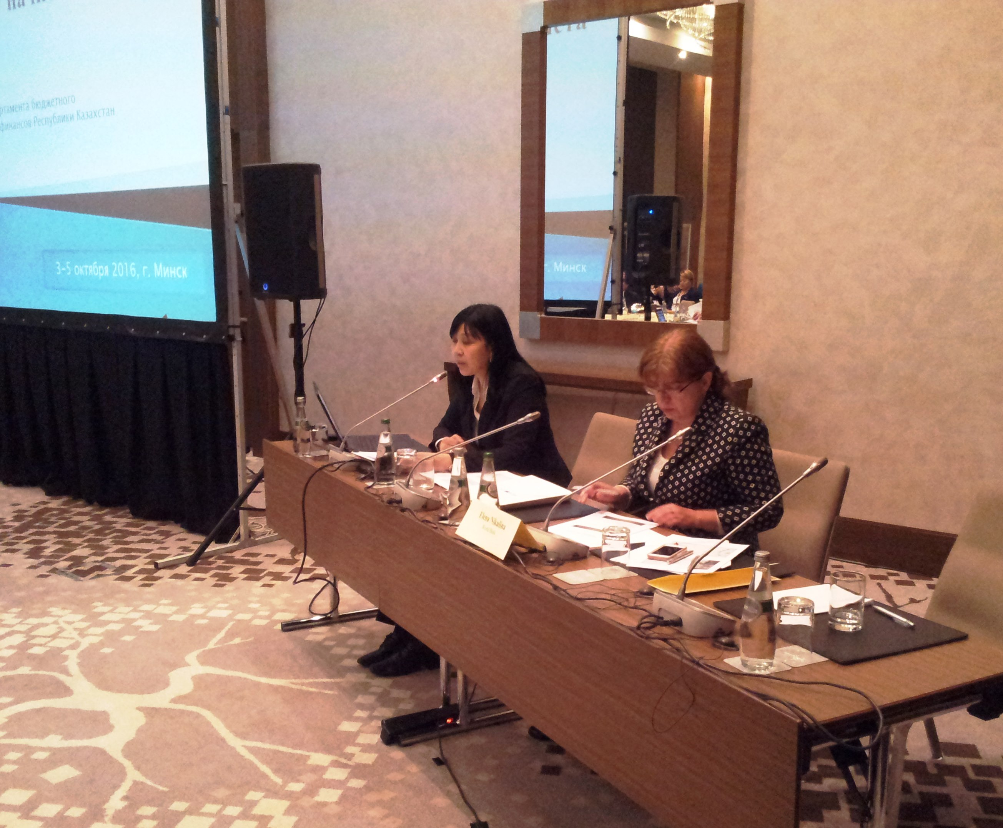
- The translation of IPSAS into Kazakh and Russian languages was arranged in 2011 and is being updated annually since that time;
- At the same time national regulations and instructions (national standards) were developed to guide implementation of the standards in the general government sector;
- Templates of all reports, prepared by the GGS entities, were reviewed and revised (362 templates in total);
- Separate software packages were developed to consolidate the data in the Treasury (one for central government, another – for subnational governments).
- Two years prior to standards implementation the Ministry conducted a series of workshops and training courses, which also provided important feedback and practical advice from the GGS accounting community;
- Existing accounting software solutions were upgraded in line with the new CoA and new consolidation rules, so the staff of accounting units had no problems with transition to the new system; and
- To MoF also convened a number of courses aimed at educating senior management on how to use and understand accrual information and what additional value this information may have for decision-making.
The entire afternoon of the second day of the workshop was devoted to group discussions during which representatives from each country made a short presentation about the background and recent status of public sector accounting reform in their country. Reports from the group discussions were presented at the beginning of the day three by Mrs. Aurela Velo (Albania) and Mrs. Cholpon Saparbaeva (Kyrgyz Republic). A short summary on selected aspects of these discussions is presented in Box 2 below.
Box 2. Snapshot of Selected Countries’ Public Accounting Reform Status
Questions | Summary of Responses
Stage of public sector accounting and reporting reform (planned, under implementation, or completed) | 9 out of 13 countries are implementing the reform; 3 countries (Albania, Belarus, and Bosnia and Herzegovina) are in the planning phase and one country (Croatia) is considering the issue
Is public accounting reform formally part of a broader PFM reform agenda? | Yes, for all countries planning or implementing reform
Is there an official strategic document guiding public accounting reform? | 9 out of 13 countries have a separate document guiding the reform
Public accounting reform timeline | Average reform timeline (estimated by the national governments) under this group of countries is 11 years
Approach to reform: IPSAS, National Standards, or National Standards largely based on IPSAS | 9 out of 13 counties went for development of National Standards largely based on IPSAS; Albania and Georgia decided to implement IPSAS; Belarus and Croatia are still developing their position
Who is leading the reform efforts and is any formal steering committee established? | Reform efforts are led by the Ministry of Finance or Treasury (depending on the institutional setup, Bosnia and Herzegovina is being an exception – with Council of Ministers taking the lead). 7 out of 13 countries established a dedicated Council to steer the reform, while 6 counties do not have such a structure in place.
Is there any external support for the reform? What type of support and from whom? | Ukraine was the only country that currently has no external support for the reform. All the other countries benefitted from the WB, IMF, SECO, EU and other donors support
How is training and certification of accountants organized? | Certification of public accountants is organized in Kazakhstan. Only 3 countries (Azerbaijan, Kazakhstan, and Georgia) have in operation dedicated training centers; Albania is considering establishing the training center; some countries (Turkey, Kyrgyz Republic, Moldova, and Tajikistan) rely on MoF staff to organize the training.
Groups were also requested to consider and discuss two further aspects of design and implementation of public sector accounting reform: firstly, which key stakeholders should be involved, their roles and how to mobilize them, and secondly, how to make best use of external resources in the process of reform. Summary of the discussions is reflected in Box 3 below.
Box 3. Summary of Discussions on Design and Implementation of Public Sector Accounting Reform
Key stakeholders to be involved  - Government and all financial decision makers  - Parliament  - GGS entities  - State owned enterprises  - Internal and External Audit Bodies  - Training institutions and professional accounting community (associations, universities, etc)  - IT companies  - Central Bank  - Donors and investors  - Citizens | How to make best use of external resources?  - Attract consultants  - Learn from lessons gained in the course of FMIS implementation  - Exposure to international experience, including via PEMPAL-like platforms  - International (bilateral) cooperation  - Private sector expertise  - Software, training  - Due diligence

The morning session of the day three continued with a presentation on developments in EU public sector accounting by Mr. Ranjan Ganguli. Mr. Ganguli reminded the audience that the sovereign debt crises underlined the need for more rigorous, transparent and comparable reporting of fiscal data. EU public sector accounting reform was initiated to increase fiscal transparency, achieve comparability within and across EU Member States, and minimize incoherence between accounting and fiscal reporting frameworks. An EU report concluded, that IPSAS cannot be implemented as they currently stand as some of the standards need reconsideration or selective adaptation. However, IPSAS were found to be a suitable reference framework for the development of European Public Sector Accounting Standards (EPSAS) for which the EU has created a working group - see http://ec.europa.eu/eurostat/web/government-finance-statistics/government-accounting.
This news stirred a lot of interest with participants and brought the audience back to the question of whether there is a need for separate national standards. Mr. Silins noted that the idea of EPSAS is similar to those in favor of national standards – because the focus is on the differences, but not on similarities. An alternative option would be to focus efforts on providing accountants with interpreted and adapted guidelines which highlighted those differences, and how they should be addressed.
The next session of the workshop was organized in the form of a panel discussion, when the experts addressed some residual issues and summarized their impressions of this three-day workshop: Issues discussed further included:
- Adopting or adapting IPSAS – The panel indicated that few if any country has in reality, fully adopted IPSAS. Most countries, require some departure from the standards, although in general these departures need not and should not be significant. Significant departures must bring in to question the overall level of comparability with IPSAS. In many cases, countries that have created national standards have actually implemented subsidiary accounting policies and guidelines. IPSAS are developed at a high level, and thus every country, even those that adopt IPSAS, must also develop more detailed accounting policies and guidelines which are more practical and useful for implementation;
- Cash basis IPSAS – There is a common misconception that cash IPSAS and accrual represent two options at different ends of a continuum. The cash basis IPSAS allows transition towards full accrual as it encourages voluntary disclosures in the notes beyond cash basis reporting. Countries, therefore need not step backwards from any current additional disclosures if the first stage is to adopt the cash basis IPSAS. A benefit of the cash basis IPSAS is that it allows a country to move towards full accrual without imposing a timeframe within which full compliance must be achieved (accrual IPSAS allows a transition period only);
- Coverage of IPSAS – in general, countries need to focus on a gradual expansion of coverage for reporting, and eventually consolidation. Each country must determine how it sequences this process. As a general rule this should target full coverage of the General Government Sector including statutory bodies and extra budgetary funds. Inclusion of subnational governments will be determined by whether they are controlled entities, or completely autonomous.
- In the future, state enterprises could be integrated for a view of the public sector, but this has challenges not least of which that these entities already report separately, probably under either IFRS or similar national based private sector reporting requirements. While there will be convergence of the reporting requirements, there will also be differences which must be addressed;
- Consolidated reporting – this lends itself to integration and automation. Consolidation manually has significant workload implications, along with the risk of material mis-statement. Many countries have been seeking to address this issue using software. This also requires a unified CoA. Ensuring that transactions between reporting entities can be separately identified from external transactions, facilitates automation or reduces the workload required for manual eliminations;
- Why reform? – Accounting reform for its own sake is unlikely to realise real benefits to a country. The reform process involves significant costs. It is important that each country has a clear vision for how each stage in accounting reform will be used and how it fits into the broader PFM reform agenda. Ideally, accounting reform objectives are defined upfront, and the relative success in achieving the objectives can be assessed through evaluation.
- Accrual budgeting – this is the most complex implementation of accrual in government. Most countries have chosen to retain cash based appropriations when implementing accrual accounting. This ensures the ultimate annual authority of the Parliament remains a core focus. There should be no compatibility issue between cash based budget releases and accrual accounting. Indeed, cash controls and management is a core element of any accrual environment, public or commercial. Currently the term accrual budgeting can mean many things. In some countries it simply refers to additional disclosures in the budget of specific balance sheet items. In other countries it relates to the appropriations themselves and the calculation of the price of government outputs to determine budget allocations. In general, accrual budgeting should only be considered after accrual accounting is fully implemented and stable. It should therefore, be a long term objective.
During the next session of the PEMPAL TCOP working group meeting Mr. Arman Vatyan, World Bank, briefed the participants of the start of the new World Bank PARIS initiative (Public Sector Accounting Reform and Institutional Strengthening), This is expected to become on instrument for technical support to the countries designing and implementing public sector accounting reforms.
The final session of the event was devoted to discussions on the future working plans of the TCOP thematic group on Public Sector Accounting and Reporting. The group members expressed their interest for further detailed discussions on specific IPSAS standards, including “Segment Reporting” and “Inventories”, as well as on country-level practical implementation experiences. The experience of Russian Federation in developing methodological instructions for the public sector accounting standards implementation was particularly mentioned in this context. The TCOP resource team will consider organizing several thematic videoconferences in 2017 to respond to these requests. Mr. Ranjan Ganguli has advised the group members to consult the recently issued “Accrual practices and reform experiences in OECD countries - Results of the 2016 OECD Accruals Survey”, as well as the IMF manual “Implementing Accrual Accounting in the Public Sector”
Representatives of Tajikistan have expressed their availability to host a face-to-face meeting of the group in September-October 2017, specific topic to be confirmed by May 2017. Another topic of priority interest for the group members is Automation of Accounting Processes, participants suggesting to organize a joint meeting of two TCOP working groups (on Public Sector Accounting and on use of IT in treasury operations).
All meeting materials are available at the PEMPAL web-site: https://www.pempal.org/events/pempal-tcop-thematic-group-meeting

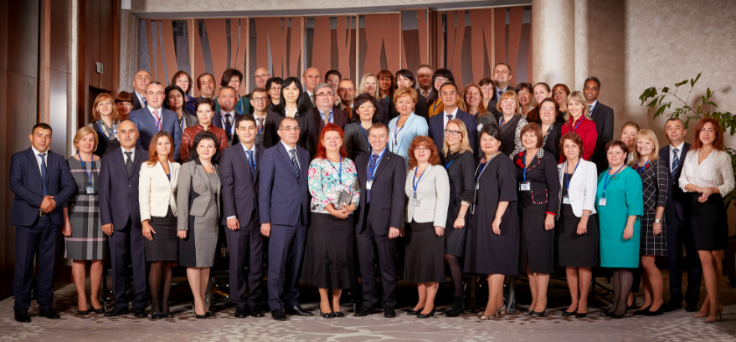

Mrs. Elena Nikulina, PEMPAL Program Team Leader, Mr. Ion Chicu, TCOP Leadership Adviser, Mrs. Galina Kuznetsova, World Bank Senior Financial Management Specialist, Mr. Mark Silins, Lead Thematic Advisor for TCOP, Mr. Ranjan Ganguli, Thematic expert on public accounting, Mrs. Yelena Slizhevskaya, PFM Consultant.
National accounting and reporting system was found fully compliant to one IPSAS, partially compliant – to 4 IPSAS, and non-compliant with 26 IPSAS
Mr Ganguli delivered this presentation on behalf of the Polish authorities due to the late withdraw of their presenter

