Meeting of the PEMPAL Treasury COP Thematic Group on
Use of Information Technologies in Treasury Operations
_____________________________________________________________
Chisinau, Moldova
On June 3-4, 2016, PEMPAL Treasury Community of Practice (TCOP) organized in Chisinau, Moldova, a meeting of the thematic group on use of ICT in treasury operations. The main objective of the meeting was to offer to its members an opportunity to informally discuss key issues relating to use of ICT, particularly in relation to how it can better enable the changing role of the treasury function. The meeting was attended by twenty-nine specialists representing 10 PEMPAL countries (Albania, Azerbaijan, Belarus, Georgia, Kazakhstan, Moldova, Russian Federation, Tajikistan, Turkey and Ukraine) and facilitated by the World Bank resource team working with TCOP. Logistical support was provided by the PEMPAL Secretariat based in the World Bank Country Office in Moscow.
For the first half of day one of the event members of the thematic group joined the main TCOP plenary workshop which was taking place concurrently in Chisinau. The theme for the plenary was Evolution of the Role and Functions of the Treasury, an important topic for ICT given it is the key driver for such evolution. During the joint session the hosts delivered presentations on their recent ICT developments, including a live demonstration of the new central financial management information system which become operational on January 1, 2016.
Mr. Yuri Turcanu, Executive Director of the Center of Electronic Government of the State Chancellery of the Government of the Republic of Moldova, delivered a presentation on Moldova’s government electronic payment service (MPay). Mr. Turcanu explained that in 2010, Moldova decided to modernize the relationship between government and its citizens by establishing electronic services accessible across the country. Two key reasons for the reform were the fight against corruption and also to provide a user friendly interface for payments made by the large Moldovan diaspora living abroad. The system was developed jointly with the Chief Information Office of the Government, Treasury and the Central Bank of Moldova and was launched in September 2013. Mr. Turcanu indicated that no fees are charged for payments relating to public services, when payments are made directly to treasury accounts - all costs are covered by the state budget. As a next step in developing the service it is planned to extend MPay for government to client (G2C) payments (e.g. pensions), revenue refunds and mobile payments. This is particularly important for those Moldovans who do not hold bank accounts, or feel uncomfortable doing so, given recent (and historical) issues in the sector.
During the question and answer session that followed Mr. Turcanu clarified that support of the system is organized in a distributed manner – the Center of Electronic Government is the owner of MPay and responsible for its operation. Design of the technical solution was outsourced while technical support is also partially outsourced.

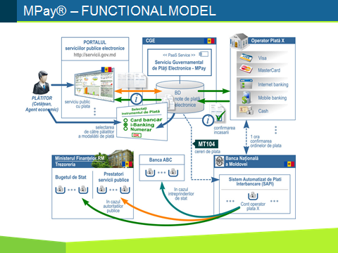

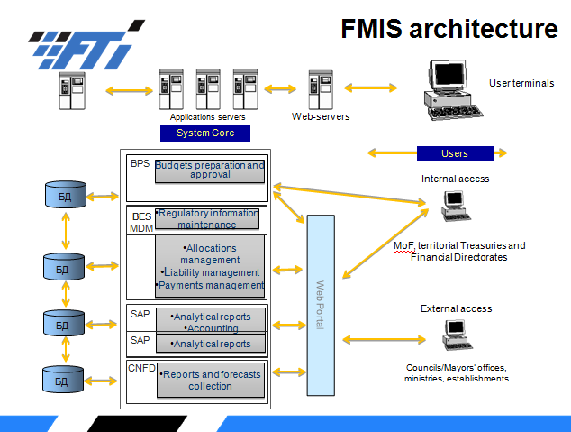
The second presentation of the morning was delivered by Mr. Denis Bacheev, Deputy Director of the State Enterprise “Fintehinform”. on the Architecture of the Public Financial Management Information System (PFMIS) of Moldova. The Moldovan PFMIS is built around the SAP platform which has been significantly modified to meet the government’s specifications. It is a web-based system, accessed by nearly 9000 users at both central and local government levels.

Moldova has some key plans for the future including: further development of analytical tools; improving data access to provide information for an open data initiative; integration with M-Pay; and the creation of a single taxpayer account to improve interaction with this important client group.
Mr. Petru Oprea, Deputy Director of the State Treasury of the Ministry of Finance of the Republic of Moldova, followed with a live demonstration of the system including contract registration and the processing of payments in the Treasury. An interesting feature of the system is its ability to create an Inter-Bank Account Number (IBAN) for vendors of the government that also imbeds elements of the Chart of Accounts to facilitate easier coding and reconciliation.
The final presentation of the morning was by Mrs. Elena Saharnyan, Director of the State Enterprise ”Fintehinform”, where she provided an overview of the history of the PFMIS implementation in Moldova. The project was initiated in 2005 with support from the World Bank with the main objective to modernize the system of PFM in Moldova. Initially the project was planned for 2006-2009, but was extended a number of times due to numerous changes in the system design and corresponding delays until the project was closed in 2013. The Ministry of Finance was not fully satisfied with the quality of the system developed by the external supplier and continued the development on its own, going live on 1st January of this year. Selected milestones are illustrated in the Box below.
Selected Milestones for Moldova PFMIS Implementation and PFM Reforms
2005-2006 | development of the terms of reference for Moldova PFMIS
March 2007 | two-stage bidding announced in accordance with World Bank’s procedures
October, 2008 | award of the contract
March 27, 2009 | conclusion of the contract for the PFMIS supply and implementation
2009-2013 | work on PFMIS development (BPS, BES/MDM, SAP/BW, CNFD modules were designed; budget execution module was not development)
2014 | approval of the new regulatory framework for PFM
2014-2015 | work on development of the budget execution module (under the contract between MoF and “Fintehinform”)
2014-2015 | training of users in applying new budget classification, revised methodologies for budget preparation, approval and adjustment, as well as training users of PFMIS
2015 | training of users in applying new chart of accounts, revised methodologies for budget execution, accounting and financial reporting
March, 2015 | launch of the PFMIS module for budget preparation (new PFM legislation and budget classification were coming into force in 2016)
December, 2015 | launch of the new budget execution system (for 2016 budget)
2016 | full coverage of the budget process by the integrated PFMIS

Mrs. Saharnyan provided thoughtful insights into the reasons for delays with the project implementation and the lessons learnt:
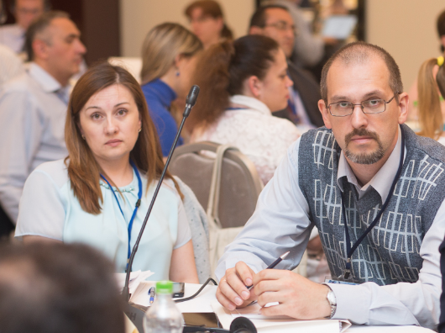
- significant changes to the project timeline were caused by delays with preparing the system design, errors in documentation, revisions in the system’s architecture as well as changes in approaches to the integration of modules;
- the supplier was not able to provide enough staff and ensure a high level of interaction among subcontractors (suboptimal and complicated project management structure, five project managers were changed during project implementation, four subcontractors were involved who used different technological approaches, system designers had no offices in Moldova and worked remotely);
- it is important that the supplier properly prepares for thorough testing (documentation, functionalities, upload of data for testing);
- high quality translation is essential as are project specialists with a good command of English (or relevant language) as large volumes of documents (primary documentation, specifications, minutes of meetings, test results, etc) need to be continually translated from/into English;
- it is important to establish a dedicated team of MoF officials (including ensuring minimal turnover of MOF and IT personnel) that will be working on the project - for the testing period MOF allocated specialists but they also had to do their daily routine work;
- suppliers must provide good quality training for MoF (including IT) personnel, provide detailed but easy-to-understand user manuals, and ensure high-quality translation; it is also important to have a dedicated and permanently accessible classroom for the testing period with enough desktops;
- it is important to understand that the introduction of new business processes is multi-dimensional and therefore can create a lot of risk. Changes are required in: work processes, the redistribution of functions within and among units, and regulations and instructions for the new processes. It is also important to effectively communicate with personnel to prepare them for the changes;
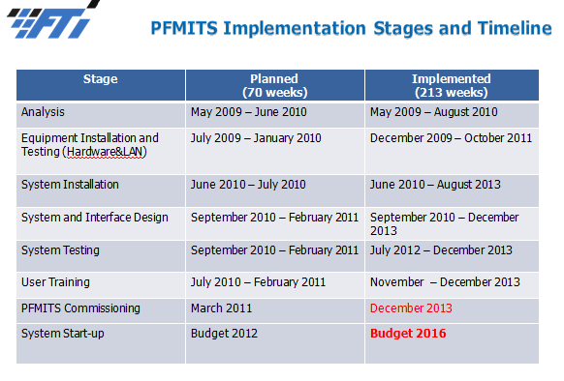
- it is important to remember that amendments to legislation in the course of project implementation increase the implementation timeline and costs – these amendments should be introduced early, at the stage of drafting specifications. After technical specifications are finalized a moratorium on amendments to legislation should be introduced and during system implementation changes to methodologies and legislation should be kept to a minimum;
- staff is the only resource that increases in value with time – the turnover of IT personnel results in a loss in this investment and a requirement to reinvest in new staff, resulting in delays to the project; and
- the key element for overall success is building a positive attitude for all stakeholders from the inception of the project, and creating a shared understanding that all the changes introduced to the business processes and technologies are steps towards improvement of PFM – change management is therefore key.
The participants of the plenary and ICT thematic group extended their appreciation to Mrs. Saharnyan for her comprehensive and candid presentation on Moldova’s experience with its PFMIS implementation. Moldova had embarked upon a major reform program, and with the benefit of hindsight, perhaps this was too ambitious and the initial timeframes too tight. Moldova’s shared experience will be useful for other countries which are moving down a similar path.
In the afternoon, the ICT thematic group split from the plenary and met to continue the discussions with ”Fintehinform” on the Moldovan PFMIS project. The session was facilitated by Mr. Ion Chicu, TCOP Advisor, and leaders of the thematic group – Mr. Nazim Gasimzade (Azerbaijan) and Mr. Andrey Narchuk (Belarus). The session was conducted in an informal manner which allowed for an active debate and exchange of opinions between professionals. Summary of the key points from the discussion is provided below:
- There was a four year delay compared to the original plan before the system was operational. The Moldovan authorities opted to not use a phased approach to the roll out of the system (for example, transition to the new unified budget classification and CoA in the existing system). The decision was to wait until all new capabilities could be introduced at one time. Technology did allow implementation of a phased approach, but it did not seem the best option from the business process perspective at the time;
- No special (or internationally accepted) formal project management methodology was followed for the PFMIS implementation. There was an implementation timeline which existed as part of the system development contract, and the work was based on regular progress reports to management. Mr. Nazim Gasimzade suggested that delays in the project timeline may have been due to the absence of a formal methodology;
- Mr. Nazim Gasimzade was interested in Moldova’s expericence in the field of knowledge management. Representatives from ” Fintehinform” commented that this is not currently part of their short-term priorities with the primary focus on the PFMIS together with introduction of the new Chart of Accounts. As a result the priority has been establishing a call-center to address all the incoming requests in these areas for assistance. Documentation for the new system is available in three languages, but it is a very time consuming exercise for the users to find answers to their questions by browsing through these lengthy manuals. As in interim solution a Q&A section was created on the MoF webpage where answers to frequently asked questions are published;
- In relation to a question about the PFMIS’s functionality for scenario analysis, Moldova clarified that the PFMIS includes specific tools for analysis and forecasting, however, this type of analysis has a significant “creativity” component which cannot easily be automated in any system;
- The group also noted the additional complexities for the use of the new system that arise from the deviations from the established budget calendar (the apporval of the current year’s budget has been delayed due to political instability and the country was operating under the interim budget).
The concluding session for day one involved discussion about the lessons learned in the process of FMIS project implementation, and identification of further topics for discussion during the second, and concluding day of the meeting. The thematic group agreed to further discuss the lessons learnt from FMIS projects implementation in relation to:
- project management;
- user support; and
- system’s change request management.
The morning session of day two commenced with Mr. Ion Chicu introducing the topics agreed for discussion the previous day. Participants shared their experiences in these areas with a summary of the key points discussed provided below.

- Project Management Arrangements (based on the Moldovan case)
Implementation arrangements in Moldova included the following structures:
- Supervisory Committee comprising representatives from the Central Bank, Ministry of Finance, Court of Accounts, Ministry of Information, donors and others
- Coordination Council headed by a Deputy Minister
- Working Groups for different thematic areas (each of them had an external IT specialist assigned)
  - WG 1 – Budget Preparation Methodology
  - WG 2 – Budget Execution Methodology
  - WG 3 – PFMIS, including the following subgroups:
      - Subgroup 3.1 – Technical Infrastructure and Networks
      - Subgroup 3.2 – Budget Preparation Module
      - Subgroup 3.3 – Budget Execution Module
      - Subgroup 3.4 – Accounting and Reporting Module
- Working Groups for PFMIS Testing, with the majority headed by MoF/Treasury specialists:
      - Technical Infrastructure and Hardware Testing Group (this group did not included MoF/Treasury staff);
      - Budget Preparation Module Testing Group
      - Budget Execution Module Testing Group
      - Accounting Module Testing Group
      - Reporting Module Testing Group
      - Integration Processes (external and internal) Testing Group
- Project Office was established as a separate administrative unit of the Ministry of Finance which handled financial management, procurement, and monitoring on a full time basis, however, the unit did not provide a technical support role. Other staff of the MoF led the technical Working Group but this was part time only, as they all had to also complete their normal work responsibilities.
The IT specialists assigned to each of the thematic working groups were responsible for assisting the staff of the Ministry of Finance to review and analyse the documentation and refine specifications. These experts were relocated to “Fintehinform” later during the project. There was also an international expert hired by the project office who was familiar with World Bank ICT procurement guidelines.
Testing of the system was conducted according to a predefined plan based on 18 hundred individual “test cases” which encompassed all aspects of the software. Review of test results took an enormous amount of time, and was a major contributing factor to the delays with system implementation. Errors and incidents were documented manually – no special software was used for this purpose.
Mrs. Saharnyan highlighted the importance of being able to include potential changes in the contract with supplier(s). In 2008 Moldova was lucky enough to be able to include the transition to the Treasury Single Account and electronic signature capabilities in the contract as they were at the negotiation stage at that time.
In regard to audit of the IT system, it was noted that at the moment, Fintehinform” does not have dedicated staff for this function but plans to hire an IT Auditor as soon as possible. The Court of Accounts of Moldova has, however, already performed several IT system’s audits as part of its broader external audit function.
Belarus representatives queried whether Moldova’s approach in not defining a full set of system specifications upfront created a risk that they would be implementing some requirements before they were ready or which achieve sub optimal results. Moldova team acknowledged that there were some risks, but also emphasised that it is not always possible to have a full understanding regarding every aspect of the system upfront, and thus some flexibility is required.
Kazaksthan participant was interested to understand why Moldova prescribes a single accounting software product for budget entities, instead of defining the ICT specifications, and allowing budget entities to procure their own systems. In Moldovas case, the software was enhanced centrally and MoF provides configuration of the system free to budget entities, while the latter are responsible for procuring the main software license.

- User Support Arrangements

Representatives of “Fintehinform” are considering establishing a dedicated call-center to manage user requests and were interested to learn more about the experiences in other PEMPAL countries. The current priority is to ensure that all users are trained in operating PFMIS. User feedback is collected in traditional ways, during workshops or by analyzing incoming queries and requests. There is also a specific software available to manage incidents, but so far users have not been granted access to this.
Mr. Rustam Boboev, the Director of the IT Center of the Tajikistan Ministry of Finance, explained that they have implemented a remote solution for user support by purchasing specific software. This allows the targeted distribution of the system issues and requests received according to the nature of the issues involved. It also includes the capacity to create a “knowledge database” which can include video instructions and user manuals. They have also created rules for distribution of user requests. In the first place the requests are handled by technical experts. If the issue cannot be resolved in a few minutes the request is forwarded to functional specialists (e.g. if a report was not generated, or some discrepancies were observed). The third layer of support is provided by system administrators and developers, while the fourth level is by the specific software developer of the related product. The Current user support unit comprises 60 people including representatives in regions.
Mr. Yerlan Shalgimbayev, the Head of IT Department of the Treasury Committee of the Kazakhstan Ministry of Finance, indicated that they have a special call center operating as part of e-government in Kazakhstan and all requests are initially directly there. There are 5-7 operators in the centre familiar with treasury execution and the MoF conducts special courses for these operators twice a year. If the issue is not resolved by these specialists the user is redirected to the Treasury call center. Mrs. Zaifun Yernazarova, the Director of the Budget Legislation Department of the Kazakhstan Ministry of Finance, added that whenever major changes to the system or methodologies are implemented the Ministry of Finance publishes phone numbers of the relevant specialists on its web page to allow users direct access to first-hand advice.
Mr. Gasimzade described the approach to user support adopted in Azerbaijan. User requests are filtered through a dedicated call center. On the front line the requests go to functional specialists who are able to connect remotely to all the desktops in the treasuries. If requests come directly from spending units operating through the Treasury web portal, IT experts provide direct assistance to resolve the issues. Mr. Gasimzade emphasized the importance of developing formal user manuals, even if they do not seem to be perfect at the very beginning. In Azerbaijan all newly hired staff have to familiarize themselves with these manuals before being permitted to proceed with the related work.

- System’s Change Request Management
The thematic group agreed that system change management was a critical but challenging issue for ICT, with stakeholders often expecting an immediate response, despite the control risks that such an approach would create.
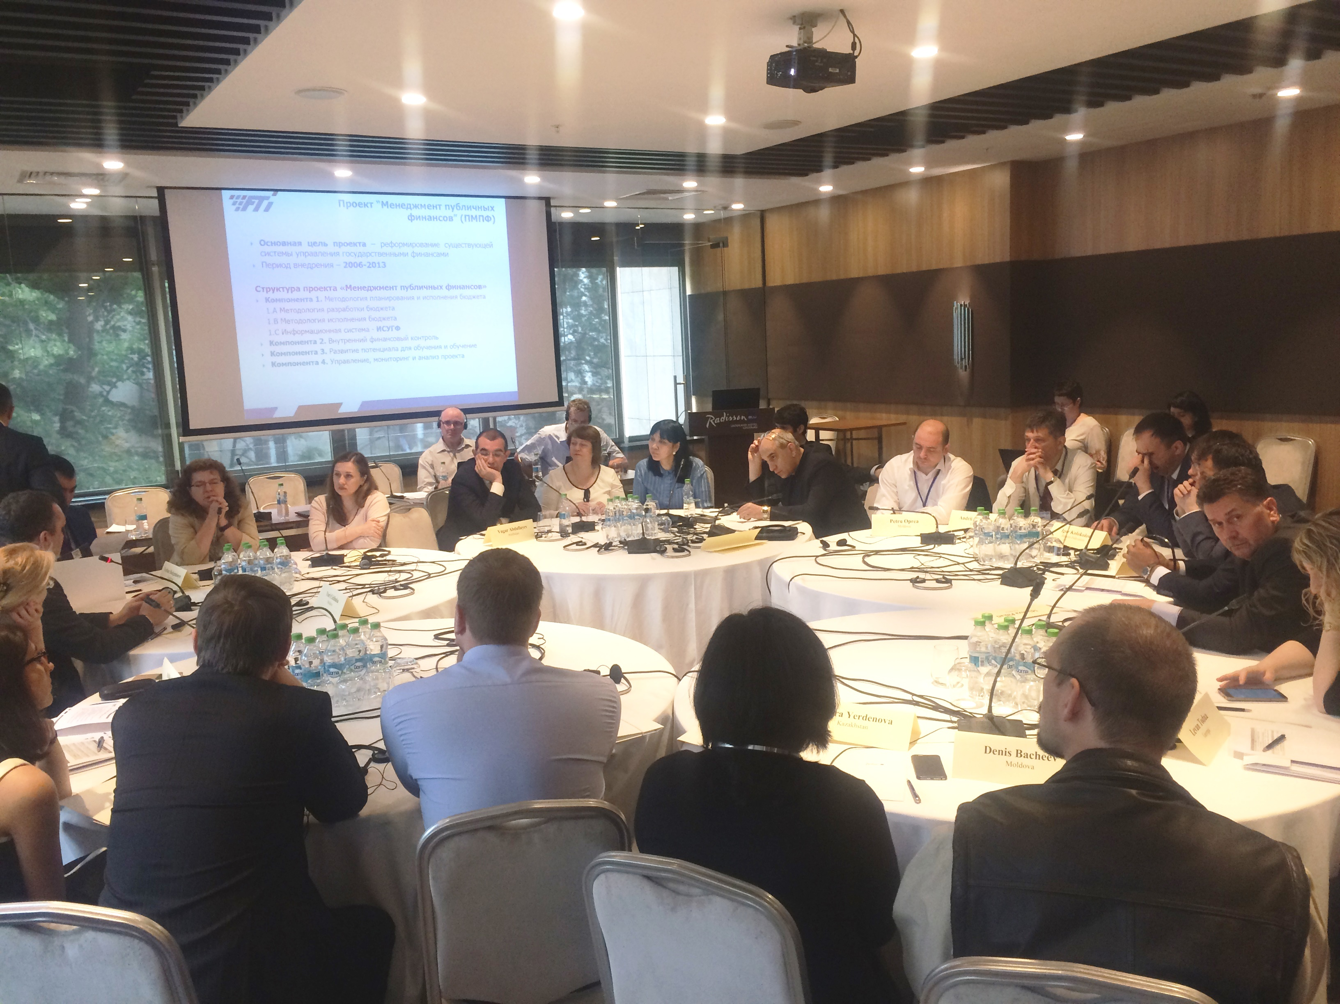
Mr. Gasimzade commented that assessment of system change requests should take into account aspects such as cost, time, scope, quality, and the risks and benefits. Based on this assessment clear priorities for change requests can be determined, including in some cases refusing the requests. He further highlighted that for certain days or periods of the year (e.g., end of a reporting period) system should be closed for any changes, to eliminate the risk, however small, that such changes present.
Mrs. Nino Tchelishvili, Deputy Head of the Treasury Service of Georgia Ministry of Finance, explained that they had established a structured change management system based on special software which documents all system request history, and provides useful background information to assist in determining whether to accept or reject these change requests. Importantly, this also creates a documented audit trail, for subsequent review. There is a business analyst in the team who assists with investigation of all incoming requests. If changes to any regulations require system changes, Treasury coordinates the process to ensure a smooth transition. Another aspect, mentioned by Mrs. Tchelishvili, was the need for rigorous testing of the whole system, even if the changes are introduced only to one process.
Mrs. Elena Saharnyan commented that the recent transition to the new PFMIS required a major change in practices for system change request management. The old system consisted of a number of independent modules and this allowed more flexibility in accommodating many of the change requests from the MoF. The current level of integration between the PFMIS modules as well as their linkages to other government systems has increased the change management risks, and “Fintehinform” has to now refuse some of the requested changes. This has been somewhat of a shock to stakeholders who became used to a more responsive change management system. It has therefore been important to communicate this issue to management along with the inherent risks that unstructured system changes will create.
Following the conclusion of discussions on the three selected questions, Mrs. Elena Nikulina also shared lessons learned by the World Bank from the Moldovan project and documented in its Implementation Completion and Results Report (ICRR):
- Overall implementation of the Moldova project was assessed as unsatisfactory – the project did not deliver the operational FMIS system despite several extensions of the closing date (the budget execution module did not pass acceptance testing and was therefore not signed-off by the Ministry of Finance);
- External factors, including major political changes, adversely affected political commitment to, and high level support of the project;
- It is very important to establish a good understanding between the supplier and the client (MoF) on many issues including the required level of customization and the physical presence of vendor representatives in-country;
- It is important to plan and sequence changes properly. Moldovan MoF chose to wait for the new information system to introduce the new unified chart of accounts and budget classification and new methodologies. This resulted in Moldova having to wait many years to implement these reforms, which could have otherwise have been in place for some time;
- FMIS projects rarely take less than 7-8 years from inception to completion. The World Bank Board of Directors is not authorized to approve projects with such a long timeline. Based on this the World Bank has revised its approach and supports a phased implementation of financial management information systems using a project series approach;
- Everyone agrees that ideally it would be good if contracts would allow for some flexibility in order to accommodate potential design changes, which are somewhat inevitable. This flexibility is hard to reach in the framework of a contract, which is a legally binding document and requires a disciplined approach to implementation. The Ministry of Finance of Moldova had no experience dealing with big international suppliers (who in contrast have lots of experience dealing with governments) and it was only at the later stages of the project that international expertise was brought in to address the issue;
- It is important to build shared understanding about fundamental methodological changes which are key for the reform. Reaching this shared understanding can take time, particularly when the changes challenge existing systems and beliefs. As an example, Moldova took more than two years to reach agreement on the need and feasibility for integration of the budget classification and chart of accounts. It is however, very positive to see that this is a core feature of the system in place today in Moldova.

During the final session of the workshop participants discussed further plans related to the work of the thematic group. A series of videoconferences will be organized during the FY2017 for discussing the following topics:
- FMIS technical support in different countries;
- Project management, Change management, Risk management;
- FMIS modules (order of implementation, integration rules, ets).

The group is also interested in Estonia’s experience in FMIS implementation, suggesting the TCOP resource team to organize a study visit in this country.
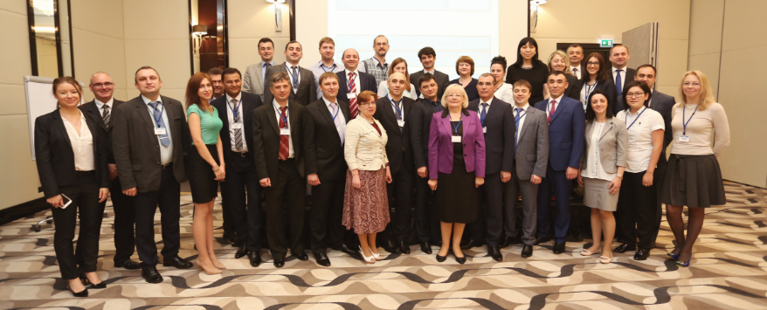
All meeting materials are available at the PEMPAL web-site: https://www.pempal.org/events/tcop-meeting-thematic-group-use-it-treasury-operations

Mrs. Elena Nikulina, PEMPAL Program Team Leader, Mr. Ion Chicu, TCOP Leadership Adviser, Mr. Mark Silins, Lead Thematic Advisor for TCOP, Mrs. Yelena Slizhevskaya, Team Member.
established by Resolution of the Government No 18, dated January 4, 2007
established by Minister of Finance’s order
established by Minister of Finance’s order
established by Minister of Finance’s order
established by Minister of Finance’s order
which is an open source solution

