Evolution of the Role and Functions of the Treasury in a Modern World
_____________________________________________________________
Chisinau, Moldova
On June 1-3, 2016, PEMPAL Treasury Community of Practice (TCOP) held a plenary meeting in Chisinau, Moldova. The main objective of the meeting was to discuss the evolving role of the government treasury function given the transition from a traditional manual processing environment to automation utilizing modern financial management information systems. The event also served as the forum for updating the TCOP activity plan for FY2017. The meeting was attended by fifty-six specialists representing 15 PEMPAL countries (Albania, Armenia, Azerbaijan, Belarus, Bosnia and Herzegovina, Croatia, Georgia, Kazakhstan, Kyrgyz Republic, Moldova, Montenegro, Russian Federation, Serbia, Tajikistan and Turkey). Observers from the Ministry of Finance of Slovakia and the Hungarian State Treasury also attended the meeting. The workshop was facilitated by the World Bank team working with TCOP, including Ms Elena Nikulina, Team Leader for PEMPAL, and Mr. Ion Chicu, Ms Yelena Slizhevskaya and Mr. Mark Silins. Logistical support was provided by the PEMPAL Secretariat based at the World Bank Country Office in Moscow.
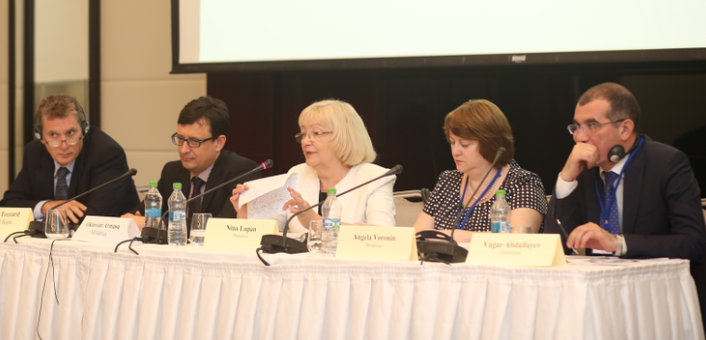
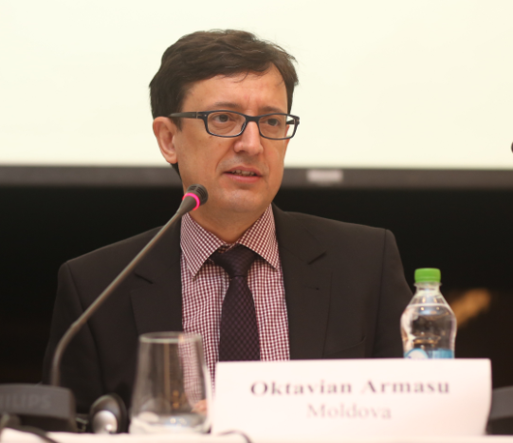
Mr. Octavian Armasu, Minister of Finance of the Republic of Moldova, formally opened the workshop. In addition to welcoming participants he highlighted the major recent PFM reforms including the launch of the public financial management information system on 1 January 2016. Mrs. Nina Lupan, Director of the State Treasury of the Ministry of Finance, noted that PEMPAL is known to be a unique platform for sharing experiences between PFM professionals, and this opportunity for exchange with peers was assisting Moldova in improving its performance and implementing many of its reforms. In welcoming participants to the workshop, Mr. Vugar Abdullayev, Chair of the PEMPAL Treasury Community of Practice and Deputy Head of the State Treasury Agency of Azerbaijan, noted that technological development is enabling a transformation of the treasury function from simple processing activities, to be more strategic in support of decision making. He noted that Moldova’s recent reforms would be very interesting for participants, and this would be supplemented by information of recent reform initiatives in other PEMPAL countries. In his opening remarks Mr. Adrian Fozzard, Governance Practice Manager, World Bank (WB). welcomed participants on behalf of the Bank, and thanked Moldova for its initiative in hosting this event. He emphasized the high importance the WB places on peer learning and the key role PEMPAL and TCOP have played in this area. He also welcomed the participation of two new countries in this event as observers, namely Hungary and Slovakia.
After the welcome speeches Mr. Vugar Abdullayev briefed the participants on the implementation of the TCOP Activity Plan for FY2016 including highlighting a number of “knowledge products” which the TCOP had produced in recent years. He also invited participants to complete the regular survey to identify areas of interest for 2017. TCOP Executive Committee is also currently contributing to the work on the new PEMPAL strategy for the period FY2018-22 Additional information on TCOP activities in FY2016 can be found in Mr. Abdullayev’s presentation (https://www.pempal.org/sites/pempal/files/tcop_activity_2016_fy-eng_vugar.ppt).
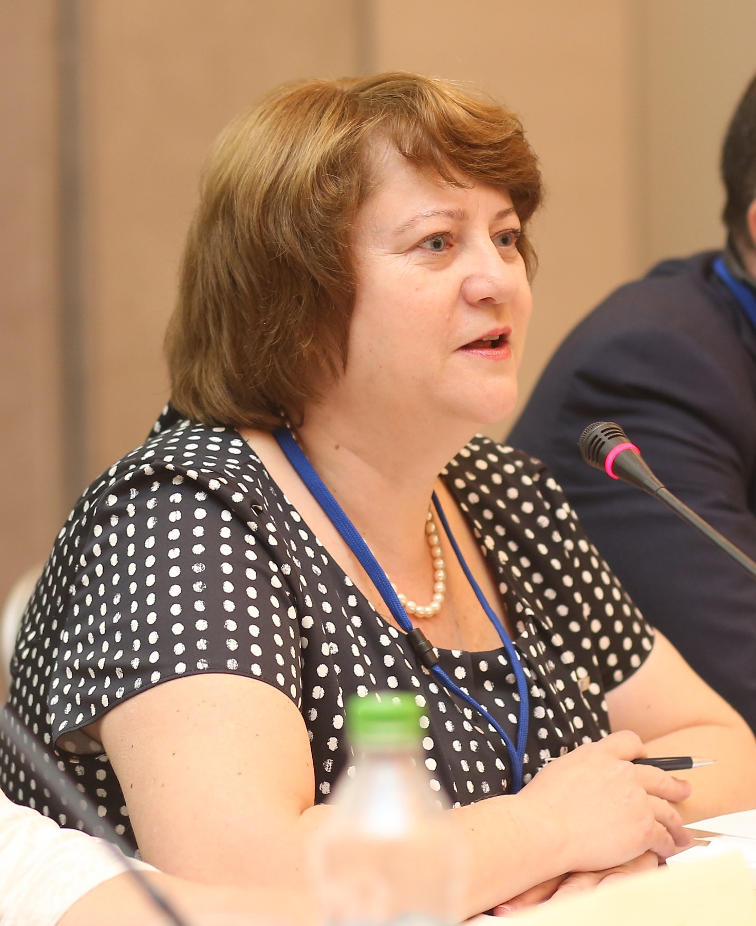
The thematic program started with presentations by the host country. Mrs. Angela Voronin, Deputy Director of the State Treasury of the Ministry of Finance, delivered an introductory presentation “PFM in Moldova: Reforms and Development Strategy”. Mrs Voronin highlighted that Moldova has an overarching National Development Strategy that extends to 2020. This is underpinned by the PFM Strategy that includes seven core components covering all aspects of PFM including the Treasury, PFMIS and accounting reform. Areas of major recent reforms have included: centralization of cash balances (including balances of donor funded projects) in the Treasury Single Account (TSA) which facilitated improved liquidity management in the Treasury; implementation of the Unified Chart of Accounts (UCoA); delegation of responsibility and control over expenditures to ministries and agencies; introduction of direct accountability of central government agencies to the Parliament; and development of the internal audit function in the general government sector. Areas of future reforms include: development of the accounts payable module for the PFMIS which will improve control over arrears and assist with liquidity forecasting; better integration of the accounting function in spending units (1C software) with the PFMIS; development and implementation of accounting standards for the public sector; further development of the PFMIS to make it a common and user friendly platform for all budget process participants including auditors and regulatory bodies.
The new Public Finance Law provided a legal basis for many of the reforms which have been implemented under the PFM Strategy, and Ms. Svetlana Placinta, Head of Methodology Department of the State Treasury, delivered the second presentation on that topic. The Law on Public Finance and Budget and Tax Responsibility, was adopted in 2014. The law provided the platform to modernize the PFM system in Moldova, including enhancing the role of budget entities, devolving many of the traditional central controls executed by the Treasury.
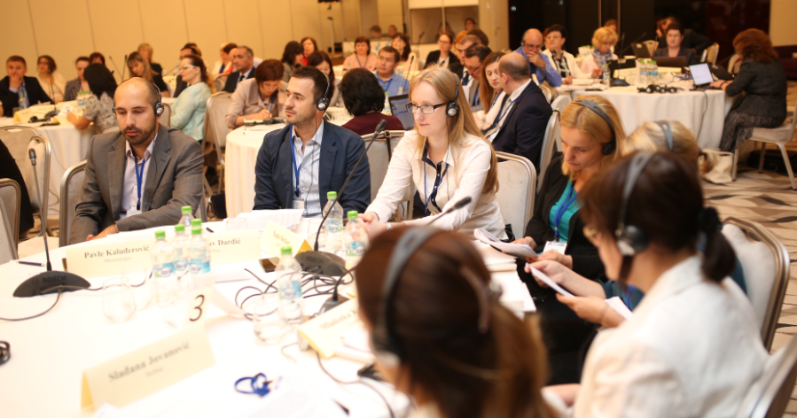
This topic generated significant interest and discussion amongst participants, with many questions posed about how such a change was possible given the strong traditional focus on central controls. Representatives of the State Treasury of Moldova clarified that this reform was indeed a big cultural change that required a lot of preparatory work and training and which was also linked to program budgeting reform – now, when the state budget is prepared based on programs, ministries must defend their performance and budgetary requests in the Parliament jointly with the Ministry of Finance. Program budgeting implies more flexibility in managing budgetary spending, which is why the Treasury moved away from detailed control over line items and will only be responsible for overall appropriation control. It was also noted that implementation of a comprehensive internal audit function in the public sector played an important role in making this shift possible – internal audit units operate in all ministries providing management with valuable advice on how to improve performance of the ministry and minimize risks in daily operations.

Mrs. Voronin also delivered the third presentation which was an overview of modernization and evolution of the treasury function in Moldova. Since the State Treasury of Moldova was established in 1993, it has gradually increased the coverage of public funds and refined the functions it performs. Key milestones particularly in relation to coverage of the Treasury Single Account (TSA) are summarized in Box 1 below.
Box 1. Development of the Treasury System of the Republic of Moldova
1993 | treasury system established
1993 – 2000 | setting up the system of territorial treasuries, increase in the Treasury coverage
2007 | MoF becomes participant of the Automated Interbank Payment System, TSA in national currency established
2008 | closure of bank accounts of the territorial treasuries with implementation of the “Client-Treasury” module and introduction of digital signature
2007-2013 | gradual transfer of accounts for donor funded projects from commercial banks to the National Bank of Moldova
2015 | accounts of public self-governing institutions transferred to the TSA
2016 | accounts of joint stock state owned enterprises are expected to be transferred to the TSA (subject to approval by the law on state budget for 2016)
Mrs. Voronin also presented an overview of the distribution of functions between the central treasury and its territorial units, which is summarized in Box 2 below.
Box 2. Functions of the Central and Territorial Treasuries in the Republic of Moldova
General Directorate of the State Treasury:
- accounting for revenues of the state budget and budgets of the health and social insurance funds
- distribution of shared national taxes and accounting for settlements between state and local budgets
- cashflow forecasting
- reporting on execution of the national public budget
- analysis of execution of budgets at all levels
- development of the methodology for budget execution, accounting and reporting in the budget sector
- provision of methodological guidance and consultation
- organization of training for employees of the territorial treasuries and other public institutions
- cooperation with the state owned enterprise “Fintehinform” the Statutory Body responsible for Treasury ICT
Territorial Treasuries:
- accounting for cash execution of the state and local budgets, and off-budget funds
- accounting for local budget revenues
- registration and accounting for contracts concluded by spending units
- processing payment documents of spending units
- preparation of operative information on execution of spending units and off-budget fund budgets
- verification and execution of payment documents submitted by tax bodies (tax refunds etc.)
- preparation, verification and release of account statements and monthly reports to treasury clients
- provision of advisory services to treasury clients
- provision of training for employees of entities, serviced by the treasury (NEW)
Mrs. Voronin highlighted that development of technologies and evolution of the Treasury function in recent years call for:
- further improvements in TSA forecasting and liquidity management techniques;
- capacity development in budget execution monitoring and analysis;
- improvement in the understanding and capacity for risk management;
- streamlining of the training process for treasury staff and its clients and moving this process to a more professional basis; and
- further revision of the functions and structure of the Treasury.
Ms. Natalia Apostol, Head of Forecasting and Cash Management of the State Treasury of the Ministry of Finance of Moldova, delivered the next session on evolution of the forecasting and liquidity management function in the Treasury. Ms. Apostol noted that the development of the cash management function in Moldova, and establishment of a dedicated cash management unit in the Treasury, resulted from the expansion of the coverage of the TSA. In 2015 the accounts of the state and local budgets constituted 67 percent of TSA funds, with the remaining 33 percent belonging to health and social funds and other off-budget entities. Ms. Apostol also described the structure and functions performed by the Cash Flow Division of the State Treasury.
The afternoon session commenced with a presentation by Ms. Lilia Zaharcu, Head of the Unit for Methodology of Accounting in the Budgetary System of the State Treasury of the Ministry of Finance, who provided an overview of the budget execution methodology in Moldova with a special focus on introduction of the new integrated Budget Classification and Unified Chart of Accounts, that had taken place in 2016. Moldova sees the transition to the UCoA as a first step towards implementation of national public accounting standards, though it is probable that the UCoA will have to be further revised once the standards are developed. Additional information on the history and future of the public accounting reform in Moldova is presented in Box 3 below.
Box 3. History and the Future of Public Accounting Reform in the Republic of Moldova
2006-2007 | elaboration of rules and requirements for PFMIS
2007-2013 | development of the Unified Chart of Accounts for the budget sector
2013-2015 | development of the new financial reporting system for the budget sector
2013-2015 | elaboration of methodological accounting and financial reporting standards for the budget sector
2014-2015 | amendments to the legal framework
2015 | updating the budget entity accounting system (1C)
2013-2015 | software testing and staff training
from 2016 | application of the Unified Chart of Accounts and new methodological accounting and financial reporting standards in the budgetary sector
2015-2020 | development of Accounting Standards for the public sector (in line with a financial agreement between the Government of the Republic of Moldova and the European Commission). First set of standards is to be developed by the end of 2017
ongoing | development of additional modules for PFMIS
ongoing | training of staff
Moldova’s experience in organizing training for budget entities was an area of significant interest for participants. Mrs. Lupan and Mrs. Voronin commented that the initial idea was to set up a dedicated training center under the MoF but these efforts were not successful. As a result they implemented a “cascading” strategy, with the staff of the MoF and “Fintehinform” training selected representatives of ministries and agencies (2 from each) and these new trainers were then required to train their subordinated agencies. Mrs. Lupan also noted that this was an extremely challenging process and that it will be important for this training to be placed on a more professional footing and delivered on a regular basis. Moldova has also already taken steps to institutionalize training as core function for territorial treasuries. Thus while ICT has reduced the processing role of these offices, the more complex PFM and ICT environment is increasing the demand for regular training and consultations.
The last presentation of day one was delivered by Ms. Victoria Sili, Head of the Service of the National Public Budget Reporting of the State Treasury of the Ministry of Finance of Moldova, who described the system of reporting on the execution of the National Public Budget of Moldova. The National Public Budget of Moldova comprises the State Budget, State Social Insurance Budget, Compulsory Health Insurance Funds and Local Budgets (reports on execution of State and Local Budgets are prepared by the Treasury). Notwithstanding the ICT reform that has taken place in Moldova, some inputs are still submitted in hard copy, making it difficult to automate the preparation of the consolidated National Public Budget execution report. Preparation of financial statements is also complicated by differences between the UCoA used by budget entities, and the CoAs in place for the National Social Insurance House and National Health Insurance Company.
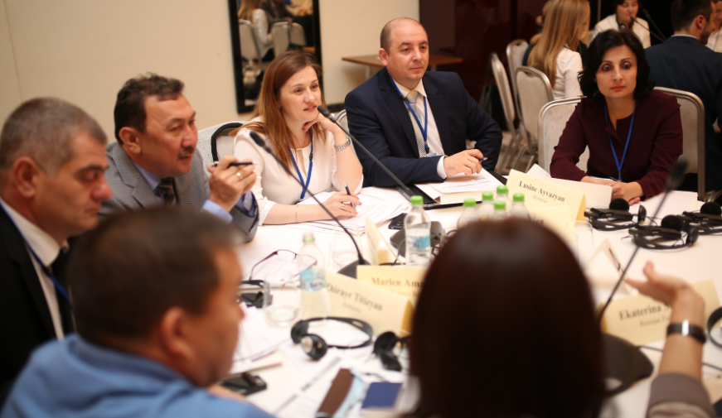
During the final session of day one the participants formed small groups to discuss the presentations by the host country and identify any lessons learnt. The participants agreed that the Government of Moldova had been able to implement a wide set of PFM reform initiatives. Particularly impressive was its success in expanding the TSA coverage, including integration of the donor project funds. Moldova’s strong commitment to training and communication was also viewed very highly. Mr. Mark Silins commended Moldova for the significant achievements to date, however he noted that there still remain a number of challenges for the Treasury in the medium term, including:
- full integration of the Chart of Accounts and Budget Classification;
- integration of the 1C accounting solution used by budget entities and the PFMIS;
- development of a single set of reports to minimize existing overlap between budget execution reports and financial statements;
- consideration how to address the requirements of the new GFSM2014 framework in further work on the national public sector accounting standards;
- developing PFMIS functionality to manage commitments and accounts payable to ensure improved controls, along with enhanced information to support better cash management and forecasting;
- clarification of the roles of Treasury taking into account the trend towards decentralization and the increased focus on risk management.
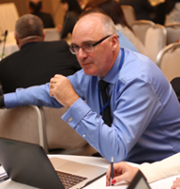
Day two of the workshop was dedicated to the topic of evolution of the treasury function. Four presenters delivered country case studies on this topic. Mr. Mark Silins, TCOP Public Finance Management Adviser, opened this session with an overview of internationally trends in this area. He highlighted that advances in ICT had provided the opportunity for a reengineering of government business processes, but not all countries had availed themselves of these opportunities. In part this was due to each countries appetite for risk. Many countries retained strong central controls for this reason. Mr. Silins reminded participants that devolution of decision making and processes had been a major trend in many OECD countries, with ex-post review replacing ex-ante checks and controls.
He also highlighted the importance of well-developed internal controls and internal audit functions in ministries and agencies before decentralization can successful take place. The shift of controls need not be at one time - treasuries can gradually reduce controls through a series of steps by focusing first on decentralization of less risky elements of PFM. Internationally there are many examples of reduced controls where risk is determined to be lower. Examples include: reduced checks for smaller value transactions and certification of system based controls for payments which also resulting in no or less centralized ex-ante checks. Mr Silins concluded by highlighting that the future of the Treasury function is not certain in every country, and will partly depend on how client oriented the Treasury is able to be. However, certain activities can be described as core to the treasury function, and other activities non-core, and may or may not be performed in the Treasury. Modern treasuries also have opportunities to be more entrepreneurial (See diagram below from the presentation).
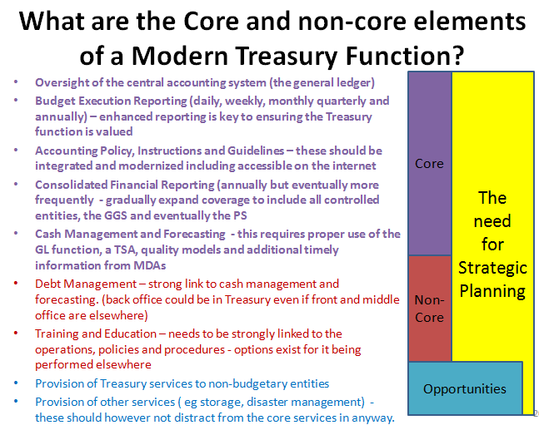
Mr. Alexandr Demidov, Deputy Head of the Federal Treasury of Russian Federation, delivered a presentation on the evolution of the control functions in the Russian Federation. Mr. Demidov noted that post-Soviet countries are known to be good at performing control functions but the inefficient use of funds remains a common problem. Mr. Demidov provided the participants with an overview of how development of treasury ICT solutions and inter-agency cooperation of different federal agencies, has helped streamline and advance control and audit techniques, as well as the analytical skills of the treasury staff.
In 2016 the Federal Service for Financial and Budget Oversight (ROSFINNADZOR) was liquidated and its functions were transferred to the Federal Treasury. Regional internal state (municipal) financial control functions were also transferred to the respective regional offices of the Federal Treasury. Participants noted that this was a unique development. A more typical trend for the countries in the region is reorganization of responsible bodies into financial inspection combined with gradual reduction in the scope of centralized financial control functions in parallel with the development of an internal audit system. It was agreed that it would be interesting to observe further evolution of this function in the Russian Federation.
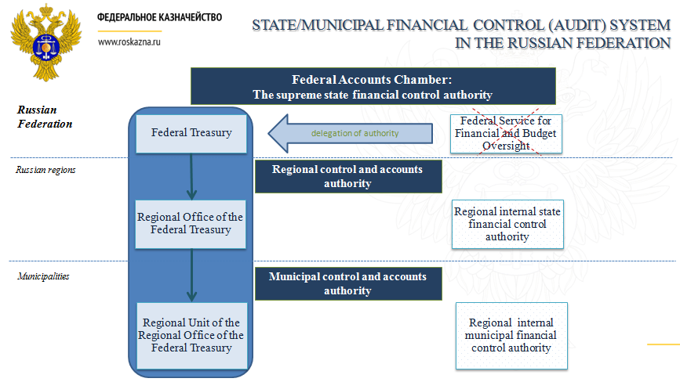

Mrs. Nino Tchelishvili, Deputy Head of the State Treasury Service of Georgia, was the next presenter who described the evolution of the role and functions of the Georgian Treasury. Mrs. Tchelishvili informed participants that the Treasury Service of Georgia was established in 1995 as a unit of the MoF but became a separate subordinated agency under the MoF in 2001. The implementation of a new web-based FMIS in 2010, which resulted in direct access by line ministries, resulted in the closure of the eleven regional treasury offices. More than 100 staff were redeployed as a result. There is now just the central treasury office with a total staffing of 97. The table below illustrates the major reforms that have taken place in the treasury during the last decade, along with the main drivers for the reforms. The State Treasury Service of Georgia is seeking further reforms including: diminishing ex-ante controls in relation to payments; developing capacity in managing financial risks; enhanced accounting and reporting including a move to implement accrual accounting.
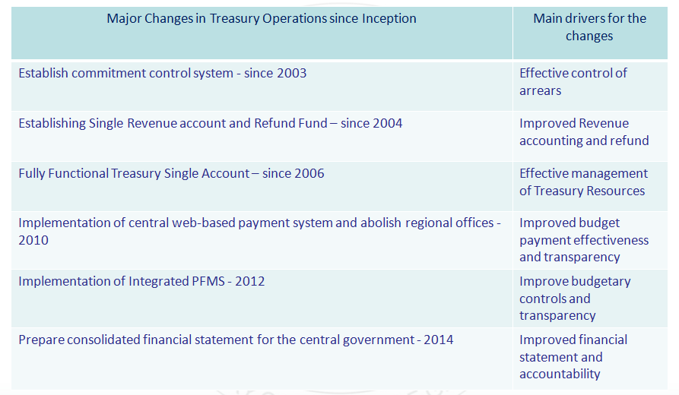

Mrs. Gabriella Sebestyén, Head of Division for Economy and Development of the Treasury of Hungary delivered the final country presentation for the morning. The Hungarian State Treasury commenced operations in 1996, with its original functions currently split between two major entities: the Hungarian State Treasury (public institution) and the Government Debt Management Agency (state owned limited company) which share responsibility for managing the TSA. The Hungarian State Treasury operates under the Ministry for the National Economy, selected milestones from its history are listed in Box 4 below.
Box 4. Selected Milestones from the History of Hungarian State Treasury
2001-2003 | Treasury split in 3 agencies: Office for State Budget; Limited company for treasury financial services (close to market operators); Debt Management Agency
2004 | due to EU accession: requirements for harmonization of reporting, new tasks for EU transfers and control of the use of EU funds
2008-2011 | partial implementation of FMIS project (release of 2 modules for accounting and reporting by central and local budget entities)
2011 | dedicated role in retail sales of government bonds to individuals
2011-2012 | improvement of web-based financial services; widening of client service network; significant increase in the number of treasury clients
2012 | outsourcing of IT development to a private company
2014 | new regulation on public accounting and Unified Chart of Accounts introduced (not fully integrated with IPSAS)
2015 | launch of IT system for central payroll (covering about 900 thousands civil servants)
ongoing | new IT system for accounts management is being introduced

Ms Sebestyén highlighted that further reforms are planned in its mid-term action plan including:
- better integration between budget preparation (conducted by the Ministry of National Economy) and the Treasury system;
- implementing commitment controls in the Treasury system; and
- overcoming a very fragmented ICT environment through the introduction of a new FMIS and data warehousing capacity.
This will also enable the Treasury to meet an ever increasing demand for reporting which it currently cannot accommodate. Additional details could be found in Mrs. Sebestyén’s presentation available on the PEMPAL web page.
The entire afternoon of the second day of the workshop was devoted to group discussions during which representatives from each country made a short presentation about the history of their treasury, the functions it performs and the prospective changes to the treasury function in the future.
Reports from the group discussions were presented at the beginning of the day three by Mrs. Mladenka Caračić (Croatia), Mr. Vugar Abdullayev (Azerbaijan) and Mrs. Zaifun Yernazarova (Kazakhstan). Part of the group worked included a brief survey the results of which are summarized in the table below.
Questions | Summary of Responses
Year Treasury Formed in each country | 1972-2005 – in 13 out of 17 countries the Treasury was formed between 1991-1996
Is the Treasury part of the MoF (P) separate from the MoF (O) | In 11 countries the Treasury is part of the MoF, in four it is a separate entity, and in two it is in different ministries
Total Staffing of the Central Treasury (number) | The size of central treasuries ranges from 25-1500 staff, with an average of 242 staff
Regional Treasury Offices (number) | 12 of the 17 countries have regional treasuries. The number of offices ranges from a low of 2 to a high of 633, with an average of 116.
Total Staffing in Regional Offices (number) | Staffing of regional treasuries range from 5 to 42,000 across the 12 countries with an average of 5046
Which of these functions are performed by the Treasury?
-Management of the central financial management information system (including the general ledger) | The Treasury in all 17 countries manages the PFMIS
-Processing of payments on behalf of the government | Payments are processed by all 17 treasuries
-Budget execution reporting | Treasuries of 15 of the 17 countries report on budget execution, Bosnia and Herzegovina and Turkey being the exceptions
-Public sector accounting policy, instructions and guidelines | Only seven countries have responsibility for accounting policy assigned to the Treasury
-Consolidated financial reporting | 15 of the 17 countries do consolidated financial reporting Bosnia and Herzegovina and Turkey being the exceptions
-Cash management and forecasting | The Treasury in all 17 countries undertakes cash management and forecasting
-Management of government accounts (TSA and other) | The Treasury in all 17 countries manages government bank accounts
-Debt management | Only four countries have debt management function performed by the Treasury
-Training and education | Three countries deliver a formal training program from the Treasury, seven deliver only informal training, and seven either rely on the MoF or another body to deliver formal training
-IT | Nine countries have an IT function within the Treasury, 8 do not, either relying on the MoF or it is managed by an independent entity
Does your country have a PFM Strategy (Action Plan) covering the Treasury? | Most countries, 14 have a strategic PFM plan that encompasses Treasury
Does your country have a Specific Treasury Strategy (Action Plan)? | Slightly more countries 9, do not have a specific plan for the Treasury, with 8 countries having such a plan
Are there other relevant strategic documents? | 11 countries have other strategic documents relevant to Treasury reform, six do not.

Groups were also requested to consider and discuss two further issues: firstly, whether the Treasury would need to improve existing functions or add new functions in the future; and secondly, whether any current functions were likely to be redundant in the future. A summary of the discussions is reflected in Box 5 below.
Box 5. – Summary of Discussions Regarding the Functions of the Treasury
Improvements or New Functions

- Enhanced monitoring and analysis
- Shifting to Active Cash Management and Forecasting
- Improved management for Risks
- Enhancing Budget Execution Methodology
- Enhancing Accounting and Financial Reporting Methodology (cash and accrual reporting harmonization)
- Developing formal training functions and a greater focus on advice to participants in the budgetary process
- Shifting to a service orientation
- Improving interfaces with other information systems

Are there functions which may not be needed in the future?
- The role and functions of territorial Treasury Offices are expected to change
- Treasury control functions should be modernized and reduced in some countries

At the conclusion of the presentations Mr. Silins summarized the key messages from the last two days:

- Technological capacity has a major influence on a country’s ability to change processes in our countries. Over the last two days every country highlighted the importance of ICT as a driver for Treasury reforms. But it is also important for countries to examine whether it is getting all the benefits from its investments – have you properly reengineered business processes or are manual processes still in place despite this investment;
- Control/risk management is an important issue for everyone. It is very much specific to each country. However, if you are serious about control, it should occur early in the process not late if it is to be efficient and effective. So effective controls particularly in an automated system should be at the time the contract/commitment occurs not when money is to be paid. Effective review of our processes and understanding risk will provide opportunities for further improvements;
- Regional Treasury offices have been a major focus at this event and it is an important area for further analysis. Countries may need to ensure that the roles evolve - Moldova appears to have commenced this process. Those countries that have a very large regional presence now stand out as the exception, rather than the rule. In fact, five countries no longer have a regional presence at all;
- The separation of Accounting Policy and financial reporting from budget execution policy and reporting is an emerging issue. In 2009 IPSAS were amended to include budgetary reporting is an integral part of financial reporting. The GFSM framework also shows how these elements can be better integrated. A unified CoA provides the roadmap for better integration of these reporting requirements. So a question for the future – should they continue to be separate or be merged in the future?
- Most countries have strategic plans. Treasury reform cannot take place in isolation from other reform. What would be interesting to examine further is whether the plans focus on our present and future clients in terms of services such as through enhancement in the reporting function. Increasing the types of reports, the timeliness of reports, undertaken financial analysis, and transparency are all important areas for development;
- If you do not manage for change it may leave you behind. Continuing to focus on low level functions such as processing at the expense of value added functions could mean that eventually the Treasury as you know it is no longer required;
- One size does not fit all. We have unique features in each of our countries – we need to adapt for that – but we also need to be objective in assessing what is a real difference and those practices which we have undertaken traditionally but which may need to change. Continue to look to your neighbours and PEMPAL countries regarding this to allow an insight into the benefits and risks for some of these changes; and

Members of the TCOP ICT Working Group joined the plenary meeting for the third day of the event. The morning session of day three continued with a set of presentations and a live demonstration of Moldova’s most recent ICT developments. Additional information on this session and the follow up discussions can be found in the report for the ICT Working Group meeting, which took place following the plenary meeting, during June 3-4, 2016.
The final session of the workshop was devoted to discussion of further plans related to work of the TCOP. According to TCOP tradition, the members’ priorities for the future events’ topics and formats have been identified through a special survey, which was conducted among the community’s members in Chisinau. TCOP members continue to be interested in discussing various aspects related to four main topics addressed within the TCOP (Public sector accounting; Use of IT in treasury operations; Cash management; Treasury control), suggesting a large number of issues for further discussions under these main themes. TCOP members also voted for further discussions on the topic of Evolution of the Treasury function. They also proposed to address in a systematic way (establishing a new thematic group) the issues related to risk management. The data collected through the Chisinau survey will serve as a background for planning the TCOP activities for the period ending on June 2017.
The next PEMPAL TCOP plenary meeting will be held during the first half of 2017 (place to be identified).

All plenary meeting materials can be found at the PEMPAL web-site: https://www.pempal.org/events/pempal-tcop-plenary-meeting

