PEMPAL EXECUTIVE MEETING Bern JULY 2016 Feedback Survey

On July 14-15, 2016 PEMPAL Cross-COP Executive Meeting on Development of PEMPAL Strategy 2017-2022 took place in Bern, Switzerland.
After the event, the on-line survey in three languages was created. The aim of the survey was to receive event feedback.

Link to the survey – https://www.surveymonkey.com/r/CSSHJNN

The survey started to collect responses on July 19 and finished on July, 28, 2016.
Invitations to take part in the survey were sent to all participants (35) of the event.
19 responses were received. 19 respondents completed their answers. In this report, we analyze all 19 responses. For further calculation, we take this quantity as 100%.
All these responses will be included in the general Feedback Event Database.
The questionnaire comprises five parts: About the Respondent, Event Delivery, Event Administration, Overall Impression, and Recommendations for the Future. There are total 21 questions in it.
ABOUT THE RESPONDENT

Q1 You are..

19 (100%) respondents gave answers. 12 respondents (63.2%) were Representatives of PEMPAL COP Executive Committee and 7 (36.8%) - Resource Persons and Donor Representatives.

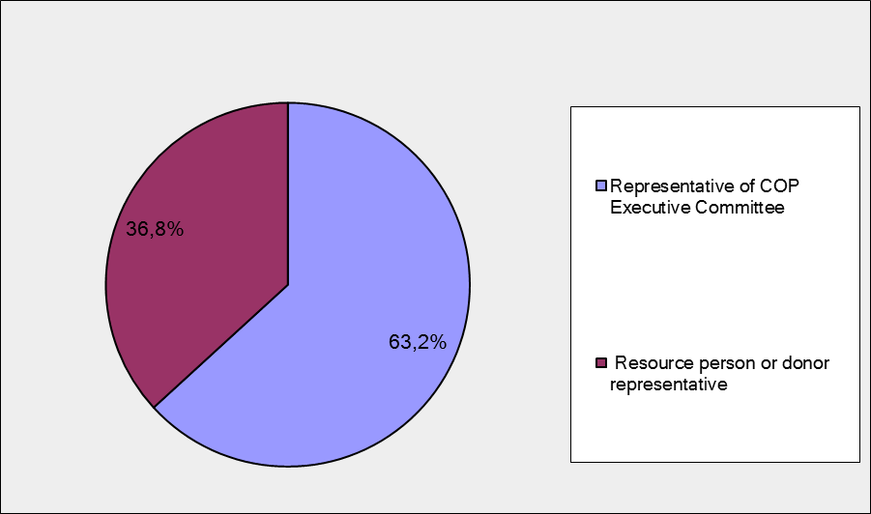
Q2. Are you representative of Steering Committee?
19 respondents (100%) answered this question.
Answer Options | Response Percent | Response Count
Yes | 31,6% | 6
No | 68,4% | 13

Q3. Was this your first participation in a PEMPAL executive meeting?

19 respondents (100%) answered this question.

Answer Options | Response Percent | Response Count
Yes | 10,5% | 2
No | 89,5% | 17

Q4. How many PEMPAL events have you attended before?
This question was seen only by those respondents who chose “No” in the previous question.

1-2 | 3-4 | 5-6 | more than 6 | Response Count
0 | 1 | 0 | 16 | 17
PART I EVENT DELIVERY

Q5. How do you rate your participation in this event?

18 (94.7%) answers were given. 16 (88.9%) respondents think that their participation in the event was ‘Active’. 2 (11.1%) respondents think that their participation was ‘Average’. And no one choses the option “Passive”.

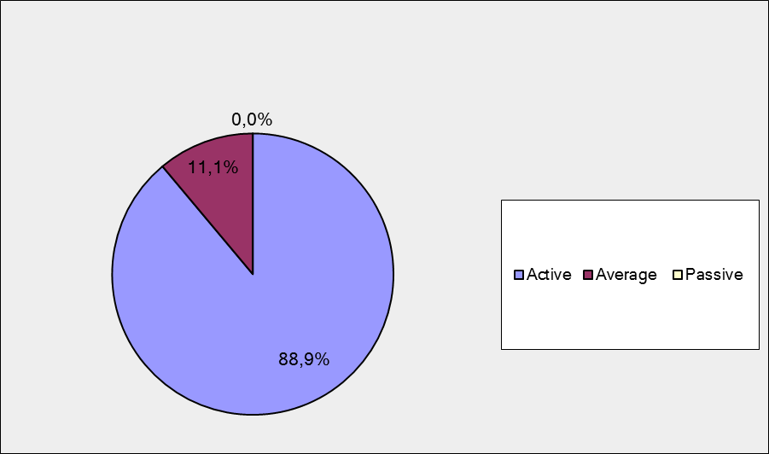

Q6. How do you rate the event duration overall?

19 respondents (100%) answered this question.
Answer Options | Response Percent | Response Count
Too short | 5,3% | 1
About right | 94,7% | 18
Too long | 0,0% | 0
Q7. How much do you agree with the following statements about the participants of the event?
19 respondents (100%) replied to this question.
Answer Options | 1 strongly disagree | 2 | 3 | 4 | 5 Strongly agree | Response Count | Average
a) The level of the event was appropriate for a person with my experience and knowledge | 0 | 0 | 0 | 3 | 15 | 18 | 4,8
b) I learned from the experience of other participants in the event | 0 | 1 | 2 | 6 | 9 | 18 | 4,3
с) Participants had about equal level of prior expertise relevant to the event topics | 0 | 0 | 1 | 8 | 9 | 18 | 4,4
d) Content of presentations, hand-outs and other materials were appropriate for a person with my level of knowledge | 0 | 0 | 0 | 4 | 15 | 19 | 4,8
Q8. How much do you agree with the following statements about the content design of the event?
19 responses (100%) were received.
Answer Options | 1 strongly disagree | 2 | 3 | 4 | 5  Strongly agree | Response Count | Average
a) The event agenda was properly planned | 0 | 0 | 0 | 1 | 18 | 19 | 4,9
b) The content of the event was properly prepared | 0 | 0 | 0 | 2 | 17 | 19 | 4,9
c) The event covered a right number of topics for the amount of time available | 0 | 0 | 0 | 4 | 15 | 19 | 4,8
d) Presentations made during the event were relevant and useful | 0 | 0 | 0 | 4 | 15 | 19 | 4,8
e) Enough time was reserved for questions to speakers | 0 | 0 | 0 | 6 | 13 | 19 | 4,7
f)The topics for the group discussions were relevant | 0 | 0 | 0 | 1 | 18 | 19 | 4,9
g) Enough time was reserved for group discussions | 0 | 0 | 0 | 1 | 18 | 19 | 4,9
1 comment was left: I liked the idea that we tackled only 3 topics as per the objectives stated in the Agenda. It kept the discussion very focused.
Q9. How much do you agree with the following statements about the outcomes of the event?
19 responses (100%) were received.
Event objective has been achieved: | 1 strongly disagree | 2 | 3 | 4 | 5  Strongly agree | Response Count | Average
a) Approaches to identifying COP thematic priorities for the next five years | 0 | 0 | 0 | 7 | 12 | 19 | 4,6
b) Feasible costing options and funding scenarios for the next strategy | 0 | 0 | 2 | 9 | 8 | 19 | 4,3
c) How can PEMPAL improve its methodology and approach to collecting success stories | 0 | 0 | 0 | 7 | 12 | 19 | 4,6
1 comment was left. Approaches to COP thematic priorities received less attention than resources and success stories. It was more presentation of priorities by COP chairs rather than discussion.
PART 2 EVENT ADMINISTRATION

Q10. Please rate the quality of the organization and administration of the event:
Answered question – 19 (100%).
Answer Options | 1 low | 2 | 3 | 4 | 5 high | Response Count | Average rating
Quality of organization | 0 | 0 | 0 | 1 | 18 | 19 | 4,9
Quality of administration | 0 | 0 | 0 | 1 | 18 | 19 | 4,9
1 comment was left: We have an excellent Secretariat team. They really try their utmost best. Kudos to them.
Q11. Did you receive agenda and event information in sufficient time before the event for them to be useful?
19 (100%) answers were given. And 100% of responses were “Yes”.
Q12. Did you receive practical information (about the accommodation and other facilities, etc.) prior to the event?
19 (100%) answers were given. And 100% of them are a response “Yes”.
Q13. Are you satisfied with the quality of simultaneous interpretation provided during the event? Q14. Are you satisfied with the quality of event materials?
18 responses were given (94.7%) to Q13. 19 (100%) — to Q14.
Answer Options | 1 low | 2 | 3 | 4 | 5 high | Response Count | Average rating
interpretation | 0 | 0 | 1 | 3 | 14 | 18 | 4,7
written translation | 0 | 0 | 2 | 5 | 12 | 19 | 4,5
There were 2 comments to Q13 and 2 comments to Q14.
Q13
- I’d like to note the very high quality of the Russian interpreters.
- Interpretation of Anna's Belenchuk presentation on BCOP priorities was not good at all, which might have affected the impression about the presentation.
Q14
- Translation of the presentation on BCOP priorities left much to be desired, it was significantly worse in comparison with average quality provided by the Bank's Moscow office translation unit during the past year.
- "There was a problem with the timing of Russian translation of some of the materials because of unavailability of translators. There was also a comment during the wrap up session about the issue with quality of Russian translation of one of the presentations"
PART 3 OVERALL IMPRESSION
Q15. Did the event disappoint, meet, or exceed your expectations?

There are 19(100%) answered question. No one was disappointed.

Answer Options | Response Percent | Response Count
Disappoint | 0,0% | 0
Meet | 78,9% | 15
Exceed | 21,1% | 4

Q16. What did you like most about the event?

10 comments were left.
- We get a kind of "brainstorming" on the discussed issues that helped in my opinion to develop the best advice and solutions.
- Level of participation and spirit of community, shared by members, resource team and donors.
- Harmonious and productive work of all the participants was prepared in advance.
- Good organization; well-structured discussions.
- Active participation, well-paced agenda and Swiss country presentations by the university staff.
- Active participation of everyone.
- Commitment of all the participants to preserve and support PEMPAL programs.
- "1. Possibility of full and comprehensive discussion and exchange of opinions and ideas because of format of group and following general debate. 2. Involvement of all the participants in the discussion."
- "I like to work in groups and then make a presentation on behalf of the whole group. Venue was very good. Logistics very good. Energizers were fantastic.
- Location.
Q17. What did you not like most about the event?
5 comments were left. 2 of them are comments like “No comment.” It means that there are 3 comments about aspects not liked by participants, but in fact, there is only one negative comment:
- Heavy hotel keys.
- Sometimes not enough time for discussions/ questions.
- Departures of some of the participants were affected by the closure of Istanbul airport.
Q18. Do you plan to brief your colleagues on this event?
18 responses were given (94.7%) and 94.4% of them (17) are “Yes”.

Q19. How do you plan to brief your colleagues?

16 responses were given.
Answer Options | Response Percent | Response Count
Share materials | 62,5% | 10
Make a presentation | 12,5% | 2
Prepare a back-to-office report | 62,5% | 10
2 informative comments were left:
- Report to supervised Deputy Minister.
- Sharing results.

Q20. Overall, my satisfaction with the event was...

Answered question – 19 (100%). Most of the respondents (90%) considered themselves as ‘highly satisfied’.

1 not satisfied | 2 | 3 | 4 | 5 highly satisfied | Response Count | Average rating
0 | 0 | 0 | 2 | 17 | 19 | 4,9

RECOMMENDATIONS FOR THE FUTURE

21. Do you have any suggestions to improve the content, approach and other aspects of such events in future?

3 comments were left.

Probably it is necessary to have joint meeting of three executive committees more often.

The only negative impression was selected Eng-Rus-Eng translation, we should carefully choose interpreters in the future.

As the rugby boss of the South African rugby team in the 60's always said........don't fiddle with a good team. I think we have a good recipe for successful events...keep it up

